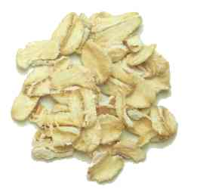

Sources:

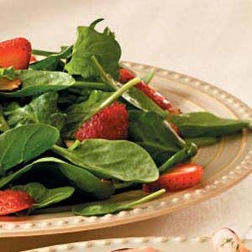



Thank you for your time!

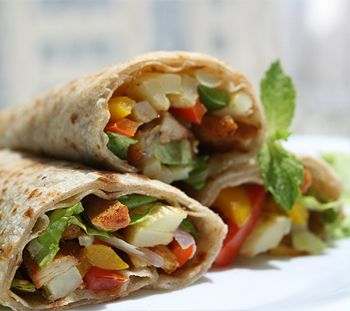

Nordqvist, C. (2010, March 31). What Is Fiber? What Is Dietary Fiber? Fiber Rich Foods. Medical News Today: Health News. Retrieved April 22, 2009, from http://www.medicalnewstoday.com/articles

Zabell, M. (n.d.). Types Of Fiber In Your Diet | LIVESTRONG.COM. LIVESTRONG.COM - Lose Weight & Get Fit with Diet, Nutrition & Fitness Tools | LIVESTRONG.COM. Retrieved June 14, 2011, from http://www.livestrong.com/article/271955-types-of-fiber-in-your-diet/

Zelman, K. (n.d.). Fiber: How Much Do I Need?. WebMD - Better information. Better health.. Retrieved November 2, 2011, from http://www.webmd.com/food-recipes/features/fiber-how-much-do-you-need







**Fill Up On Fiber:**

By: Rachel Enck

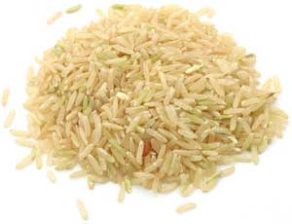

**Fiber Benefits:**

**1.T2 Diabetes** (By lengthening the time taken for the stomach to empty, soluble fiber slows down the absorption of sugar thus controlling blood sugar levels).

**2. Heart Disease** (By binding with bile containing cholesterol, soluble fiber helps to lower cholesterol by forcing the liver to pull cholesterol out of the blood.)

**3. Constipation** (Insoluble fiber increases the weight, size, and softness of stool so it can pass easier through the colon.)

**4. Diarrhea** (By absorbing excess liquid in the colon soluble fiber curbs diarrhea.)

**5. Colon Cancer** (By balancing the pH levels in your intestines, soluble fiber may help prevent colon cancer.)

**6. Weight Management** (soluble fiber prevents overeating by increasing satiety.)

**What is fiber?**

According to the Medilexicon medical dictionary, fiber is "Nutrients in the diet that is not digested by gastrointestinal enzymes."

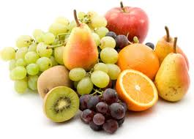

**How much fiber do you need?**

“Women need around 25 grams per day and men should get around 38 grams per day, according to an Institute of Medicine formula based on getting 14 grams of fiber for every 1,000 calories.”



**Soluble vs. Insoluble Fiber**

1. **Soluble fiber:** dissolves in water.

**Benefits:** Can control diarrhea, regulate blood sugar levels, lower cholesterol, and help with weight loss.

**Sources:**

• Oats and barely

• Legumes (beans, peas)

• Soybeans (soymilk, tofu, bean curd)

• Rice and potatoes

• Apples, bananas and berries

• Dried Fruit

1. **Insoluble fiber:** does not dissolve in water.

**Benefits**: Reduces constipation, helps eliminate toxins and balances pH in colon.

**Sources:**

• Whole wheat foods

• Bran

• Nuts

• Seeds

• Salad greens

• Skin of fruits and root vegetables

**Types of Fiber:**

* **Cellulose** - an insoluble polysaccharide found highest in green vegetables.
* **Lignin** - an insoluble complex polymer typically found in seeds.
* **Pectin** - a water-soluble polysaccharide typically found in fruit.
* **Inulin** - a water-soluble polysaccharide prebiotic typically found in roots or rhizomes like onions and artichokes.
* **Chitins** - an insoluble, polysaccharide found in the cell walls of mushrooms.
* **Gums** - a water-soluble polysaccharide typically found in seeds.