NOTICE OF UNSAFE AND UNHEALTHFUL WORKING CONDITIONS
VIOLATION NUMBER: 02
DATE: 4 May 2006

LOCATION: DRMO Lajes Field, Terceira, Portugal

DESCRIPTION OF HAZARD: The mast safety back rest has a broken weld on one support and its frame, bent. The operator’s seat cover is cracked through and muffler, corroded. Some safety identification markers are bleached out from sunlight/age.

RECOMMENDED ABATEMENT DATE: Within 90 days.

INTERIM ABATEMENT: N/A

RECOMMENDED MEASURES: Replace the back rest, load safety rack; seat, muffler and identification markers with OEM-approved parts. The Grammer seat, model MSG 20 with retractable seat belt, p/n 143467 is approved and offered by Hyster UK to improve seating comfort with full suspension seating. Padded armrests are an available option. Suspension seating is intended to address equipment vibration acceleration (transmitted to the operator) standards of 0.8 meters per second per second (0.8m/sec/sec). Most other parts are available through FEDLOG requisition procedures.

JUSTIFICATION/STANDARD(S) VIOLATED:

1) EC/EU: Council Directive 89/655/EEC of 30 November 1989 concerning the minimum safety and health requirements for the use of work equipment by workers at work:

Section II, Employers' Obligations.

a) Article 3, General obligations:

1. The employer did not take the measures necessary to ensure that the work equipment made available to workers in the undertaking and/or establishment is suitable for the work to be carried out or properly adapted for that purpose and may be used by workers without impairment to their safety or health.

2. Where it was not possible fully so to ensure that workers can use work equipment without (any) risk to their safety or health, the employer did not take appropriate measures to minimize the risks.

b) Article 4, Rules concerning work equipment:

2. The employer did not take the measures necessary to ensure that, throughout its
working life, work equipment was kept, by means of adequate maintenance, at a level such that it complies with the paragraph 1. (a) and (b) provisions.

2) OSHA 29 CFR 1910.178(p)(l): Powered industrial truck(s) with defect(s) or in any way unsafe had not been withdrawn from service until restored to safe operating condition(s).

3) OSHA 29 CFR 1910.178(a)(6): The user (operator) did not assure that all markings are in place and are maintained in legible condition.

RISK ASSESSMENT CODE: 4(IIIC)

FOR MORE INFORMATION CONTACT: DES-Europe Safety Office, DSN: 338-7650 or safety@europe.dla.mil.

SEVERITY CODE:
I - PERMANENT DISABILITY
II - PARTIAL DISABILITY
III-LOST WORK DAY
IV - FIRST AID

PROBABILITY CODE:
A - LIKELY TO OCCUR
B - PROBABLY WILL OCCUR
C- MAY OCCUR
D - UNLIKELY TO OCCUR

NOTICE OF UNSAFE AND UNHEALTHFUL WORKING CONDITIONS

VIOLATION NUMBER: 03

DATE: 4 May 2006

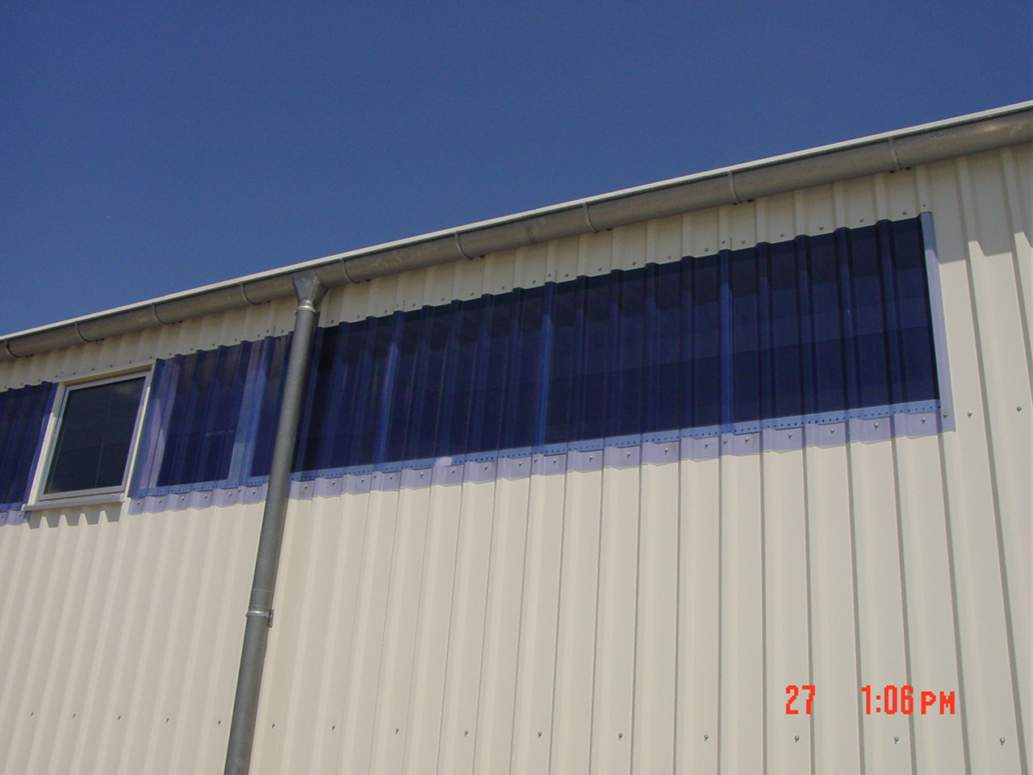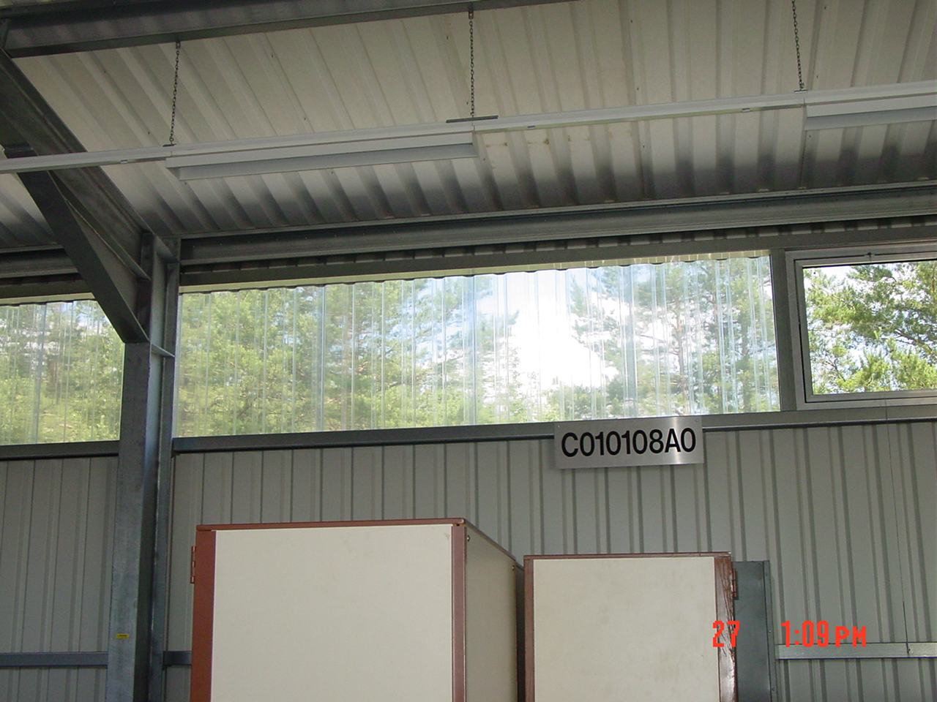
Example of natural lighting supplied through sidelights using polycarbonate plastic sheeting; a.k.a., Rooflite MB™.

LOCATION: DRMO Lajes Field, Terceira, Portugal

DESCRIPTION OF HAZARD: Natural (sun) light is excluded from the warehouses and new office area.

RECOMMENDED ABATEMENT DATE: Within 6 months.

INTERIM ABATEMENT: N/A

RECOMMENDED MEASURES:

Submit a work request for procurement and installation of corrugated clear polycarbonate plastic panels to replace some metal corrugated panels in the warehouse walls. Also, procure and install lockable windows with screens in the new office area opening into the warehouse. This will allow natural (sun) light to enter the office area through windows.

JUSTIFICATION/STANDARD VIOLATED:

1) EC/EU: Council Directive 89/654/EEC of 30 November 1989 concerning the minimum safety and health requirements for the workplace:
• Annex I, Minimum Safety and Health Requirements for Workplaces Used for the First Time, as Referred to in Article 3 of the Directive 1:
8. Natural and artificial room lighting:
8.1. Workplaces must as far as possible receive sufficient natural light and be equipped with artificial lighting adequate for the protection of workers' safety and health.
8.2. Lighting installations in rooms containing workplaces and in passageways must be placed in such a way that there is no risk of accident to workers as a result of the type of lighting fitted.
8.3. Workplaces in which workers are especially exposed to risks in the event of failure of artificial lighting must be provided with emergency lighting of adequate intensity.

2) NFPA 101:2003-42.2.9 Emergency Lighting. Emergency lighting shall be provided in normally occupied storage occupancies in accordance with Section 7.9, except for spaces occupied only during daylight hours with natural illumination in accordance with 42.2.8.2.

RISK ASSESSMENT CODE: 4(IIIC)

FOR MORE INFORMATION CONTACT: DES-Europe Safety Office, DSN: 338-7650 or safety@europe.dla.mil.

SEVERITY CODE:
I - PERMANENT DISABILITY
II - PARTIAL DISABILITY
III- LOST WORK DAY
IV-FIRST AID

PROBABILITY CODE:
A - LIKELY TO OCCUR
B - PROBABLY WILL OCCUR
C - MAY OCCUR
D - UNLIKELY TO OCCUR

NOTICE OF UNSAFE AND UNHEALTHFUL WORKING CONDITIONS

VIOLATION NUMBER: 04

DATE: 4 May 2006

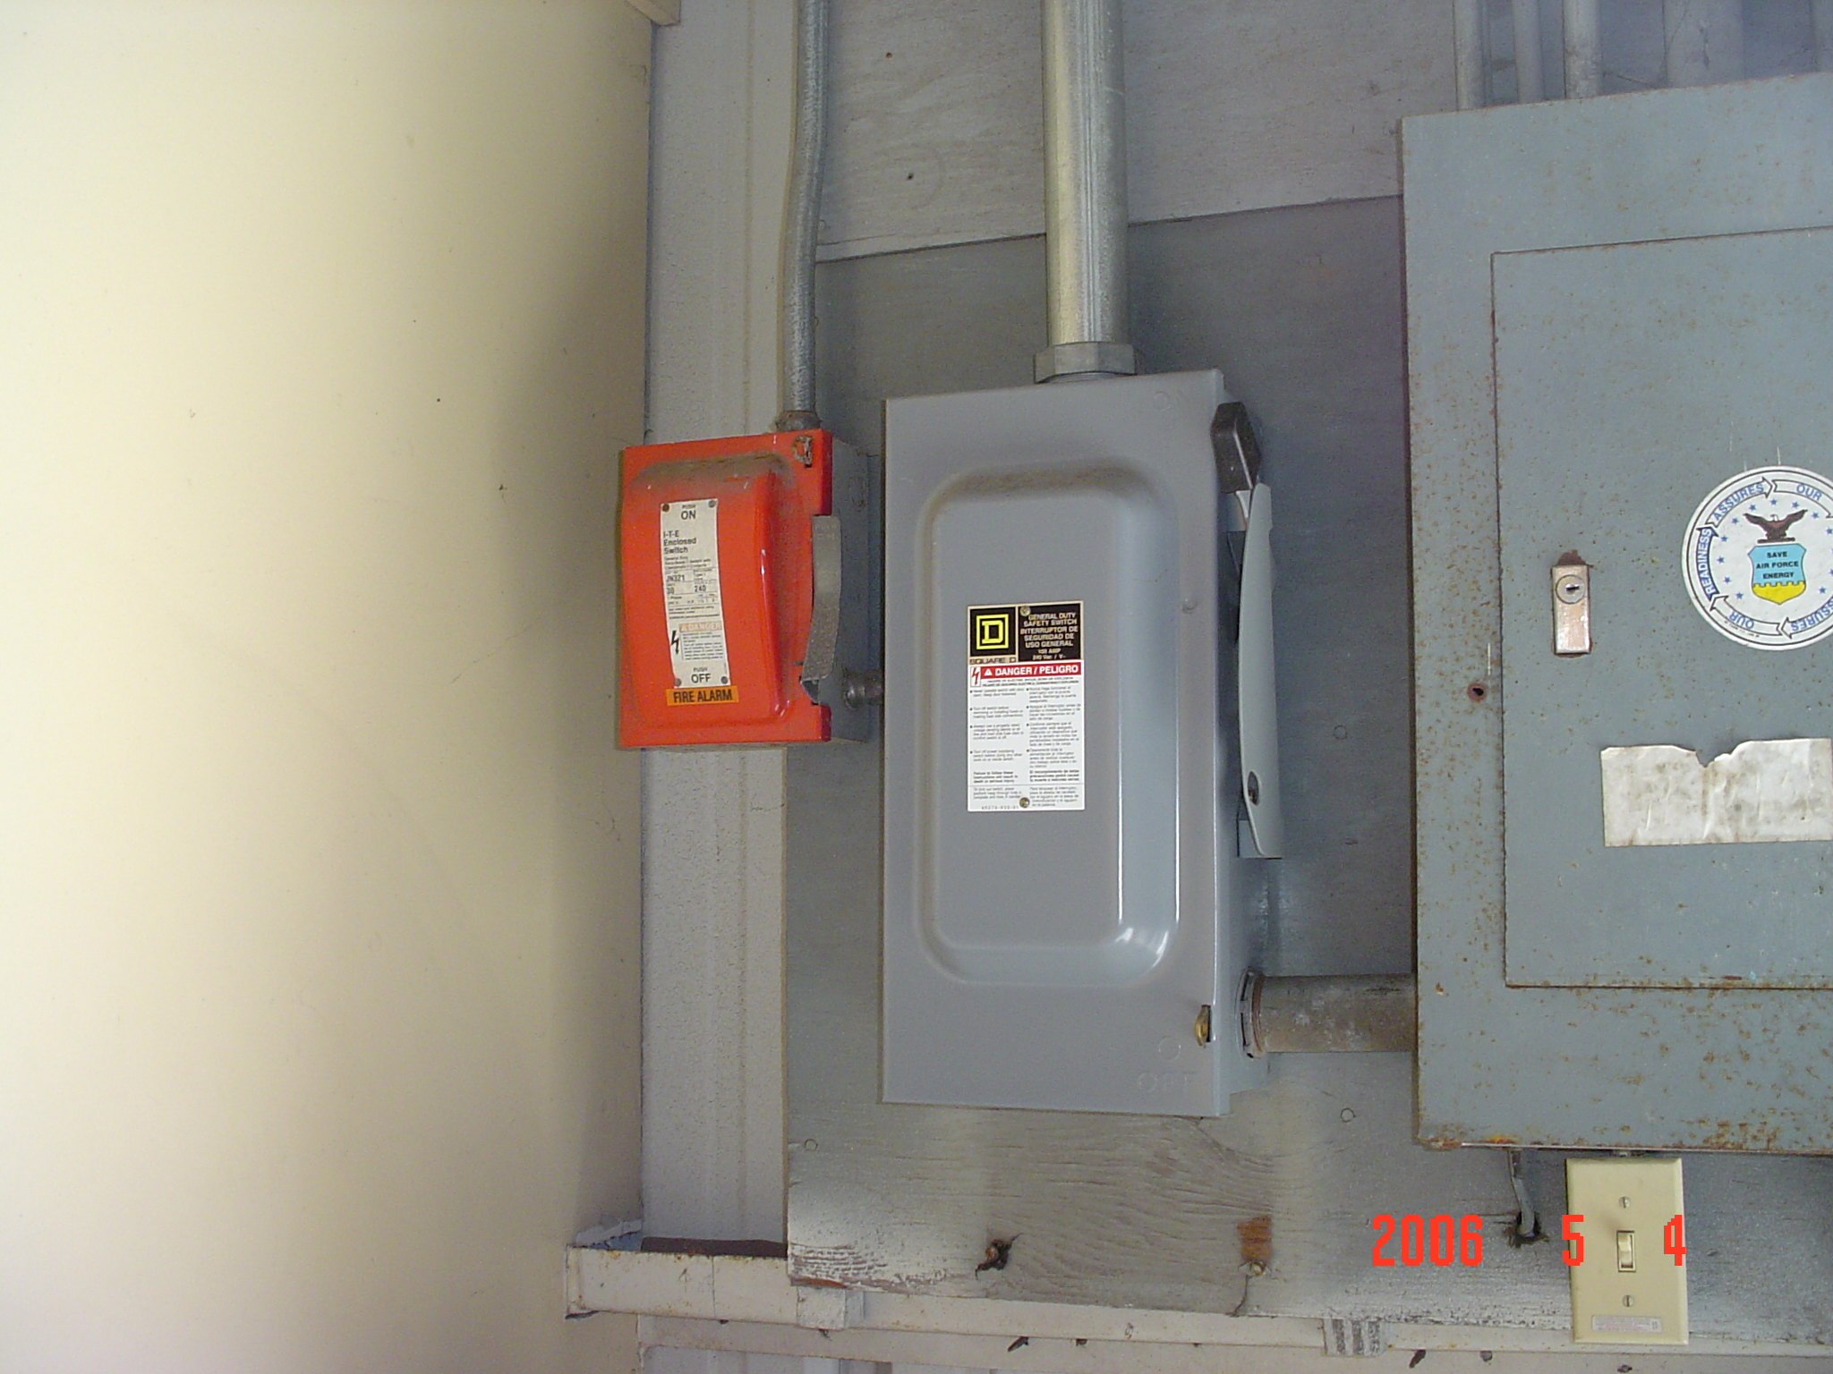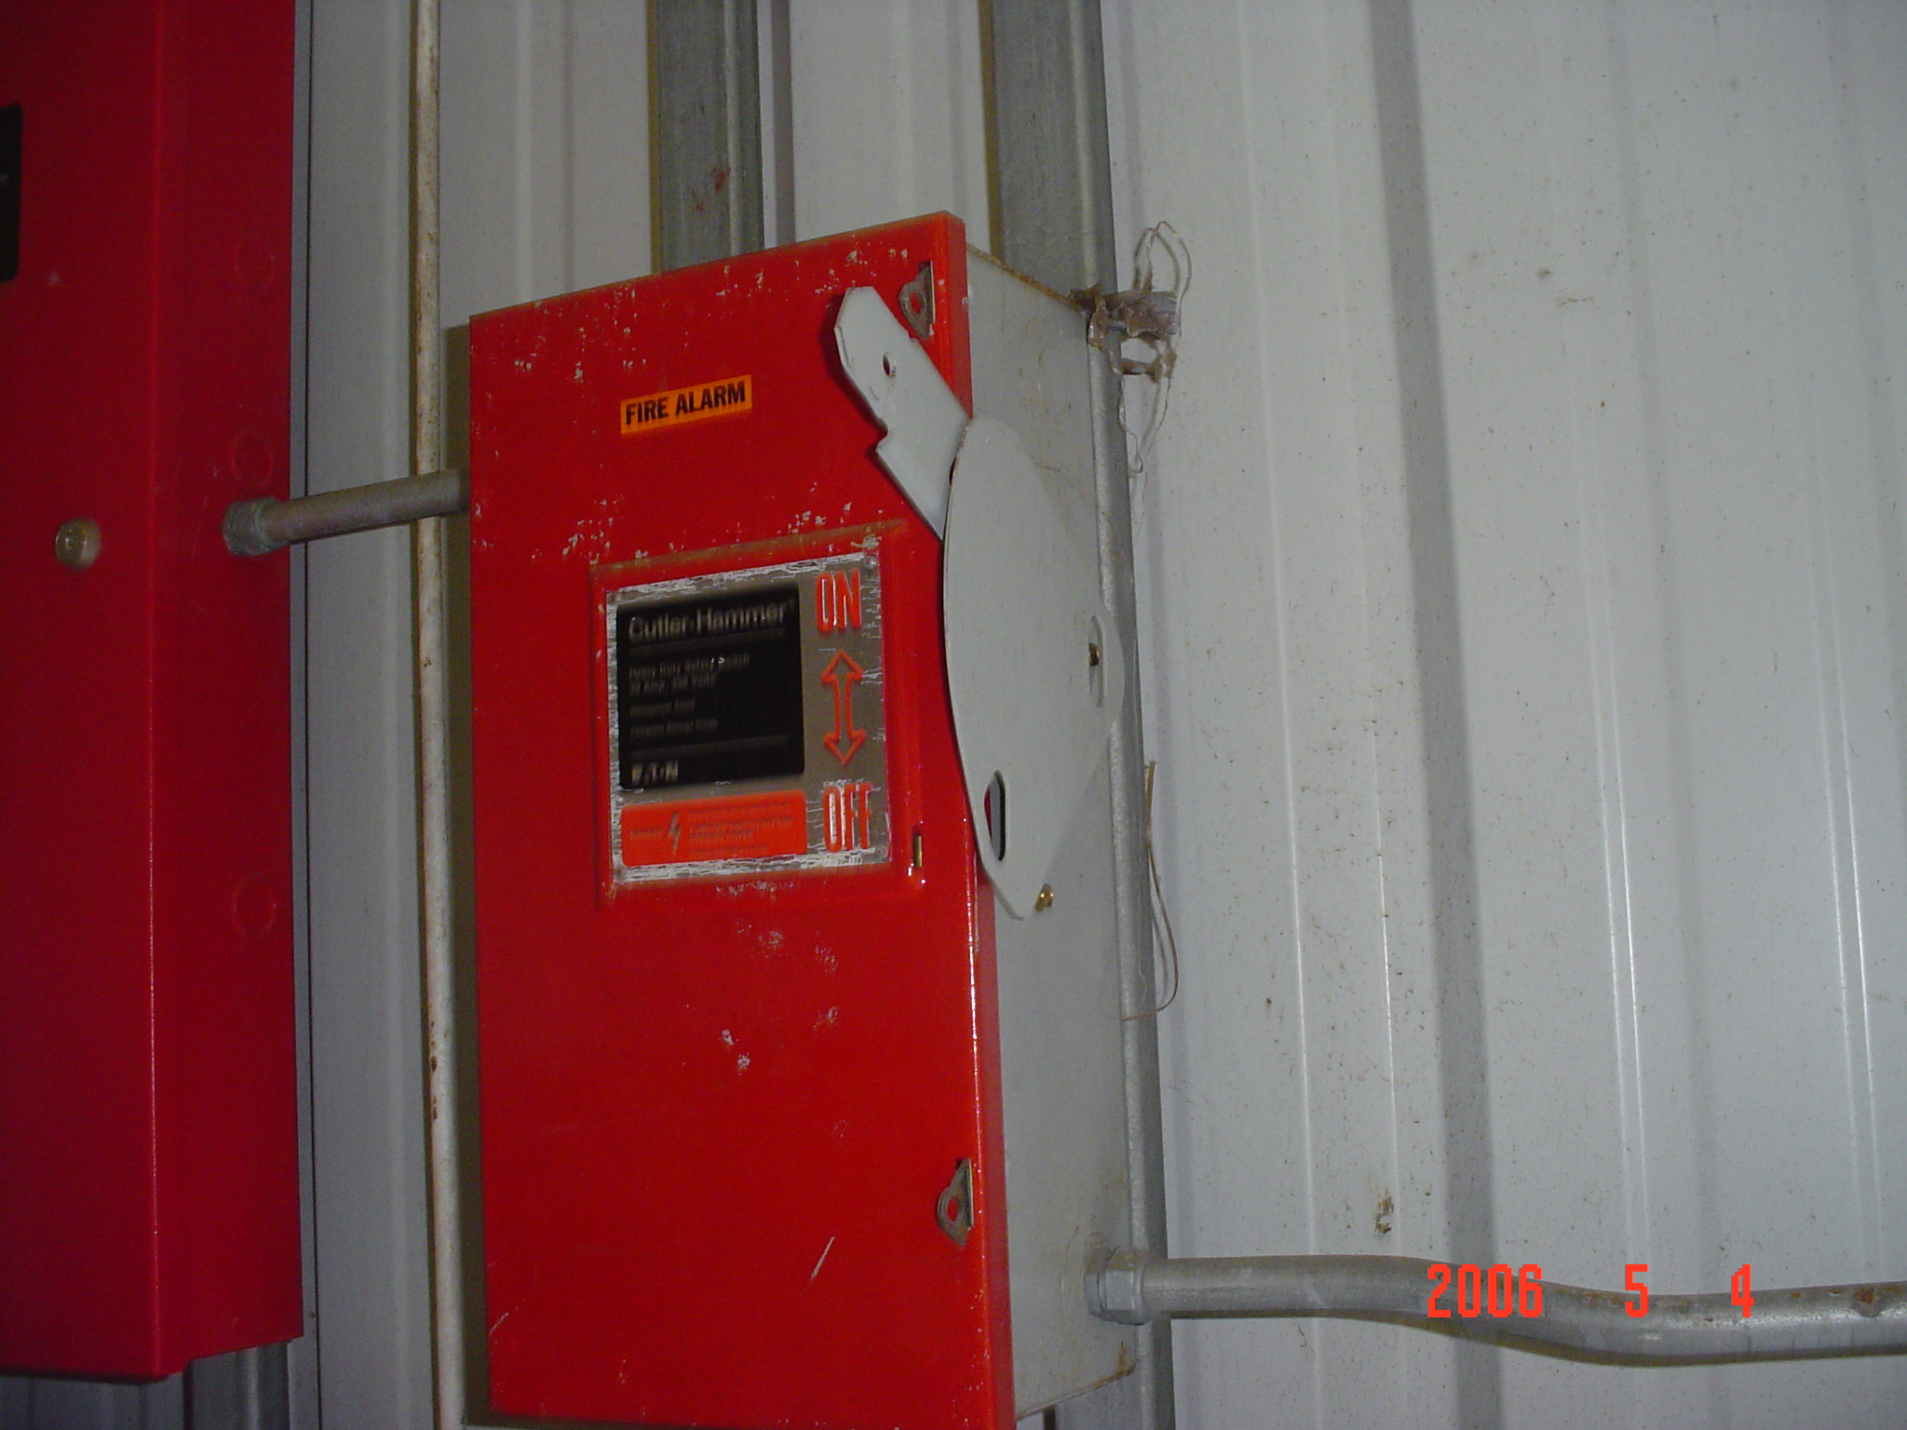

LOCATION: DRMO Lajes Field, Terceira, Portugal

DESCRIPTION OF HAZARD: Electrical pull boxes (disconnect switches) are unlabeled, unlocked and one pull handle has its insulation removed. One circuit breaker panel board is missing a cover and shows obvious signs of corrosion.

RECOMMENDED ABATEMENT DATE: Within 30 days receipt.

INTERIM ABATEMENT: N/A

RECOMMENDED MEASURES: A four (4) mm wide or larger electrical cord tie, or other approved locking mechanism may be used to secure pull box panels from access to unqualified workers. Replace the metal handle insulator with a type approved by the pull box manufacturer. Label electrical pull boxes with the yellow triangle with black lighting bolt caution pictogram. Maintenance of the interior of electrical pull boxes is restricted to qualified and authorized workers only and must be kept locked. When under service, such switches are both locked and tagged-out in the “off” position by qualified workers.

JUSTIFICATION/STANDARD(S) VIOLATED:

NFPA 70E:2004-400.10 Electrical Connections.

400.16 Guarding of Live Parts.
(A) Live Parts Guarded Against Accidental Contact. Except as elsewhere required or permitted by this standard, live parts of electric equipment operating at 50 volts or more shall be guarded against accidental contact by approved enclosures or by any of the following means:
(1) By location in a room, vault, or similar enclosure that is accessible only to qualified persons.
(2) By suitable permanent, substantial partitions or screens arranged so that only qualified persons have access to the space within reach of the live parts. Any openings in such partitions or screens shall be sized and located so that persons are not likely to come into accidental contact with the live parts or to bring conducting objects into contact with them.
(3) By location on a suitable balcony, gallery, or platform elevated and arranged so as to exclude unqualified persons.
(4) By elevation of 2.5 m (8 ft) or more above the floor or other working surface.

(C) Warning Signs. Entrances to rooms and other guarded locations that contain exposed live parts operating at 50 volts or more shall be marked with conspicuous warning signs forbidding unqualified persons to enter.

RISK ASSESSMENT CODE: 3(IIC)

FOR MORE INFORMATION CONTACT: DES-Europe Safety Office, DSN: 338-7650 or safety@europe.dla.mil.

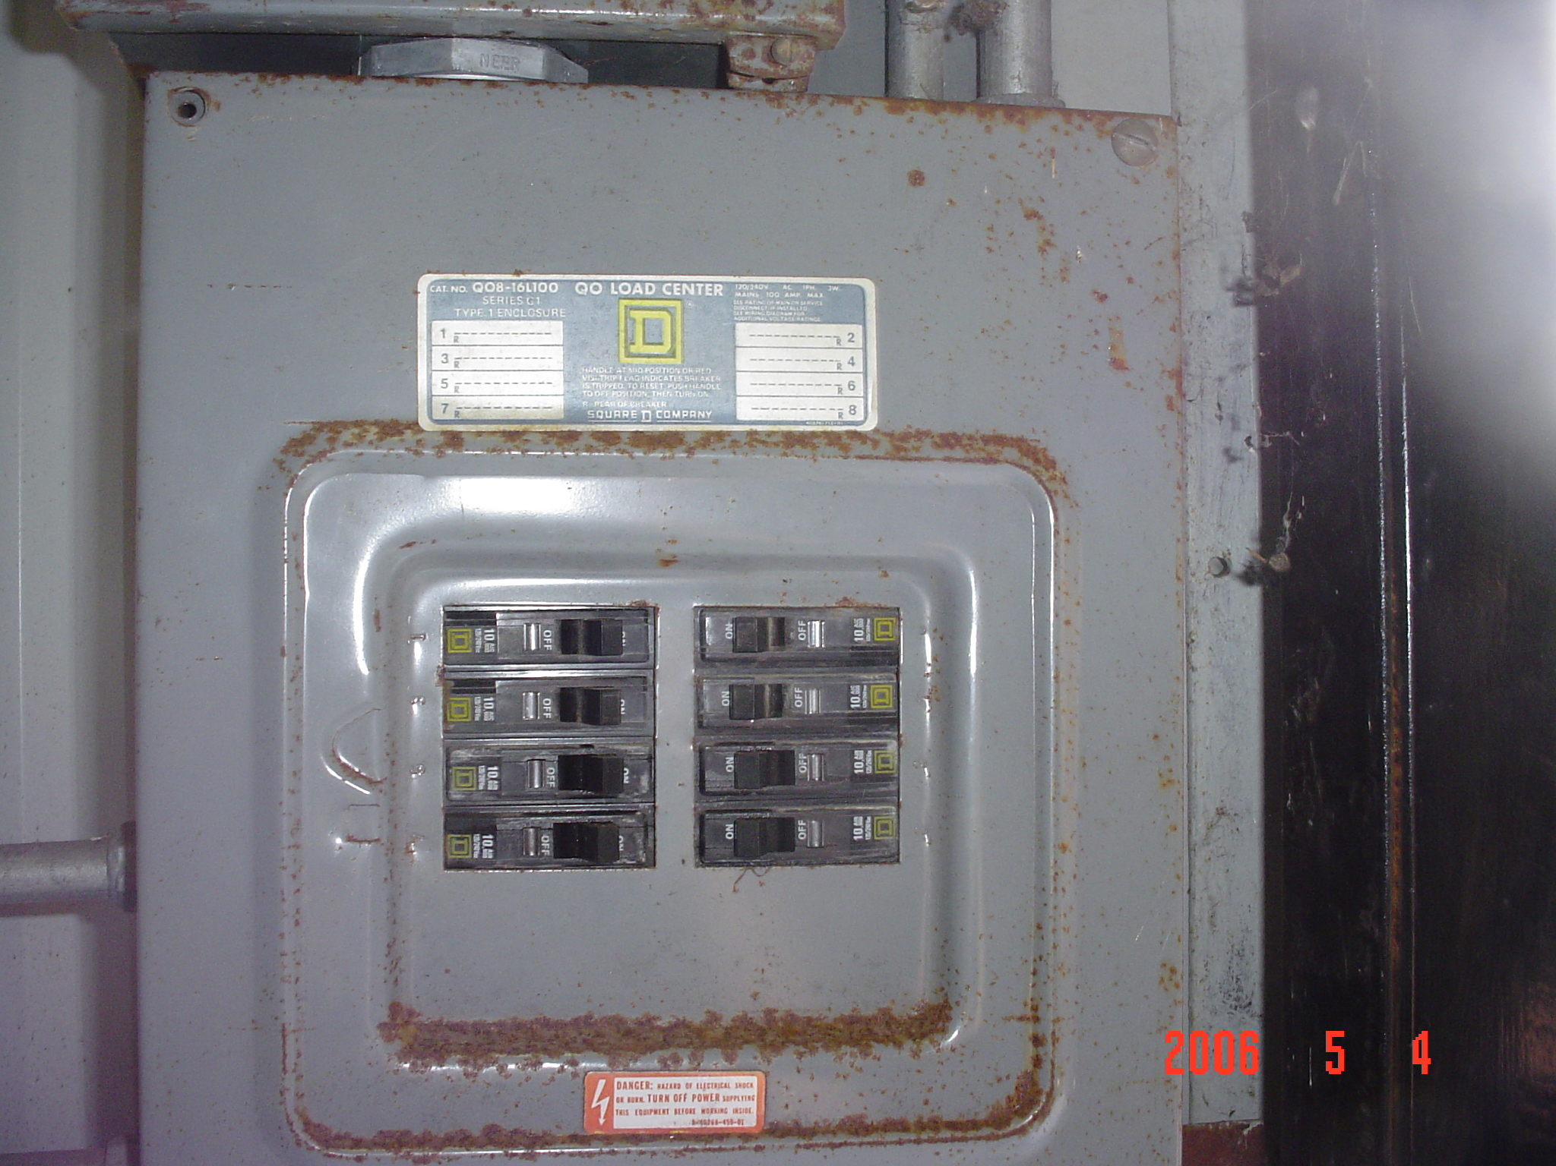

SEVERITY CODE:
I - PERMANENT DISABILITY
II - PARTIAL DISABILITY
III- LOST WORK DAY
IV-FIRST AID

PROBABILITY CODE:
A - LIKELY TO OCCUR
B - PROBABLY WILL OCCUR
C - MAY OCCUR
D - UNLIKELY TO OCCUR

