IN REPLY
-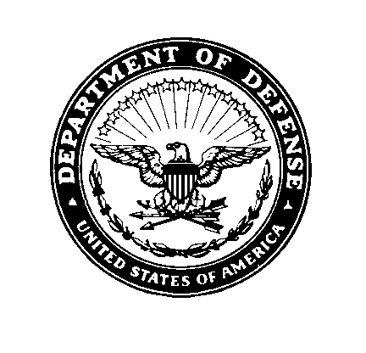
REFER TO: DES-DE (Safety)

MEMORANDUM FOR COMMANDER, DESCE

SUBJECT: Annual Safety and Occupational Health Assistance Visits, Inspections and
Notices of Unsafe or Unhealthful Working Conditions at DESCE Petroleum Lab

A Safety Program Evaluation and Inspection of DESCE Petroleum Lab, Rhine Ordnance Barracks, Kaiserslautern, Germany was conducted on 12 April 2005 by Robert Watson, Safety Specialist and Lawrence Matlock, Safety Manager, DLA Enterprise Support-Europe Safety Office. The visit was conducted IAW the following references:

References:

(a) DLAD 5025.30, The One Book, DSS, Environment & Safety, 27 August 2003
(b) DoDD 1000.3, Safety and Occupational Health Policy for DoD
(c) DoDI 6055.1, DoD Occupational Safety and Health Program
(d) E.O. 12196, Occupational Safety and Health Programs for Federal Employees
(e) DoDI 6050.5, DoD Hazard Communication Program
(f) DoDI 6055.12, Hearing Conservation Program
(g) DoDI 6055.5, Industrial Hygiene and Occupational Health
(h) DoDI 6055.4, DoD Traffic Safety Program
(i) DoDI 6055.7, Accident Investigation, Reporting, and Recordkeeping
(j) DoDI 6055.8, Occupational Radiation Protection Program
(k) 29 CFR 1960, Department of Labor Regulations on Federal Employee Occupational
Safety and Health Programs
(l) 29 CFR 1910, Occupational Safety and Health Standards (adopted as DoD
Occupational Safety and Health Standards)
(m) National Safety Council, Accident Prevention Manual for Industrial Operations
(n) Kaiserslautern Military Community Instruction 32-2002, The Fire Protection
Operations and Fire Prevention Program

Subject inspection was conducted on 12 April 2005 in accordance with the requirements of reference (a). An in-brief and out-brief were conducted with SFC Norman Villaroso, Lab NCOIC. Other personnel contacted during the inspection:

SSG Melvin Floyd, Sr. Lab Technician
Ms. Tina Blauth, Lab Technician
Ms. Erlinda Hertel, Administrative Assistant
Mr. William “Mike” Cochran, Assistant QA Mgr, DESCE
Ms. Jamie MacKenzie, Occupational Health Nurse, CHPPM-EUR (Pulaski)
SMSgt Helen Younger, Superintendent, Public Health, 86th AMDS
Mr. Thomas Ruf, Fire Inspector, 415th BSB

A report of the inspection is attached. Notices of Unsafe and Unhealthful Working Conditions with estimated Risk Assessment Codes are provided according to 29 CFR 1960 and procedures outlined in DoDI 6055.1, respectively.

Summary:

DESCE-Petroleum Lab is located in facility 320 on Rhine Ordnance Barracks. Four personnel work at this location performing laboratory analysis of submitted fuel samples. The lab requires a Chemical Hygiene Plan. The routine scheduling and completion of occupational physical examinations for local national employees, particularly the lab technician, are of concern.

For additional information or assistance, please contact me at DSN: 338-7542.

ROBERT A. WATSON
Safety Specialist

Reviewed By:

LAWRENCE D. MATLOCK
Safety & Occupational Health Manager

Attachments:
1. Violation No. 1, RAC 4 (IIIC)
2. Violation No. 2, RAC 5 (IVD)

cc:
DES-DESCE (Safety Office)
DES-DE
DES-EH
DESCE (Safety)

NOTICE OF UNSAFE AND UNHEALTHFUL WORKING CONDITIONS

VIOLATION NO: 01

DATE: 13 April 2005

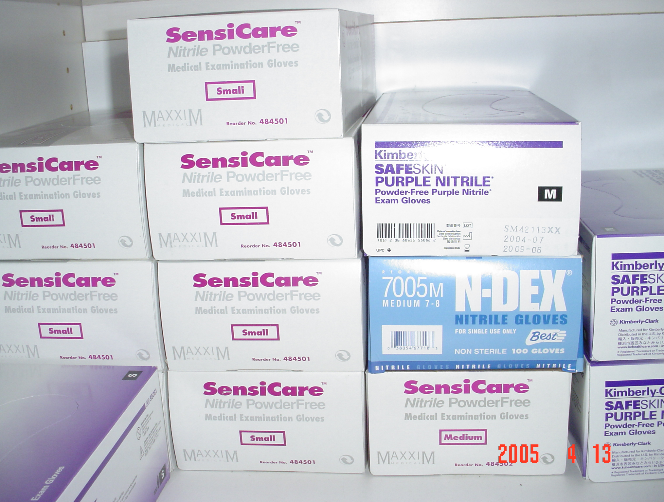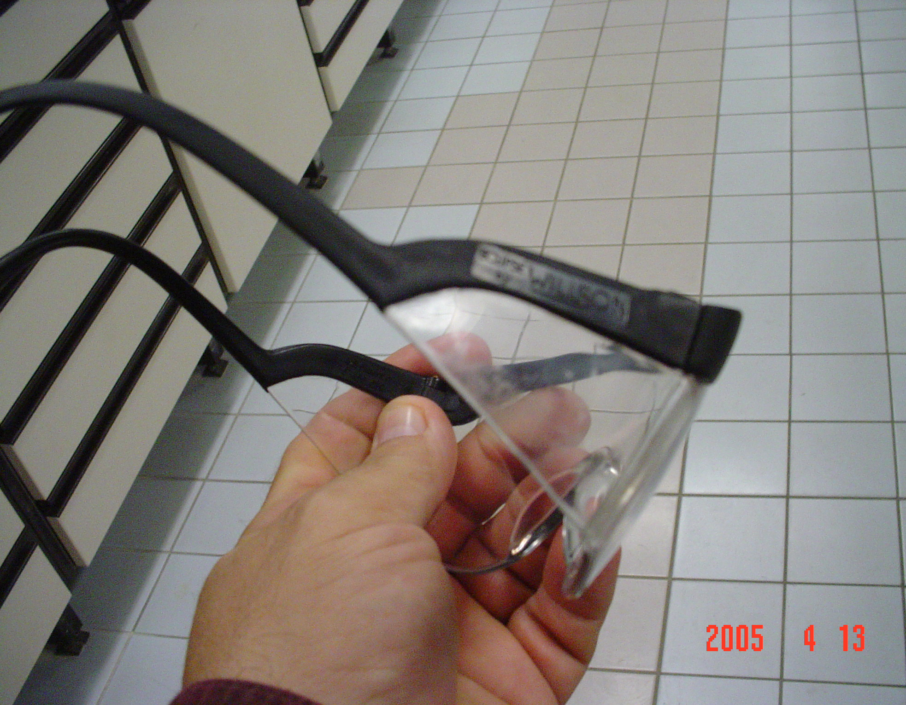

LOCATION: DESCE Fuels Lab, Rhine Ordnance Barracks, Kaiserslautern, Germany

DESCRIPTION OF HAZARD: PPE does not appear to be selected based upon an assessment of work area hazards. Available single-use, nitrile gloves are not rated for chemical resistance. Available safety glasses are ANSI Z87.1 and rated for high impact resistance only.

RECOMMENDED ABATEMENT DATE: Within 45 days of receipt.

INTERIM ABATEMENT:
1) Procure N-Dex Plus or similar, 8-mil, single-use, powder-free, nitrile gloves which will prevent contact from work area chemicals when used according to the manufacturer’s breakthrough test results. NSNs: 8415-01-415-6482/6481 are available in med and large sizes, respectively.
2) Procure indirect vented, splash resistant goggles meeting ANSI Z87.1-1989 (R1998) or similar CE (DIN EN 166) marked product. NSN: 4240-01-501-7029 is available in FEDLOG.

RECOMMENDED MEASURES: Coordinate with USACHPPM-EUR Industrial Hygiene at Landstuhl, DSN: 486-7039 to arrange a comprehensive industrial hygiene survey of employee exposures to chemicals and analysis by-products.

JUSTIFICATION/STANDARD VIOLATED:

1) OSHA 29 CFR 1910.132(d): Hazard assessment and equipment selection.
a) 1910.132(d)(1): The employer did not assess the workplace to determine if hazards are present, or are likely to be present, which necessitate the use of personal protective equipment (PPE). If such hazards are present, or likely to be present, the employer shall:
1 1910.132(d)(1)(i): Select, and have each affected employee use, the types of PPE that will protect the affected employee from the hazards identified in the hazard assessment;
2 1910.132(d)(1)(ii): Communicate selection decisions to each affected employee; and,
3 1910.132(d)(1)(iii): Select PPE that properly fits each affected employee. NOTE: Non-mandatory Appendix B contains an example of procedures that would comply with the requirement for a hazard assessment.
See Appendix B for guidance at: http://www.osha.gov/pls/oshaweb/owadisp.show_document?p_table=STANDARDS&p_id=10120
b) 1910.132(d)(2): The employer did not verify that the required workplace hazard assessment has been performed through a written certification that identifies the workplace evaluated; the person certifying that the evaluation has been performed; the date(s) of the hazard assessment; and, which identifies the document as a certification of hazard assessment.

2) OSHA 29 CFR 1910.133(a)(6): The design, construction, testing and/or use of devices for eye and/or face protection was not in accordance with American National Standard for Occupational and Educational Eye and Face Protection, Z87.1- 1989 (R1998).

3) DoDI 6055.1: E4. ENCLOSURE 4; DOD PERSONAL PROTECTIVE EQUIPMENT PROGRAM

E4.2. RESPONSIBILITIES; The Heads of the DoD Components shall ensure that:

E4.2.1. Workplaces are evaluated to determine PPE requirements. Qualified safety and health personnel shall perform these evaluations and recommend appropriate personal protective equipment.

4) EC/EU: Council Directive of 30 November 1989 on the minimum health and safety requirements for the use by workers of personal protective equipment at the workplace (third individual directive within the meaning of Article 16 (1) of Directive 89/391/EEC) (89/656/EEC).

SECTION II, EMPLOYERS' OBLIGATIONS

Article 4; General Provisions:
1. Personal protective equipment must comply with the relevant Community provisions on design and manufacture with respect to safety and health. All personal protective equipment must:
- be appropriate for the risks involved, without itself leading to any increased risk;
- correspond to existing conditions at the workplace;
- take account of ergonomic requirements and the worker's state of health;
- fit the wearer correctly after any necessary adjustment.

2. Where the presence of more than one risk makes it necessary for a worker to wear simultaneously more than one item of personal protective equipment, such equipment must be compatible and continue to be effective against the risk or risks in question.

3. The conditions of use of personal protective equipment, in particular the period for which it is worn, shall be determined on the basis of the seriousness of the risk, the frequency of exposure to the risk, the characteristics of the workstation of each worker and the performance of the personal protective equipment.

4. Personal protective equipment is, in principle, intended for personal use. If the circumstances require personal protective equipment to be worn by more than one person, appropriate measures shall be taken to ensure that such use does not create any health or hygiene problem for the different users.

5. Adequate information on each item of personal protective equipment, required under paragraphs 1 and 2, shall be provided and made available within the undertaking and/or establishment.

6. Personal protective equipment shall be provided free of charge by the employer, who shall ensure its good working order and satisfactory hygienic condition by means of the necessary maintenance, repair and replacements.

7. The employer shall first inform the worker of the risks against which the wearing of the personal protective equipment protects him.

8. The employer shall arrange for training and shall, if appropriate, organize demonstrations in the wearing of personal protective equipment.

9. Personal protective equipment may be used only for the purposes specified, except in specific and exceptional circumstances. It must be used in accordance with instructions. Such instructions must be understandable to the workers.

Article 5; Assessment of personal protective equipment:

1. Before choosing personal protective equipment, the employer is required to assess whether the personal protective equipment he intends to use satisfies the requirements of Article 4 (1) and (2). This assessment shall involve:
- an analysis and assessment of risks which cannot be avoided by other means;
- the definition of the characteristics which personal protective equipment must have in order to be effective against the risks referred to in (a), taking into account any risks which this equipment itself may create;
- comparison of the characteristics of the personal protective equipment available with he characteristics referred to in (b).

2. The assessment provided for in paragraph 1 shall be reviewed if any changes are made to any of its elements.

Article 7, Information for workers: Without prejudice to Article 10 of Directive 89/391/EEC, workers and/or their representatives shall be informed of all measures to be taken with regard to the health and safety of workers when personal protective equipment is used by workers at work.

RISK ASSESSMENT CODE: 4(IIIC)

FOR MORE INFORMATION CONTACT: For additional information, please contact Lawrence Matlock (Safety Manager) or Robert Watson (Safety Specialist) at DSN: 338-7650/7542 or FAX, DSN: 338-7707. E-Mail: safety@europe.dla.mil

SEVERITY CODE: PROBABILITY CODE:
I - PERMANENT DISABILITY A. - LIKELY TO OCCUR
II - PARTIAL DISABILITY B - PROBABLY WILL OCCUR
III- LOST WORK DAY C - MAY OCCUR
IV - FIRST AID D - UNLIKELY TO OCCUR

NOTICE OF UNSAFE AND UNHEALTHFUL WORKING CONDITIONS

VIOLATION NO: 02

DATE: 13 April 2005

LOCATION: DESCE Fuels Lab, Rhine Ordnance Barracks, Kaiserslautern, Germany

DESCRIPTION OF HAZARD: No written Chemical Hygiene Plan.

RECOMMENDED ABATEMENT DATE: Within 45 days of receipt.

INTERIM ABATEMENT: Brief employees on the contents of 29 CFR 1910.1450 that was provided as staff assistance during the annual training day, hosted by DLA-E.

RECOMMENDED MEASURES: Appoint a Chemical Hygiene Officer for the Fuels Lab. Coordinate with OL, DET 3, WR-ALC/AFTLF, DSN: 238-2043/2797 to review a Chemical Hygiene Plan for a similar fuel lab operation. Also, the Chemical Hygiene Officer at CHPPM-Europe’s Laboratory, Landstuhl may provide a working copy of his plan to use as a template draft. See CHPPM Technical Guide 183, Developing Your Chemical Hygiene Plan for further information at: http://chppm-www.apgea.army.mil/documents/TG/TECHGUID/Tg183.pdf

JUSTIFICATION/STANDARD VIOLATED:

1) OSHA 29 CFR 1910.1450(e)(1)(i): Where hazardous chemicals were used in the workplace, the employer did not develop and carry out the provisions of a written Chemical Hygiene Plan which were capable of protecting employees from health hazards associated with hazardous chemicals.

2) OSHA 29 CFR 1910.1450(f)(3)(i): The employer did not inform laboratory employees of the contents of this standard and its appendices.

RISK ASSESSMENT CODE: 5(IVD)

FOR MORE INFORMATION CONTACT: For additional information, please contact Lawrence Matlock (Safety Manager) or Robert Watson (Safety Specialist) at DSN: 338-7650/7542 or FAX, DSN: 338-7707. E-Mail: safety@europe.dla.mil

SEVERITY CODE: PROBABILITY CODE:
I - PERMANENT DISABILITY A. - LIKELY TO OCCUR
II - PARTIAL DISABILITY B - PROBABLY WILL OCCUR
III- LOST WORK DAY C - MAY OCCUR
IV - FIRST AID D – UNLIKELY TO OCCUR

