David Purdie
Oklahoma State University
Stillwater, OK 74078
555-555-5555

Photo Release
FOR IMMEDIATE RELEASE For More Information, Contact:
Oct. 13, 2011 David Purdie
Director of Media Relations
555-555-5555
david.purdie@okstate.edu
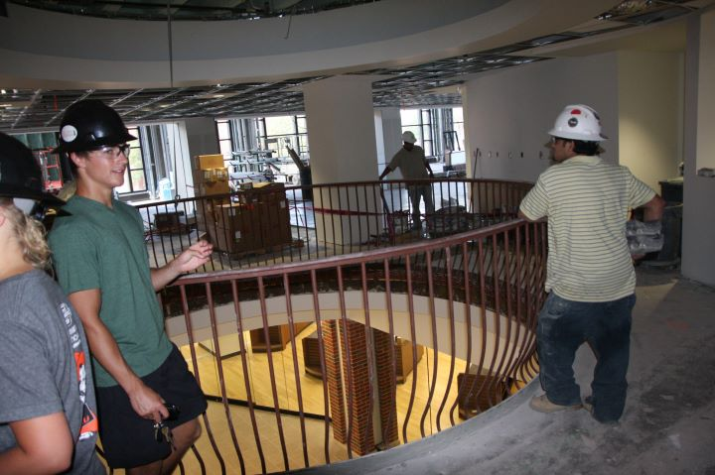
James Paganis, Oklahoma State University SGA Vice President’s Chief of Staff, watches construction workers meeting the Nov. 1, 2011, renovation deadline of the Campus Life area on the second floor of the Student Union.

Student Union Director, Mitch Kilcrease, watches a construction worker install LED lights to the new addition of the second floor in the Student Union to meet the Nov. 1, 2011, renovation deadline.

###

