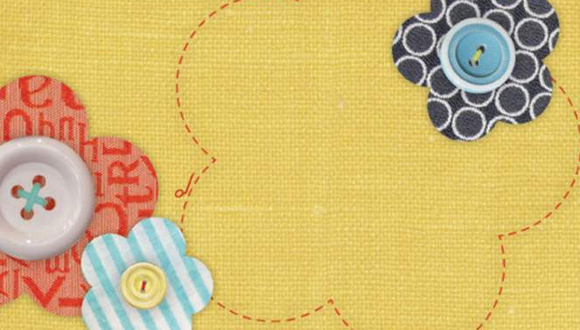
Heartfelt Quilts
homemade quilts and other
specialty items

Prices
Quilt- $75
Table Runner/Wall hanging-$25 each
Pot Holders w/ Insul-Bright- $7 each
Gift Bags- $4 each
Pin Cushions- $8 each
Coffee Cozy with cup- $8 each
Coffee Cozy- $4 each
Dog Toys
Large- $3
Small- $2

