Oklahoma State University
Student Union Renovation Project
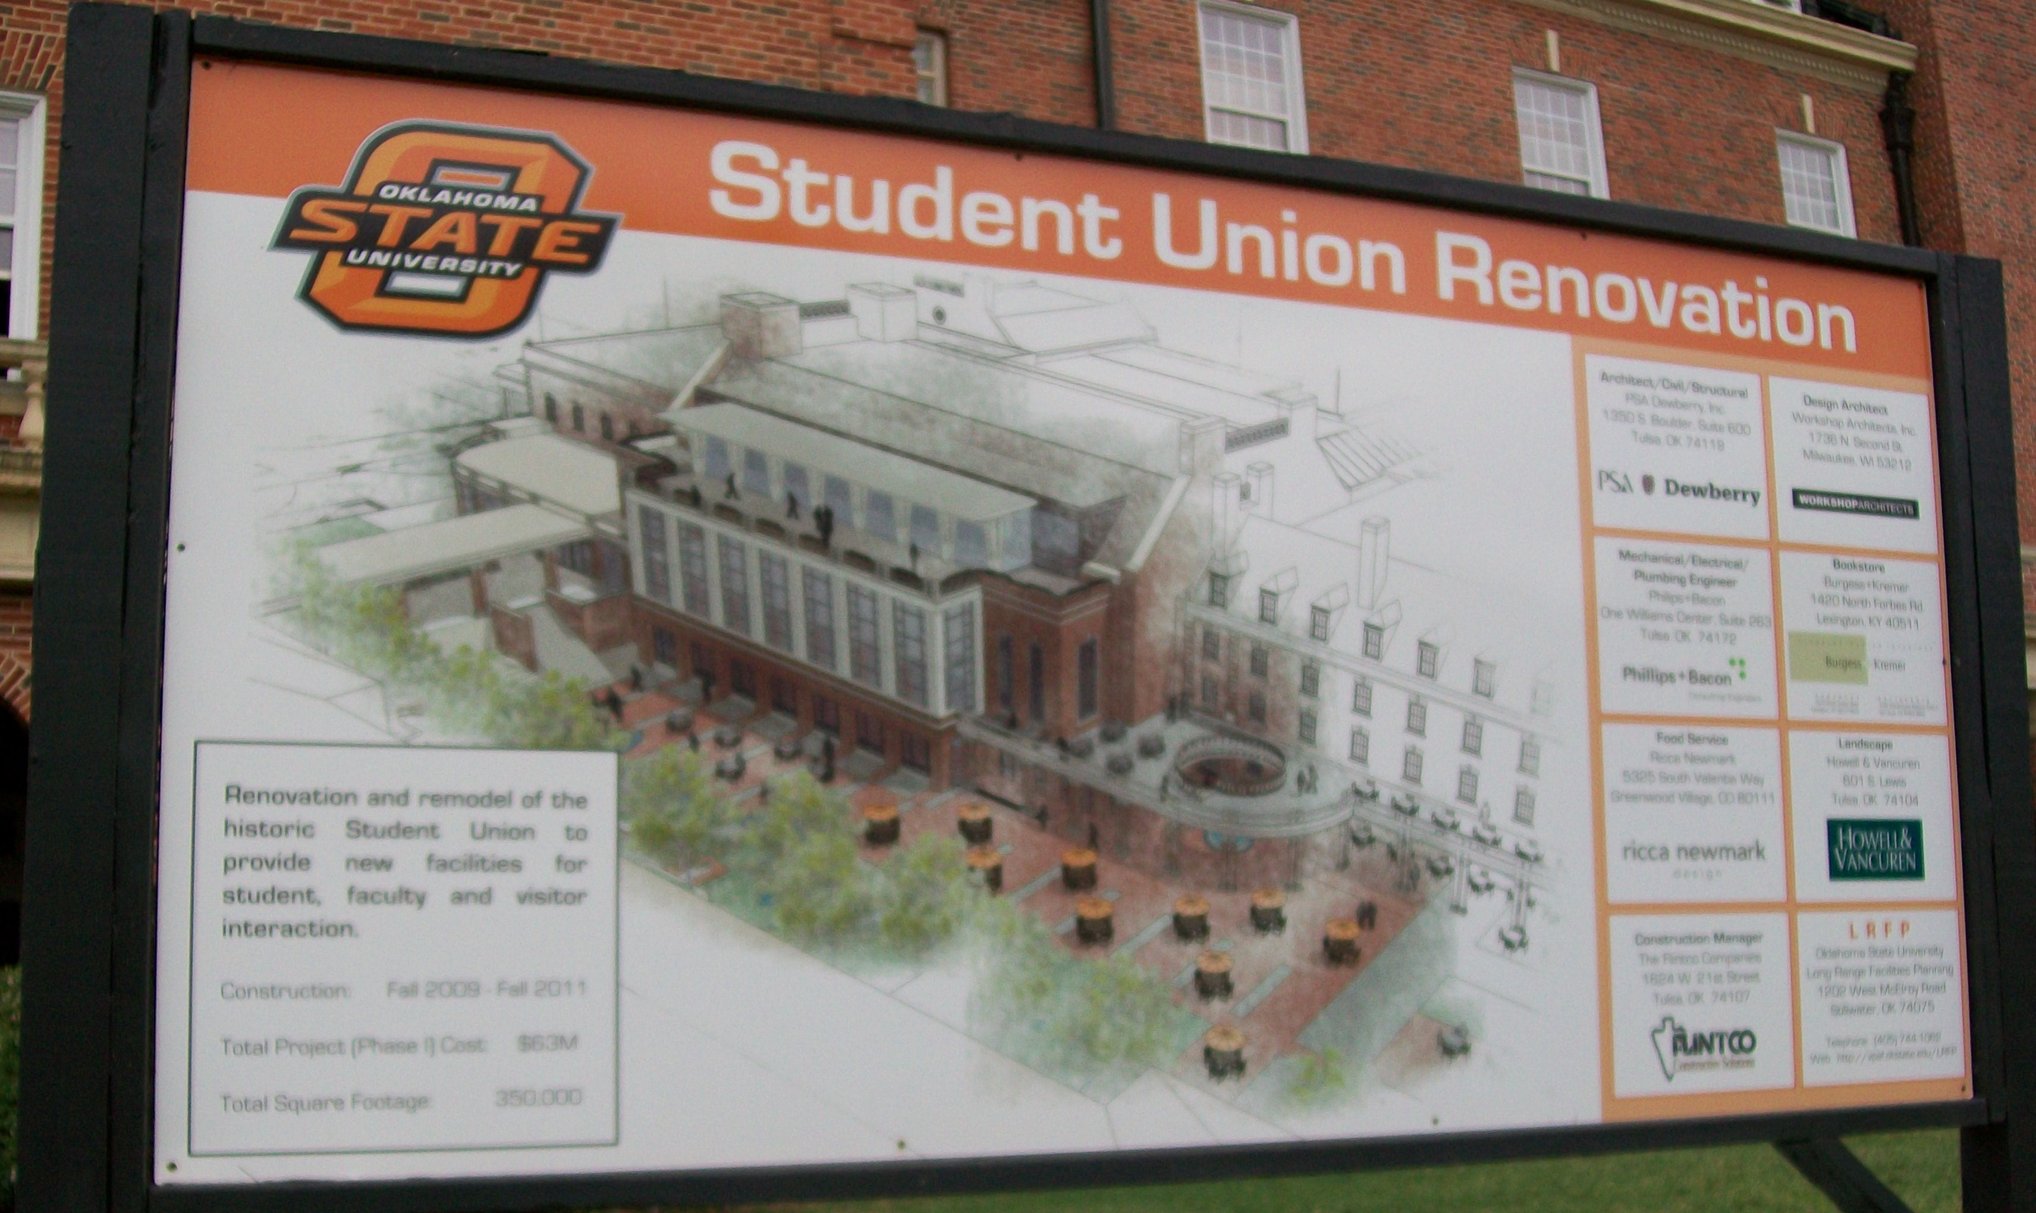
Fall 2011

Oklahoma State University
Stillwater, Okla.
405-744-5000

News Release

FOR IMMEDIATE RELEASE FOR MORE INFORMATION, CONTACT:
Oct. 10, 2011 Kiara Ealy
Director of Media Relations
405-412-5065
Kealy1991@gmail.com

Oklahoma State University holds Student Union celebration

STILLWATER, Okla.—Students, faculty, staff and alumni of OSU have a big celebration to look forward to next week. After nearly two years of renovation, retail shops, the bookstore, the food court and Campus Life will move back into the Student Union. OSU cowboys and cowgirls will also be celebrating the 61 years the Union has existed and been a campus staple. The celebration will begin next Friday.
The Student Union celebration is scheduled to begin at 9 a.m. on Friday, Oct. 21, on the Union’s balcony. President Burns Hargis and First Lady Ann Hargis will have a ribbon cutting to officially declare the renovation complete. “This is an exciting time to be a part of Oklahoma State University,” President Hargis said. “Our Student Union will continue to be the greatest in the world and be a place for cowboys and cowgirls to create everlasting memories,” he said.
Built in 1950 under the direction of President Henry G. Bennett, the OSU Student Union holds a special place in the hearts of both past and present students. Dennis Busch, a former OSU student from 1969-1974, worked and met his future wife at the Student Union. “Is the Union important in my life? It only gave me a career and a family!” Busch said.
-more-
-Student Union Celebration 2-

Present students like freshman Janelle Mitchell look forward to the memories that will be made at the newly renovated Student Union. “I know it will serve as a place for me to interact with new people and be able to get involved on campus,” Mitchell said.
The Student Union facelift has cost $63 million. Square footage of the building has increased by 350,000, still making OSU’s Student Union the largest in the world. Funding for the building was made possible by student fees, university funds, bonds and private donations. The renovation was much needed with a growing student body and more than 400 student organizations on campus.
###

Oklahoma State University
Stillwater, Okla.
405-744-5000

Backgrounder

FOR IMMEDIATE RELEASE FOR MORE INFORMATION, CONTACT:
Oct. 10, 2011 Kiara Ealy
Director of Media Relations
405-412-5065
Kealy1991@gmail.com

Oklahoma State University Student Union
In 1926, OSU President Knapp proposed spending $200,000 on a Student Union to fit the needs of a growing student body. Construction on the facility never began while he was president.
After he was appointed in 1928, President Henry G. Bennett proposed a 25 Year Plan that called for a student union.
In 1945, revenue bonds for the Student Union were approved. The building was to include a bookstore, cafeteria, and hotel all owned by the college. Plans for additional space allowed the placement of numerous retail stores, recreational areas, a bowling alley, and a billiards room.
The OSU Student Union officially opened its doors in 1950. It was built by Manhattan Construction Company.
Several changes have been made to the student union since its construction including several additions and upgrades. It has been updated in some area every decade. OSU’s Student Union still remains the largest in the world.
###
Oklahoma State University
Stillwater, Okla.
405-744-5000

Fact Sheet

FOR IMMEDIATE RELEASE FOR MORE INFORMATION, CONTACT:
Oct. 10, 2011 Kiara Ealy
Director of Media Relations
405-412-5065
Kealy1991@gmail.com
Oklahoma State University holds Student Union celebration
What: OSU’s Student Union renovation project has been completed.
A ribbon cutting will be held Oct. 21, at 9 a.m. on the Student Union’s balcony to declare the renovation a milestone and success.

Who: President Burns Hargis and First Lady Ann Hargis will host the event.
They will be joined by students, faculty, staff and alumni for the celebration.

Where: Oklahoma State University in Stillwater, Okla.

When: The Student Union celebration will take place on Oct. 21, 2011.

Why: “The Student Union renovation was needed in order for our campus to grow. Our Student Union will continue to be the greatest in the world and be a place for cowboys and cowgirls to create everlasting memories.”

-Burns Hargis, President
Oklahoma State University

References

1. "CommScope Networks 21,000 Students at World's Largest Student Union."Http://origin.library.constantcontact.com/download/get/file/1102861932251-136/CommScope+Case+Study.pdf. CommScope, May 2011. Web. 11 Oct. 2011.

2. Sanderson, J. Lewie, R. Dean McGlamery, and David C. Peters. "The "Waldorf" of Student Unions." A History of the Oklahoma State University Campus. Stillwater: Oklahoma State University, 1990. 233-53. Print.

3. "Student Union Renovation." OSU Student Union. Oklahoma State University. Web. 11 Oct. 2011. <http://union.okstate.edu/renovation/index.htm>.

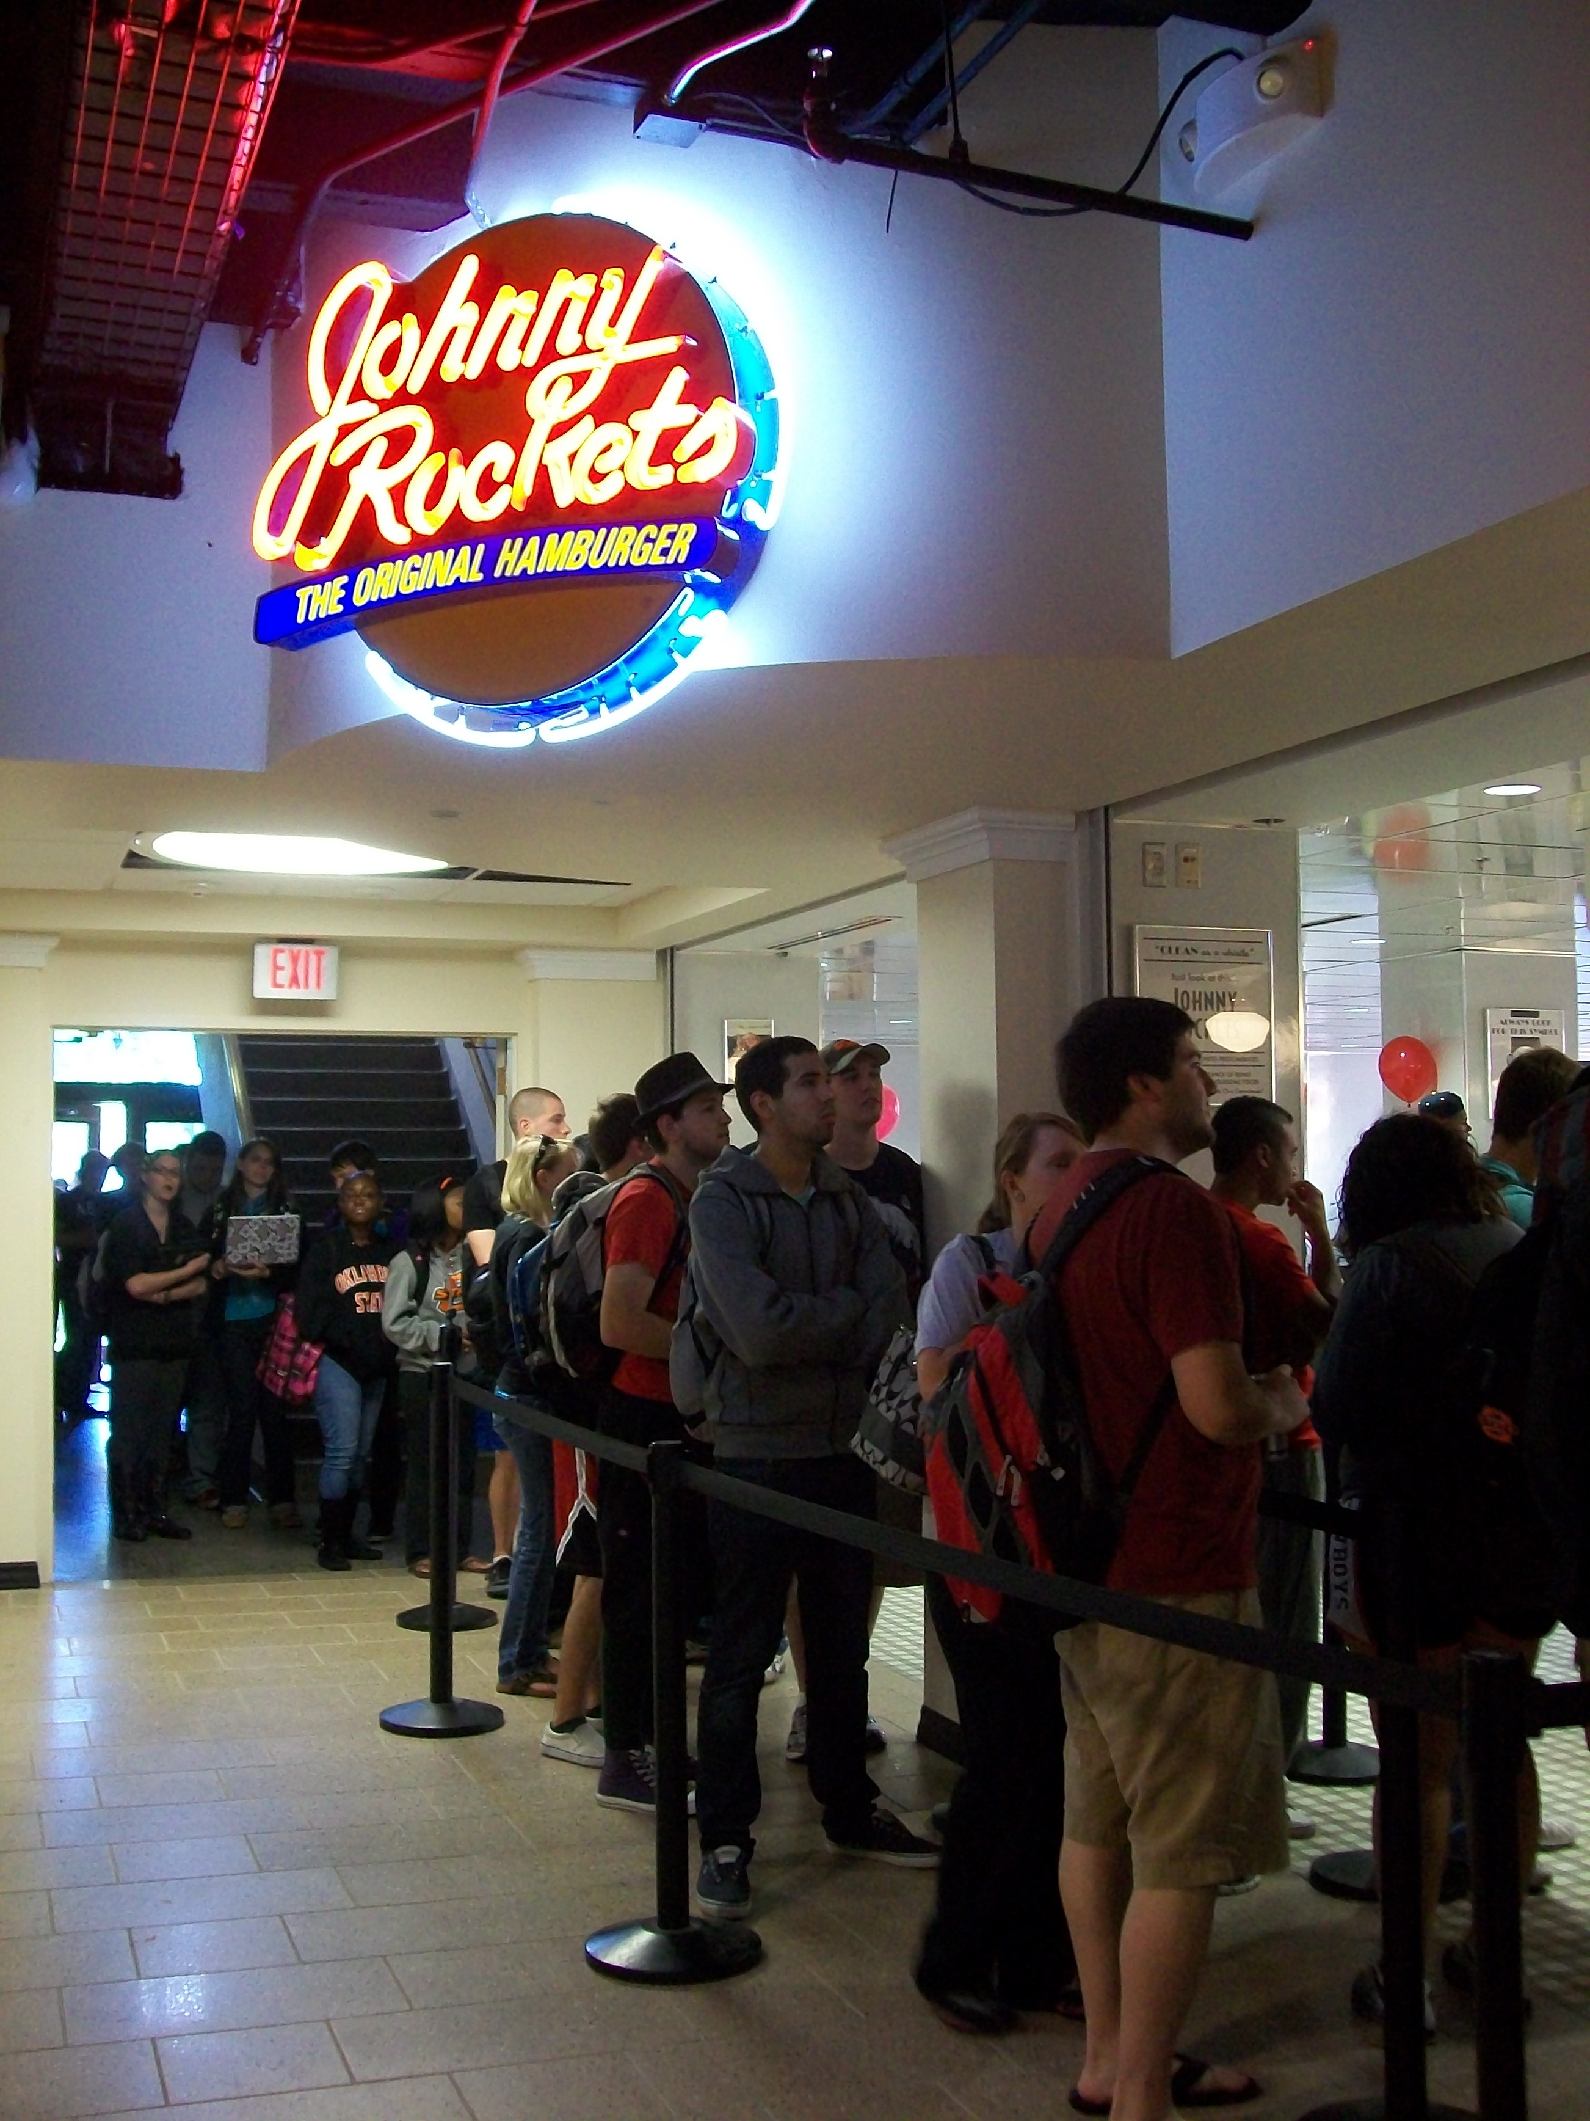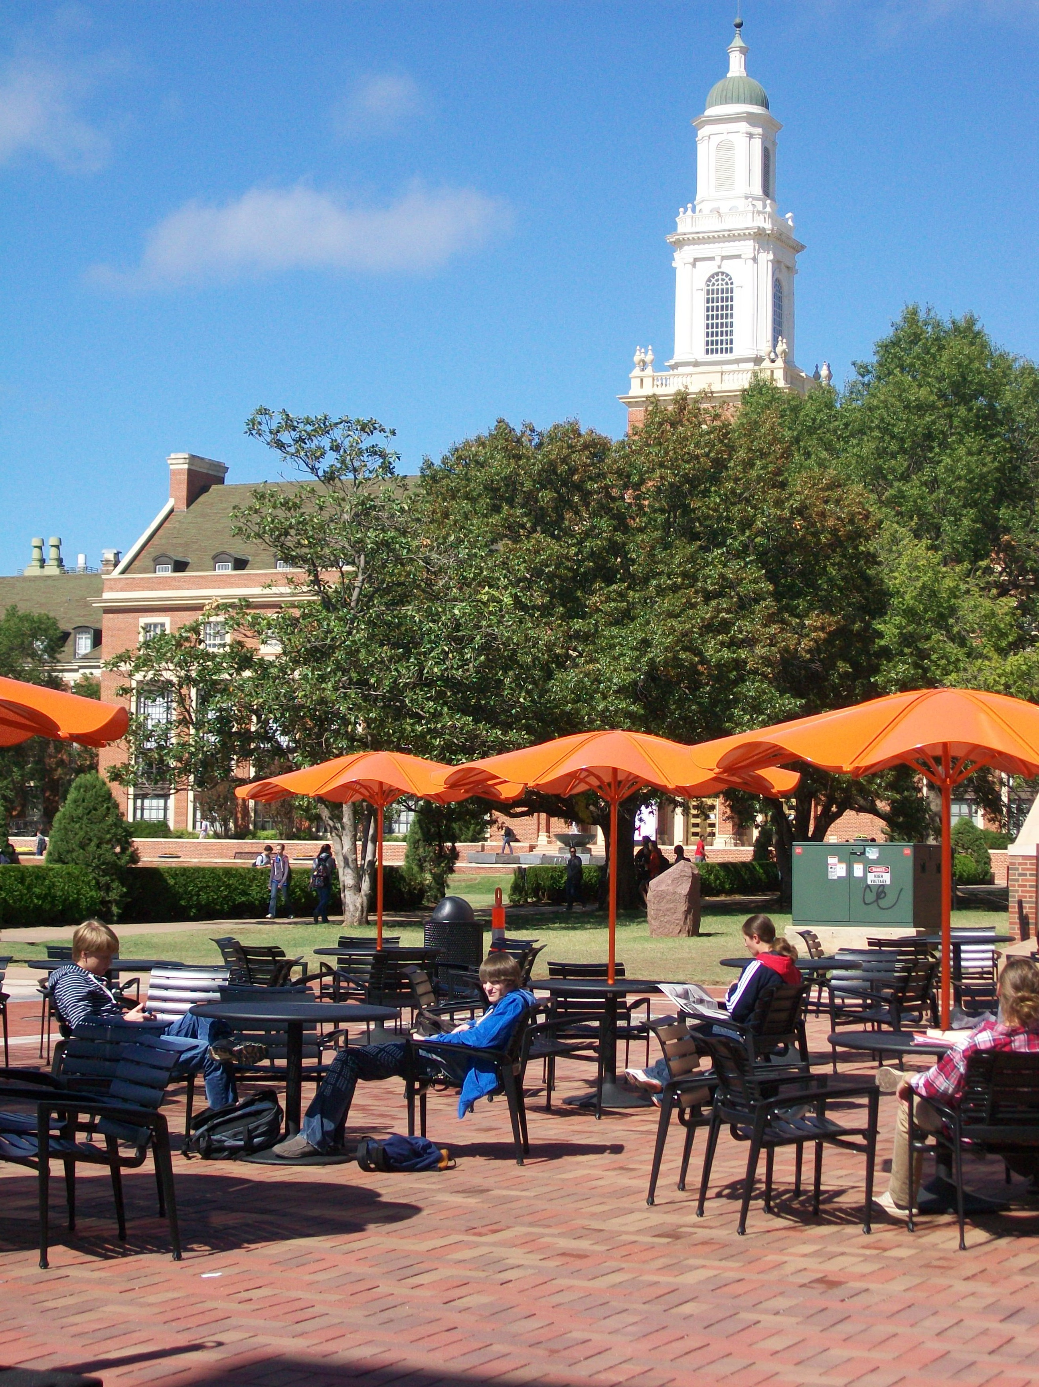
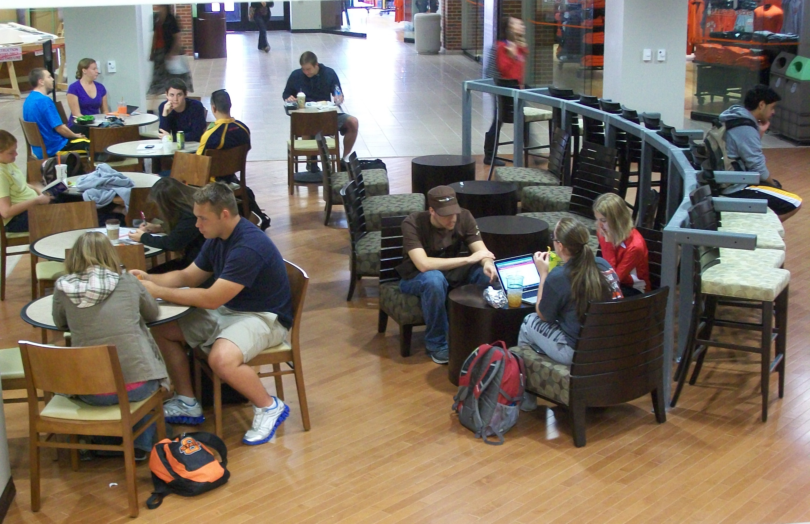
There’s been a lot of buzz around the student union as the renovation project nears completion. Starting from far left, (a) students bear a long line to be some of the first to try Johnny Rockets, (b) the new sitting area between the union and the library makes grabbing a bite to eat and studying convenient, (c) OSU students enjoy comfy seats in front of Caribou Coffee.

