Oklahoma State University
Stillwater, OK 74078
405-744-5000

News Release

FOR IMMEDIATE RELEASE FOR MORE INFORMATION, CONTACT:
Oct. 13, 2011 Maggie Fair
Director of Media Relations
405-694-5533
maggie.fair@okstate.edu

Oklahoma State reveals renovated student union

STILLWATER, Okla.—Oklahoma State University will reveal its renovated student union Monday, Oct. 17, at 10 a.m. on Hester Street.
Ideas for renovating the student union came about as early as November 2005 and exterior construction began in January 2010, resulting in the relocation of retail and dining options to temporary trailers.
“We know the students have been anxious about retail and dining,” Student Union Director Mitch Kilcrease said. “We can’t wait to let everyone inside to see the finished product.”
The renovated union will include new dining options like Jamba Juice, Caribou Coffee and Baja Fresh.
Kilcrease will speak about the renovation and the benefits it will have for the university. Samples from some of the new restaurants, raffle prizes and tours of the student union will be available.
###

Oklahoma State University
Stillwater, OK 74078
405-744-5000

Fact Sheet

FOR IMMEDIATE RELEASE FOR MORE INFORMATION, CONTACT:
Oct. 13, 2011 Maggie Fair
Director of Media Relations
405-694-5533
maggie.fair@okstate.edu

Oklahoma State reveals renovated student union

What: Oklahoma State University will reveal its newly renovated student union on Monday. The project has been underway for more than five years and students and faculty are excited for the unveiling ceremony. The new union will include more modern architecture, more space for visitors and more dining options.

During the ceremony, Student Union Director Mitch Kilcrease will speak and unveil the finished product. Samples from some restaurants will be offered, prizes will be raffled and tours of the union will be given.

Who: Kilcrease will host the dedication event and unveil the finished union to university students, faculty and guests.

Where: The ceremony will take place on Hester Street in Stillwater, Okla., near the front entrance of the student union.

When: The union will be unveiled on Monday, Oct. 17 at 10 a.m.

Why: “We know students have been anxious about retail and dining,” Student Union Director Mitch Kilcrease said. “We can’t wait to let everyone inside to see the finished product and finally have a place to hang out and eat on campus.”

###

Oklahoma State University
Stillwater, OK 74078
405-744-5000

Backgrounder

FOR IMMEDIATE RELEASE FOR MORE INFORMATION, CONTACT:
Oct. 13, 2011 Maggie Fair
Director of Media Relations
405-694-5533
maggie.fair@okstate.edu

A historical student union through the years

Since its opening in August 1950, Oklahoma State University’s student union has been a place that encourages creative and innovative learning through its educational, cultural and social activities. It has housed lounges, dance rooms, snack bars, restaurants, gift shops, game rooms, a hotel and a bowling alley at one time. The union has undergone many changes in the past several decades.
The parking garage next to the student union’s hotel was built in the 1970s, and in 1978, the cafeteria was redesigned into a food court to bring a more up-to-date look to the union. In 1986, the union’s bookstore and hotel were redesigned. The Campus Life area was remodeled in the union’s basement in 1997, and the following year, the Center for Student Services, otherwise known as the Atrium, began being built and opened in 2000. The union’s ballroom, lounges, theater, food court, student store and retail shops were updated in the past decade.
The union’s most recent and elaborate renovation aims to improve the iconic building to meet students’ modern-day needs while still maintaining the history, commitment and legacy it has stood for for the last 60 years.
###
Oklahoma State University
Stillwater, OK 74078
405-744-5000

Photo Release

FOR IMMEDIATE RELEASE FOR MORE INFORMATION, CONTACT:
Oct. 13, 2011 Maggie Fair
Director of Media Relations
405-694-5533
maggie.fair@okstate.edu

Student union’s finishing touches

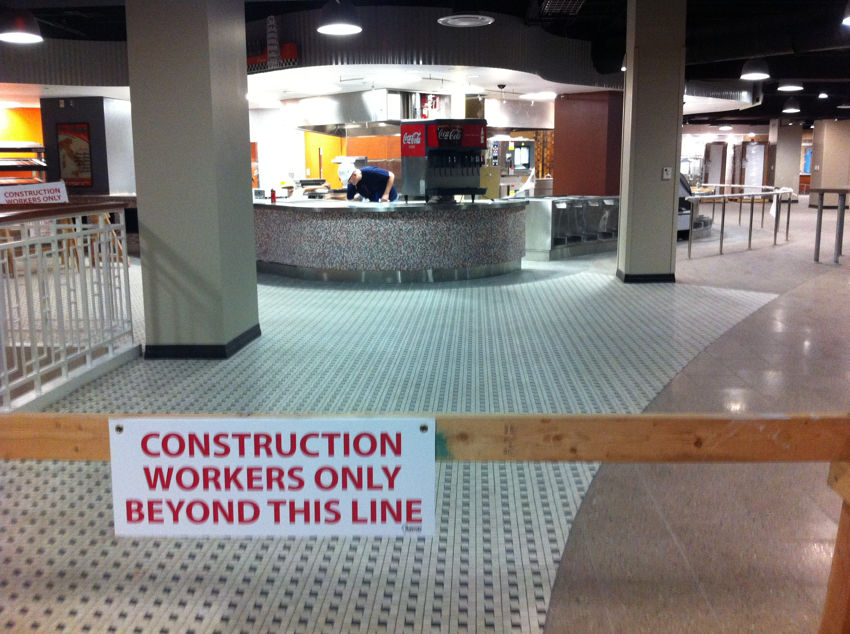
After months of walking through blocked-off hallways, students will get a chance to walk into the finished food court, with new dining options like Mambo Italiano and Baja Fresh.

-more-

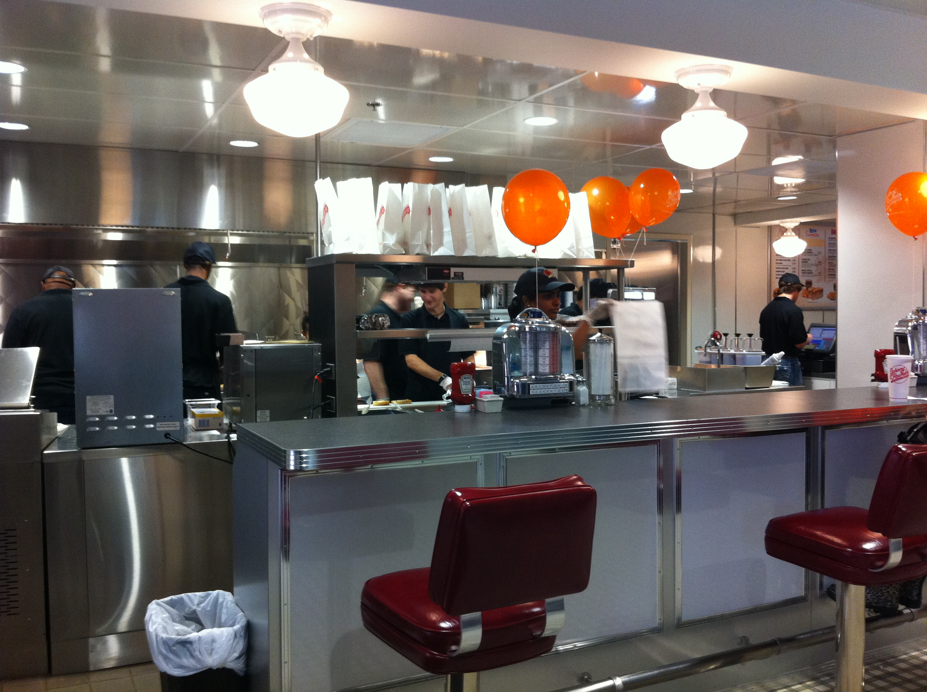
Employees of the recently opened Johnny Rockets burger joint bustle behind the counter to get burgers and fries out for awaiting students.

-more-

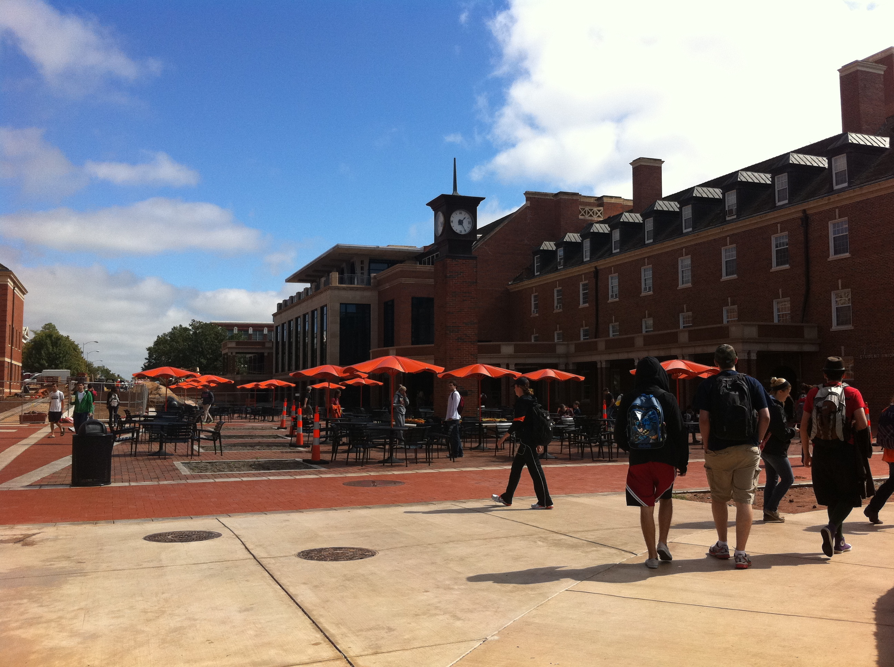
Students again have seating outside the student union with a beautiful view of both the union and Edmon Low Library.

###

Sources

“OSU/A&M System Directory.” <https://app.it.okstate.edu/directory/index.php/module/Default/action/DeptResult?id=560&page=14&dept_name=S>.
“Student Union Renovation Project: Building History.” 2007. <http://union.okstate.edu/renovation/BuildingHistory.htm>.
“Student Union Renovation Project: Project Overview.” <http://union.okstate.edu/renovation/ProjectOverview.htm>.
“Student Union Renovation Project: Project Timeline.” <http://union.okstate.edu/renovation/ProjectTimeline.htm>.
“The Student Union at Oklahoma State University.” 2007. <http://union.okstate.edu>.

