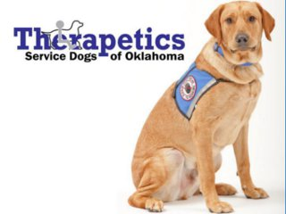

For Immediate Release
11/29/11
Susan Hartman
(918) 270-4226
shartman@therapetics.org

Keep Therapetics of Tulsa alive by participating in the Holiday Card Fundraiser
Tulsa, Okla.- - Therapetics of Tulsa starts its Holiday Card Fundraiser on November 1 and continues through January 31. All proceeds help Therapetics to continue to provide service dogs free of charge to Oklahomans with disabilities.
Individuals can go to therapeutics.org or stop by the Therapetics office to purchase the Holiday Cards. Therapetics of Tulsa is located at 9433 E. 51st street, Suite J, Tulsa, Ok 74145. The cards are available in packs of 10 and cost $10 each.
Each pack consists of three different cards featuring pictures of Therapetics trained service dogs in a holiday themed background.

-More-
“Do you need to get a friend or loved one a gift and are unsure of what to get them? Let Therapetics help you,” said Susan Hartman.
Donations can be made in a person’s name and Therapetics will send them one of their holiday cards. A minimum of $10 is required.

About Therapetics of Tulsa
Therapetics is a 501(c)(3) non-profit organization that breeds, trains and places service dogs to assist Oklahomans with physical disabilities. Therapetics main purpose is to enrich the lives of Oklahomans with physical disabilities one dog at a time. For more information, please visit http://www.therapetics.org.

-30-

