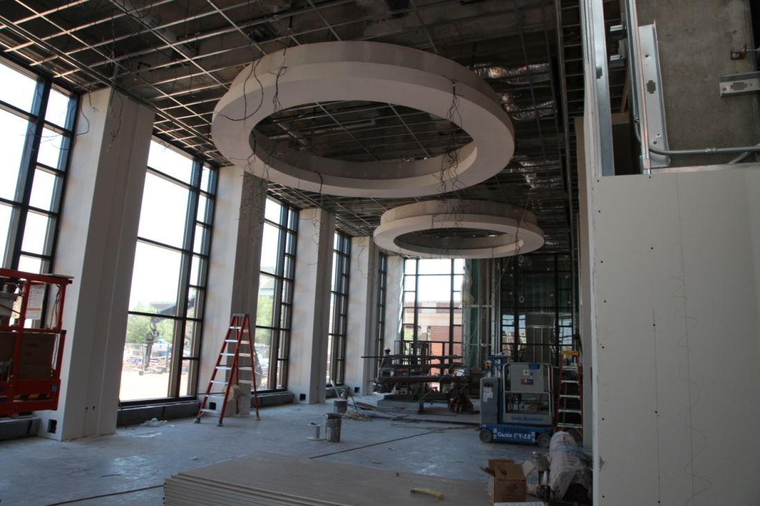

Sneak Peak of SU Renovations

Balcony overlooking campus

Brittanie Douglas, OSU Foundation PR Intern, interviewing the Student Union Director, Mitch Kilcrease, for STATE magazine article.

An inside look of the new student lounge area