Student Union Renovation Project 2005-2012

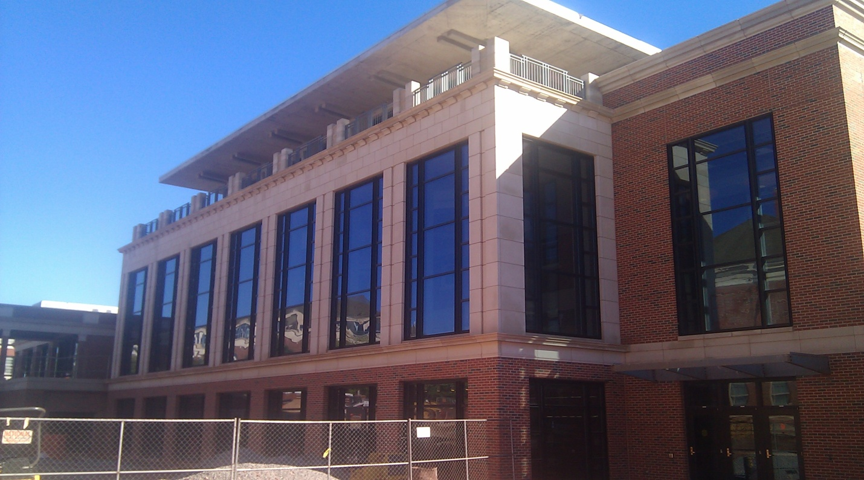

Alexa Ivins
3700 W. 19th Ave. Apt. I-3
Stillwater, OK 74074
580-623-3387
alexa.ivins@okstate.edu

Oklahoma State University
Stillwater, OK 74078

News Release

FOR IMMEDIATE RELEASE FOR MORE INFORMATION, CONTACT:
October 11, 2011 Alexa Ivins
Director of Media Relations
580-623-3387
alexa.ivins@okstate.edu

Upcoming Dedication Event to be held for the New Student Union at Oklahoma State

Stillwater, Okla. – Students, faculty, friends, family and alumni, the Oklahoma State University Student Union Planning Committee is proud to announce after six years of planning and execution the renovation process is almost complete. Planning Committee President, Linda Stephens, said, “Everyone involved in the project has dedicated much time and effort to make this renovation possible and are very excited to see the final outcome of the project and introduce it to the students and faculty here at OSU.” The final project completion date has been set for Jan. 11, 2012, only three months away.

Please gather in the Chi-O Clock courtyard outside the union before the ceremony begins at 3:30p.m. for punch and cake. Refreshments will end and 4 p.m. and the ceremony will begin at the main front entrance to the student union on the building’s southeast side.

At the entrance, there will be a brief ribbon-cutting ceremony performed by the president of the University, Mr. Burns Hargis. After the ribbon-cutting ceremony is complete, Garth Brooks will give a live performance in the Student Union Little Theatre. Inside the union, the bookstore and food services will offer half price goods on dedication day.

Linda Stephens, said, “We all look forward to seeing you enjoy the new facility come January. Please come out and show your support and appreciation at the dedication.”

###

Oklahoma State University
Stillwater, OK 74078

Fact Sheet

FOR IMMEDIATE RELEASE FOR MORE INFORMATION, CONTACT:
October 11, 2011 AlexaIvins
Director of Media Relations
580-623-3387
alexa.ivins@okstate.edu

New Student Union Dedication Ceremony at Oklahoma State University

What: OSU Student Union dedication ceremony.

Who: The event is open to the general public. President Burns Hargis will perform a ribbon-cutting ceremony to honor the completion of the renovation at the Oklahoma State Student Union main entrance and alumni member Garth Brooks will also give a performance.

Where: The Student Union at Oklahoma State University in Stillwater, Okla.

When: Jan. 18, 2011

Refreshments – 3:30 p.m.

Ribbon-cutting – 4 p.m.

Concert – 5 p.m.

Why: “Everyone involved in the project has dedicated much time and effort to make this renovation possible and are very excited to see the final outcome of the project and introduce it to the students and faculty here at OSU.”
-Linda Stephens, Planning Committee president

###

Oklahoma State University
Stillwater, OK 74078

Backgrounder

FOR IMMEDIATE RELEASE FOR MORE INFORMATION, CONTACT:
October 11, 2011 Alexa Ivins
Director of Media Relations
580-623-3387
alexa.ivins@okstate.edu

OSU Student Union Renovation
Since its founding, the Oklahoma State Student Union has been revered by, not only students and faculty, but also by alumni as one of the most utilized buildings on campus and the center of campus life at OSU.
In 1937, OSU President Henry Bennett laid out a 25-year plan for the campus which included the building of a student union and 10 other buildings. The plan was adopted and many years of planning took place. The first groundbreaking for the project began in 1948, and two years later the student union was completed and opened in the fall of 1950.
Since the student union was built, it has faced multiple renovations including, the addition of five more levels on the northeast side of the building in 1963, the expansion of the bookstore and theatre in 1965, the addition of the underground parking garage in the 1970s, and the redesign of the cafeteria into a food court in 1978. Renovation has been an ongoing process for the union at OSU and there have been subsequent renovations prior to the current project.
The initial need for the latest renovation project became apparent in 2005 after studies conducted revealed the student union didn’t meet current students’ needs. The study showed the following regarding the union: the bookstore was small and inconvenient, food options were not viewed positively, there were building accessibility issues, mechanical systems were inefficient, use of space was inefficient, and it didn’t offer students adequate gathering space. The Student Union Planning Committee was responsible for getting the project in the works and began taking steps to make it happen in 2005, and they have been working on the project for the last six years and will continue until its scheduled completion in January 2012.
###

Oklahoma State University
Stillwater, OK 74078

Photo Release

FOR IMMEDIATE RELEASE FOR MORE INFORMATION, CONTACT:
October 11, 2011 AlexaIvins
Director of Media Relations
580-623-3387
alexa.ivins@okstate.edu

Student’s Enjoy New Facilities at the Student Union Cafeteria

Student’s anxiously wait in line to try out one of the menu items at the new
Johnny Rockets restaurant in the OSU Student Union. The restaurant was opened for business in November 2011 and has received positive feedback from the students who’ve tried it.
Photograph and caption – Alexa Ivins
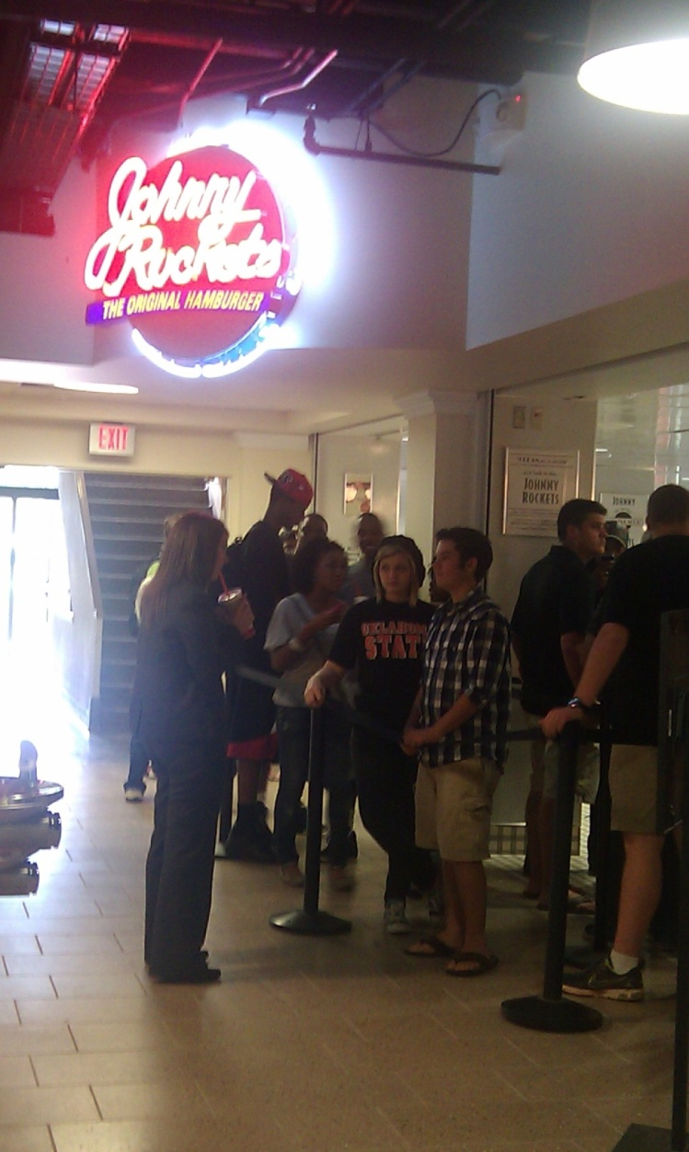
Resources

http://union.okstate.edu/renovation/index.htm

http://www.facebook.com/osuunionproject

http://www.delicious.com/BonnieAnn/sc3353+newsrelease

cover photo taken by Alexa Ivins

student photo and caption by Alexa Ivins

Textbook: Strategic Writing
Multimedia Writing For Public Relations,
Advertising And More
2nd ed. Marsh, Guth, and Short

