Oklahoma State University
Stillwater, OK 74011

Media Release

FOR IMMEDIATE RELEASE FOR MORE INFORMATION, CONTACT:
Oct 13, 2011 Trent Raleigh
Director, Media Relations
918-830-3732
trent.raleigh@okstate.edu

Chesapeake Energy Donating to Student Union

Stillwater, Okla. – Oklahoma State University announced on Tuesday that Chesapeake Energy Corporation plans to donate $1 million dollars to the OSU student union renovations project. The donation ceremony will be held inside the newly renovated student union on the Saturday of OSU Homecoming, dedicating what has been termed “The Void.”

“The Void” is a colorfully lit 15-feet wide circular gap placed in front of the student store that allows visitors to view the space above and below them from the first or second floor. It symbolizes Chesapeake’s dedication to OSU alumni and current students, giving those alumni the ability to look over those who are currently in attendance at the university hoping to guide them in the right direction.

“It might be a strange thing to have our name on but we feel it fit our company and shows our continued dedication to Oklahoma State,” Chesapeake Chairman of the Board Aubrey McClendon said. “This is just one small step in the middle of many leaps and bounds we have planned with OSU and we couldn’t be more excited.”

This donation comes four days after Friday’s announcement of a new $60 million dollar business school building to be built in the coming semesters. Chesapeake Energy Corporation is contributing $5 million dollars to the new project, earning the Chesapeake Energy Student Success Center to be named in their honor.

The dedication is to be held on Saturday October 29, 2011 at 11:30 am. Additional information on the student union renovation can be found at http://union.okstate.edu/renovation or you can contact Trent Raleigh at 918-830-3732 with any questions.

###
Oklahoma State University
Stillwater, OK 74011

Backgrounder

FOR IMMEDIATE RELEASE FOR MORE INFORMATION, CONTACT:
Oct 13, 2011 Trent Raleigh
Director, Media Relations
918-830-3732
trent.raleigh@okstate.edu

Background to Chesapeake Dedication

The Oklahoma State University student union renovation has been a project dating back to November 2005. OSU understood the need for the aging infrastructure to undergo major changes to stay current with the evolving times. The project started in December of 2009 beginning construction on the fifth floor of the historic building and the construction has been on going ever since.

To many, the long and tedious process has been much of a hassle with the movement of food and school supply vendors that are used in the majority of students every day routines. There is relief in sight. With the December 2011 construction contract fast approaching, there are periodical openings of student resources in the months before.

Chesapeake Energy Corporation looked upon the renovations as a pivotal moment to make their presence known on campus. The Board of Directors representing Chesapeake, OSU President Burns Hargis among them, decided to take hold of the opportunity to contribute millions into the educational and campus experience of OSU students taking on a $5 million dollar commitment to the Branding Success campaign with an additional $1 million towards the student union renovation fund.

For more information on the entire student union renovation project, please visit http://union.okstate.edu/renovation/index.htm
###

Oklahoma State University
Stillwater, OK 74011

Fact Sheet

FOR IMMEDIATE RELEASE FOR MORE INFORMATION, CONTACT:
Oct 13, 2011 Trent Raleigh
Director, Media Relations
918-830-3732
trent.raleigh@okstate.edu

Chesapeake Energy’s Million Dollar Dedication to “The Void”

What: Oklahoma State University student union ceiling gap termed “The Void” near student store to be dedicated by Chesapeake Energy Corporation during homecoming week with million dollar gift.

Who: Chesapeake Energy Corporation and Oklahoma State University.

Where: Oklahoma State student union Stillwater, Oklahoma.

When: October 29, 2011 – Homecoming weekend.
Why: Chesapeake Energy donates an additional $1 million dollars to student union renovations for future students and alumni with dedication of symbolic “Void” above the entrance of the student store on homecoming weekend.

###

Oklahoma State University
Stillwater, OK 74011

Photo Release

FOR IMMEDIATE RELEASE FOR MORE INFORMATION, CONTACT:
Oct 13, 2011 Trent Raleigh
Director, Media Relations
918-830-3732
trent.raleigh@okstate.edu

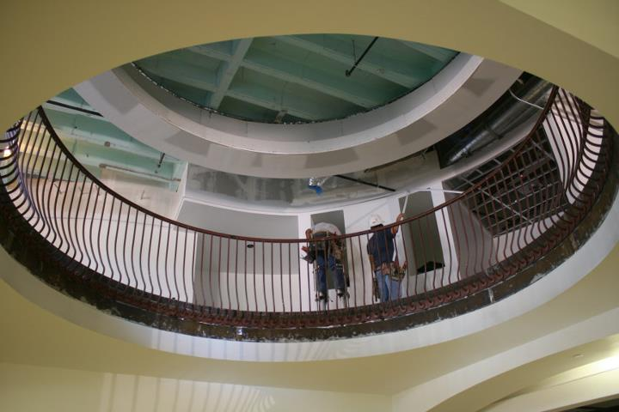
Construction of “The Void” from the first floor symbolizing students ability to “look up” to those who have come before them.

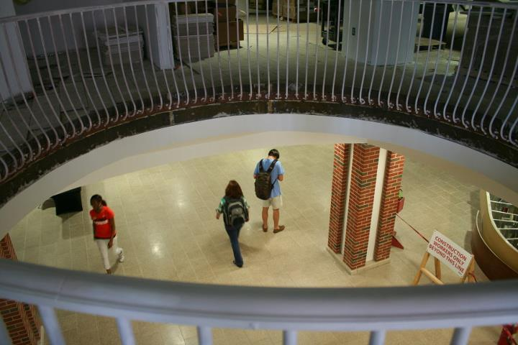
Nearing Completion “The Void” allows onlookers to see below them. This view symbolizes those Alumni that have come and gone looking down upon current students and faculty.
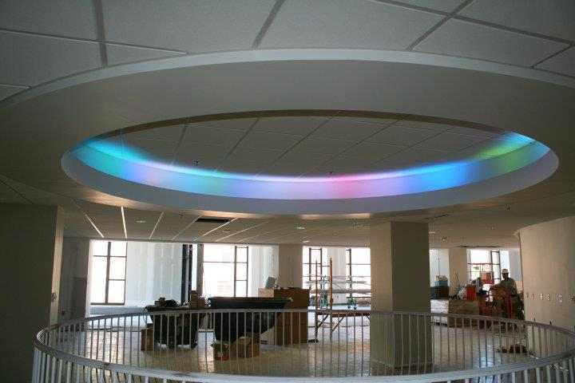
Finishing touches above “The Void” on second floor. Symbolizes the diversity within our community and creating our own single color to live by.

Photos By: http://www.facebook.com/osuunionproject

###

