TO: Dr. Rybas,
FROM: Brianna Mitchell
DATE: September 27, 2011
SUBJECT: Technical Definition
Research has shown that Hypertension is one of the most common disorders in older people. It is known as the silent killer, due to very little, or no symptoms. It can cause stroke and heart disease. There are many different groups of people who are at risk. This document was written to explain the disorder to individuals who haven’t heard of it, and show ways to help avoid it.
In order to create my document, I picked a word I though most non-medical based individuals knew little about. I then created a definition that was easy to understand. I expanded my definition by breaking down the word, explaining what it was and how you can get it, and giving risk factors, symptoms, tests, and ways to avoid it. I used an organized format with titles to help the reader focus on the abundance of information. I picked two pictures that showed a description of what happens, so they can understand visually, and a chart of low, normal, and high blood pressure numbers.
I feel as though this definition is a good quality definition. I put together enough information for the reader to truly get an understanding of the word. This assignment was difficult in the fact that I didn’t know how much information would be considered too much. I hope I included just the right amount of information. If this could be longer than one page, I could have included more information about how you test for high blood pressure.
I hope this document can inform all non-medical based individuals about the dangers of high blood pressure and the importance of getting their blood pressure checked on a routine basis.
See technical definition attached.

Hypertension: When a person is said to have hypertension, it is meant that his or her mean arterial pressure is greater than the upper range of accepted normality (Guyton 225).

Word breakdown:
Hyper= high, beyond, excessive, above normal
Tension= force
The excessive force refers to the pressure of the blood on the walls of the arteries.
What is hypertension?
Hypertension is the term used to describe high blood pressure. Blood pressure is the measurement of force against the walls of your arteries. Arteries are vessels that carry blood from the heart to the tissues and organs of the body. Blood pressure readings are given in two numbers. For example: 120/80. The top number is known as systolic and the bottom number as diastolic. Systolic pressure is the pressure in the arteries as the heart contracts and pumps blood into them. Diastolic pressure is the pressure in the arteries after the heart relaxes after the contraction. Normal blood pressure is considered to be lower than 120/80. High blood pressure (hypertension) is when your blood pressure is 140/90 or above. Hypertension increases the risk of stroke and heart disease.
Figure 1.2
Figure 1.1
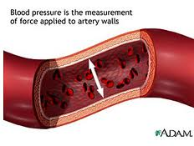
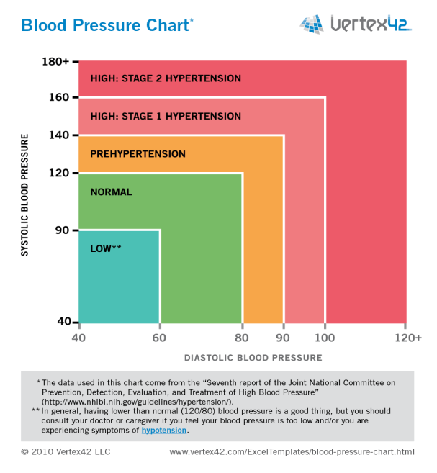
Causes, incidence, and risk factors:
Hypertension is most common in older people. Other risk groups include: African Americans, obese patients, patients that have a lot of stress or anxiety in their life, patients that drink too much alcohol (more than 1 drink per day for women and 2 for men), patients that consume too much salt in their diet, patients with a family history of high blood pressure, patients with diabetes, patients that smoke, and patients with other medical conditions that cause hypertension (High Blood Pressure).
Symptoms:
The majority of patients that suffer from hypertension have no symptoms.
Tests:
Blood pressure reading tests can be performed at the doctor’s office, or machines can be found at most local Pharmacies.
Treatments:
Treatments include eating healthier, exercising regularly, quitting smoking, limiting alcohol intake, limiting sodium intake, limiting stress, and staying at a healthy body weight. If needed, prescription medication can be used to treat hypertension (High Blood Pressure).
Works Cited:
Guyton, Arthur C., and John E. Hall. Textbook of Medical Physiology. Philadelphia: Saunders, 2000. Print.
“High Blood Pressure Symptoms, Causes, Treatment - The Metabolic Syndrome and Obesity on MedicineNet." Web. 21 Sept. 2011. <http://www.medicinenet.com/high_blood_pressure/ page7.htm>.
Figures Cited
"Blood Pressure : Blood Pressure Chart." Blood Pressure : High Blood Pressure Information. Web. 21 Sept. 2011. <http://www.vertex42.com/ExcelTemplates/blood-pressure-chart.html >. Figure 1.2.
"CDC - DHDSP - About High Blood Pressure." Centers for Disease Control and Prevention. Web. 21 Sept. 2011. <http://www.cdc.gov/bloodpressure/about.htm>. Figure 1.1.

