A Case of Nerves Before Your First TV Interview… the PR side
By Mandy Vavrinak on July 27th, 2011
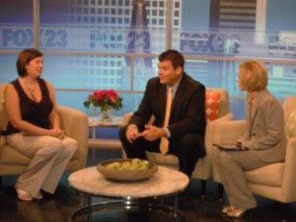
Jessica Johnson of Tulsa Custom Concierge talks with Ron Terrell and Michelle Linn of Fox23 Daybreak during her segment.
NOTE: This post is by Crossroads Communications intern Brenna Wiebe. She’s been involved in several of our client projects from brainstorming to execution this summer and I asked her to share some aspect of that. This is her post. — Mandy
This week I had my first opportunity to see my work pay off on television. This interview segment was like my little baby… I watched it grow before my eyes as I saw it from pitch to production. By the time it was over, I felt like a mother sending her child off to college. Along with this sense of accomplishment came an unexpected bundle of nerves.
Once I found out that my pitch would make it on a local morning show, I was excited. Then my boss told me that she wouldn’t be there because of a doctor’s appointment. Upon hearing this, my stomach dropped. A sudden rush of nerves overcame my body. I didn’t know what to do. I had never done this before. (Mandy says: I promised her I WOULD do client prep and be there to walk her and the client in, do the initial check and prep, but would have to leave the station before the segment was scheduled to go… but I knew she would handle it well because she’s been on several on-sites with me for client prep before an interview.) The morning of the interview came and I felt somewhat calmer about the whole situation. Once my boss left for her doctor’s appointment, my real test came. I walked the client to the set and tried to have a conversation with her to get her mind off of any impending nerves she had. Thankfully the anchors were great and so when the client mentioned something to them about being nervous, they reassured her that there was no reason to be.
After the segment, I walked with the client out of the studio and reassured her that everything went well even though it was her first time on camera. (Mandy says: and it truly did… the segment was a success. I wasn’t surprised at Brenna’s competence nor Jessica’s poise on camera.) Whew…that is over. It was a big sense of relief knowing that things didn’t fall apart on my watch. But I guess the whole point of this post was to talk about some aspect of handling television. Well here is my advice after this experience: No matter how nervous you as the PR person are, never let your client see that side… It will save an on-air nervous breakdown!

