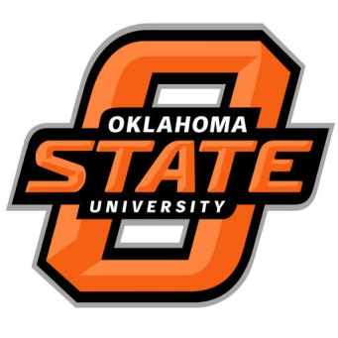

**What is AWSM?**

A volunteer-managed nonprofit founded in 1987 as a support network and advocacy group for women who work in sports writing, editing, broadcast and production, and public and media relations. Membership of more than 600 men and women includes professionals in the industry and students aspiring to sports media careers. AWSM works to promote and increase diversity in sports media. Members have been placed with employers such as Sports Illustrated, ESPN, MLB.com and several sports teams across the country.

**Benefits for Students**

* Networking and contacts
* Internship opportunities
* Scholarships
* Job opportunities

**OSU Chapter**

Monthly meetings give students the chance to attend speaker events to gain knowledge and techniques used by sports professionals in the field today. Mike Sowell, OSU School of Strategic Communications professor, is our chapter supervisor.

**How Can You Help?**

Become a sponsor and have the opportunity to have your business and logo advertised across campus monthly. Also, have your logo on our T-shirt!

Become a sponsor of the FIRST collegiate chapter

**Contact:**

Brittanie Douglas (832)696-5866

Aubrie Hancock (817) 675-3615