Al Castaldo
MKT 400

Objective 1
Descriptive Statistics
 | N | Minimum | Maximum | Mean | Std. Deviation
How Many People are With You? | 238 | .00 | 32.00 | 3.2731 | 3.02259
Days at the Fair this Year | 234 | 1.00 | 12.00 | 1.7778 | 1.67338
Times at Fair in Last 5 Years | 238 | 1.00 | 5.00 | 3.4202 | 1.62520
Days Attend Fair Per Year | 184 | 1.00 | 12.00 | 2.0707 | 1.91640
Valid N (listwise) | 181

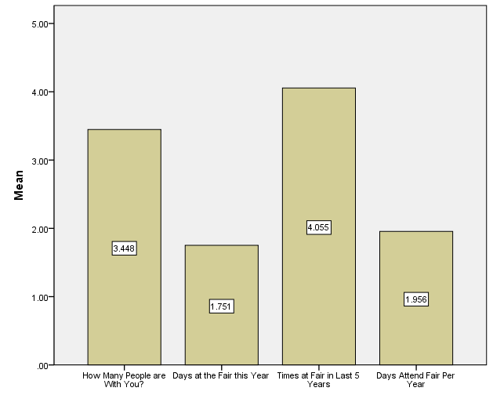

Statistics
Plan on Coming to Fair Next Year?
N | Valid | 218
 | Missing | 23

Plan on Coming to Fair Next Year?
 |  | Frequency | Percent | Valid Percent | Cumulative Percent
Valid | Yes | 205 | 85.1 | 94.0 | 94.0
 | No | 13 | 5.4 | 6.0 | 100.0
 | Total | 218 | 90.5 | 100.0
Missing | DK | 22 | 9.1
 | System | 1 | .4
 | Total | 23 | 9.5
Total |  | 241 | 100.0

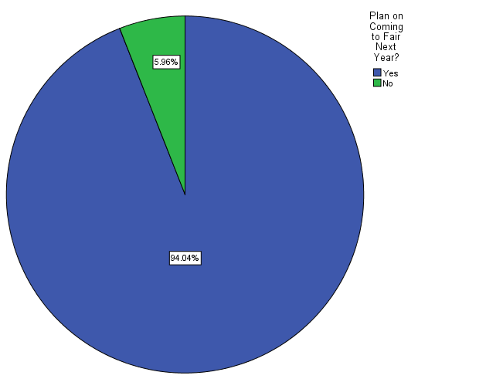
Objective 2

Case Summary
 | Cases
 | Valid |  | Missing |  | Total
 | N | Percent | N | Percent | N | Percent
$FAIRINFOª | 240 | 99.6% | 1 | .4% | 241 | 100.0%
a. Dichotomy group tabulated at value 1.

$FAIRINFO Frequencies
 |  | Responses |  | Percent of Cases
 |  | N | Percent
$FAIRINFOª | See Fair Information on TV? | 95 | 15.7% | 39.6%
 | Hear Fair Information on Radio? | 107 | 17.7% | 44.6%
 | See Fair Information in Newspaper? | 133 | 22.0% | 55.4%
 | See Fair Information on Billboards? | 93 | 15.4% | 38.8%
 | See Fair Information on Flyer? | 22 | 3.6% | 9.2%
 | Fair Information via Word of Mouth? | 123 | 20.3% | 51.2%
 | Other Source of Fair Information? | 29 | 4.8% | 12.1%
 | Dont Know how received Fair Info | 3 | .5% | 1.3%
Total |  | 605 | 100.0% | 252.1%
a. Dichotomy group tabulated at value 1.

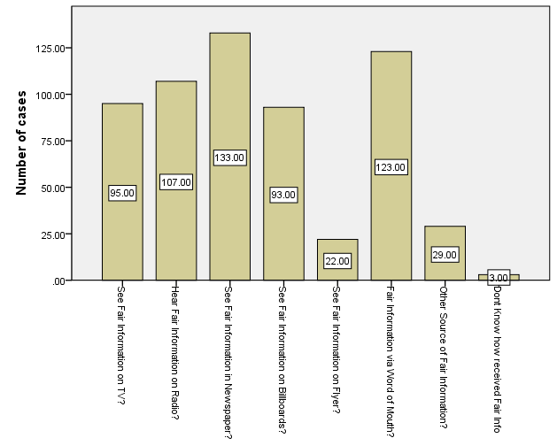

Statistics
Radio Station Listened To Most
N | Valid | 240
 | Missing | 1

Radio Station Listened To Most
 |  | Frequency | Percent | Valid Percent | Cumulative Percent
Valid | WBLX | 33 | 13.7 | 13.8 | 13.8
 | WMEZ | 8 | 3.3 | 3.3 | 17.1
 | WKSJ | 1 | .4 | .4 | 17.5
 | Rocket | 5 | 2.1 | 2.1 | 19.6
 | WABB | 21 | 8.7 | 8.8 | 28.3
 | WWSF | 3 | 1.2 | 1.3 | 29.6
 | WMXC | 3 | 1.2 | 1.3 | 30.8
 | WKRG | 1 | .4 | .4 | 31.3
 | Arrow | 23 | 9.5 | 9.6 | 40.8
 | WTKX | 19 | 7.9 | 7.9 | 48.8
 | WXBM | 61 | 25.3 | 25.4 | 74.2
 | WDWG | 7 | 2.9 | 2.9 | 77.1
 | WAVH | 4 | 1.7 | 1.7 | 78.8
 | WOWW | 11 | 4.6 | 4.6 | 83.3
 | CNN | 1 | .4 | .4 | 83.8
 | WCOA | 5 | 2.1 | 2.1 | 85.8
 | Don't Listen to Radio | 9 | 3.7 | 3.8 | 89.6
 | Other Radio Station | 20 | 8.3 | 8.3 | 97.9
 | Don't Know | 5 | 2.1 | 2.1 | 100.0
 | Total | 240 | 99.6 | 100.0
Missing | System | 1 | .4
Total |  | 241 | 100.0

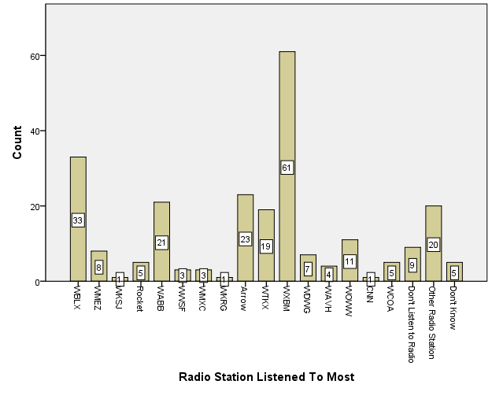

Statistics
TV Station Watched Most
N | Valid | 236
 | Missing | 5

TV Station Watched Most
 |  | Frequency | Percent | Valid Percent | Cumulative Percent
Valid | WEAR 3 | 91 | 37.8 | 38.6 | 38.6
 | WKRG5 | 26 | 10.8 | 11.0 | 49.6
 | FOXTV10 | 39 | 16.2 | 16.5 | 66.1
 | WALA11 | 9 | 3.7 | 3.8 | 69.9
 | BLABTV | 1 | .4 | .4 | 70.3
 | WJTC 12 or 44 | 4 | 1.7 | 1.7 | 72.0
 | Don't Watch TV | 13 | 5.4 | 5.5 | 77.5
 | Other | 53 | 22.0 | 22.5 | 100.0
 | Total | 236 | 97.9 | 100.0
Missing | 99.00 | 4 | 1.7
 | System | 1 | .4
 | Total | 5 | 2.1
Total |  | 241 | 100.0

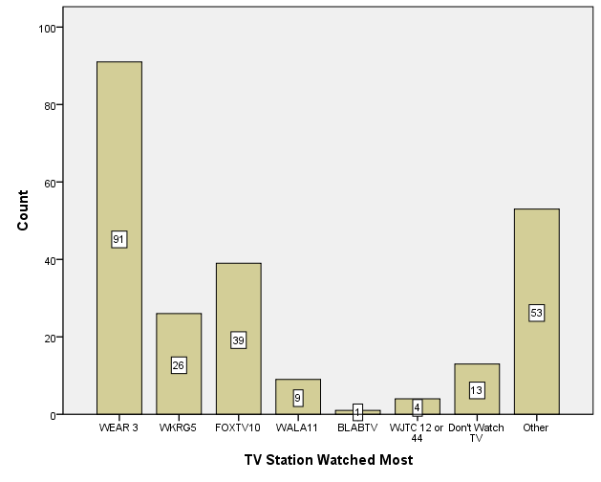

OBJECTIVE 3

Descriptive Statistics
 | N | Minimum | Maximum | Mean | Std. Deviation
How Many Days Attend Fair this Year | 200 | .00 | 365.00 | 62.1450 | 126.69095
Valid N (listwise) | 200

Decided to come 62 days before the fair took place

Statistics
 |  | Main Attraction Drawing You to Fair | Second Reason You Came to Fair
N | Valid | 237 | 223
 | Missing | 4 | 18

Main Attraction Drawing You to Fair
 |  | Frequency | Percent | Valid Percent | Cumulative Percent
Valid | Livestock | 12 | 5.0 | 5.1 | 5.1
 | Exhibits | 26 | 10.8 | 11.0 | 16.0
 | Music | 41 | 17.0 | 17.3 | 33.3
 | Rides | 92 | 38.2 | 38.8 | 72.2
 | Games | 8 | 3.3 | 3.4 | 75.5
 | Food | 23 | 9.5 | 9.7 | 85.2
 | Other | 33 | 13.7 | 13.9 | 99.2
 | DK | 2 | .8 | .8 | 100.0
 | Total | 237 | 98.3 | 100.0
Missing | System | 4 | 1.7
Total |  | 241 | 100.0

Second Reason You Came to Fair
 |  | Frequency | Percent | Valid Percent | Cumulative Percent
Valid | Livestock | 6 | 2.5 | 2.7 | 2.7
 | Exhibits | 40 | 16.6 | 17.9 | 20.6
 | Music | 34 | 14.1 | 15.2 | 35.9
 | Rides | 46 | 19.1 | 20.6 | 56.5
 | Games | 32 | 13.3 | 14.3 | 70.9
 | Food | 46 | 19.1 | 20.6 | 91.5
 | Other | 13 | 5.4 | 5.8 | 97.3
 | DK | 6 | 2.5 | 2.7 | 100.0
 | Total | 223 | 92.5 | 100.0
Missing | System | 18 | 7.5
Total |  | 241 | 100.0

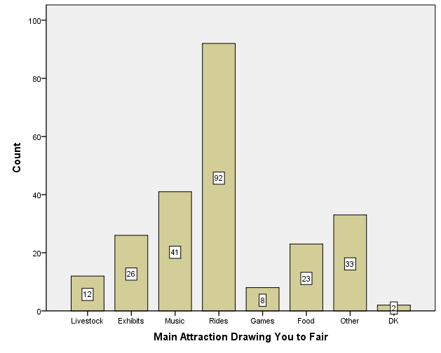
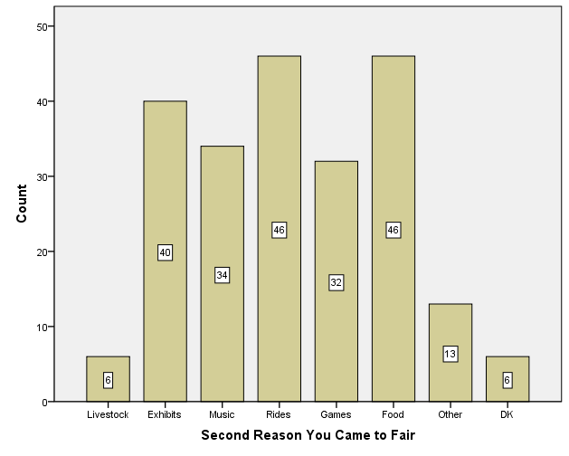

Descriptive Statistics
 | N | Minimum | Maximum | Mean | Std. Deviation
How Much Money Spent on Yourself | 237 | .00 | 200.00 | 35.6667 | 30.94056
Valid N (listwise) | 237

This shows the average amount of money spent per person at the fair.

Objective 4

Statistics
Live in Escambia or Santa Rosa?
N | Valid | 240
 | Missing | 1

Live in Escambia or Santa Rosa?
 |  | Frequency | Percent | Valid Percent | Cumulative Percent
Valid | Yes | 211 | 87.6 | 87.9 | 87.9
 | No | 29 | 12.0 | 12.1 | 100.0
 | Total | 240 | 99.6 | 100.0
Missing | System | 1 | .4
Total |  | 241 | 100.0

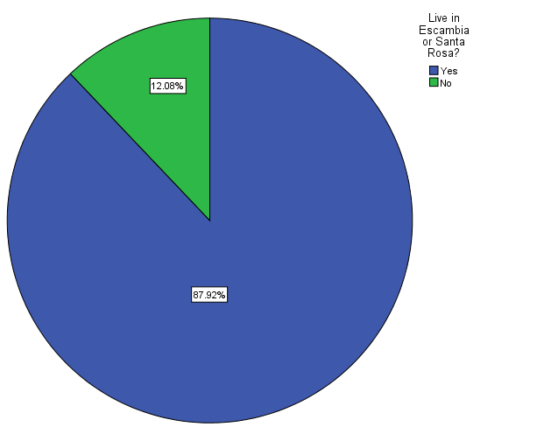

Statistics
Spend Night in Hotel/Motel?
N | Valid | 26
 | Missing | 215

Spend Night in Hotel/Motel?
 |  | Frequency | Percent | Valid Percent | Cumulative Percent
Valid | Yes | 1 | .4 | 3.8 | 3.8
 | No | 24 | 10.0 | 92.3 | 96.2
 | DK | 1 | .4 | 3.8 | 100.0
 | Total | 26 | 10.8 | 100.0
Missing | System | 215 | 89.2
Total |  | 241 | 100.0

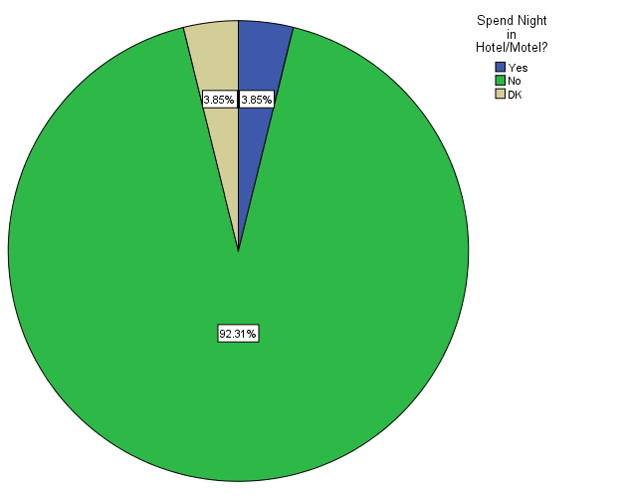

Case Summary
 | Cases
 | Valid |  | Missing |  | Total
 | N | Percent | N | Percent | N | Percent
$Patronª | 24 | 10.0% | 217 | 90.0% | 241 | 100.0%
a. Dichotomy group tabulated at value 1.

$Patron Frequencies
 |  | Responses |  | Percent of Cases
 |  | N | Percent
$Patronª | Patronize a Gas Station? | 15 | 30.6% | 62.5%
 | Patronize a Convenience Store? | 11 | 22.4% | 45.8%
 | Patronize a Restaurant? | 11 | 22.4% | 45.8%
 | Patronize a Supermarket? | 4 | 8.2% | 16.7%
 | Patronize Other Business? | 5 | 10.2% | 20.8%
 | Don't Know | 3 | 6.1% | 12.5%
Total |  | 49 | 100.0% | 204.2%
a. Dichotomy group tabulated at value 1.

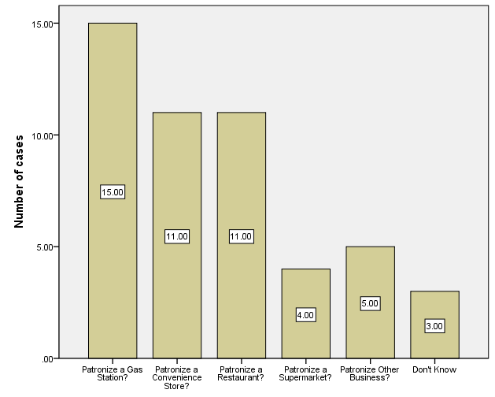

Descriptive Statistics
 | N | Minimum | Maximum | Mean | Std. Deviation
Total Money Spent on Trip? | 22 | $5 | $500 | $117.73 | $176.566
Valid N (listwise) | 22

This shows the average money spent on the trip

Descriptive Statistics
 | N | Minimum | Maximum | Mean | Std. Deviation
Miles Traveled, One Way, to Fair? | 237 | 1.00 | 3000.00 | 32.0738 | 196.12523
Valid N (listwise) | 237

As you can see the average miles traveled by a person is 32, and the maximum is 3000

Objective 5
Statistics
 |  | Rate Ride & Games Employees | Rate Other Fair Employees | Rate Security | Rate the Fair Overall
N | Valid | 219 | 224 | 232 | 239
 | Missing | 22 | 17 | 9 | 2

Rate Ride & Games Employees
 |  | Frequency | Percent | Valid Percent | Cumulative Percent
Valid | Poor | 5 | 2.1 | 2.3 | 2.3
 | 2.00 | 7 | 2.9 | 3.2 | 5.5
 | 3.00 | 9 | 3.7 | 4.1 | 9.6
 | 4.00 | 12 | 5.0 | 5.5 | 15.1
 | 5.00 | 35 | 14.5 | 16.0 | 31.1
 | 6.00 | 27 | 11.2 | 12.3 | 43.4
 | 7.00 | 37 | 15.4 | 16.9 | 60.3
 | 8.00 | 43 | 17.8 | 19.6 | 79.9
 | 9.00 | 15 | 6.2 | 6.8 | 86.8
 | Excellent | 29 | 12.0 | 13.2 | 100.0
 | Total | 219 | 90.9 | 100.0
Missing | 99.00 | 2 | .8
 | System | 20 | 8.3
 | Total | 22 | 9.1
Total |  | 241 | 100.0

Rate Other Fair Employees
 |  | Frequency | Percent | Valid Percent | Cumulative Percent
Valid | Poor | 5 | 2.1 | 2.2 | 2.2
 | 2.00 | 4 | 1.7 | 1.8 | 4.0
 | 3.00 | 6 | 2.5 | 2.7 | 6.7
 | 4.00 | 5 | 2.1 | 2.2 | 8.9
 | 5.00 | 30 | 12.4 | 13.4 | 22.3
 | 6.00 | 15 | 6.2 | 6.7 | 29.0
 | 7.00 | 32 | 13.3 | 14.3 | 43.3
 | 8.00 | 62 | 25.7 | 27.7 | 71.0
 | 9.00 | 27 | 11.2 | 12.1 | 83.0
 | Excellent | 38 | 15.8 | 17.0 | 100.0
 | Total | 224 | 92.9 | 100.0
Missing | 99.00 | 5 | 2.1
 | System | 12 | 5.0
 | Total | 17 | 7.1
Total |  | 241 | 100.0

Rate Security
 |  | Frequency | Percent | Valid Percent | Cumulative Percent
Valid | Poor | 4 | 1.7 | 1.7 | 1.7
 | 2.00 | 5 | 2.1 | 2.2 | 3.9
 | 3.00 | 3 | 1.2 | 1.3 | 5.2
 | 4.00 | 1 | .4 | .4 | 5.6
 | 5.00 | 14 | 5.8 | 6.0 | 11.6
 | 6.00 | 8 | 3.3 | 3.4 | 15.1
 | 7.00 | 19 | 7.9 | 8.2 | 23.3
 | 8.00 | 48 | 19.9 | 20.7 | 44.0
 | 9.00 | 36 | 14.9 | 15.5 | 59.5
 | Excellent | 94 | 39.0 | 40.5 | 100.0
 | Total | 232 | 96.3 | 100.0
Missing | 99.00 | 4 | 1.7
 | System | 5 | 2.1
 | Total | 9 | 3.7
Total |  | 241 | 100.0

Rate the Fair Overall
 |  | Frequency | Percent | Valid Percent | Cumulative Percent
Valid | Poor | 2 | .8 | .8 | .8
 | 2.00 | 2 | .8 | .8 | 1.7
 | 3.00 | 3 | 1.2 | 1.3 | 2.9
 | 4.00 | 4 | 1.7 | 1.7 | 4.6
 | 5.00 | 11 | 4.6 | 4.6 | 9.2
 | 6.00 | 16 | 6.6 | 6.7 | 15.9
 | 7.00 | 28 | 11.6 | 11.7 | 27.6
 | 8.00 | 53 | 22.0 | 22.2 | 49.8
 | 9.00 | 54 | 22.4 | 22.6 | 72.4
 | Excellent | 66 | 27.4 | 27.6 | 100.0
 | Total | 239 | 99.2 | 100.0
Missing | System | 2 | .8
Total |  | 241 | 100.0
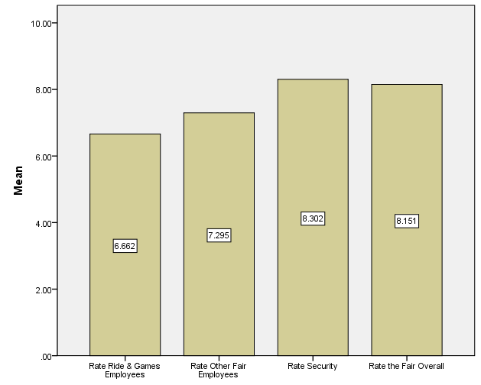

Statistics
To Improve the Fair
N | Valid | 198
 | Missing | 43

To Improve the Fair
 |  | Frequency | Percent | Valid Percent | Cumulative Percent
Valid | Nothing; it is fine | 24 | 10.0 | 12.1 | 12.1
 | Positive Comment | 2 | .8 | 1.0 | 13.1
 | Prices too high | 27 | 11.2 | 13.6 | 26.8
 | Prices too high on Rides | 9 | 3.7 | 4.5 | 31.3
 | Prices too high on Food | 3 | 1.2 | 1.5 | 32.8
 | Admission price too High | 7 | 2.9 | 3.5 | 36.4
 | More Rides | 15 | 6.2 | 7.6 | 43.9
 | Greater variety of rides | 7 | 2.9 | 3.5 | 47.5
 | Lines too long for rides | 2 | .8 | 1.0 | 48.5
 | Rides too close together | 2 | .8 | 1.0 | 49.5
 | More Food | 1 | .4 | .5 | 50.0
 | Music too loud | 2 | .8 | 1.0 | 51.0
 | Want different types of Music | 3 | 1.2 | 1.5 | 52.5
 | Games Unfair | 1 | .4 | .5 | 53.0
 | Games too Expensive | 2 | .8 | 1.0 | 54.0
 | Game Carneys Harass | 1 | .4 | .5 | 54.5
 | Cover the Concert/Stage Area | 1 | .4 | .5 | 55.1
 | Provide More Seating | 3 | 1.2 | 1.5 | 56.6
 | More Bathrooms | 2 | .8 | 1.0 | 57.6
 | Better Bathrooms | 3 | 1.2 | 1.5 | 59.1
 | More Handstamp Days | 4 | 1.7 | 2.0 | 61.1
 | Employees are Dirty | 6 | 2.5 | 3.0 | 64.1
 | Other | 71 | 29.5 | 35.9 | 100.0
 | Total | 198 | 82.2 | 100.0
Missing | DK | 18 | 7.5
 | System | 25 | 10.4
 | Total | 43 | 17.8
Total |  | 241 | 100.0

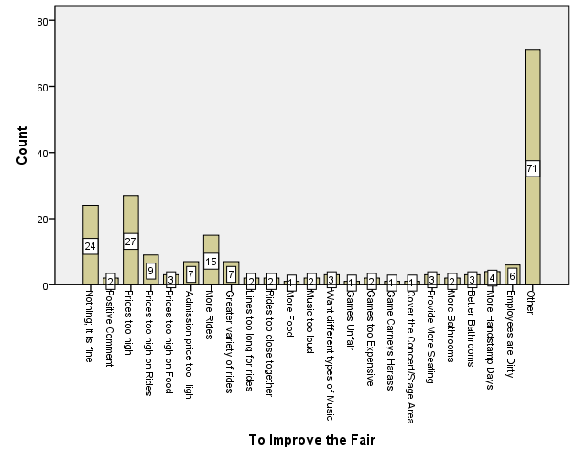
Objective 6

Statistics
ZIP Code of Residence
N | Valid | 234
 | Missing | 7

ZIP Code of Residence
 |  | Frequency | Percent | Valid Percent | Cumulative Percent
Valid | 31716.00 | 1 | .4 | .4 | .4
 | 32501.00 | 3 | 1.2 | 1.3 | 1.7
 | 32503.00 | 19 | 7.9 | 8.1 | 9.8
 | 32504.00 | 10 | 4.1 | 4.3 | 14.1
 | 32505.00 | 15 | 6.2 | 6.4 | 20.5
 | 32506.00 | 13 | 5.4 | 5.6 | 26.1
 | 32507.00 | 20 | 8.3 | 8.5 | 34.6
 | 32511.00 | 1 | .4 | .4 | 35.0
 | 32512.00 | 1 | .4 | .4 | 35.5
 | 32513.00 | 1 | .4 | .4 | 35.9
 | 32514.00 | 30 | 12.4 | 12.8 | 48.7
 | 32525.00 | 4 | 1.7 | 1.7 | 50.4
 | 32526.00 | 15 | 6.2 | 6.4 | 56.8
 | 32531.00 | 1 | .4 | .4 | 57.3
 | 32533.00 | 21 | 8.7 | 9.0 | 66.2
 | 32534.00 | 6 | 2.5 | 2.6 | 68.8
 | 32536.00 | 1 | .4 | .4 | 69.2
 | 32539.00 | 1 | .4 | .4 | 69.7
 | 32547.00 | 2 | .8 | .9 | 70.5
 | 32548.00 | 1 | .4 | .4 | 70.9
 | 32560.00 | 1 | .4 | .4 | 71.4
 | 32561.00 | 10 | 4.1 | 4.3 | 75.6
 | 32562.00 | 1 | .4 | .4 | 76.1
 | 32564.00 | 1 | .4 | .4 | 76.5
 | 32565.00 | 5 | 2.1 | 2.1 | 78.6
 | 32566.00 | 3 | 1.2 | 1.3 | 79.9
 | 32570.00 | 7 | 2.9 | 3.0 | 82.9
 | 32571.00 | 9 | 3.7 | 3.8 | 86.8
 | 32577.00 | 4 | 1.7 | 1.7 | 88.5
 | 32578.00 | 2 | .8 | .9 | 89.3
 | 32580.00 | 1 | .4 | .4 | 89.7
 | 32583.00 | 9 | 3.7 | 3.8 | 93.6
 | 36401.00 | 1 | .4 | .4 | 94.0
 | 36426.00 | 2 | .8 | .9 | 94.9
 | 36502.00 | 2 | .8 | .9 | 95.7
 | 36507.00 | 1 | .4 | .4 | 96.2
 | 36547.00 | 1 | .4 | .4 | 96.6
 | 36551.00 | 1 | .4 | .4 | 97.0
 | 36567.00 | 1 | .4 | .4 | 97.4
 | 36715.00 | 1 | .4 | .4 | 97.9
 | 37075.00 | 1 | .4 | .4 | 98.3
 | 43482.00 | 1 | .4 | .4 | 98.7
 | 44316.00 | 1 | .4 | .4 | 99.1
 | 47112.00 | 1 | .4 | .4 | 99.6
 | 98532.00 | 1 | .4 | .4 | 100.0
 | Total | 234 | 97.1 | 100.0
Missing | System | 7 | 2.9
Total |  | 241 | 100.0

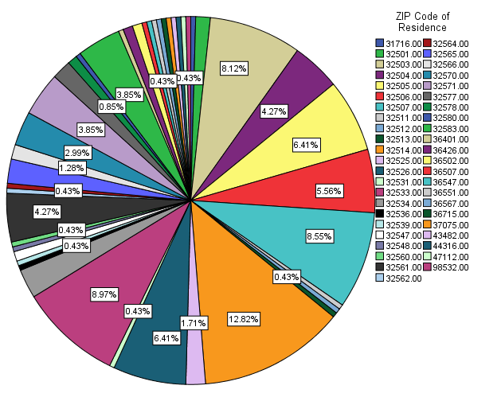

Statistics
q23age
N | Valid | 239
 | Missing | 2

q23age
 |  | Frequency | Percent | Valid Percent | Cumulative Percent
Valid | 16-17 | 19 | 7.9 | 7.9 | 7.9
 | 18-24 | 53 | 22.0 | 22.2 | 30.1
 | 25-34 | 69 | 28.6 | 28.9 | 59.0
 | 35-49 | 66 | 27.4 | 27.6 | 86.6
 | 50+ | 31 | 12.9 | 13.0 | 99.6
 | Refused to Answer | 1 | .4 | .4 | 100.0
 | Total | 239 | 99.2 | 100.0
Missing | System | 2 | .8
Total |  | 241 | 100.0

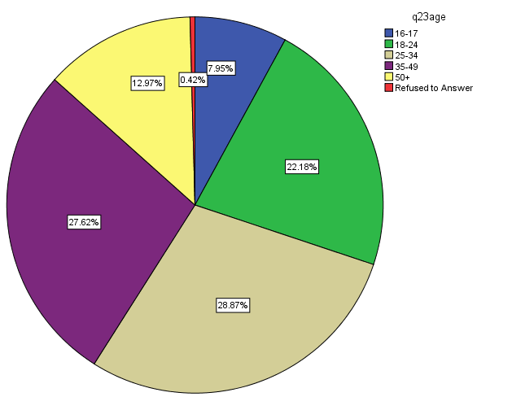

Statistics
Gender
N | Valid | 238
 | Missing | 3

Gender
 |  | Frequency | Percent | Valid Percent | Cumulative Percent
Valid | Male | 113 | 46.9 | 47.5 | 47.5
 | Female | 125 | 51.9 | 52.5 | 100.0
 | Total | 238 | 98.8 | 100.0
Missing | System | 3 | 1.2
Total |  | 241 | 100.0

