Bedrock Construction Group
2012
University of Chicago RFP
Bedrock Construction Group is pleased to present our proposal for the University of Chicago Medical Center Interior Renovation Project. Our company qualifications and project proposal is enclosed in the following documents.

University Of Chicago Hospital
5841 S Maryland Ave, Chicago, IL 60637
773-702-1000
773-702-1100

January 23, 2012
123 N. Michigan Blvd. Chicago, IL 60612 P: 312-265-3455 F: 312-265-3456
www.bedrockconstruction.com
Bedrock Construction Group

University of Chicago
Owner
5841 S Maryland Ave
Chicago, IL 60637-1448
(773) 702-1000

Dear Mr. Smith,

Thank you for your interest in Bedrock Construction Group. We are pleased to submit our proposal to be considered as the Construction Manager at Risk for the University of Chicago Hospital project.

We believe Bedrock is the ideal firm to provide construction services for the following reasons:

Leader in Healthcare – Bedrock is a leader in healthcare construction. With an ASHE Certified project management and superintendent staff dedicated to our healthcare group, he have completed projects at 45 different hospital campuses, the majority of those in Illinois. Healthcare construction represents over 400 million in contracts currently under construction. In 2011, Bedrock was ranked the 45th largest Construction Manager by ENR.

Cost Effective Solutions – Bedrock is proud of the reputation it has built for delivering healthcare projects both on time and on budget. We stand behind the belief that getting involved at the preconstruction phase enables the team to work collaboratively to find the best cost solutions, and ultimately keep the project on budget. We also pride ourselves in providing BIM Modeling Technology for all of the mechanical systems on this project. We believe this will create an efficient and cost effective work atmosphere during the construction process.

Safety – At Bedrock, safety is a value that exceeds all others. We believe that the safety of the hospital faculty and patients is of the utmost importance, and is our number one priority everyday. We have focused our efforts on our people and processes to continue safety improvements and achieve an accident-free work place. We understand what it takes to work in a hospital environment, and how important it is to have an infection control risk assessment (ICRA) plan in place. We have every intention of installing temporary barricades to completely isolate construction space from patient and general areas during on-going construction. We take a 360 degree approach on hospital safety and consider every patient to be one of our own.

If you have any additional questions, please feel free to contact me directly. We look forward to being of service to University of Chicago Hospital, and to the opportunity to discussing our approach to this exciting project in the near future.

Yours sincerely,

Bedrock Construction Group

Jordan Ohl
President

Table of Contents_______________________________________

- Criteria One: Statement of Qualifications and Availability to Undertake the Project
- Criteria Two: Ability to Provide Construction Management Services
- Criteria Three: Qualifications of Construction Manager at Risk Team
- Criteria Four: Past Performance On Representative CM-R Projects
- Criteria Six: Ability to Manage Construction Safety Risks
- Criteria Seven: Ability to Establish Budgets and Control Costs On Past Projects
- Criteria Eight: Ability to Meet Schedules on Past Projects
- Criteria Nine: Knowledge of Current Construction Methodologies, Technologies, and Best Practices
- Criteria Ten: Ability to Identify and Resolve Problems on Past Projects
- Special Services: BIM Coordination; Self-Perform Work; Pre-Fabrication
- General Conditions & Fee
- Project Schedule
- Site Logistics Plan

Criteria One: Statement of Qualifications and Availability to Undertake the Project

Statement of Availability and Commitment

I, the undersigned, hereby declare that I agree to participate exclusively with the owner, University of Chicago, in the above-mentioned request for Construction Manager at Risk services for the University of Chicago Hospital Project.
I further declare that I am able and willing to work
• For the period(s) foreseen in the Specific Terms of reference attached to the above referenced request for the position for which my CV has been included in the offer of the Construction Manager at Risk and
• Within the execution period of the specific contract which runs from November 20, 2007 to August 12, 2009
I confirm that I am not engaged in another U of C-funded project in a position for which my services are required during the above periods and that I will not charge the same working day to more than one project
.
By making this declaration, I agree should this offer be accepted, I am fully aware that if I am not available at the expected start date of my services for reasons other than ill-health or force of nature, I may be subject to exclusion from other tender procedures and contracts funded by the University of Chicago Hospital and that the notification of award of specific contract to the Construction Manager at Risk contractor may be rendered null and void.
Name:
Signature:
Date:

Criteria Two: Ability to Provide Construction Management Services

Request 3.2.1

Volume History for Last Five (5) Years

Bedrock | IL Contracts per Year (Millions)
Year | Number | Value | % Change
2007 | 129 | 650 | 5%
2008 | 89 | 400 | 38%
2009 | 90 | 410 | 1%
2010 | 101 | 525 | 22%
2011 | 112 | 605 | 13%

Bedrock | National Contracts per Year (Millions)
Year | Number | Value | % Change
2007 | 199 | 900 | 8%
2008 | 150 | 765 | 23%
2009 | 169 | 825 | 24%
2010 | 177 | 887 | 41%
2011 | 214 | 923 | 35%

Bedrock | Revenue Totals per Year (Millions)
Year | Total Revenue | % Change
2007 | 32.5 | 5%
2008 | 8 | 75%
2009 | 12.3 | 35%
2010 | 21 | 41%
2011 | 30.25 | 31%

Total Bonding Capacity: $700,000,000

Available Bonding Capacity: $500,000,000

Current Volume and Backlog: Backlog at 10/31/2011 = $305,800,000
Projected Volume: Year 2012 = $600,000,000

Request 3.2.3
Bedrock Construction is not currently for sale or involved in any transaction to expand or to become acquired by another business entity.
Request 3.2.4
Bedrock Construction has NOT been involved in any litigation, nor had claims filed, against our firm and therefore will not affect our performance under a contract with the owner.
Request 3.2.5
Bedrock Construction is NOT currently in default on any loan agreement or financing agreement with any bank, financial institution, or any other entity.
Request 3.2.6
No relationship exists by relative, business associate, capital funding agreement, or any other such kinship between our firm and any Owner employee, officer or Regent.

Criteria Three: Qualifications of Construction Manager at Risk Team

Request 3.3.1

Construction Manager at Risk (CMAR) Delivery Method

Not only are we 100% responsible for the work we subcontract, but we commit to delivering project excellence within a Guaranteed Maximum Price (GMP) with the Construction Manager at Risk (CMAR) delivery method.
As a CMAR, Bedrock Construction is brought into a project early in the design phase as an expert consultant to work side-by-side with the chosen architect to analyze and select materials, systems, and equipment based on cost, benefits, and availability. In balancing the schedule, costs, quality, and scope of the project, decisions can be made to modify the design concept instead of wasting time, effort, and money redesigning and/or modifying completed construction documents. With the CMAR delivery method, we serve as the general contractor following the design phase

Project Team Line of Authority Organization Chart

Estimated Time Each Team Member Will Be Involved:

Michael Mitchell: Preconstruction – 25% Construction – 50%

Matt Frost: Preconstruction – 100% Construction – 100%

John Hampton: Preconstruction – 30% Construction – 100%

Wesley Beane: Preconstruction – 10% Construction – 15%

There will be no outside consultants working on this project. Bedrock Construction will estimate, budget, manage, and closeout this project using the in-house employees listed in our project organizational chart above. Their resumes have been provided below.

Project Executive – Michael Mitchell

Michael joined Bedrock Construction Company in 1984 and specializes in the healthcare
Market in Chicago and the surrounding areas. Michael is responsible for overall construction management of Preconstruction and Construction Phase services. Management of areas, under his direction include: client relations, cost control, estimating, value engineering, systems analysis, quality control, project coordination, safety, expediting, negotiations, purchasing and scheduling.

PROFESSIONAL DATA
• Bachelor of Science – Civil Engineering; University of Illinois, Urbana, Illinois
• LEED AP+ BD&C
• ASHE Healthcare Construction Certificate
• ASHE The Next Generation of Infection Control
PROJECT EXPERIENCE
Advocate Condell Medical Center
Advocate Health Care
Libertyville, Illinois

West Tower Addition: Construction of a six-story, 175,000 s.f. steel structure with a curtainwall and precast exterior. Interior space consists of outpatient and inpatient diagnostics spaces at the basement and 1st floor (Physical Therapy,
Sleep Labs, Pulmonary Therapy, Non-Invasive Cardiology, Cardiac Rehab, Wound Care Clinic and a new Chapel). There is no 2nd floor in order to match 3rd floor elevations with the existing facility. The 3rd and 4th floors contain new bed-nursing units with 36 patient rooms on each floor. The 5th floor is designed as soft space –
planned for open office cubicles with some enclosed rooms – prepared for eventual conversion into another 36-bed nursing unit. The 6th floor holds the mechanical penthouse. Other components include a connector bridge, tunnel, 5,000 s.f. of
renovation space and sitework consisting of a stormwater detention basin, replacement parking lot and campus driveways, relocated public street entrance
and a healing garden.

Central DuPage Hospital
Central DuPage Health Systems
Winfield, Illinois

DC Upgrade Phase 2: Project included increased UPS capacity and increased cooling capacity. Work undertaken while Data Center was live and without interruption to operations. Highly phased work.
LL Diagnostic Imaging: Build-out of a 5,800 s.f. imaging space. Includes CT Room, Radiology rooms, Ultrasound Room and a Stress room.
Diagnostic Imaging: Build-out of a 32,000 s.f. imaging space. Includes MRI rooms, CT rooms, Radiology rooms, Ultrasound rooms, Vascular lab, Imaging reading rooms and associated offices, locker rooms, waiting areas and support spaces.
Bed Pavilion: New 275,000 s.f. bed tower addition to existing hospital. 204 patient rooms spanning three separate four-floor wings. New 7,000 s.f. ambulance bay connecting to existing emergency department (also under renovation). Lower level consisting of 25,000 s.f. of executive offices, auditorium and conference areas. Seeking LEED Silver Certification.
NICU Expansion: Renovation of existing NICU into 14 Level 2 beds and 8 Level 3 beds. New nurses’ station, soiled utility, equipment storage, cleans work, break and conference room. 11,300 s.f.
New Parking Structure: Six-story, cast-in-place parking structure with architectural precast skin and stair and elevator tower. 844 parking spaces.
269,681 s.f.
Ambulatory Services Pavilion: Construction of a 341,000 s.f. building with
200,000 s.f. of hospital services and 141,000 s.f. of medical office space. Hospital services included Invasive Cardiology, Noninvasive Cardiology, Physician Treatment Center, Sleep Lab, Pulmonary Lab, Gastro Lab and Outpatient Imaging. Work incorporated an additional 100,000 s.f. of parking structure to support the ASP building.
North Tower: Construction of a 36,400 s.f. environmental services tower.
Women’s Center Addition: 154,000 s.f. addition including 8 new surgery suites, Central Sterile, Mother/Baby addition, Administration space and Dining expansion.
Ambulatory Services Parking Structure: 100,000 s.f. parking structure to support ASP building.
Renovation Space: Approximately 125,000 s.f. of renovation space including Labor and Delivery, Pharmacy, Same Day Surgery, PACU, Switchboard, Behavioral Health, Gift Shop, Kitchen, Servery and various hospital support space.
Road Relocation/Building Utilities: Relocation of campus access road and associated utilities

Sr. Project Manager – Matt Frost

Matt began his career in construction in 1999, joining Berock Construction Group as a Project Manager in 2006. He specializes in healthcare construction, renovations and new construction work. Matt coordinates all day-to-day activities with the project staff and provides Pre-Construction and Construction phase project management consisting of estimating, pricing of alternates, competitive subcontractor bidding, purchasing and awarding of subcontracts, scheduling, expediting, establishment of on- site lines of authority to carry out the project plan and conducting progress meetings. His responsibilities also include establishing and monitoring cost controls, processing and distributing all shop drawings and samples, securing permits as required and administering the terms of the contract.

PROFESSIONAL DATA
Bachelor of Science – Civil Engineering; Northwestern University, Evanston, Illinois
LEED AP+ BD&C
30-Hour OSHA Certified
ASHE Healthcare Construction Certificate
PROJECT EXPERIENCE

Inpatient Bed Expansion Rehabilitation Institute of Chicago Chicago, Illinois
18,000 s.f. complete demolition and build-out of the 9th floor of the Rehabilitation Institute.
Project will consist of 24 new patient beds and associated rehabilitation areas, lab space and other support spaces.
Anticipated completion date January 2012.

Orthopedic Ambulatory Building
Midwest Orthopedics at Rush / Rush University Medical Center
Chicago, Illinois

Construction of a new 222,000 s.f. orthopedic ambulatory care building with five stories above grade and two stories below.
Metal panel and curtainwall skin.
Interior build-out of outpatient offices and related facilities of the department of Orthopedics on four floors.
The interior construction includes two MRI rooms, one CT procedure room, six radiology rooms, one fluoro-radiology room, one gait lab and one bio-mechanics lab.
Certified LEED Gold.

Central DuPage Hospital
Central DuPage Health Systems
Winfield, Illinois

LL Diagnostic Imaging: Build-out of a 5,800 s.f. imaging space. Includes CT Room, Radiology rooms, Ultrasound Room and a Stress room.
Diagnostic Imaging: Build-out of a 32,000 s.f. imaging space. Includes MRI rooms, CT rooms, Radiology rooms, Ultrasound rooms, Vascular lab, Imaging reading rooms and associated offices, locker rooms, waiting areas and support spaces.
Bed Pavilion: New 275,000 s.f. bed tower addition to existing hospital. 204 patient rooms spanning three separate four-floor wings. New 7,000 s.f. ambulance bay connecting to existing emergency department (also under renovation). Lower level consisting of 25,000 s.f. of executive offices, auditorium and conference areas. Seeking LEED Silver Certification.

Lake Forest Hospital – Grayslake Campus Northwestern Lake Forest Hospital Grayslake, Illinois
Ambulatory Surgical Treatment Center: Addition includes four operating rooms and pre- and post-operations rooms. 63,000 s.f. Seeking LEED Silver Certification.
Cancer Care Center: Addition and renovation includes new radiation therapy with linear accelerator and infusion therapy. 9,000 s.f.

Superintendent - John Hampton

John began his career with Bedrock Construction Group in 1981 and specializes in the
healthcare market. He is responsible for coordinating the overall construction project while keeping the client in full operation. He works closely with all members of the project team, including the client, architect, project manager and subcontractors.
PROFESSIONAL DATA
Carpenter’s Apprentice
30-Hour OSHA Certified
ASHE Healthcare Construction Certificate
PROJECT EXPERIENCE

Central DuPage Hospital
Central DuPage Health Systems
Winfield, Illinois

LL Diagnostic Imaging: Build-out of a 5,800 s.f. imaging space. Includes CT Room, Radiology rooms, Ultrasound Room and a Stress room.
Diagnostic Imaging: Build-out of a 32,000 s.f. imaging space. Includes MRI rooms, CT rooms, Radiology rooms, Ultrasound rooms, Vascular lab, Imaging reading rooms and associated offices, locker rooms, waiting areas and support spaces.
Bed Pavilion: New 275,000 s.f. bed tower addition to existing hospital. 204 patient rooms spanning three separate four-floor wings. New 7,000 s.f. ambulance bay connecting to existing emergency department (also under renovation). Lower level consisting of 25,000 s.f. of executive offices, auditorium and conference areas. Seeking LEED Silver Certification.
Roof Repairs
EP Upgrade Phase 2: Added EM Power Capacity. Generators and tanks.
DC Upgrade Phase 2: Added cooling and UPS to existing data center.
Emergency Department Expansion and Renovation: Renovation of an existing emergency department of approximately 40,000 s.f. Multiple phase project with new pediatric exam, critical care and triage rooms.
MRI Move: Alterations to existing MRI #1 room to allow the delivery of a new MRI
machine.

Patient Addition
Provena Saint Joseph Medical Center
Joliet, Illinois

New Bed Tower Addition: New 8-story, 264,000 s.f. Patient Bed Tower Addition connected to the existing hospital which included 196 private patient rooms, administration area, 300 seat auditorium, winter garden and new main entrance. Parking Lots: Added to new surface parking lots. 207,750 s.f.

Central Plant Upgrade & Renovation: Complete renovation of the exterior structure, relocated all cooling towers, replaced boilers and water heaters, built new boiler control room, upgraded electrical service feed, added new generators and upgraded fuel delivery system, added new chillers, built out 6,000 s.f. for new office space and locker rooms.
New Parking Structure: Built new 701 car precast parking structure. 226,965 s.f.
4th Floor Cardiac Cath Labs: Renovation of two existing cath labs into two new cath labs. Project occurred over two phases. Also included renovation of four
patient rooms into eight prep holding areas. 3,020 s.f.
Surface Parking Lots: Built (2) new surface parking lots on campus to support
470 cars.
“B” Building AHU Upgrade: Added new 90,000 CFM AHU and tied into the existing “B” building HVAC systems to increase capacity and resolve building deficiencies.
Lower Level Moves: 25 miscellaneous office build-out projects throughout the existing hospital to create the link space needed for a new building tie-in. 19,219 s.f.
Data Center Renovation: Renovate 4,500 s.f. of hospital backfill space for a new data center to support the existing campus and new expansion.
“F” Building AHU Relocation: Built a new penthouse on 4th floor of the “F”
building and install (2) new 40,000 CFM AHU’s to allow for the demolition and new building connections.
First Floor Renovations
Innovations Exhaust Hood: Furnish and install a cooking hood inside existing kitchen. Occurred while kitchen remained fully operational.

Quality Control – Wesley Beane

As Quality Control Director, Wesley is responsible for the effectiveness of Bedrock’s Quality Control efforts. He began his career in construction in 1980 and joined Bedrock Construction Group in 1988. After spending many years leading the safety department, Wesley took over developing Quality Control Services Group, which provides valuable strategic insights and provides a foundation that effectively sets the project team up for success.

PROFESSIONAL DATA
Bachelor of Science – Construction Engineering; Iowa State University, Ames, Iowa
Master of Science – Civil Engineering; Iowa State University, Ames, Iowa
LEED AP
30-Hour OSHA Certified

PROJECT EXPERIENCE
Central DuPage Health Systems
Winfield, Illinois

Wesley oversaw the Quality Control phase of the following projects at Central DuPage
Hospital:
NICU Expansion
Emergency Department Expansion and Renovation
New Parking Structure Ambulatory Services Pavilion North Tower
Women’s Center Addition
Ambulatory Services Parking Structure
Renovation Space
Road Relocation/Building Utilities Data Center Relocation Switchboard Relocation Predevelopment Project

Parkview Regional Medical Center
Fort Wayne, Indiana

New construction of an 800,000 s.f., nine-story replacement medical center supplying 430 beds to the surrounding communities.
The new facility includes a new, state-of-the-art core hospital, central plant, heart center and other additions.

Carle Heart & Vascular Institute Carle Foundation Hospital Urbana, Illinois

Includes a new nine-story bed tower with an outpatient clinic and non-invasive diagnostics departments on the first floor with interventional cardiology on the second floor. Cardiac intensive care and medical/surgical patient rooms, 138 total, located on the upper floors. 380,000 s.f.

Orthopaedic Ambulatory Building
Midwest Orthopaedics at Rush / Rush University Medical Center
Chicago, Illinois

• Construction of a new 222,000 s.f. orthopaedic ambulatory care building with five stories above grade and two stories below.
• Metal panel and curtainwall skin.
• Interior build-out of outpatient offices and related facilities of the department of Orthopedics on four floors.
• The interior construction includes two MRI rooms, one CT procedure room, six radiology rooms, one fluoro-radiology room, one gait lab and one bio-mechanics lab.

Criteria Four: Past Performance On Representative CM-R Projects

3.4.1

Past Projects

St. Ive’s Medical Center Oak Park, IL

New Construction of a 259,872 SF 12-story tower to accommodate 234 new patient rooms on the east side of the existing Medical Center. The patient rooms house medical/surgical, pediatric and ICU beds. The design included decentralized nurses’ stations and nursing support functions, including hand washing at strategic locations in the work path. Family areas in each patient room, a resource library for patients and families, atrium space and healing gardens.

Type of Project: New Construction
Size of Building: 259,872 SF

Project Cost:
Contract Award Amount: $67,455,824
Total Amount of Change Orders: None
Final Project Cost: $67,455,824

Contract Format: GMP, CM at Risk

Building Name & Address: St. Ive’s Medical Center - 2546 Mercy Lane, Oak Park, IL 61243

Owner: St. Ive’s medical Center

Architect: HDR Architecture

Hopes and Dreams Child Care Center Tinley Park, IL

Construction of new 114,322 SF children’s medical facility with five stories above grade and a basement included metal panel and curtain wall skin, and an interior build-out of patient rooms and outpatient offices. The interior construction includes two MRI rooms, one CT procedure room, one radiology room, one fluro-radiology room, and one nuclear radiopharmaceutical lab. Project included LEED Silver Certification.

Type of Project: New Construction
Size of Building: 114,322 SF

Scope of Services
Preconstruction and Construction, GC and CM

Project Cost Info
Contract Award Amount: $21,000,000
Total Amount of Change Orders: $3,450,000
Final Project Cost: $24,450,000

Contract Format: GMP, CM at Risk

Building Name & Address: Hopes and Dreams Child Care Center – 32 Ohio St. Tinley Park, IL 67895

Owner: Hopes and Dreams Child Care Center

Architect: Perkins + Will

Senior Support Center Chicago, IL

Renovation of existing senior center and interior build-out of floors 2 and 3. Construction consisted of renovating 75,000 SF of existing patient rooms, administration offices, activities room, cafeteria, entertainment center, exercise facility, and lobby space on the first floor. New construction consisted of 20,000 SF of additional patient beds, employee conference rooms, and a children’s play area.

Type of Project: Renovation and Build-Out
Size of Building: Renovation of 75,000 SF, New Construction of 20,000 SF

Project Cost Info
Contract Award Amount: $13,000,000
Total Amount of Change Orders: None
Final Project Cost: $13,000,000

Contract Format: GMP, CM at Risk

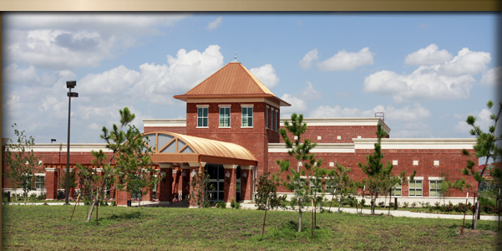

Building Name & Address: Senior Support Center – 344 W. Huron St. Chicago, IL 60612

Owner: Senior Support Center

Architect: RTKL Associates, Inc.

Criteria Six: Ability to Manage Construction Safety Risks

Safety Information:

At Bedrock Construction, safety is the value that exceeds all others. Every member of the Project Team is empowered to make safe decisions and is held accountable for their actions. The safety program succeeds through proactive training programs available to all employees and required of all supervisors, a company-wide accountability program and an unwavering commitment from top management.

Every person on a Bedrock job site is required to follow Bedrock safety standards. Subcontractors are subject to a rigors qualification process, including review of EMR and past safety record. Subcontractors are required to complete a Site-Specific Safety Plan prior to starting work, which is reviewed by Bedrock project team, the safety department and the subcontractor. Many of Bedrock’s programs exceed OSHA requirements; therefore this step is crucial to other overall job success.

Extensive reporting ensures that safety standards are followed throughout the entire course of the project. These include:

- Master project safety plan, compiled with the entire project team
- Daily task hazard analysis completed for each trade crew
- Daily tool box talks to discuss potential safety issues
- Job site safety inspections on a weekly basis, often more frequently
- Weekly subcontractor and Project Safety Audits are documented using an electronic system which allows immediate analysis and communication of safety related issues.

The Bedrock construction safety department personnel are qualified to instruct a variety of safety classes, including OSHA 10 and 30 Hour construction safety training, 1st Aid/CPR/AED, competent person trenching/exaction, respirator fit testing, fall protection and steel erection safety training.

In addition, Bedrock employs site safety coordinators, who are assigned to specific job sites as the complexity and scope of a project demands. These safety officers are trades persons who often perform a dual role on the job site coordinators.

Self Performing Information:

Bedrock Construction Group is capable of self performing:

Carpentry Concrete Demolition Drywall Acoustical

Request 3.6.6
Bedrock Construction is 100% committed to providing and improving an Experience Modification Rate (EMR) that is very competitive with the industry best. The three (3) most recent EMR’s according to the annual insurance-year ratings are as follows:
- EMR January 2011……..0.64
- EMR January 2010……..0.68
- EMR January 2009……..0.70
Request 3.6.7 & 3.6.8
It is essential that Bedrock Construction send every worker home safe every day. Our experience and enthusiasm for providing a safe atmosphere is helping us create the safest working environment possible. Our firms OSHA Recordable Incident Rates (RIR) and OSHA Lost Workday Case Incident Rates (LWCIR) reflect our progress.
Incidence rates for Bedrock Construction | Total recordable cases of injuries and illnesses | Injury and Illness cases with days away from work, job transfer, or restriction
2011 7.2 4.4
2010 7.9 4.9
2009 8.4 5.5

CRITERIA SEVEN: RESPONDENT’S ABILITY TO ESTABLISH BUDGETS AND CONTROL COSTS ON
PAST PROJECTS

Request 3.7.1

Our fiduciary responsibility as a Construction Manager at Risk using Guaranteed Maximum Price (GMP) is to provide the owner with information and professional knowledge of any areas of the project that we believe need special attention during the preconstruction phase. Our goal is to establish a positive, progressive relationship with the owner.

Request 3.7.2

At Bedrock Construction we use an innovative and unique approach to estimating projects. We believe it is essential to get as many key players involved as soon as possible in the estimating process. We included estimators, project managers, and superintendents at the very beginning of the estimate. Having everyone involved can help eliminate potential problems with the project. By eliminating as much risk as possible it enables Bedrock to provide the most accurate estimate for the owner.

Step 1
Analyze initial project scope and compare similar project costs

Step 2
Take-off project scope with help from all personnel

Step 3
Review project estimate and update if required

Step 4
Provide the owner with a highly accurate, updated estimate

Request 3.7.3

At Bedrock Construction, we believe for every hour of pre-construction cost planning and scope review our company saves 10 hours during the construction process. Our best cost control method is to prevent cost problems from occurring during the building phase. Our project team tediously and meticulously combs through all project documents prior to awarding any subcontractor. We create excel spread sheets for each individual trade with a complete scope of work. The next step we take consists of sit down scope review meetings with the three best qualified subcontractors to find and correct any holes in the documents and scope of work. Once both parties agree on the correct scope of work, Bedrock will draft of a final contract to send to the subcontractor. As you can see from St. Ive’s Medical Center, there were no change orders issued. This demonstrates our ability to correctly identify all scope of work for the entire project and keep cost’s within our initial budget.

Request 3.7.4

Bedrock Construction believes that working with the project architect/engineer and their consultants to provide a GMP and maintain it throughout the project is a huge advantage. The main area we try to improve is communication. Working with a GMP it is essential that everyone is on the same page and potential set backs are avoided at all cost. As the project progresses collaboration between the A&E and Bedrock will enable the project to meet and exceed the owner’s expectations.

Request 3.7.6

The owner intends to accept a Guaranteed Maximum Price prior to the completion of the Construction Documents. Since the owner will be accepting a GMP prior to construction it becomes Bedrock Construction’s responsibility to ensure that all information is acquired when we arrive at a complete GMP. By working hand in hand with the A&E we can ensure that all information is communicated effectively to provide 100% complete design documents. We dedicate several resources to ensure that all owner requirements are met along with all architectural design requirements. Also, our legal team is included to reduce risk and ensure that 100% of the construction documents are aligned with the original project scope.

CRITERIA EIGHT: RESPONDENT’S ABILITY TO MEET SCHEDULES ON PAST PROJECTS

Request 3.8.1

Every schedule that Bedrock Construction develops goes through three phases during the construction process. Phase one is the preconstruction planning phase. This is where we get as many people involved as possible in order to produce the most accurate schedule. A large emphasis is placed on the planning phase because we believe spending more time planning can reduce future problems. We also know that there are unforeseeable problems that can occur. This leads to our second phase, which is making a base schedule. Our company uses the software Primavera 6.0 (P6) to develop the project schedule. The second phase is where we create a thorough project schedule in P6. Here we can set up an original schedule that will serve as a base line for comparison purposes. The last phase of the schedule is the updating phase. We will continually update the schedule in order to provide and accurate, up to date representation of where we are on the project.

Request 3.8.2

The construction industry is looking for bigger; better projects and they want them built in half the time. We know it is essential to stay on track and assure a timely completion of the project. The most critical thing we do to stay on task is update our schedule. By continually updating our schedule we are able to compare it to our original and see where we stand. This helps us foresee any possible delays and manage the work accordingly, in order to stay on schedule. For example, the Hopes and Dreams Child Care Center we completed was built in Tinley Park, IL. We had a severe winter which caused delays in the project. However, the proper pre-planning was done and this delay did not impact the critical project path, so the overall project completion date was not changed.

Request 3.8.3

Once a master schedule is created we have a very good understanding of how to set up work schedules to perform the work. Again, by involving superintendents early on in the design phase we are able to provide accurate task durations, which are reflected in our work schedules. We also use company historical data to determine work schedules. Work schedules are created by the project manager and superintendent. It works very similar to our project schedule procedures. We create a master work schedule and update it as the project progresses. This enables us to stay on task and work very efficiently. For example, the Senior Support Center we completed in Chicago, IL was a renovation of 75,000 sf. Obviously this was going to include a large amount of labor. Our project manager was able to use our company’s historical data and advice from our superintendent to set up very accurate work schedules. This allowed us to come in under budget.

Request 3.8.4

It is a firm belief at Bedrock Construction that as a company we must adapt or die. The industry is changing rapidly in so many ways and adapting is crucial to continue developing a successful company. One of the ways we have adapted as a company is by using Primavera to compute all our project schedules. This enables us to provide the most up to date and accurate schedule. It also allows us to be highly efficient. Below is schedule in Primavera 6.0 for the Senior Support Center project we completed.

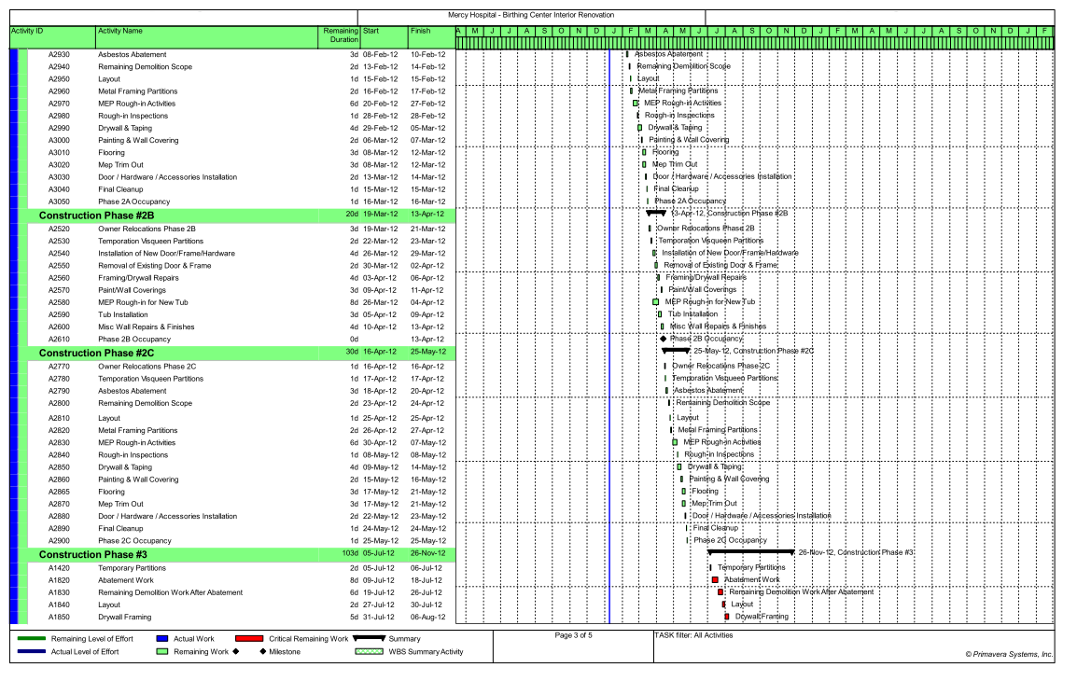

CRITERIA NINE: RESPONDENT’S KNOWLEDGE OF CURRENT CONSTRUCTION METHODOLOGIES, TECHNOLOGIES, AND BEST PRACTICES

Request 3.9.1

The goal of our quality assurance program is to efficiently and accurately perform our construction services while maintaining a high level of workmanship, care and professional judgment to ensure that our work will be free from defects and in conformity with the requirements of the construction documents. At Bedrock Construction we have specific procedures that must be followed when it comes to quality assurance. Paperwork, pictures, and videos will be used, along with the supervision of all the work performed by a quality assurance director. For example, the St. Ive’s Medical Center we completed in Oak Park, Illinois we had to provide the owner with a quality report every month with documented pictures to ensure quality control.

Request 3.9.3

Perhaps one of the biggest constructability programs we support is getting the proper personnel involved from the very beginning of the project. This allows us to be very efficient throughout the project. For example, the owner of the Hopes and Dreams Child Care Center wanted large tile squares for the bathrooms and we recommended using VCT, which provided the same quality with a much cheaper installation rate. This enabled us to save money in the budget without sacrificing any quality assurance.

Request 3.9.4

Bedrock Construction provides a rigorous selection process when choosing trade contractors. By only advertising to trade contractors who have met specific pre-qualifications we are able to acquire only firms that we deem fit. We are committed to excellence and demand this out of all trade contractors we hire.

Request 3.9.5

Bedrock Construction has developed a strong, positive relationship with several subcontractors in the Chicago land area.

Request 3.9.6

When we were rewarded the Hopes and Dreams Child Care Center, or any project that matter, we began the preconstruction planning process. The Hopes and Dreams Child Care Center required that we included site offices, gang boxes, and other materials for site mobilization. All of these materials will be equipped with locks and properly stored to deter theft.

Request 3.9.7

Based out of Chicago, Bedrock Construction is very familiar with site congestion. During the St. Ive’s Medical Center project we had to close down a section of road in order to do some of our crane picks. With proper planning we were able to accomplish this with no impact on project cost or schedule.

Request 3.9.8

Bedrock Construction has proved time and time again that preconstruction services are among the industry best. We have been able to stay with the project budget and avoid delays. We also are very successful at coordinating all MEP systems on renovation projects.

Request 3.9.9
Bedrock Construction offers the highest quality services and strives to provide the owner with a project that is within budget and on schedule. We are also very innovated with new technologies and provide the owner with hassle free reports on their project.
CRITERIA TEN: RESPONDENT’S ABILITY TO IDENTIFY AND RESOLVE PROBLEMS ON PAST PROJECTS

Request 3.10.3

Bedrock Construction has had experience on numerous renovation projects. A vast amount of these renovation projects have been in healthcare facilities. We understand the extreme importance of how to accomplish work without disrupting the occupied facility, especially in healthcare work. Procedures are accounted for early in the preconstruction phase to help ensure the project goes as planned with no setbacks.

Request 3.10.4

Fortunately, Bedrock Construction focuses enough attention for the very beginning of the project we have not experienced any major conflicts with the owner, architect or subcontractors. We have had minor issues with the architect not completing submittals and RFI’s in a timely fashion. On the St. Ive’s Medical Center project we had many long lead items and required procurement early on in the project. This was stressed several times at weekly meetings and architect responded accordingly.

SPECIAL SERVICES:

BIM COORDINATION

PRE-FABRICATION

SELF PERFORM WORK

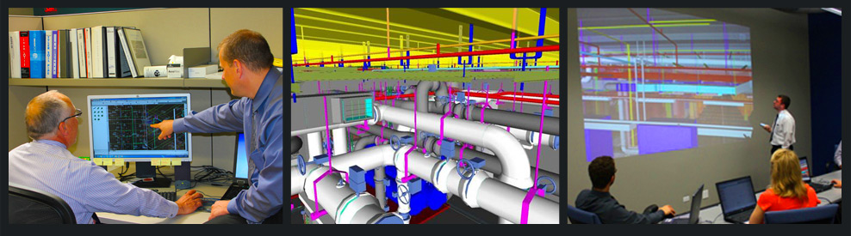
BIM Leadership
Building Information Modeling (BIM) is an integrated process that enhances the design, construction, operation and maintenance of the facility. While many companies talk about BIM, The Hill Group began integrating this technology into our construction process systems in 2003. Today we are recognized as the Chicago area’s BIM-capable leader in successful pre-construction planning, design, prefabrication, purchasing/inventory control, construction management, commissioning, test and balance, and building operations.
Bedrock Construction Group is proud to say that our company will be teaming up with The Hill Group on this project. We will sub out all mechanical work to Hill including: HVAC Systems, Medical Gas Systems, Plumbing Systems, and Fire Protection Systems. By combining all Mechanical work packages and subcontracting these scopes of work to one contractor, we can effectively manage all this work more efficiently. Also, by utilizing Hill’s expertise in all of these fields, there will be less coordination issues leading to less overall problems during the construction phase.

At Bedrock, we believe that the more time spent in planning and coordinating, less time is spent correcting MEP field issues. By spending extra money during pre-construction and creating BIM modeling systems, we will save money over the construction project duration. BIM systems have been proven to completely eliminate field coordination issues during construction because we can map out all MEP site work before it is ever installed in the building. By doing this, all conflicts and issues that develop can be seen and addressed before construction work ever begins. This saves minutes, hours, and days which in turn saves you money.

Project’s Hill Is Currently Utilizing BIM Services On Include:

- Ann & Robert H. Lurie Children’s Hospital of Chicago
- Northwest Community Hospital
- Alexian Brothers Medical Center

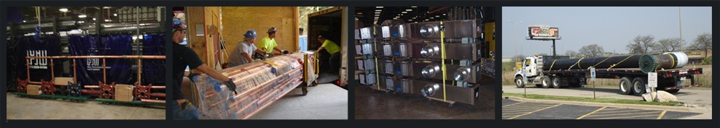
Prefabrication Shop
Engineering News Record magazine consistently ranks The Hill Group among the nation’s largest sheet metal contractors. A primary goal at The Hill Group is to maximize Building Information Modeling (BIM) efficiencies by prefabricating as much sheet metal, piping, plumbing, and fire protection as possible in order to minimize field labor. Each trade uses standardized construction techniques detailed in internally published manuals, and Lean manufacturing principles are stressed.
We attribute the success of our prefabrication shops to:
- highly skilled union tradesmen,
- efficient shop layout, and
- state-of-the-art equipment
To utilize the efficiencies of BIM Modeling Systems, Bedrock & Hill plans to prefabricate as much of the Mechanical system equipment and material as possible before anything is brought out to the project site. Not only does this compliment the reason for using BIM Modeling, but this is also a very effective method to deter any field installation issues. Not only does prefabricating the systems in shop help prevent field issues, it also saves time and money. By building the mechanical systems in house in a controlled atmosphere, Hill can complete these tasks far more accurately and efficiently. This will contribute to a lower bottom line in the end.

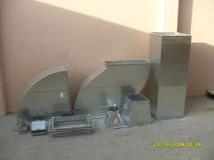
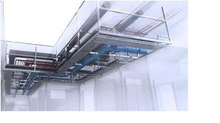

Self-Perform Work
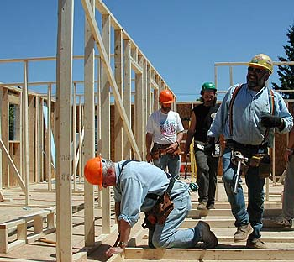
Our self-performing capabilities are a major factor that sets Bedrock Construction apart from the rest of the industry. Self-performing work enables us to influence many aspects throughout the project. Some of these areas include:
- Controlling the schedule
- Assuring the highest quality
- Securing costs
- Fewer work scope disputes
- Increased labor efficiencies
- Better safety records
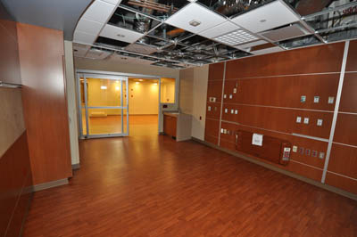
Bedrock Construction employs over 250 union tradesmen that specialize in different areas of work. We are able to self –perform work in the following areas: demolition, masonry, rough carpentry, acoustic ceilings, and drywall. Our customers realize that by having us self-perform work, they minimize risk, while gaining many potential benefits. Finally, Bedrock stands behind the craftsmanship and quality of the work we provide.

Dedicated to Quality

General Conditions Estimate and Fee

Project Schedule

Site Logistics Plan

