Consulting Firm

Client Communication Audit

Table of Contents

Executive Summary 3

Introduction 4-5

Organization Strengths 6-9

- Leadership 7

- Communication Climate 8

- Commitment 8

- Incentives within the Organization 8

Organization Opportunities for Improvement 10

- Space 11

- Evaluating Position Roles 11

- Higher Management Understanding Lower Employees 12

Recommendations 15
- Create Set Role Identities 16
- More Space for Lancer Lines 16

- Create a way for leadership to understand staff 17

Conclusion 18
References 19
Appendix 20

- Interview Instrument 21

- Survey Instrument 22-23

List of Illustrations

Figure 1: Leadership 10

Figure 2: Commitment

EXECUTIVE SUMMARY

The following is an analysis of the Denali Consulting Firm’s communication audit of the client at Longwood University. Based upon our observations as well as our interpretations of the data collected through interviews and survey responses, we have provided a detailed summary of recommendations to help further the success of the client. In the following report you will find a comprehensive analysis of the strengths, weaknesses, and recommendations that we have developed. An outline of our findings is provided below.
Strengths
• Good Communication Climate
• Leadership
• Commitment
• Incentives within the Organization
Opportunities for Improvement
• More privacy for Lancer Line
• Unclear position roles
• Understanding of leadership and staff

INTRODUCTION

Through a comprehensive communication audit of the client, Denali Consulting Firm evaluated the organization’s communication patterns. The purpose of this audit is to provide them with the means to improve in their overall performance as a student and faculty organization. Denali Consulting Firm received authorization from the client’s Board of Directors in order to conduct a communication audit during the fall 2010 semester. The focus was on the internal communication between the staff of the office, the Board of Directors and the students that work there and how the communication affects the organization as a whole.

Research Methods

During the communication audit, members of Denali Consulting Firm attended Board of Directors meetings weekly and observed the client. Members of Denali Consulting Firm then gathered data by interviewing voluntary participants within the Office of University Advancement and conducting a survey which was open to all members.

Meetings/ Observations

Through attending weekly meetings, members of Denali Consulting Firm were able to observe how business was conducted at the Board of Directors meetings and how Lancer Line worked. Members of the firm took notes and studied the communication functions observable and available. Observations of the client were made from the beginning of September through November, 2010.

Interviews
Towards the end of our observations, members of the Denali Consulting Firm conducted six interviews with students and staff of the client.

Through these interviews we were able to gain an inside perspective of strengths and areas for improvement within the organization. See Appendix for a complete list of the interview questions.

Surveys
Denali Consulting Firm used an online survey provider, Survey Monkey, to develop a survey for the client’s members to evaluate the communication between members of the organization. Questions in the survey were derived from existing professional communication and its tools, including the International Communication Association and the Downs– Adrian Communication Satisfaction Survey. Denali Consulting Firm sent the survey to the members of the organization via e-mail so they could assess their communication. The survey was taken by twenty eight members of the organization. The members of the organization were asked about the new leadership of the organization, commitment of the members, and their relationships with other members of the organization.

Limitations

The results of the communication audit conducted by Denali Consulting Firm are based upon brief observations and both interviews and surveys were only completed by voluntary participants. Some areas may be underrepresented due the amount of time available to conduct the audit. Concerns may also be misrepresented based upon the fact that interviews and surveys were completed by only those members who wished to share their opinions

Report Organization

Through a detailed analysis of the client, Denali Consulting Firm evaluated both the strengths and areas for improvement of the communication within the organization. By conducting this audit, Denali Consulting Firm hopes to offer recommendations to further enhance the performance of the client.

Consulting Firm

ORGANIZATIONAL STRENGTHS

The information for this section was gathered through interviews, surveys and observations of meetings and Lancer Line. The following is a summary of the strengths of communication within the client:

• Leadership
• Welcoming communication climate
• Commitment
• Incentives within the Organization

Leadership:
An important consideration in understanding the context for perceptions of leadership within the client is the resignation in September 2010 of the former Vice President and the appointment of a new person as the Interim Vice President. Overall, members reported satisfaction with the new leadership in the organization. Multiple interviews revealed this positive impact of the new leadership, one interviewee stated “He is a great leader, experienced, personable, knowledgeable, and very popular with alumnae and campus”. It was determined that there was a lack of leadership before he was in the position and now there is an opportunity to change for the better through leadership. Members within the organization, over half of the survey participants, agreed that the leadership of the organization are doing the right things to ensure the organization's success. According Downs & Adrian (2004), “the relationships among managers profoundly affect the organization’s communicative health. These relationships often set the tone for the rest of the organization”. The members of the organization acknowledge that the leaders are doing what is best for the organization and over half also agreed with feeling committed and proud to be a member. Leadership can impact other members’ feelings of commitment and how they portray themselves as proud or not to be a member. The results of the survey yielded that the members are happy with the leadership and with the level of commitment they have, an influence which plays off of each other. Top leadership has improved greatly and has made a positive impact on the entire office in doing so. Figure 1 shows the strength of leadership according to our survey.

Communication Climate
Through interviews we have found that the general consensus is that the client has a very welcoming and friendly communication environment. Co-workers and managers have expressed that everyone usually gets along very well. One employee stated that “everyone’s door is always open, I love working here and how friendly we all are to one another.” Through our observations, we noted that in meetings everyone took turns and really listened to what the other person had to say. The meetings felt formal but not intimidating, with a lot of encouragement to hear new ideas.

Commitment:
Our observations indicate that the most of the members within the organizations have a strong commitment to their organization. Through interviews, we were able to learn that the members of the organization are committed to raising money by the incentives they are given. By setting these incentives and goals, they feel the need to achieve them and are praised for doing so. Since the members of the organization are excited about working, it boosts their morale and work productivity. Due to the strong commitment, Lancer Lines is productive while working and raising money. As you can see in Figure 2, 85% of surveyees answered that they felt committed to the organization.

Incentives Within the Organization:
The client’s employees have expressed that they greatly appreciate the incentives they receive for reaching their monetary goal. These incentives make them feel appreciated and encourage them to continue working hard. These monetary incentives are a great way to show the employees that the client appreciates them and recognizes how hard they have worked. Students put a lot of emotional labor into their job as callers, the incentives given to them help encourage and keep them motivated to continue their hard work.

Figure 1
Leadership
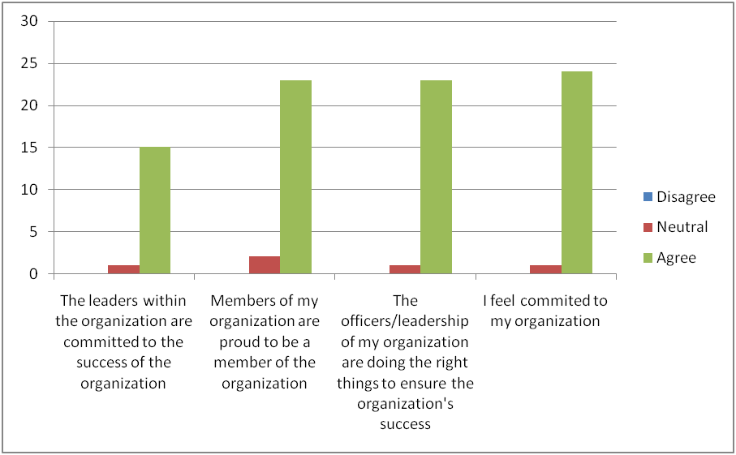

Figure 2
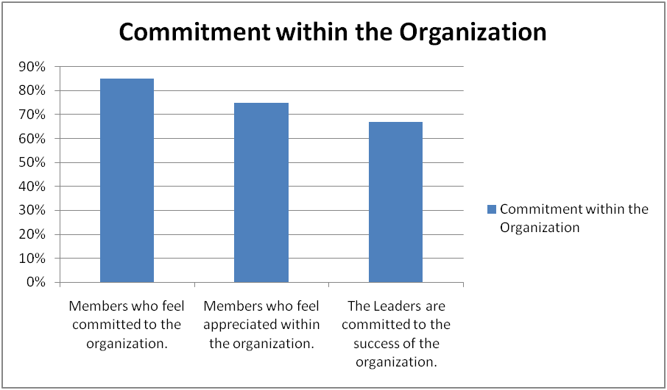

Consulting Firm

ORGANIZATIONAL OPPORTUNITIES
FOR IMPROVEMENT

Information for this area was gathered through observations of meetings, interviews and surveys. In the following section you will find an explanation of the following areas of improvement:
• Work Environment
• Evaluating Position Roles
• Leadership understanding staff members
Work Environment
While conducting our interviews, many employees from Lancer Line felt that there was not enough physical space in their work environment to be fully productive at their job. Several employees mentioned that they sit entirely too close to their coworkers, and that there simply is not enough space in their work setting. Potential donors on the phone hear a lot of noise in the background, when really it is just other Lancer Line employees contacting other donors. This issue may be particularly salient when callers are talking to older alumnae. Some employees of Lancer Line have great difficulty hearing potential donors when they are speaking to them, since they are sitting within a very close range to their fellow coworkers. Having more physical space or other means of mitigating background noises between each other would be beneficial, and would allow Lancer Line employees to talk on the phone more comfortably.

Evaluating Position Roles
Several of the people we interviewed were unclear of their position roles. Many had a general idea of what they were supposed to be doing, but did not necessarily know their job description fully. Having a set, formal, and written job description may provide additional role clarity would allow employees to know exactly what they need to be doing at all times. Having a set job description would allow employees and supervisors to remain on task, and not get distracted or confused about what duties they need to be performing. Everyone needs to be assigned a certain task/job to perform, and be sure they are not overlapping or confusing themselves with another employee’s duties. Having everyone fully be aware of (and know)

their job description and position role will greatly benefit the organization, and allow for a more productive workplace. There may be some necessary overlap within positions and most positions will include responsibilities not specified in the position description from time to time.

Leadership understanding staff

While we observed that the communication climate in the organization is typically positive, some staff members believed that executive staff members do not always consider the implications of decisions and how they affect the “line-level "staff positions. During one interview, a member said, “Sometimes they don’t understand the needs of the callers because they haven’t experienced doing the job of calling them.” If senior management participated with Lancer Lines more, the members of Lancer Lines may feel that the higher management understood their role better. This could be important, because belief that senior management is concerned about individual employee well-being is one of the strongest predictors of employee engagement. The organization does a great job communicating to one another, but there may need to be more interaction with the callers while they are calling. Students use a concept called emotion work daily in their work. This means that while they may be feeling very angry inside because the person on the other end of the phone is being very rude, they control their emotions and change how they are really feeling to convey an appropriate attitude towards the client. By taking the time to truly understand what this is like, the students of Lancer Line will feel more appreciated for the hard work they do.

Consulting Firm

Recommendations

In the following section you will find the following recommendations:
• Create set role identities
• More space for Lancer Line
• Create a way for higher management to understand positions of lower employees

Create Set Role Identities
Through interviews, we found that some employees are unsure of their exact roles within the organization. Many interviewees stated that they would like to have a clear description of what exactly their position entails. By working with Human Resources , the organization can find job descriptions for the various positions of the organization so that every employee can have a description of their position. This would also allow everyone in the organization to have clear role descriptions for every position, that way they know who to go to for a particular need. To further enhance each person’s job position description, we suggest that each person write their own description of their position and then meet with the Interim Vice President to compare notes and discuss what should be changed or added and to compare their job description with their day to day tasks.

More Privacy for Lancer Lines
Our first suggestion for creating more privacy within Lancer Line would be to set up table-top partitions , which would be beneficial since it would be a way of making it easier to hear when people are on the phones with various donors. Partitions would create a sort of cubicle like area, providing the caller with privacy, but also allowing the students the option to talk to other students since that is one of the benefits they like so much about working at Lancer Line. Another idea would be to have headsets instead of regular telephones which would block out excess noise from surrounding callers. Lastly, table cloths on the tables would be beneficial because they would help to eliminate at least a little of the background noise. Anything that absorbs excess sound and acts as a sound barrier would be very helpful.

Opportunities for executive level to understand staff level positions
Through interviews and data from our survey, we concluded that lower positions feel that upper management does not always understand the difficulty of their role, especially within Lancer Line. Our recommendation for fixing this is to have a faculty and staff calling night with Lancer Line. This would provide a way for the client to truly understand what it is like to call alumni and other donors and ask for contributions. A fun way to do this could be to pair each member of the faculty with a student caller. This way the student could feel like they are in the upper position for a change. Each student could “train” their assigned partner and show them how to make a phone call, what to say and how to record the monetary donation. This would help students and employees of Lancer Line feel like the upper management really understands their job and all that entails and how asking for money is no easy task. This recommendation would be very cheap to execute and will greatly improve the morale and confidence of the students and faculty of Lancer Line.

Conclusion
Denali Consulting Firm recognizes that client has organizational strengths in leadership, the communication climate, commitment and incentives within the organization. We encourage the client to continue with these strengths and always strive to maximize the potential of these areas. With that being said, we encourage the client to strive to continually improve all aspects of their organization. With this in mind, Denali Consulting Firm has identified three areas of improvement which we hope to see addressed and improved.
After analyzing these areas for improvement we have developed recommendations which we think will greatly improve the organization in all aspects. We understand that our recommendations for more privacy and space in Lancer Line, set role identities and an understanding of lower positions from upper management will take time, dedication and effort from all members of the organization. However, we feel that the Office of University Advancement is a strong organization that can succeed with these opportunities.
Denali Consulting Firm feels that the client is a strong, well organized organization that has many strengths and we have full confidence that the organization will have no problem implementing our recommendations and going above and beyond with them.

References
Downs, C. W. & Adrian, A. D. (2004). Assessing organizational communication: Strategic communication audits. New York: Guilford Press.

Consulting Firm

APPENDICES

APPENDIX A

Complete List of Interview Questions:
1. What is your name?
2. Describe your position within the organization
3. Tell us how you feel about the recent change of leadership in your organization. Explain.
4. How would you evaluate communication from top management?
5. Describe the communication relationship you have with your immediate supervisor. Top management? Coworkers?
6. Describe the way decisions are made in your organization.
A. What decisions do you normally make?
B. What information do you need to make these decisions?
C. Are there formal or informal policies that determine how you get
Information?
7. What are the major communication strengths of the organization?
8. What are the major communication weaknesses of the organization?
9. What do you see as the greatest unresolved problem of the organization?
10. How would you describe the general communication climate here?
11. How do you get ideas about how your superiors feel about your work?
12. How does your physical work setting here affect your communication?
13. What criteria for effective communication are used in this organization? How do these compare with the way people talk about communication?
14. When conflict occurs, how is it resolved? What actions are taken or is there
a certain protocol to be followed?
15. What ideas and changes do you think would benefit the organization?
16. Is there anything I left out that I should have included?

APPENDIX B: SURVEY
Complete List of Survey Questions:

1. How do you feel about the communication relationship within the organization? (1 is least agreeable, 5 is most agreeable)
I trust my coworkers 1 2 3 4 5
I can tell my immediate supervisor when things are going wrong 1 2 3 4 5
My organization encourages differences of opinion 1 2 3 4 5
I have say in decisions that affect my job 1 2 3 4 5
I influence operations in my unit or department 1 2 3 4 5
I have a part in accomplishing my organization’s goals 1 2 3 4 5

Information Received
1. How much information do I receive from members within my organization? (1 is no information at all, 5 is most of information received)
Coworkers in my own department 1 2 3 4 5
Leaders and supervisors 1 2 3 4 5
The “grapevine” 1 2 3 4 5

How satisfied are you with..( 1 being not satisfied, 5 being completely satisfied)
My opportunity to “make a difference”and to contribute to the overall success of my organization 1 2 3 4 5
My organization’s overall communication efforts 1 2 3 4 5
Working in my organization 1 2 3 4 5

How much information do you receive in the following ways: (1 is no information, 5 is ample information)
Face to Face 1 2 3 4 5
Written letters, notices and emails 1 2 3 4 5
Meeting with immediate supervisor 1 2 3 4 5
Meeting with top management 1 2 3 4 5
Meeting with coworkers 1 2 3 4 5
Informal meetings 1 2 3 4 5
Formal meetings 1 2 3 4 5

I am satisfied with the extent to which the information shared through informal communication channels is accurate:
Strongly Disagree
Disagree
Neutral
Agree
Strongly Agree

When an issue arises who do you communicate with and how do you communicate? Generally, how do you employees get information that affects the personally? For example, how do they find out about new polices? Upcoming events? New clients?

Commitment
Commitment within the organization: (strongly agree, agree, neutral, disagree, strongly disagree)
I feel committed to my organization: SA, A, N, D, SD
I feel appreciated within the organization: SA, A, N, D, SD
The other people within my organization are committed to their roles: SA, A, N, D, SD
The leaders within the organization are committed to the success of the organization:
SA, A, N, D, SD
Please indicate the extent to which you agree with the following statements about satisfaction within the organization and communication:
Members of my organization are proud to be a member of the organization: SA, A, N,
D, SD
The officers/leadership of my organization are proud to be a member of the
Organization: SA, A, N, D, SD
I am satisfied with the information I receive about the successes and failures of my
organization: SA, A, N, D, SD
I am satisfied with the information I receive about how my job performance compares
to others: SA, A, N, D, SD

Roles within the organization
How strongly do you agree with the following statements
Everyone in my organization works together as a team: SA, A, N, D, SD
I am satisfied with the extent to which my immediate supervisor listens to me and pays attention to my ideas and concerns: SA, A, N, D, SD
I am satisfied with the extent to which the organization’s leadership understands the problems faced by the average member of the organization: SA, A, N, D, SD
I am satisfied with the extent to which communication from my peers in the organization motivates me to help the organization achieve its goals: SA, A, N, D, SD
The leadership in my organization cares about my well being: SA, A, N, D, SD

Participation
Indicate your satisfaction with the following (only if you are responsible for staff as a manager or supervisor)
Extent to which my staff are responsive to downward-directive communication
Strongly Disagree
Disagree
Netural
Agree
Strongly Agree

When an issue arises who do you communicate with and how do you communicate? Generally, how do you employees get information that affects the personally? For example, how do they find out about new polices? Upcoming events? New clients?

Commitment
Commitment within the organization: (strongly agree, agree, neutral, disagree, strongly disagree)
I feel committed to my organization: SA, A, N, D, SD
I feel appreciated within the organization: SA, A, N, D, SD
The other people within my organization are committed to their roles: SA, A, N, D, SD
The leaders within the organization are committed to the success of the organization:
SA, A, N, D, SD
Please indicate the extent to which you agree with the following statements about satisfaction within the organization and communication:
Members of my organization are proud to be a member of the organization: SA, A, N,
D, SD
The officers/leadership of my organization are proud to be a member of the
Organization: SA, A, N, D, SD
I am satisfied with the information I receive about the successes and failures of my
organization: SA, A, N, D, SD
I am satisfied with the information I receive about how my job performance compares
to others: SA, A, N, D, SD

Roles within the organization
How strongly do you agree with the following statements
Everyone in my organization works together as a team: SA, A, N, D, SD
I am satisfied with the extent to which my immediate supervisor listens to me and pays attention to my ideas and concerns: SA, A, N, D, SD
I am satisfied with the extent to which the organization’s leadership understands the problems faced by the average member of the organization: SA, A, N, D, SD
I am satisfied with the extent to which communication from my peers in the organization motivates me to help the organization achieve its goals: SA, A, N, D, SD
The leadership in my organization cares about my well being: SA, A, N, D, SD

Participation
Indicate your satisfaction with the following (only if you are responsible for staff as a manager or supervisor)
Extent to which my staff are responsive to downward-directive communication
Strongly Disagree
Disagree
Netural
Agree

