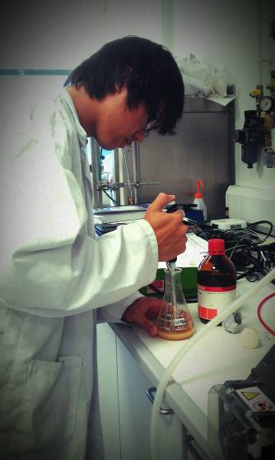

**Creation of a system for the control of the biomass level of a cell suspension.**

**Kenneth Wong**

**June 27th – August 12th 2011**

**Supervisor: Professor Gerard Markx**

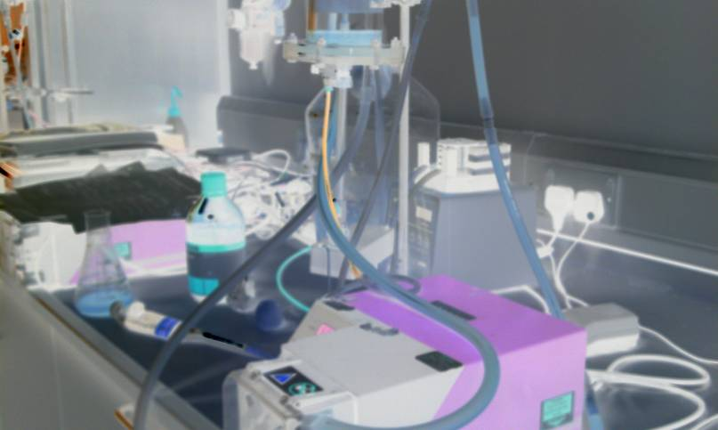

**Abstract**

A system was designed to control the biomass level of a yeast suspension based on dielectric spectroscopy. A dielectric spectroscope- a Biomass Monitor -was calibrated with frequency and capacitance checks. The most efficient medium for yeast to ferment in was also determined in small scale fermentations. A PID control program was designed and implemented in the graphical programming environment LabVIEW. The program was tested on 2 different scenarios: i) a yeast pitching system in which a continuous flow of medium was pumped into a tank; the program had to turn on a pump to add more yeast suspension to keep biomass levels in the tank and the outflow at a specific setpoint; and ii) a continuous culture system in which yeast cells were allowed to grow on the medium, and program was used to control a pump to add medium to the suspension in order to maintain the biomass level at a setpoint. It was shown that the control system was able to maintain the biomass levels at a specific setpoint in both scenarios.

**Introduction**

Dielectric spectroscopy is a way of measuring the dielectric properties of a sample as a function of frequency. It is achieved by generating an external electric field with a set of electrodes which induce the material within the field to form dipoles aligned with the electric field. The measurement of the relation between the voltage and the current gives a measure of the ability of the material to form dipoles returning a permittivity (capacitance). Cells give a particularly large capacitance which can then be analyzed to determine concentration of the cells in the medium.In this project an Aber Instuments Biomass Monitor 220 will be used to perform the dielectric spectroscopy. The Biomass Monitor 220 is Aber’s latest and most advanced instrument for on-line measurement of viable cells in fermentors. It is suitable for almost any type of cell and support structure.

PID Control is a typical control loop feedback operation. The PID controller calculates an output based on the error of the input, i.e. the difference between the value of the process variable and set point. The algorithm used to calculate the controller output has three terms: proportional, integral and derivative (P, I, and D). The P, I, and D have constants associated with them. Determining the optimum values of these parameters “tuning” can decrease the response time for the system to stabilize.

A variety of system is used to implement PID. Here control will be set up on a computer using the programming language LabVIEW. LabVIEW is a graphical programming environment used by millions of engineers and scientists to develop sophisticated measurement, test, and control systems using intuitive graphical icons and wires that resemble a flowchart. It offers unrivaled integration with thousands of hardware devices and provides hundreds of built-in libraries for advanced analysis and data visualization – all for creating virtual instrumentation. The LabVIEW platform is scalable across multiple targets and OSs, and, since its introduction in 1986, it has become an industry leader.

**Aims and Objectives**

The aim of the present study is to design and implement a control system to regulate the biomass level in a given cell suspension countering the increase of cell concentration due to fermentation.

To achieve this, we must:

* Calibrate and test the biomass monitor
* Create a PID control program
* Test the program on a cell suspension on a system with a disturbance.
* Determine the optimal media for fermentation of yeast.
* Test the program on a cell suspension on a system where fermentation of cells is the disturbance.

**Materials and Methods**

*Calibration*

High activity, pressed baker’s yeast was obtained from DCL craftbake, stored at 0-4 ºC for a maximum of 12 days. Dehydrated malt extract was obtained from Oxoid Ltd. 500ml of malt extract solution at 20g/L was prepared with deionised water.

In the first experiment, the biomass monitor probe was placed into the malt extract only to perform frequency checks, testing 20 frequencies between 40 and 20000kHz on a logarithmic scale. The capacitance was recorded for each frequency. This frequency check was performed again in a 40pF/cm (@400kHz) and an 80pF/cm (@400kHz) yeast suspension.

For capacitance calibration 400ml of malt extract solution was prepared. 100g of pressed yeast was resuspended with malt extract to a final volume of 150ml obtaining a thick yeast suspension. 10ml of this concentrated yeast suspension was added with a pipette 14 times every 2 mins and each time the capacitance and conductivity was measured on the biomass monitor and recorded.

For higher concentrations, 300g of pressed yeast was resuspended with 300g of malt extract solution to form a 50:50 concentrated yeast suspension. 50ml of malt extract was added instead every 2 mins 18 times and again each time the capacitance and conductivity measured and recorded.

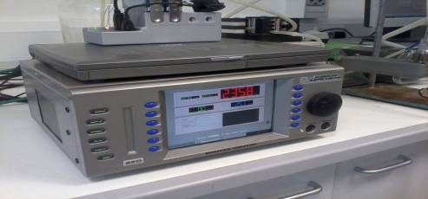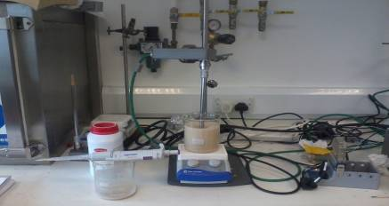

Figure . Biomass Monitor and calibration(right)

##### LabVIEW Program Function and Description

The control program was created in LabVIEW 2010.

Before beginning the program, the values for the parameters for the P, I, D gain and the set point must first be allocated on the front panel.

The program loops until STOP button is pressed on front panel. During a loop, it goes through the following steps:

1. Get current input from Biomass Monitor through DAQ Assistant by using the NI9203 0-20mA current input device.
   1. Obtain data at a frequency of 0.25Hz.
2. Convert inputs from current to capacitance and conductivity.
   1. Display values of capacitance and conductivity on a chart on the front panel of the program.
   2. Values also to be logged in an .lvm file for recording and reference.
3. Analyze capacitance input versus set point to calculate a suitable control output.
   1. Calculate output using PID algorithm: - ((Kp*Error) + (Ki*IntegralOfErrors) + (Kd*DerivativeOfErrors).
   2. Display output value on a different chart in the front panel but log onto same .lvm file as was used to store capacitance and conductivity values.
4. Create the voltage output signal to the Dynamax RP-1 peristaltic pump by using the NI 9263 ±10V voltage output device.

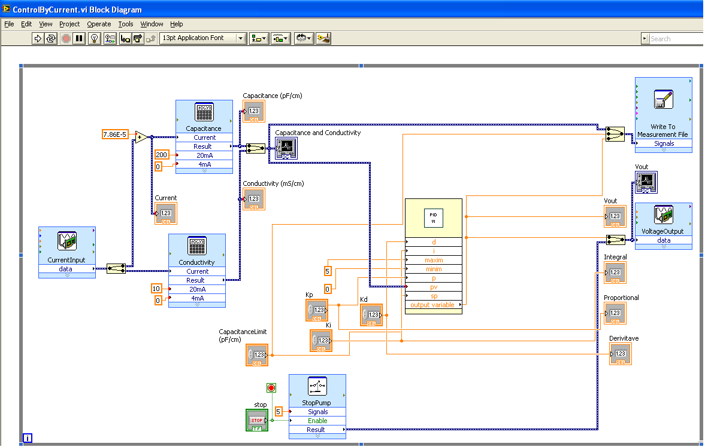

Figure . PID Control Program in LabVIEW

STOP Button

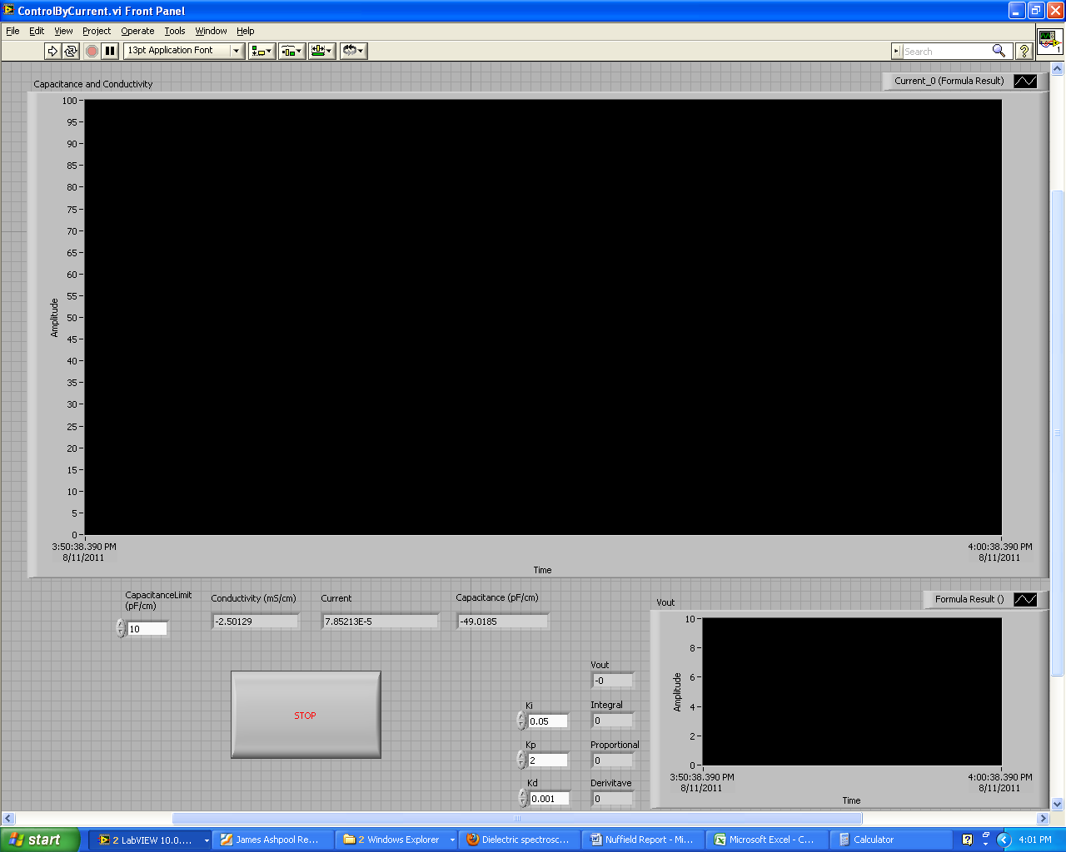

Figure . Program Front Panel

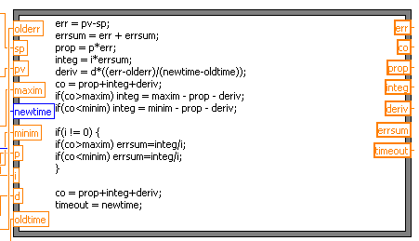

Figure . PID Control Algorithm on LabVIEW

PID Control Algorithm on LabVIEW Code Explanation.

* First of all the error is calculated, the process variable minus the setpoint (instead of the setpoint minus the process variable as the disturbance is fermentation, which increases the capacitance, which we need to counter). [err = pv-sp]
* To get the integral of the errors, it is simply adding up all of the errors cumulatively. [errsum = err+errsum]
* Proportional Value is calculated by multiplying Proportional Gain by error. [prop = p*err]
* Integral Value is calculated by multiplying Integral Gain by integral of errors. [integ = i*errsum]
* Derivative Value is calculated by multiplying Derivative Gain by current rate of change. [deriv = d*((err-olderr)/(newtime-oldtime))]
* Controller Output is calculated by adding up the Proportional, Integral and Derivative Values. [co = prop+integ+deriv]
* To ensure that the Controller Output does not exceed the maximum or minimum available output value, if it does, the integral value is forced to be a number that when added to the proportional and derivative, does not exceed the max or min output. [if(co>maxim)integ=maxim-prop-deriv],[if(co<minim)integ=minim-prop-deriv] And the integral of the errors (errsum) remains constant and will not further increase or decrease until the output no longer exceeds the max or min output. [if(co>maxim)errsum=integ/i],[if(co<minim)errsum=integ/i]
* For robustness, as there may be cases where integral gain, i, can be equal to zero, in those cases the lines: [if(co>maxim)errsum=integ/i],[if(co<minim)errsum=integ/i] will not be executed.

Figure . Early implementation of control program

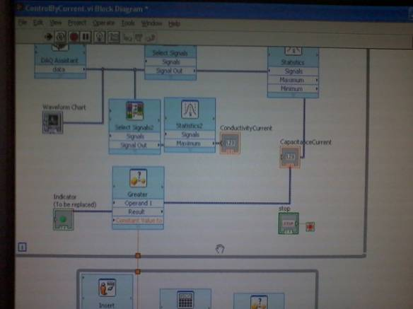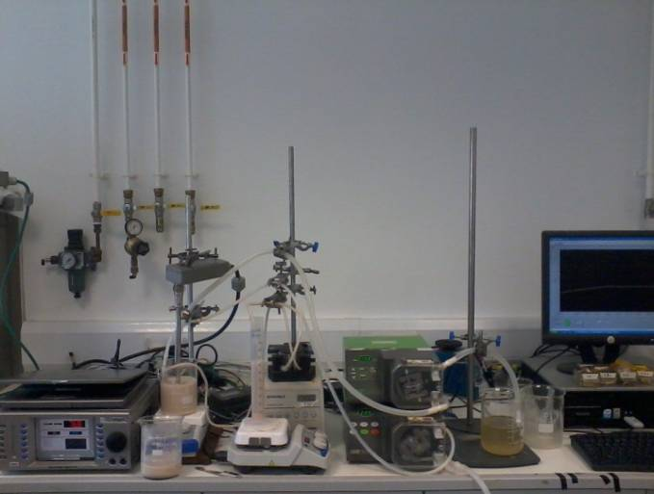

Figure . PID Control with yeast suspension and with constant flow of media as a disturbance

**Apparatus**

* used with the fermentation system only

* Aber Biomass Monitor 220
* Interface Device (NI cDAQ-9174)
* 0-20mA Current Input Device (NI 9203)
* ±10V Voltage Output Device (NI 9263)
* 2x Peristaltic Pump (Watson Marlow 505S)
* Voltage Controllable Peristaltic Pump (Dynamax Rp-1)
* Air Pump (Interpret APMINI)*
* Tubing
* Computer with LabVIEW 2010 installed
* 3x Beakers
* Clamp stand and clamps
* Fermentor and 2x 10L container

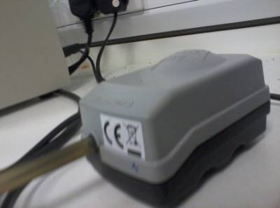

Figure . NI cDAQ-9174 with NI 9203 and NI 9263

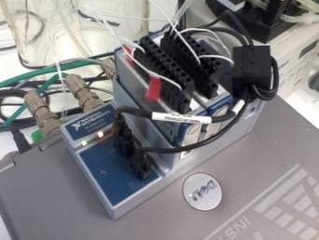

Figure . Interpret APMINI

Figure . Dynamax RP-1

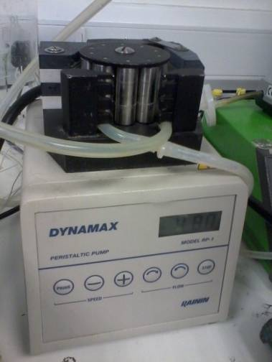

Probe

Recycle Out

Overflow, Waste Out.

Air In

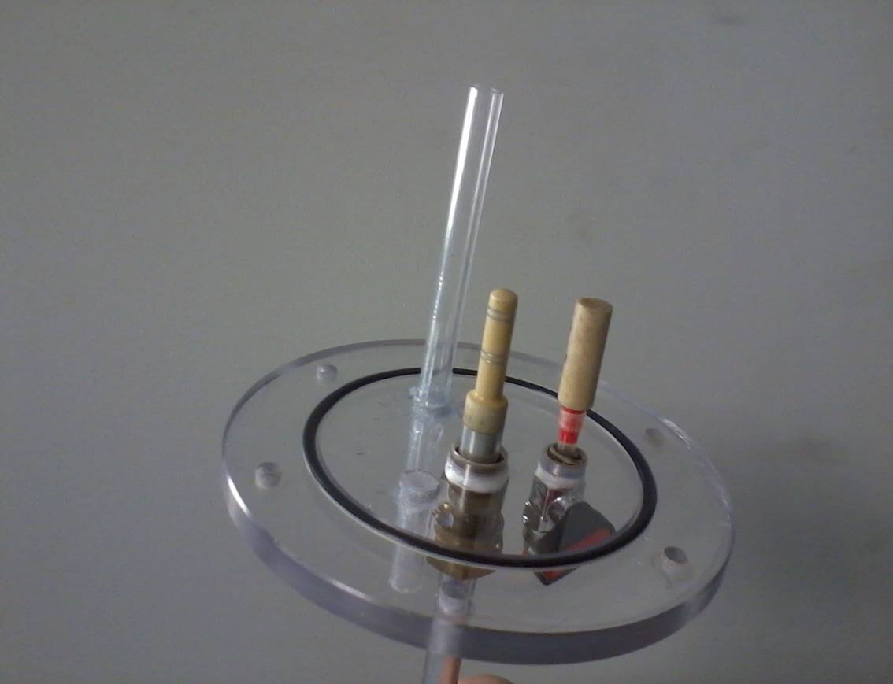

Figure . Fermentor Base

Recycle In

Media In

Air Out

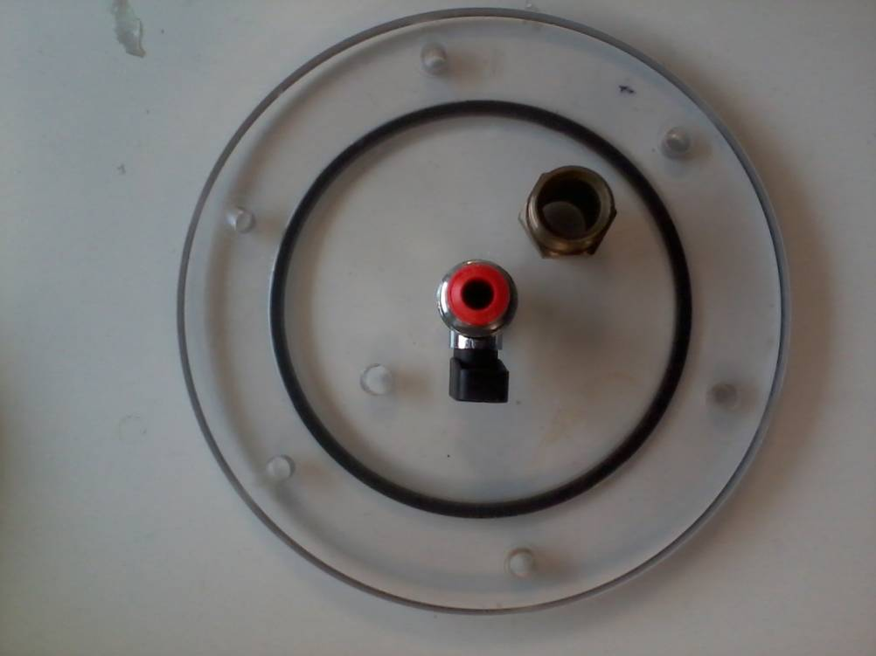

Figure . Fermentor Top

**Control of Biomass Level during Yeast pitching**

* 1L+ 20g/L malt extract solution was made up
* A 500ml 50% yeast suspension (250g pressed yeast, 250ml deionized water) was made up and placed on magnetic stirrer to keep yeast suspended.
* A 20pF/cm yeast suspension (roughly 45g in 500ml) was made up and placed on another magnetic stirrer.
* The Biomass monitor was zeroed on malt extract solution, then probe placed in 20pF/cm yeast suspension.
* The pump was turned on, to set a constant flow of medium into controlled yeast suspension.
* The PID program was run and the setpoint set to 40pF/cm; the change in the capacitance was observed until the system was stable.
* When stable, the setpoint was changed to 80pF/cm and the capacitance observed.
* The control system was tested with proportional only gain and then with proportional and integral gain.

**Optimisation of the medium**

Preliminary experiments showed that the biomass levels obtained by growth on malt extract were quite small, giving too low a capacitance to effectively control the biomass levels with. The source of the error was believed to be the fact that the fermentation medium (20g/L malt extract solution) was not optimal for biomass production, so tests were performed on a small scale with 2 different types of standard yeast fermentation media to determine the best media to perform the fermentation on.

These were the media tested:

*Malt Extract Broth* (per 100ml):

3g of dehydrated malt extract

0.5g of mycological peptone

*MYGP broth* (per 100ml):

0.3g of dehydrated malt extract

0.3g of dehydrated yeast extract

0.5g of mycological peptone

1g of glucose

100mls of 1x, 2x and 3x concentrations of each type were put into Erlenmeyer flasks, autoclaved then 1g of baker’s yeast was added and the suspensions were left in an incubator at 25 degrees Celsius and 130 rpm to ferment for 2 days. In addition for accuracy, the background capacitance was obtained as well. This was done by centrifuging the suspensions at 4600rpm at 2mins and then the capacitance of the media only was tested.

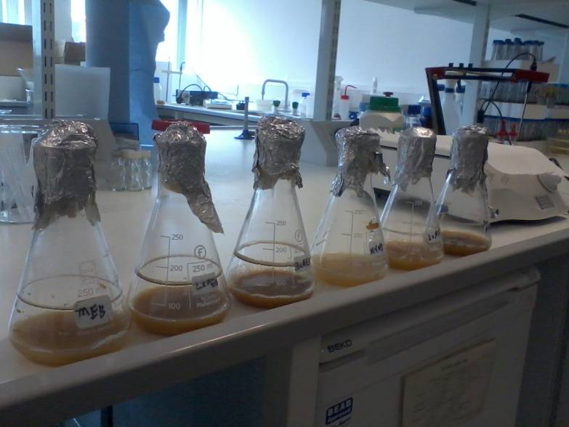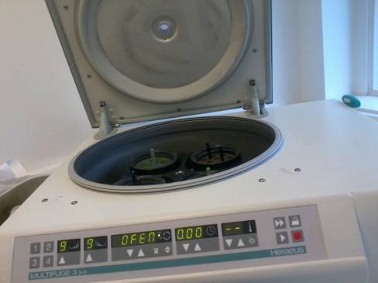

Figure . Centrifuge

Figure . Test flasks

**Continuous Culture**

* 5L of media was made up and placed in 10L container
* Tubing was attached to fermentor and media and waste containers, then autoclaved at 110ºC for 10minutes.
* 500ml of media was pumped into the fermentor, and biomass monitor was turned on and left to stabilize for 30 mins before biomass monitor was zeroed.
* Concentrated (more than 50:50) yeast suspension was made up into a sterile container.
* Yeast suspension was added into the fermentor through a sterile needle injected into the top of the recycle tubing until the biomass monitor read roughly 3 pF/cm.
* The Watson Marlow 505S Peristaltic Pump was turned on to recycle the content of the fermentor so that the yeast did not settle at the bottom.
* The system left for 2 days to ferment and details of fermentation were logged onto chart recorder.
* After 2 days the suspension was concentrated enough (roughly 15 – 20 pF/cm) to begin PID Control. PID Control program was started and the setpoint set to about 10 pF/cm and left to control system.
* When the medium was exhausted, the system was stopped and results were analyzed.

**Results and Discussions:**

Figure 14 shown frequency spectra for malt extract (20 pF/cm) and two suspensions of yeast with different concentrations.



Figure . Frequency spectrum of medium and yeast suspensions



Figure . Capacitance as a function of yeast concentration.

From the frequency calibration it was determined that a frequency of ~400kHz was to be used as it was when the malt extract was ~0 pF/cm. Additionally we saw the relationship between the frequency and capacitance of the cell suspension, which was interesting but unecessary for this investigation.

The capacitance check revealed a linear relationship between the cell concentration and capacitance, apart from a slight error when transferring containers produced abnormally high values between the cell concentrations of 37% and 46%. The error was suspected to be the change to a container of a different size, perhaps interfering with the electric field used to produce capacitance, thus measures were taken to revert back to the same size container to continue. The linear relationship does not sustain at higher cell concentrations where the capacitance tends to a limit. However the use of those high concentrations was not necessary and therefore linearity between cell concentration and capacitance was assumed in further experiments.

*Yeast pitching*

In the first experiment with the control system, it was tried to control the yeast concentration in in a flow. This was done by measuring the yeast concentration in a tank into which a continuous flow of medium was pumped. By adding yeast to the tank the Biomass levl in the outflow could be controlled.

Figure 16 shows the use of a proportional only control system for controlling the biomass level:

Start Capacitance: 20 Setpoint 1: 40 Setpoint 2: 80



Figure .Yeast pitching. Proportional control only.

Proportional + Integral Control:

Start Capacitance: 20 Setpoint: 40

*Proportional only control:*

The results show that although the controller seemed to work, the setpoints were never reached. This is due to only proportional gain being used, where the speed of the output (yeast suspension going in) calculated from the difference between measured variable and setpoints could never reach the speed of the input (malt extract going in), returning an ‘offset’, a difference between the steadied capacitance and the actual setpoint. It was found that the higher the setpoint, the greater the offset.

*Proportional and Integral Control:*

To counter this offset, an integral gain was added to the controller. Results are shown in Figure 17. From the graph we can see that the system did stabilize at the setpoint of 40pF/cm, however a large overshoot was observed, with the capacitance passing the setpoint by up to 3pF/cm. The capacitance continued to oscillate, steadily decreasing until it stabilized at the setpoint. The large overshoot was theorized to be the result of i) the integral gain being too high due to a large value for Ki, and ii) the lack of a derivative gain.



Figure . Yeast pitching. Proportional and Integral Control

*Optimisation of medium*

Yeast was grown on different media in order to optimize fermentation media for the biomass control experiment. Capacitances of the yeast cell suspensions and centrifuged medium ate shown in Table 1.

Table 1. Capacitance data for medium optimization.

|  |  |  |  |
| --- | --- | --- | --- |
| Media | Capacitance(pF/cm) of suspension | Background Capacitance(pF/cm) | Capacitance difference(pF/cm) |
| Malt Extract Broth | 2.5 | -5.5 | 8.0 |
| 2x MEB | 4.0 | -5.5 | 9.5 |
| 3x MEB | 7.9 | -5.2 | 13.1 |
| MYGP Broth | 0.6 | -5.8 | 6.4 |
| 2x MYGPB | 3.6 | -5.2 | 8.8 |
| 3x MYGPB | 4.9 | -5.5 | 10.4 |

It was found that the Malt Extract Broth was the most effective standard medium and the higher the concentration, the stronger the fermentation, thus it was chosen that 3xMEB would be used in the fermentation of yeast. The stronger growth was probably due to the higher carbohydrate concentration as well as the extra source of nitrogen given by the mycological peptone aiding the growing of yeast.

*Continuous culture*

A continuous culture was set up. The yeast was allowed to grow, and when the capacitance had reached 20pF/cm a setpoint was set of 10 pF/cm. The trace of the capacitance shown in Figure 18 shows show that:

1. The fermentation of yeast with 3xMEB media produced a fast and steady growth of yeast cells.
2. The PID controller using all 3 gains (proportional, integral and derivative) was programmed and setup successfully, as the program counteracts the disturbance (growth of yeast) to return and sustain a steady capacitance at the setpoint, with a relatively small overshoot and settling time.

Thus in the final fermentation, the aim of the project was achieved.



Figure 18. Control of the biomass level in a continuous yeast culture.

Control with fermentation as the disturbance:

Final Fermentation:

Proportional, Integral and Derivative Control:

Start Capacitance: 20 Setpoint: 10

**Conclusions and suggestions for further work**

It was shown that the Biomass Monitor, in combination with a Labview-based control system, can be effectively used in yeast pitching and for controlling the biomass level during a continuous yeast culture. The medium used for continuous cell culture needs to provide sufficient biomass level; 3X malt extract broth was found to be suitable.

*Further Improvements:*

To fully optimize the system, the three gain constants (Kd, Ki, and Kp) must be tuned in order to generate a controller that when the setpoint is changed, will stablilize the system at the correct setpoint, in the lowest time possible, and with as little overshoot as possible.

**References**

Further information about LabView and its use in control can be obtained at:

[www.ni.com](http://www.ni.com)

Further information about dielectric spectroscopy can be obtained at:

[www.aber-instruments.co.uk](http://www.aber-instruments.co.uk)