 **Robert J. Petitto, EDUCATOR, TS**

1523 Williams Avenue, Saint Charles, IL 60174

Cell: (630) 740-8988 **∙** Email: r.petitto@gmail.com

Dear Sir or Madam,

With a Master’s Degree in Instructional Technology, a Bachelor’s Degree in Music Education, as well as a Technology Specialist and Spanish Language and Literature Certifications, it is with great eagerness that I present my resume in response to the position available. I am a seasoned educator at Glenbard North High School with a strong background in second language acquisition and instructional technology including distance technology, e-learning, collaborative Web2.0 technology and integrated classroom technology tools.

* I designed a SMART Board training presentation and led workshops at the 2009, 2010 and 2011 District-Wide Fall Institute day for a panel of fellow educators looking to improve their proficiency in the use of the SMART Board hardware and Notebook 10 software.
* I served as a Technology Mentor for the 2010-11 and 2011-12 school years, during which I have provided training sessions, and technology integration advice to fellow staff members.
* I led workshops on technology integration for the Foreign Language department including SMART Board hardware/software, Classroom Performance System hardware/software, Web2.0 technology, ReLan Language Learning Laboratory hardware/software, and FirstClass Email and Conference client.
* I have successfully integrated the use of edmodo.com, an academic social media/e-instruction delivery and classroom management platform, with my students in order to provide them with opportunities for independent and interdependent practice outside of the classroom.
* In the spring of 2011, I created a video slideshow advocating the importance of maintaining healthy habits before and during standardized testing season which was played in the school cafeteria for a two-week period.

A résumé is enclosed for additional background information, qualifications and skill sets.

I am seeking to move to a new position in the field of education. I welcome the opportunity to meet with you in order to discuss the extensive multimedia production and technology integration experiences that I’ve acquired as a Spanish teacher.

Thank you for your time and consideration.

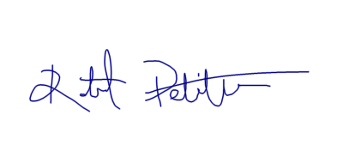Respectfully yours,

Robert Petitto