PBPC News and Views

Palm Beach Pet Center now provides full-service, luxury pet care. Our services are now offered to owners of both dogs and cats. Our survey to all of our current clients strongly endorsed broadening our services to include cats.

Grand Opening—Huge Success
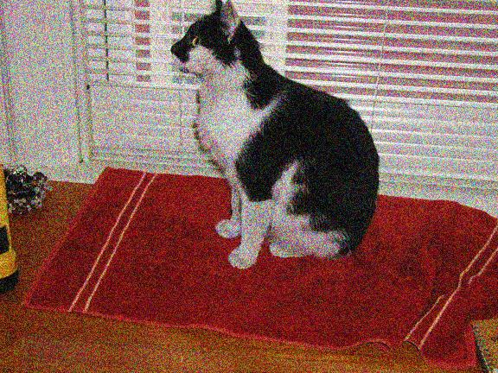
Thanks to all of you who turned out for the Grand Opening ceremony. The attendance far exceeded our expectations and was a fun event for both owners and pets. Many clients enjoyed the tour of the new cat facility and meeting the new veterinarians who specialize in medical services for cats. Sadie was the first to use these new facilities.

Picture-Taking Sessions
We encourage all clients to have pictures taken of their pets. The schedule is posted in the main office and on our website. Your written permission is required to feature the pets in our publications and on the website. The form is provided at the picture taking sessions. Lizzie was the first to have her picture taken.

Suites
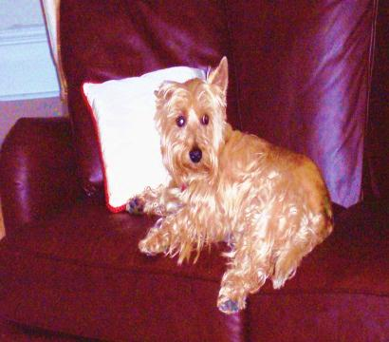
Andy laid first claim to reservations in one of the luxury suites and tried out the new leather couch that arrived this week. Three levels of luxury suites are available in addition to the standard units. Luxury suites feature all of the comforts of home—couches, comfortable beds, rugs, TV/VCR, toys, windows, climate control, premium food, a play yard, and a homey atmosphere.

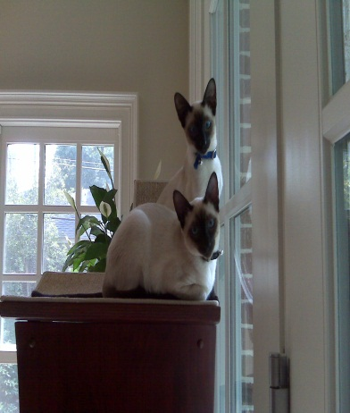
Multiple Pets per Unit
Standard units can accommodate two or three small or medium-size dogs or cats. All three levels of luxury suites are large enough to accommodate any size pets. Henry and Choo were happy that they can stay together in one of the luxury suites with comfortable furniture and a climbing tree.

Grooming and Spa
Professional groomers pamper your pet with all natural products at the grooming salon and spa. Standard grooming services include:
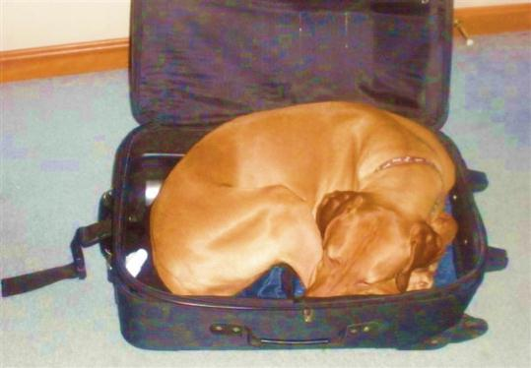
- Bathing
- Trimming
- Scissor finishing
- Nail trimming
- Ear cleaning
- Teeth brushing
Molly particularly likes the sumptuous spa treatments including whirlpool and massage therapy. Massage therapy increases circulation, relaxes muscles, and stimulates the skin. Grooming and spa services are available
by special appointment or while your pet is boarding or in Doggy Day Camp.

Palm Beach Pet Center Boutique
The Boutique provides one-stop shopping to meet all of your cats or dog's needs and desires.
- Scientifically prepared food
- Treats
- Beds
- Carriers
- Bowls and dishes
- Collars, harnesses, and leashes
- Natural grooming products
- Coats, raincoats, and sweaters
- Toys
- Pet staircases
- Grooming tools

Doggie Day Camp
Day camp is a wonderful experience for daytime pet accommodations. Day camp includes supervised play, games, exercises, treats, nature trail walks, and socialization with other pets. Kosh does not like to be left behind when the family goes on trips, but he is a regular at day camp and particularly enjoys playing with other campers in the two-acre outdoor play area. A 5,000-square-foot indoor pet romping room is available during inclement weather. Both facilities are supervised by trained staff.

Total Professional Care
Board-certified veterinarians and highly trained technicians provide the highest level of pet care using state-of-the-art technology. Medical services for both dogs and cats include:
- Comprehensive physical exams
- Immunizations
- Preventive medicine
- Microchip database
- All areas of internal medicine
- Surgical services
- Radiology
- Dental care
- Nutritional specialists
- Pharmacy
- Pain management
- Hospice service

