Tsunami 2004
The 2004 Indian Ocean earthquake was a megethrust earthquake under the sea that occurred at 00:58:53 UTC on Sunday, December 26, 2004 on the west coast of Sumatra, Indonesia. The earthquake was caused by subduction and resulted into the most destructive Tsunami along the coastline of Indian Ocean. The countries affected by this tsunami were Indonesia, India, Sri Lanka and Thailand. Among them, Thailand was the most affected country. This earthquake caused waves of 30 metres high which washed away the coastal regions of these countries. It also affected the countries of Malaysia, Maldives, Somalia, Myanmar, Kenya, Bangladesh, Tanzania, Yemen, Seychelles and South Africa to some extent. The forces which were building up in the core of the Earth for many years were released suddenly on the December 26, which caused this earthquake resulted in Tsunami, a series of violent waves grew at a height of 30 metres and at high speed washed away the coastal areas of many countries. The 9.0 magnitude earthquake was under the Indian Ocean near the west coast of island of Sumatra in Indonesia. Subduction caused the movement of the Earth plates also known as Tectonics plates, which displaced high volumes of water, delivering the wild waves in all the directions.
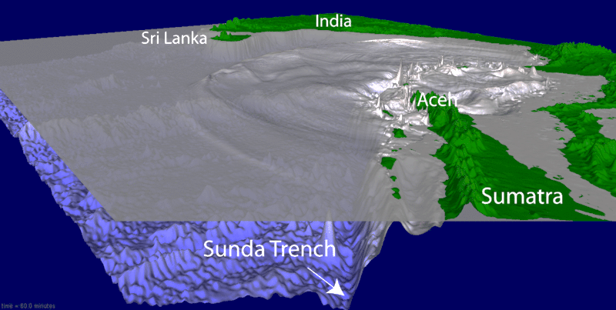
This earthquake had a magnitude of M_{w} 9.1-9.3, which was measured as the third largest earthquake with the longest duration of 8 to 10 minutes. Tsunami took the lives of more than 169,752 people from different countries with Indonesia having the maximum number of deaths and more than 127,294 were found missing. Many of them lost their homes and their families. There were lots of tourists visiting this area for their vacation as of Christmas, who also lost their lives.
The estimated damaged properties were about $8.4 billion as estimated by International Monetary Fund, with Indonesia suffering the maximum of $5.4 billion. About $5 billion of money were committed by the donor countries to help reconstruct the property, that has been destroyed by Tsunami and also to recover the fishing, tourism and other industries in Indonesia, Sri Lanka and India. The cost of recovery due to social impact for thousands of survivors was estimated to $9 billion and the time of recovery was estimated about 10 years. The coastal regions were totally destroyed which caused the fishing and tourism industries to suffer the most. Many people who had been related to these industries were jobless and about 2 million people lost their homes.
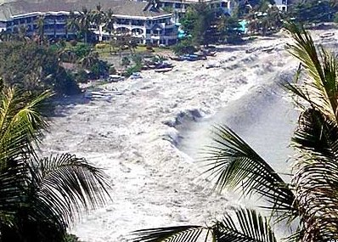
Aceh province of Indonesia suffered the greatest loss of life after this tsunami. There were 126,804 found dead, 93,458 missing and 474,619 displaced. The estimated damage by the Indonesian Government was $4.5 billion to $5 billion. Housing, transport vehicles and industries like agriculture, fisheries suffered loss of $2.8 billion, which is about 63% of the total damage. The environmental damage was estimate about $0.55 billion which is 12 % of total damage. The death toll reached to 31,000 in Sri Lanka and about 4,000 are missing and 2,000 were displaced. The recovery and reconstruction cost in Sri Lanka was estimated about $1.5 billion where housing, tourism, fisheries and transport were the major losses. In some years temporary housing and shelter were provided to most of them but the major issues were to provide jobs for thousands of people who lost their source of living and to provide them with their permanent homes. In India, more than 10,700 people died and 5,600 are missing, who were assumed to be dead later. As reported by the World Bank and Asian Development Bank, the reconstruction cost was estimated to $1.2 billion. Tsunami did not have a high impact on India’s economy as the suffered states were the one, who contributes very less to the country’s economy. The death counter was 5,400 in Thailand and missing numbers are 2,900. It was assumed that the poverty level would be increased as a result of Tsunami as people were homeless and jobless.
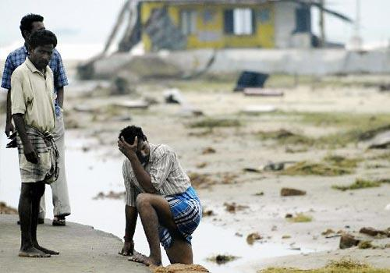
The cause of this Tsunami was vast and destructive. Millions of people lost their home resulting in more poverty level. Thousands of industries came to an end resulting in jobless people and increasing unemployment rate. Hundreds thousands of children lost their family which were their source of money for education and other needs of life. Many tourists from other countries lost their lives which also affected their families. The affected country’s economies were affected to greater extent which was not easy to build up again. The agriculture industries were also affected as the crops were destroyed and the soil erosion took place due to this heavy flood. Some of the affected islands were permanent evacuated.
After the disaster the displaced people were shifted to the relief camps for shelter. Many recovery campaigns and activities had been carried out which include temporary shelter, housing, legal service, education, jobs, health campaigns, protection of children and other issues.
The world health organisation estimated that some of the survivors of tsunami were suffering from psychiatric disorders. Many of them experienced traumatic disorder. Some of them thought their life was in danger. Some of them were suffering from depression and severe anxiety.
I would recommend these survivors to have a mighty heart and carry on with their new life. I know it is hard to forget the effects of Tsunami but I believe that it is their second life and they should build it up in a new way. It is better to make a nice future rather than thinking about the same every moment. I would recommend the countries to support these survivors in the best way they can by providing them all their needs. Health campaign and other services to protect these survivors should be increased. The countries other than the victim countries should provide their help in the form of money. As the technology has been growing, there should be a system to forecast these disasters to alert the countries and to protect a millions of life and avoid destruction of million dollar properties.

References
http://news.nationalgeographic.com/news/2004/12/1227_041226_tsunami.html
http://en.wikipedia.org/wiki/2004_Indian_Ocean_earthquake_and_tsunami
http://maureen-k-fleury.suite101.com/indian-ocean-tsunami-2004-a50374
http://ptsd.about.com/od/causesanddevelopment/a/tsunami.htm
http://www.adb.org/Documents/Reports/Tsunami/india-assessment-full-report.pdf
http://en.wikipedia.org/wiki/2004_Indian_Ocean_earthquake_and_tsunami
http://www.chinadaily.com.cn/world/2009-08/19/content_8589535.htm
http://edition.cnn.com/2005/WORLD/asiapcf/11/30/tsunami.economic.impact/index.html
http://www.abilityinfo.com/ticker/arch/archtsunami.html
http://www.jobsletter.org.nz/jbl22200.htm

