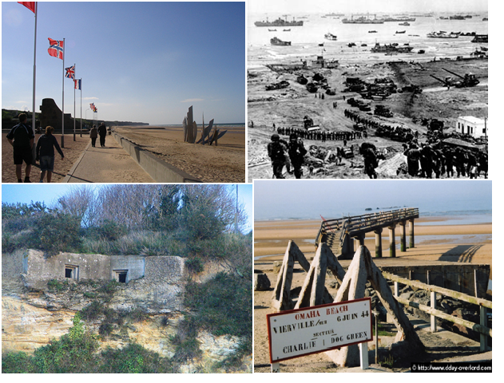

Omaha Beach:
“A Flawed Victory”

By: Eric Papesh

Paper Overview:

- Omaha Beach: An Introduction

- The Strategy for D-Day

- D-Day: The Battle Begins

- Unexpected Opposition

- The Battle for the Beach

- The End Result

Omaha Beach: An Introduction

Of the five beach assault landings that occurred on June 6, 1944, D-day, on the beaches of Normandy, Omaha Beach was the only one that was ever in doubt. Just minutes after the first U.S. beach landing over 1/3 of the troops assaulting the beach in the first wave were wiped out by German gun fire. The beach, termed “Bloody Omaha”, was considered the most difficult to take because of its rough coastal terrain and the unexpected resistance by top-rate German divisions and inadequate fire support from the allies. However, over the course of the day the American forces were able to breach the Atlantic wall and gain a foothold along the French coast.
While we were visiting Normandy, I was able to walk along Omaha Beach and see for myself what the battlefield looked like, though much has changed in the last 65 years. Just trying to imagine what the assault must have been like for any soldier who had to move along the beach under heavy German fire and no supporting fire is unthinkable in my mind. The shear casualty rates that were described on memorials around the beaches really put into perspective the violence that occurred on those beaches in the course of only a day of fighting.
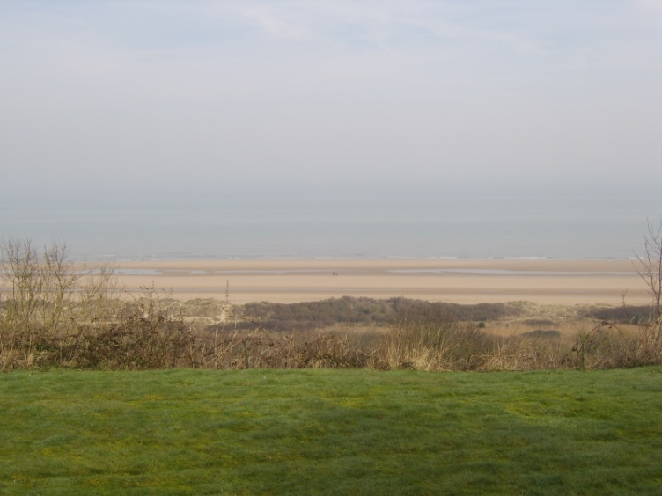
This is a picture of Omaha Beach from the Normandy American Cemetery located just off the coast. The hillside clefts down into a steep Cliffside covered with trees and rocks. My own personal experience, the climb down and back up was difficult without anyone shooting; the men who made that climb were true soldiers.
The Strategy for D-Day

The plans for D-day came about long before the assaults even took place. An attack on the “Fortress Europe” was planned in early 1942 after the failure of the Dieppe raid earlier that year. The D-day plan “Operation Overlord” began to take shape in 1943 after the allied forces came to realize the importance of an amphibious attack strategy on the French coastline. The initial planning phase was an argument between Winston Churchill wartime leader for Great Britain and the United States military commanders. The Americans argued for a direct assault on Germany, while Churchill wanted to attack Italy and move up into Germany. The major disagreement dealt with two water to land attacks, Operation Neptune and operation Anvil, the first in northwestern France and the other on the Mediterranean Coast. The British opposed the second as it would drain their forces from the Italian borders at the time. This meant that the majority of the forces that would take part in the attacks would be American soldiers; this would make them the leader in the Allied coalition.
One of the problems that the allies would come across when planning the D-day attacks was the increased German fortifications along the French Coastline. The British planners began to develop an artificial harbor that would provide a base for the leaders to strategize until some other ports were captured during the attacks. The first completed draft of Operation Overlord was approved by the Combined Joint Chiefs of Staff in August 1943. The initial plan proposed that Operation Neptune would take place in May 1944 closely followed by Operation Anvil, which would shift all amphibious forces across the English Channel to the Mediterranean.
Operation Overlord itself consisted of four main phases. The First, Operation Pointblank, had already been put into action. Its main purpose was to gain superiority in the skies over the future battlefield, by destroying any resistance from the German Luftwaffe, mainly airfields, production factories and fuel depots in the surrounding vicinity. This would also deceive the Germans as to where the American forces would be attacking in the next phase of the attack, Operation Fortitude. The second phase was also an air attack aimed at cutting off communications for the German forces. The allies bombed communications centers, roads, and rail networks to prevent German reinforcements from arriving too soon in the battle. To keep the battles location a secret many of the air attacks took place over Pas de Calais. The third phase, Operation Neptune, would be the amphibious landing on the Normandy beaches. The last phase was to build-up soldiers to reinforce the bridgeheads in preparation for a campaign in France.
The German perspective on the allied attacks was most certainly distorted by the deceptive bombings that cut off the German forces along the beaches from the mainland. Hitler felt it unnecessary to heed the old war adage of “he, who defends everything, defends nothing”. His forces were scattered all over the European continent, Hitler did not know where the main attack would come from until it was too late. With his Luftwaffe decaying due to the American bombings Hitler was unable to muster up air support to defend his territories, he knew an attack was imminent but the Allies had the element of surprise on their side.
The consensus of German leaders believed that the main allied attack would occur against either Pas de Calais or the Picardy coast. Allied landings in early 1944 made the Germans more sure, using the landings as a way to displace troops to hold the borders when the allied attacks finally occurred. With Berlin unwilling to send more reserves to hold the borders, the Allies realized the importance of the D-day attacks as a major operation instead of another diversion to demoralize the German resistance.

D-Day: The Battle Begins

The D-day attacks were originally supposed to occur on June 5th 1944. However, Eisenhower believed that the bad weather and poor conditions in the Channel would have made the attacks nearly impossible. The attacks were postponed until the next day, June 6th 1944. The Germans believed that the bad weather would not dissipate for a few days and that an attack would still be weeks away considering the conditions. This caused the German leaders to lower the alert status to low believing the weather would hinder any allied activities.
Late June 5th, the Germans picked up a French resistance radio transmission stating that an allied attack would occur in the next 48 hours, prompting recon planes to sweep the English Channel for any allied activities. Most of the German officers believed it to be a false alarm and did not alert any of the armies about a possible attack.
Early the next morning, the allies sent minesweepers to clear a path through any possible minefields, and set markers on the beaches so the allied troops knew where to go( no minefields were found to have been placed in the vicinity of Omaha Beach). At 0300hrs Task Force O naval ships dropped anchor only 25,000 yards away from the beaches to prepare landing crafts. At 0330hrs the first set of assault troops were called to their posts for debarkation, they would load the landing crafts at 0415hrs. Over the next hour landing crafts began to gradually set off from the transports heading for the beach area. The first crafts aimed to arrive at Omaha Beach at 0600hrs. the sea conditions were fairly choppy with waves as high as 6ft, which was causing many of the troops to get very seasick before they even reached the beaches.
The German forces became aware of a possible attack when they were alerted of paratroopers dropping in around the area near artillery depots around the beach areas. Around 0310hrs. General Marcks of the German army ordered the corps reserve, Kampfgruppe Meyer, to move towards Montmartin-Deville to keep a route open between the 709th division at Utah beach and the 352nd division at Omaha beach. This would be a fatal decision as more troops would be needed along the beach fronts rather than the roads around the beaches.
Around 0320hrs. German artillery positions came under heavy air attack, most of the damage occurred around Pointe du-Hoc. While the air raids took out some of the artillery defending the beaches, the allied transports made their way towards the beaches in cover of darkness. The visibility at the time gave the allied naval ships enough cover to remain unseen until just before the attacks started, which was just enough time for the boats to land on the beaches. At 0545hrs the Task Force O battleships and destroyers began the preliminary bombing of the beach to clear out any German beach positions to give the allies a small spot to land and begin their inland assault.
The initial landing plan was to have the boats drop off the troops a short distance from shore leaving a short walk to shore. The first beach landings occurred at 0630hrs. with troops running up the shoreline of the beach. The water was choppy and tanks were not able to make the cross down the beach so they had to be dropped off right at the shore. The divisions were split up into four groups: Fox Red, Fox Green, Easy Red, and Easy Green.

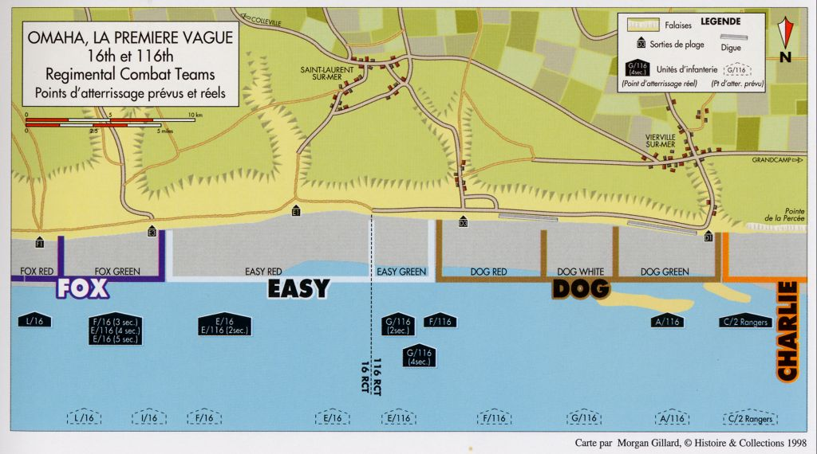 This is a map of the first wave that arrived on the beach during the early attack on Omaha Beach. You can see the divisions and the landing sites and where German soldiers were stationed.
The first wave came under heavy anti-tank fire which sank many of the incoming tank ships for the allies. German machinegun fire wiped out many of the remaining tanks and a vast majority of the first wave of troops. On all sides of the beach tanks were being wiped out thus limiting the cover fire for the allies as they moved up the beaches. After all the fire subsided only 18 of the 48 regiment tanks landed on shore with the first wave. The first wave of soldiers consisting of 1,450 soldiers began moving up the beaches at 0631hrs. As they left the landing crafts they were bombarded with machinegun fire which would wipe out a vast majority of the front line before they even reached the beaches.
Those who reached the beaches had little refuge as there was little to no supporting fire and few bomb craters to hide in against the German gunfire. When compared to the other beaches that were attacked that day, Omaha Beach was the most difficult to land on because of the sheer machinegun force that was focused on the incoming transport boats. The western end of the beach, the Dog Green Company, drew the most intense fire, slaughtering nearly 90% of the soldiers who were coming to shore. The attacking allies realized that there were more German forces then they had originally expected to be defending Omaha Beach.

Unexpected Opposition
The Allied forces knew that the Germans had an advantage on the beaches. They took refuge on the high ground among the cliffs just off the beaches, giving them excellent vantage points for machinegun fire on the incoming allied soldiers. They had built bunkers into the Cliffside as a base for protection and as cover from possible sea and air bombings that could take out their forces.
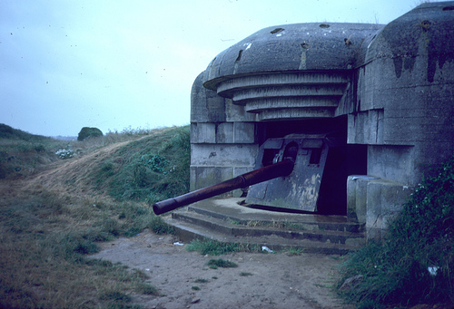
This is a picture of one of the German bunkers located inland from Omaha Beach. The bunkers provided both cover from enemy fire and a safe spot away from the beaches to take out ships with long range fire. When we walked around the area, you could see how some of the bunkers had been reduced to rubble due to enemy fire.

The allies had intelligence stating that the German forces stationed along the beaches of Normandy were all low level soldiers that would not put up much resistance against an allied attack on the beaches. However, unbeknownst to the Americans the Germans has sent divisions of top-rate German soldiers to guard Omaha Beach, making the assault more difficult if not impossible for the incoming allied fighters. With the addition troops that fortified the beaches also came plenty of extra artillery for additional support. The bunkers were built around Bauform 667 anti-tank guns, which were very effective being aimed parallel to the beach.
The Bunkers were built into the cliff sides, thus making them extremely sturdy and well hidden from a distance away. They also had a defensive wall on the side facing the sea, so they could withstand attacks from the warships that the allies had just off the coast of Omaha Beach. The guns themselves were armor plated to they could also withstand ranged attacks and still work well enough to continue the attacks on the beach. In total there were 8 anti-tank gun bunkers, two 88mm guns, three 50mm anti-tank guns, and a few other anti-tank guns scatter around the bluffs overlooking the beach area. This made it near impossible to get any landing crafts to shore to drop off tanks and other armaments for the allies.
Along with larger defenses came nests of machineguns around the base of the beaches in the dugout pits, which provided safe cover and also a vantage point to shoot at incoming allied boats. Along with barbed-wire fences and the possibility of land mines planted in the fields the American troops were caught off guard by the vast size and strength of the German forces that inhabited Omaha Beach. With the higher ground and vast amounts of artillery, the German forces were much stronger then the allied troopers and small band of tanks that made it ashore in the first waves of the D-Day attacks.
The Battle for the Beach

As what remained of the first wave continued to attack the second wave of reinforcements arrived at the beaches between 0700 and 0800hr. Problems arose with navigation, as the tide began to pick up and push the incoming boats off course, landing along the western shores where there was heavy fire which pined them down. As more and more waves of troops began to land, the beaches became very crowded which made it difficult to move up the beaches and into the bluffs to attack the Germans. By 0800hrs. the tide had risen to 8ft. covering many of the obstacles that lay on the beach and drowning many of the severely wounded soldiers that were stranded at the ends of the beach. Around 0900hrs. the American forces were finally able to create a large gap in the German defenses and began the march through the bluffs towards the German bunkers. The casualty rate steadily decreased and the allies were able to increase their numbers along the beach front.
The German bunkers began to take heavy damage and quite a few were destroyed over the course of the day. The picture below is an example of some of the damage that was done to the bunkers that were inland from the beaches.
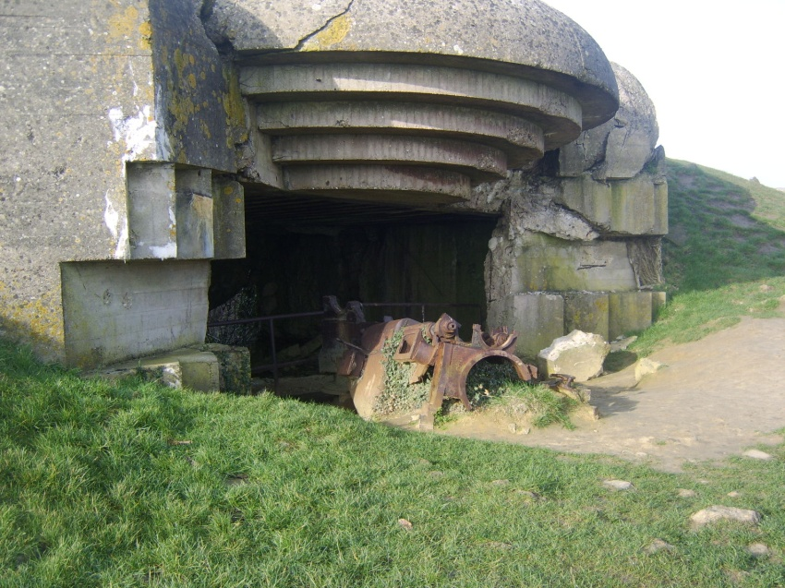
Here is a picture of one of the German bunkers that was inland off the beaches. This shows that the American gunships were still able to have some impact on the battle so far from shore. They were able to take out the heavy German guns that defended against tanks and warships as well.

When we walked along the beaches and saw firsthand the damage that had been done to some of the German bunkers, I was taken aback by the great distances that were reached by the allied warships stationed off shore. The damage that was down would have surely killed almost anyone inside the bunker or trapped them inside as the roof collapsed overtop.
As troops continued to breech the barbed-wire barriers, the remaining tanks were ordered to assault the German fortifications that were still intact, which were wiping out troops with machinegun fire. Engineers were also hard at work clearing the beaches of obstacles and other debris that was preventing the tanks from moving up the lines. The downside of the increased movement up the beach was the slowed movement of landing crafts dropping off troops because of the debris that cluttered the beaches. This chaotic issue would cause a stalemate on the beach for a few hours leaving some companies stranded waiting for more resources to attack the Germans. The Allied destroyers were ordered to continuously fire on the Germans to keep them preoccupied as the allies regrouped and resupplied. When Pointe du-Hoc was finally taken, after allied troops scaled the cliff side to wipe out German bunker resistance, the American troops had an easier time gaining group back at Omaha.
After along afternoon of artillery fire and fighting up the beaches to the bluffs the Americans were finally able to gain a strong position against the Germans who still resided in the beachside bunkers. At 1800hrs. the road to Vierville was finally open and the Germans were completely cut off from resupplying and reinforcements. With other German stronghold falling throughout the afternoon, the Americans had successfully taken Omaha beach after perhaps one of the most difficult beach battles of the war.
The End Result

By the end of D-Day, the American force had a strong hold on Omaha Beach, holding on to about a mile inland. The plan was not a complete success as they were hoping to gain more territory, but it was not a failure either as they were able to push the Germans back. A total of 34,200 allied troops landed on Omaha beach that day, and the number of casualties will never be completely accurate. What is known is that a vast majority of the men were killed or wounded by the incoming machinegun fire that bombarded the landing crafts and also from drowning on the beaches. The performance of the U.S. Navy during the attacks on Omaha Beach has become an example for current attack measure for naval training today.
The German perspective was more pessimistic as they believed the attack would be thwarted during the early morning, with German victory by mid-afternoon. The rate of German causalities is significantly less than those of the Americans, but their losses were substantial none the less. With no reserves in the ranks for the Germans defeat was imminent and so they were forced out of the beaches of Normandy.
The success of D-Day on all fronts was a huge morality boost for the Allied forces as it gave them hope of victory in Europe. This first step was a foothold that would grow over the course of the next few months, culminating in recapturing Paris from Hitler in late 1944 and the move into Germany in 1945. Hitler knew that this loss would cause a change in the tides and he began to lose his grip on his territories. The victory at Omaha Beach was a key factor in the Germans eventual defeat and the end of the second World War.

Works Cited
Zaloga, Steve. D-Day 1944: Omaha Beach. Oxford, Osprey Series ©2003

Thompson, R.W. D-day: Spearhead of the Invasion. Random House Inc. ©1968.

Lewis, Adrian. Omaha Beach: A Flawed Victory. Journal of Military History: June 2006, Vol.70, Iss.3

Personal Journal kept during the trip. Includes documented information seen while in Normandy and pamphlet info. from the beach sites.

