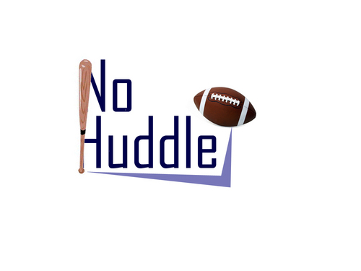
RMU NO HUDDLE
Tuesday and Thursday 10:00pm-11:00pm
Fall 2011- Spring 2012
Website: rmuradio.com
Twitter: https://twitter.com/#!/RMU_NoHuddle
Facebook: http://www.facebook.com/groups/286748878048821/
Hosts:
Chris Cappella (@C_Cappella), Lee Kunkel (@Kunkel5)

Theme:
Sports radio show, covering football, basketball, baseball, hockey, both pro and college.

Guests who have came on show:
Shane P. Hallam (www.draftcountdown.com), Jason McIntyre (thebiglead.com), Andrew Chiappazzi (Rivals.com, ColonialsCorner.com), Andrew Toole (Head Men’s basketball coach for Robert Morris University).

