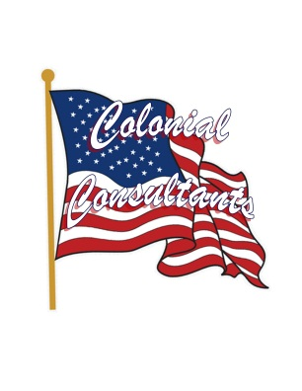
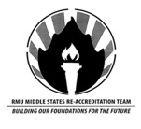

Universities big and small, he is the man to give a call.
Scott Branvold has seen how many universities are to be run. He has taught and gained valuable experience at a wide variety of schools, including large schools like the University of Oklahoma and small schools such as Lewis-Clark State College, Idaho. He has had two stints at Robert Morris University and has served on many boards over the years, specifically in the athletic department. There is no doubt that Branvold was a great asset to have on the Middle States reaccreditation committee, and he was happy to serve. Branvold served under David Majka and Mark Eschenfelder. The committee was part of a process that strengthens and sustains higher education, making it worthy of public confidence and making sure RMU delivers on their message of being a high level institution.
“I learned a lot about other schools, especially about outcomes assessment. I really enjoyed working with other people, and got to know different people who I usually don’t get to interact with here at RMU.” Branvold stated that though RMU is known as a small school, the departments are widely separated, and he usually does not have time to get to know others around the university. This was an opportunity for him to not only get to know others but also learn about different departments at RMU. When asked about how the review process went, Branvold stated that, “I enjoyed the review process a lot. It was an open process in which everyone’s opinion was valued, and that is a good thing. We were able to figure out different ways to better ourselves as a university, and that is the long lasting benefit to this process.”
When asked if he would participate again in the Middle States review process, Branvold said, “Absolutely. I feel it is an obligation. This is a major accreditation and very important to the University. It isn’t a burden, and you learn a lot and get to interact with unique highly accredited people.” Through this process, Scott Branvold was able to learn a lot about how a university is to be run; he certainly is becoming an expert in that field as his experience grows.
Contact:
Lee Kunkel
Public Relations Specialist
717-434-9222
Ltkst2@mail.rmu.edu

“I enjoyed the review process a lot. It was an open process in which everyone’s opinion was valued, and that is a good thing. We were able to figure out different ways to better ourselves as a university, and that is the long lasting benefit to this process.”
