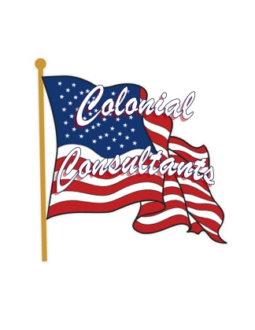
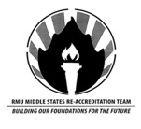

A Great Farewell.
RMU will be losing one of the best faculty members the institution has to offer. Dr. Andrea Frantz has given a lot to Robert Morris University the past few years. She has been asked to do many tasks, and has accomplished almost all of them. She came to Robert Morris because the university needed a Journalism professor, and she was just the person for the job. She had the task of revamping the entire journalism program, and on top of that, she was the head of the RMU Communication department. These tasks were quite time consuming and took a great deal of effort and energy. “I refused to cut back on my teaching schedule. I love to teach, and I came here to be a teacher. My students mean so much to me, and I wasn’t going to cut back on my time spent with them.” Frantz will be moving on in her career but will not forget all she has accomplished at RMU.
Despite all these responsibilities over the years, Frantz decided to assist RMU once more and be a member of the Middle States reaccreditation committee. She was placed on committee seven serving under the guidance of David Hudak and Diane Todd Bucci. “I said I would do anything, I just wanted to help out. I assisted in research and helped with the document development,” said Frantz when asked about her duties. Frantz noted that one great part about the process was the feedback. There were many opportunities for people to have their voice heard, and she really enjoyed working with others. The committee was part of a process that strengthens and sustains higher education, making it worthy of public confidence and making sure RMU delivers on their message of being a high level institution. Her committee was responsible in some research but focused on document development.
Andrea Frantz recently decided that she was going to move back home, and will be leaving for a similar job in Iowa in the coming weeks. She will miss RMU a lot, and noted that it’s her students that she will miss the most. As you can see, Dr Frantz has been a huge part of the success RMU has enjoyed the past few years; after all, there aren’t many people on this campus with a list of accomplishments quite like hers. There is no doubt she will be missed, and everyone is thankful for all she has done for this university.
Contact:
Lee Kunkel
Public Relations Specialist
717-434-9222
Ltkst2@mail.rmu.edu

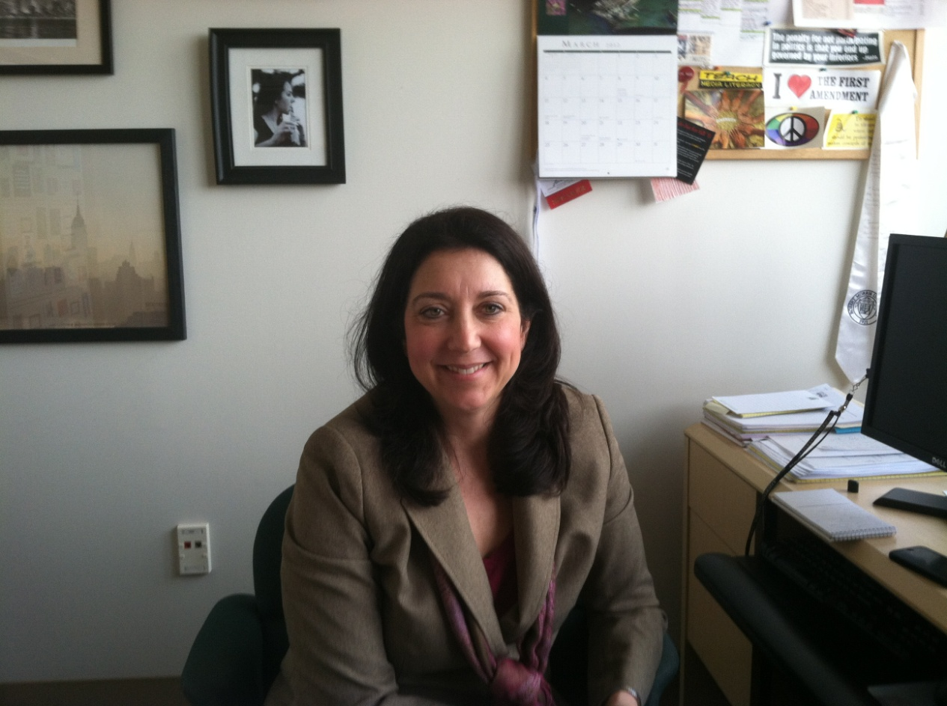
“I said I would do anything, I just wanted to help out. I assisted in research and helped with the document development.”

