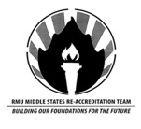
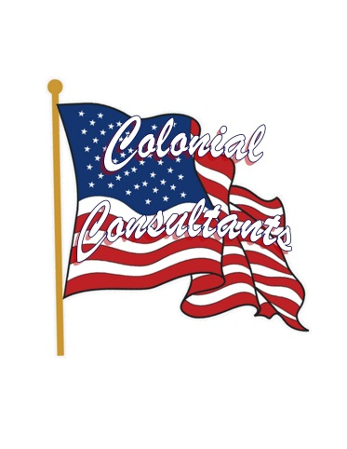

Not your typical student
Heidi Wiedenhofer is not your typical Robert Morris student. She is not only a full time student but a full time employee at RMU’s Island Sports Center as well. She previously taught cosmetology in Pittsburgh when a new opportunity arose. She was given the chance to work and go to school at RMU, and she took full advantage of this unique opportunity. Heidi is on track to graduate with a degree in Communication this spring and will get her degree in only 3 years. She goes to school full time, works full time and still was able to find time to be a part of the Middle States reaccreditation committee. Heidi served under served under David Majka and Mark Eschenfelder. The committee was part of a process that strengthens and sustains higher education, making it worthy of public confidence and making sure RMU delivers on their message of being a high level institution.
Heidi was viewed as an RMU employee for the reaccreditation committee but was able to use her student perspective many times throughout the process. When asked why she chose to be a part of the process with her busy schedule Heidi said, “I wanted to be part of something special. I’ve worked for Middle States on the high school level and I knew I could make a difference here at Robert Morris.” She did a lot of research and focused on getting documents from many different departments throughout RMU.
Heidi noted that teamwork and deadlines were two very important factors during the review process. She loved her group, and said that everyone worked really well together. The toughest part was deadlines. “Some departments were difficult to get information from and when you have a set deadline and you have a lot of information to sift through, you can get really overwhelmed.” She added, “Overall, I loved my experience working for the review committee. I’d do it again in a heartbeat.” Heidi learned a lot throughout this unique process; but hey, she is one unique RMU student, so that’s not too surprising to hear.
Contact:
Lee Kunkel
Public Relations Specialist
717-434-9222
Ltkst2@mail.rmu.edu

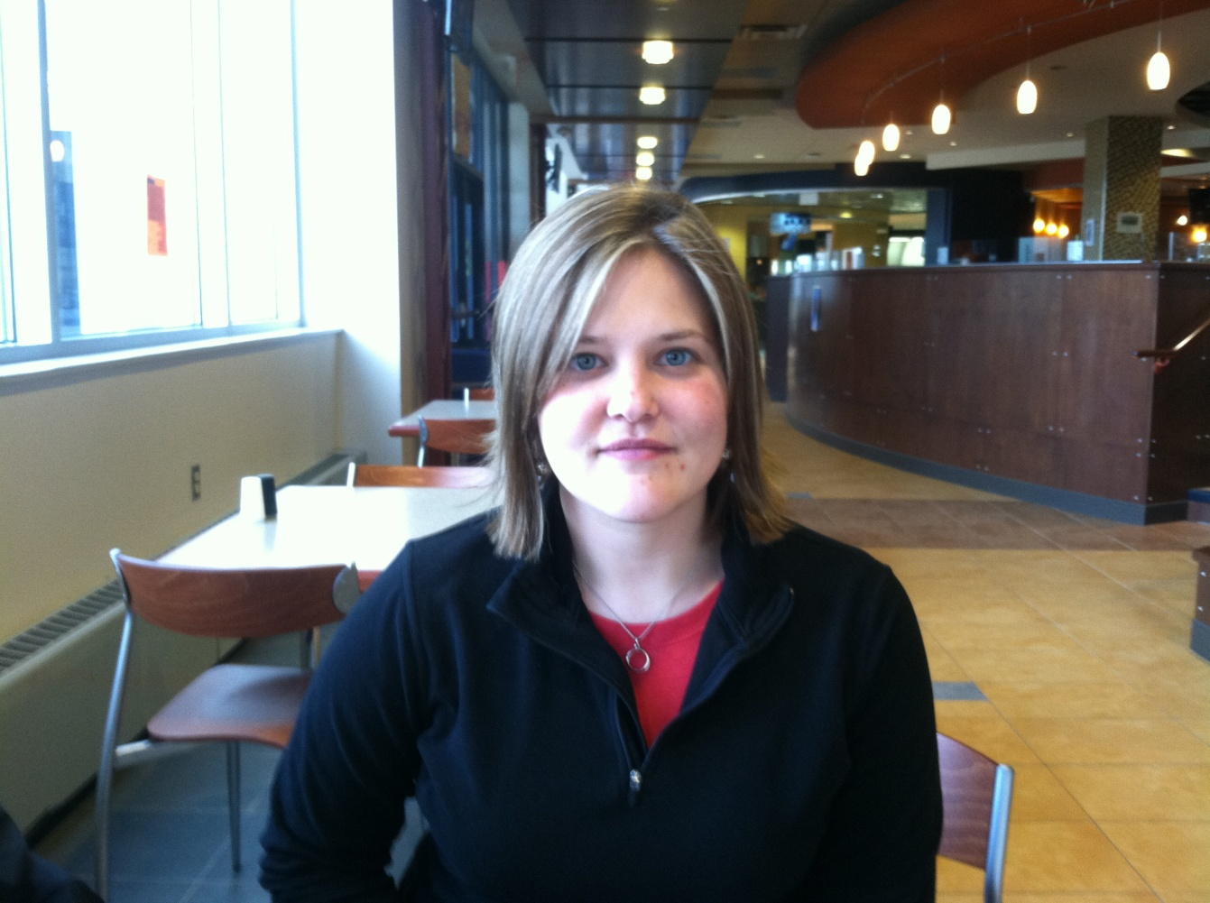
“I wanted to be part of something special. I’ve worked for Middle States on the high school level and I knew I could make a difference here at Robert Morris.”

