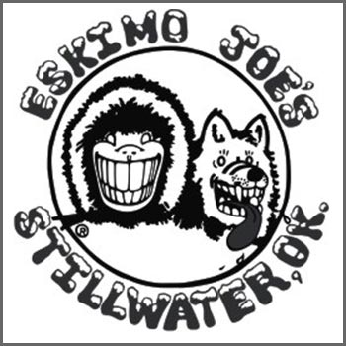

Eskimo Joes
501 W. Elm
Stillwater, Oklahoma 74074
1-800-256-5637

February 24, 2011

Mr. Jack Wilson
Associate Publisher
P.O. Box 1123
Los Angelos, CA 45678

Dear Mr. Wilson:

Eskimo Joe’s is located in Stillwater, Okla., directly in the shadows of Oklahoma State University and is the ultimate hang out location and restaurant of choice for college students in the area. From our classic burgers, to our well-known cheese fries and milkshakes, the food is perfect for post-sports game cravings and Joe’s is the “must visit” staple restaurant to any Stillwater visitor.

Aside from all of this, Eskimo Joes was Voted Best College Post-Game Hangout by Sporting News, ranked #2 in “The Perfect 10 College Sports Bars” by Sports Illustrated and named in Playboy.com’s Top 10 College Sports Bars. The nightlife is the prime aspect of Joes. Through the years we have offered the very best in live entertainment and typically for no cover charge! Our unique layout creates an awesome venue that provides a lot of bird's-eye viewing of your favorite bands in a most intimate setting. We have played host to some of the best talent in our state, our surrounding states, and have even had the privilege of hosting a few national acts.

After reviewing the 2011 Integrated Editorial Calendar for Restaurant News, I think that Eskimo Joes would be a great fit during your featured theme “On-site trends: Colleges and Universities.” I also noticed that Restaurant News was looking for NRN.com coverage onsite including multimedia on college/university late-night dining. Eskimo Joes would be more than willing to allow news coverage and media teams into the restaurant and we would love to promote the news coverage to the university students and have them discuss their experiences and connections to the restaurant. Oklahoma State University and Eskimo Joe’s truly have a unique bond that should be showcased.

I will follow up with you on Thursday, March 3 to see if I might be able to provide information and further discuss details on featuring Eskimo Joes into an upcoming article for Restaurant News. Thank you for your time and consideration. Please do not hesitate to contact me if you have any questions. My phone number is (913) 269-8180 and my e-mail is Rachel.noland@osuagencyteam.com.

Sincerely,

Sarah Brown
Public Relations Director

