Sarah Brown

Strategic Message Planner: Paulie’s Pizza Shoppe

Client and Product:
Paulie’s Pizza Shoppe specializes in gourmet pizza options. Their pizzas are certified organic and appeal to health-conscious consumers.

Paulie’s Pizza Shoppe was founded six months ago by three college students from Oklahoma State University. They created the restaurant to provide a healthy alternative opposed to traditional pizza restaurants in the area. Paulie’s Pizza uses only the most fresh and natural ingredients and locally grown products to ensure the highest quality food for our customers.

The restaurant has a variety of options including traditional toppings, vegetarian, fruit and health-conscious dessert pizzas. The consumer has complete control over their topping selections and amount per pizza.

Each pizza is individually hand designed and thoughtfully made to cater to the customer’s satisfaction.

Target Audience:
The target audience for this ad is health-conscious young adults ages 18-25. These are college-aged students who are always busy and looking for a quick alternative to fast food without the additional calories.

The average age of the target audience is 21.5. Most are concerned about their appearance and body image to others. Its members have a limited disposable income and most are supported by their parents due to being full-time college students.

Product Benefits:
Paulie’s Pizza Shoppe’s pizzas are delicious, healthy and convenient. The restaurant offers many choices and an overall guilt-free way to enjoy pizza. For those with the sweet tooth, our dessert pizzas are a great way to satisfy your cravings without sacrificing the calories.

Current Brand Image:
Paulie’s Pizza Shoppe is a new restaurant, and therefore has little brand image. If any, it is perceived as a trendy college student restaurant.

Desired Brand Image:
Paulie’s Pizza Shoppe is the ultimate upscale pizza lounge for health conscious college students. The restaurant offers delicious and healthy alternatives for college students who desire to live a healthy lifestyle.

Direct Competitors:
Direct competitors are other pizza restaurants in the Stillwater, Oklahoma area.
- Hideaway: The target audience has a positive image of this well-known restaurant. It is centrally located directly neat the campus. However, members of the target audience wish that the meals were more healthy and offered better dessert options without the calories. Hideaway consumers leave the restaurant feeling full and guilty.
- Mazzios, Papa Johns, Cici’s, Little Caesars, Pizza Hut and Dominos: The target audience has a negative perception on these places. They are fast, easy and accessible and at times the target audience indulges in these for their convenience, but it is a last resort.

Indirect Competitors:
Indirect competitors are store-bought pizzas and other fast food or casual dining options. Some of these store-bought pizzas include Tony’s Pizza, Red Baron, Digiorno, Fruschetta, California Pizza Kitchen, Lean Cuisine, etc. Members of the target audience enjoy these on an occasional basis, but do not like the calories. They often do not have time or the resources to accommodate for cooking these items as many live in college dorms or other housing alternatives. They want to stray away from home cooking options and prefer a lounge or restaurant style type of environment.
Advertising Goal:
To convince members of the target audience that Paulie’s Pizza Shoppe is the ultimate trendy and upscale pizza lounge and offers the most healthy choices of pizza to accommodate their on the go lifestyle.

Strategic Message:
Paulie’s Pizza Shoppe offers a great way to satisfy your cravings without sacrificing the calories.

Supporting Benefits:

Feature: Benefit:
Only fresh, natural ingredients Better quality of product
Organic toppings
Locally grown toppings
Reduced calories Healthier lifestyle
Individually crafted pizzas Customer has complete control

Ad Copy:

SATISFY YOUR CRAVINGS WITHOUT SACRIFICING THE CALORIES

Are you looking for a hip pizza place that offers healthy choices for pizzas and desserts?

Look no further!

PAULIE’S PIZZA SHOPPE is the ultimate trendy and upscale pizza lounge that serves the healthiest choices of pizza to accommodate YOUR on the go lifestyle.

Paulie’s Pizza uses only the most fresh and natural ingredients and locally grown products to ensure the highest quality food for our customers.

We have a variety of options including traditional toppings, vegetarian, fruit and health-conscious dessert pizzas.

YOU have the opportunity to DESIGN your own masterpiece and take complete CONTROL of your order.

Paulie’s Pizza Shoppe is conveniently located at 3rd and Knoblock on University Corner.

EAT NOW. You don’t have to wait any longer.

Stop by after a workout or take a study break!

Sketch Layout:

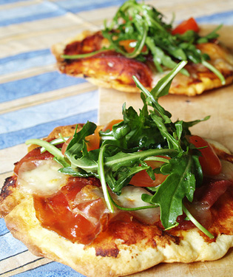
SATISFY YOUR CRAVINGS WITHOUT SACRIFICING THE CALORIES
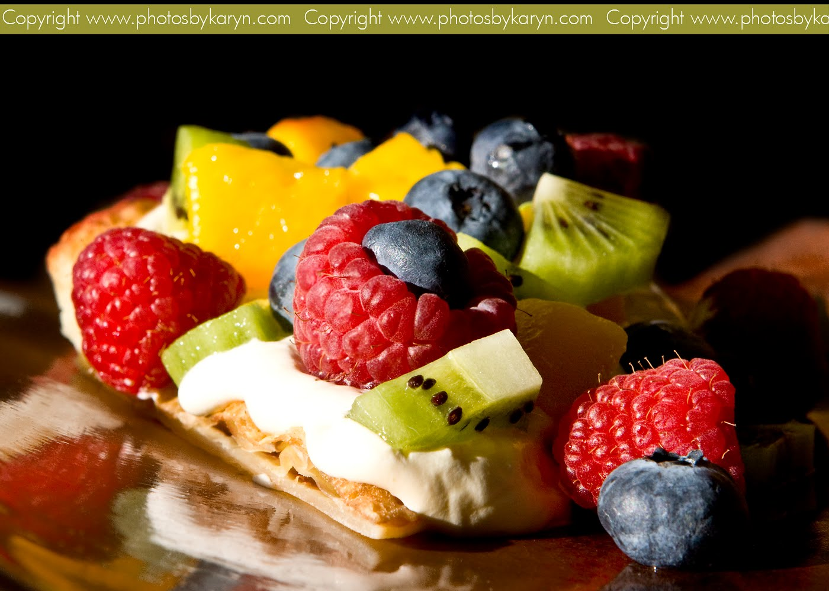

Are you looking for a hip pizza place that offers healthy choices for pizzas and desserts?

Look no further!

PAULIE’S PIZZA SHOPPE is the ultimate trendy and upscale pizza lounge that serves the healthiest choices of pizza to accommodate YOUR on the go lifestyle.

PAULIE’S PIZZA uses only the most fresh and natural ingredients and locally grown products to ensure the highest quality food for our customers.

We have a variety of options including traditional toppings, vegetarian, fruit and health-conscious dessert pizzas.

YOU have the opportunity to DESIGN your own masterpiece and take complete CONTROL of YOUR order.

PAULIE’S PIZZA SHOPPE is conveniently located at 3rd and Knoblock on University Corner.

EAT NOW. You don’t have to wait any longer.

Stop by TODAY after a workout or for a study break.

