Oklahoma State University
Morrill Hall 413
Stillwater, OK 74078

8 April 2010

University Dining Services
470 Student Union
Stillwater, OK 74078

Dear University Dining Services:

We are glad to present you with our plan to construct a small concession stand just north of the Edmon Low library. This project which involves the building of the concession stand also includes: obtaining of necessary equipment, opening and operating the stand, and personnel management. Our project incorporates all of the details that will be needed to begin the initial planning as soon as possible. You will find all of this information in terms of both proposal and PowerPoint presentation which will be gave in class.
Through our use of student surveys and word of mouth, we came to the unanimous conclusion that students want their dining options more evenly spread throughout the Oklahoma State University Stillwater Campus. With more options in more locations, they feel they will have more time to eat during the day without being late for class- this is what our project is striving for.
Although this project might seem like a great task to undertake, we believe that if our plan is followed, all the labor will be well worth the money and time spent building and organizing this new establishment. If you have any questions about our project plan, please don’t hesitate to contact us. You can reach us by email at lezliez@okstate.edu; phillip.chatelain@okstate.edu; john.holman@okstate.edu. We truly appreciate the time you have spent learning about our proposal and we look forward to starting this project right away.

Sincerely,

Lezlie Zucker
Phillip Chatelain
John Holman

Enclosure: Proposal and PowerPoint Presentation

Improvement of Hot Food Options at Oklahoma State University: Establishment of a Centralized Concession Stand on Campus

Phillip Chatelain
Lezlie Zucker
John Holman
Table of Contents

Abstract ii
Introduction 1
Purpose Statement 1
Problems 1
Problem Solution 2
Franchise Selection 2
The Construction of the Building 2
Opening the Business 2
The Hiring and Training Process 2
Cost Analysis 3
Equipment 3
Building 3
Upkeep and Food Supply 3
Employee Costs 3
Vendor 3
Conclusion 4
Appendix A: Contact Information 5
Appendix B: Cost Pie Chart 6
Appendix C: Individual Equipment Costs 7
Appendix D: Location 8
Works Cited (MLA) 9

Abstract
Currently the options for obtaining hot food on campus are very limited. Although cold food can be found in many locations, warm meals are harder to come across. Establishing a short order restaurant on the north side of the library quad would provide a source of hot food easily accessible to everyone. Opening a concession stand at a new location will also decrease the time it currently takes to get a meal. With more eating choices and fewer lines, students and faculty will be able to get their food much faster and still be on time for class. This new business also means more job opportunities available for students. The design and construction of this project can be completed by engineering apprentices, allowing students to become more involved as well as cutting budget costs. All in all, establishing a new short order restaurant at an easily assessable location will not only provide hungry people with hot food, but also provide them with jobs and convenience.

Introduction

Purpose Statement
We are proposing that a stadium-style concession stand be built in the Quad north of the Edmon Low library so that the students of Oklahoma State University have a more accessible option to get hot food during the school day. This project would greatly benefit the university and should make students happier.

Problems
The current locations to get hot food on campus are limited to the Student Union Building and the Kerr-Drummond residence hall. These places are located on opposite sides of the campus of the University and when a student can get to them, the lines are long and inefficient during peak eating hours, especially lunch.
This brings the other point to light, that the locations for a hot meal are too far apart for a student to get something warm in between classes. There are some students who have to go to class for whole days at a time, or through the usual lunch hour, and these people have to either skip lunch or eat too late in the afternoon, which either makes them eat a late dinner or skip dinner altogether. The habit of skipping meals is horrible for the human body, both depriving it of nutrients and making it so that at the next meal they will overeat, and further the cycle of unhealthy behavior. With the current focus on health and weight in the American people, the way that school makes people miss meals because the people are not able to get a meal at an appropriate time during the day.
In a survey conducted by the members of the group, 2 out of every 3 students would like to have a concession stand, like the one that we are proposing, somewhere centrally located on campus for ease of access. The offerings of this stand would be similar to the ones offered by a stadium concession stand, such as hot dogs, nachos, burgers, turkey legs, and various other dry goods and hot foods.
This stand would also bring revenue into the University, which is something that it always needs. The cost of the stand would be much less than the revenue generated by the stand in one semester or perhaps even one month.
The stand would also allow students another employment opportunity in the Stillwater community, and there is definitely a need for jobs in the area. It is difficult to find a job both during the summer and during school. With the extra income generated by these students, they will spend more of it in Stillwater, thus helping the economy out and making Stillwater a little better.

Problem Solution

Franchise Selection
After an assessment of several franchises, we concluded that JARCO offered the most reasonable deal in terms of reliability, equipment, assistance, food variety, training, and start up costs. The following is a summary of our findings on JARCO Industries:
- High quality concessions equipment
- Annual maintenance checks of all equipment, including insurance to replace any equipment which fails.
- Start up cost of $65,000
- On-site employee training upon request
- Fast response time when responding to problems encountered
Franchising with JARCO Industries will make the establishment of this business smoother and provide assistance in the areas addressed above.

The Construction of the Building
Construction of the concession stand will take place as soon as the funds are available for the project. The location will be as mentioned, on the quad north of the Edmon Low Library. The size of the building should be 30 feet x 20 feet as this will provide enough room to both store the equipment and let employees have room to operate it. Sawatzky Construction will be in charge of the construction of the building. This will be a major cost in the project as our estimates show for a 30 feet x 20 feet building costs approximately $95,000. Plans are for the construction of the building to last three to four months and the opening of the stand be several weeks afterward, offering time to set up all the equipment and train new employees how to operate them.

Opening the Business
Once the construction of the building is complete the process of getting the business up and running should begin. Circumstances that must be taken care of prior to opening include: installing equipment, setting up the transaction system, hiring employees, and training employees. JARCO Industries stated they would supply and install all needed equipment needed in order to get the stand fully functional. Because of this, the General Manager will be able to focus more on evaluating possible employee candidates.

The Hiring and Training Process
This on-campus business will provide students easy access to the job; therefore students are preferred candidates for employment. After employment decisions are made, those individuals selected for the job must then be trained on all the equipment. JARCO provides trainers who will provide several learning sessions to the new employees. These training sessions will be mandatory. Following each of them a quiz will be given to assess how well the employee grasped what they have learned. This will allow us to be sure that not only are the employees’ safe, but the customers as well.

Cost Analysis
Because starting a concession stand from the ground-up can be costly, we have included a cost analysis outlining the various items that we will have to account for. Also, Appendix B outlines the distribution of costs among the proposed $250,000 budget. In Appendix C, we have included a list of equipment that we will need to purchase for the stand.
Equipment
The equipment necessary to start a concession stand is not a minor expense. The estimated cost of all of the equipment needed is approximately $19,000 (JARCO: Concession Equipment and Supplies). Included in this number is $10,000 for other miscellaneous supplies that are not included in our beginning list, which includes the items needed for serving, not including ovens and other needed items.
Building
An ideal size for the concession stand is 30 feet x 20 feet. According to an engineering student at Oklahoma State University, the structure of a building this size will cost approximately $95,000. Also included in the building expenses is the cost of running electricity, gas, and water into our stand. This procedure will cost another $8,500, including labor.
Upkeep and Food Supply
To continuously meet our customer’s needs, we will run our business according to supply and demand. Ordering food for the stand must be done at least once or twice a week. The estimated cost of the ongoing food supply is estimated to be $900-$1000 weekly. The upkeep of the building is very important also. The concession stand must be properly cleaned and examined on a regular basis to ensure the highest quality of food to our customers. These cleanings and inspections will run us about $400 a month.
Employee Costs
Hiring student employees will assure that this small business and its employees, are well taken care of. No less than five people must be hired to sufficiently run this concession stand. They must be paid minimum wage- $7.25. This will cost us no less than $1,000 a week. We must also take into consideration the management staff. Hiring one General Manager and one Assistant Manager will cost approximately another $1,250 every week.
Vendor
If an above vendor is selected we will also have to include that company’s franchise cost in our start up budget. Whichever vendor is selected could run us anywhere from $65,000-$85,000.

Conclusion
We created this proposal to fulfill a need on the Oklahoma State University campus. The benefits of this project would far outweigh the negatives, becoming a great asset to the OSU community, as well as the Stillwater community in general, bringing more money from external sources into the local economy. I look forward to working with you on this project, and making OSU, and Stillwater a better place to live.

Appendix A: Contact Information

John Holman  John.holman@okstate.edu  Mechanical Engineering | Lezlie Zucker  lezliez@okstate.edu  Animal Science | Phillip Chatelain  phillip.chatelain@okstate.edu  Computer Science

Appendix B: Cost Pie Chart

Appendix C: Individual Equipment Costs
Equipment needed to start our concession stand, as well as the prices, according to JARCO Industries, is:
- HOT DOG STEAMER 35SSA
Item Code: 35SSA
PRICE: $486.45
- NACHO CHEESE WARMER WITH PUMP
Item Code: 3WLA-P
PRICE: $384.10
- HUMDIFIED WARMER, 16" PIZZA
Item Code: 5551PZ
PRICE: $924.65
- ECONO 14 POPCORN MACHINE
Item Code: 2121
PRICE: $896.81
- PRETZEL DISPLAY MERCHANDISER
Item Code: 16PD-A
PRICE: $598.57
- 5 CU/FT REFRIGERATED MERCHANDISER
Item Code: TGM-5R
PRICE: $630.63

- 36" ELECTRIC CHAR-BROILER
Item Code: 5136CD
PRICE: $2,477.10
- ECONOMY ELECTRIC TWIN POT FRYER, 30 LB, 208 VOLTS
Item Code: 530TED
PRICE: $1,542.15
- DRAWER WARMER, 2 DRAWER-1 CONTROL
Item Code: SDW2
PRICE: $1,763.19

Appendix D: Location
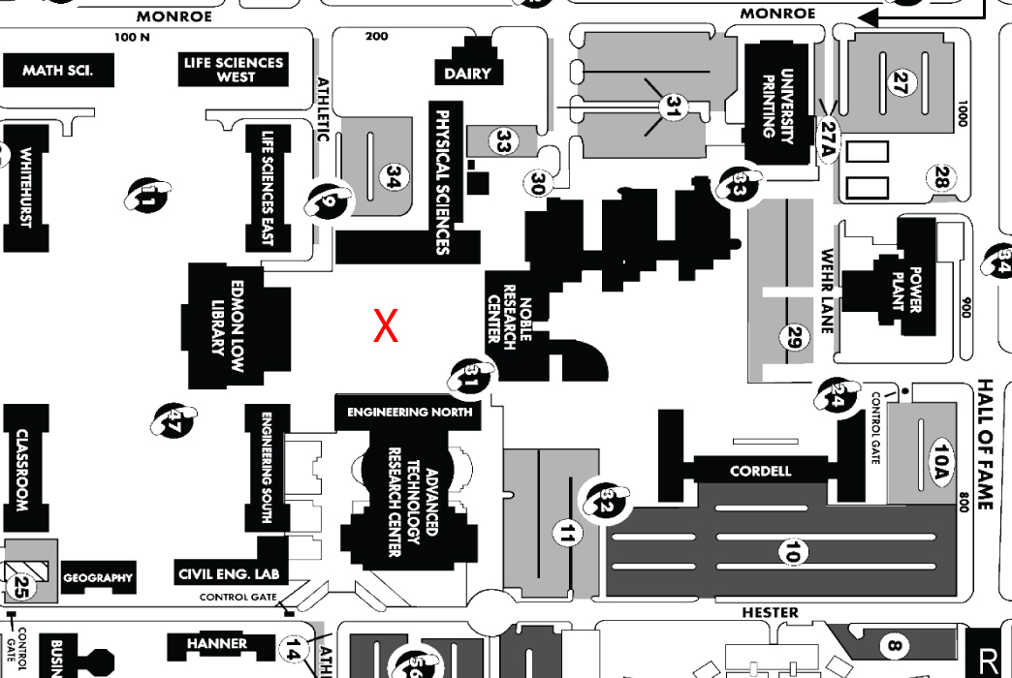

Works Cited (MLA)

“JARCO: Concession Equipment and Supplies.” Welcome to the World’s Concession Equipment Superstore. JARCO Industries. n.d. Web. 28 Mar. 2010. <http://www.concessionstands.com/>.

