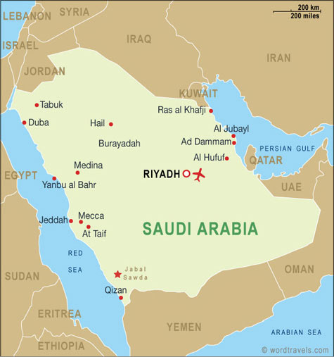
SAUDI ARABIA
BACKGROUND: The Capital of Saudi Arabia is Riyadh. Approximately 26 million people live in Saudi, with 90 percent of them being Arab. The people of Saudi Arabia are 100 percent Islamic and their major language is Arabic. The literacy rate is 79 percent and a person can expect to live around 75 years if they live in Saudi Arabia. Saudi government is a hereditary monarchy. Only 1percent of the land can be sued for agriculture and all employment opportunities are in the cities or in the oil-producing regions. Wahhabism, a strict and puritanical form of Sunni Islam, is a religious movement that is in Saudi. Although there has been some relaxation of the code due to the country’s modernization, it remains the law today. Saudi Arabia’s strict adherence to Islamic law not only imposes harsh punishments for many crimes, but also restricts human rights. Crude oil and petroleum are two major industries of the country and they export $113 billion a year, while only importing $36 billion.
MUSLIMS IN THE NEWS:
- 149 suspected militants were recently arrested from Al Qaeda over the past eight months, including many with ties to Yemen.
- A tip from Saudi intelligence officials to the Obama administration on Oct. 28 that bombs might be on cargo flights prompted officials in the United States and several other countries to begin a frantic search of their planes.
- The Obama administration has agreed to sell Saudi Arabia $60 billion dollar worth of weapons systems, including as many as 84 new F-15 fighter jets and three types of helicopters.
- Saudi Arabia and other Arab governments sided with Israel in urging the U.S. to stop Iran from developing a nuclear bomb, according to U.S. embassy leaked cables.
- King Abdullah, who is 86 years old, just recently had back surgery and the question has arisen over who will take his spot when he dies.
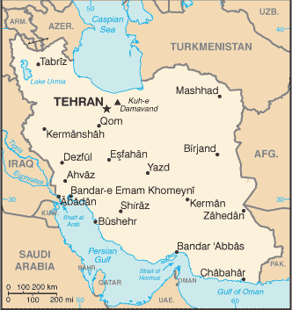
IRAN
BACKGROUND: Teheran is the capital of the rugged country of Iran. The main language is Farsi and 89 percent of the people are Shia Muslim, while 9 percent are Sunni. This is the only country that is mostly Shia. People live about 70 years, the population is 68.9 million and the literacy rate is 80 percent. In 1979 the Islamic Revolution took place. Khumeni was head of the revolution; he got rid of the Shah. Everyone paid Sadaam to fight Khumeni so he didn’t take over the gulf. They fought for eight years and now they are both poor countries. Iran changed its name from Persia because it sounded more European. People from Iran don’t like Arabs. Iran is governed by religious people with no legal parties. Oil is their main source of exports.
MUSLIMS IN THE NEWS:

- On Dec. 5, 2010 suicide bombers killed at least 41 people in Chabahar, Iran, when they attacked a mosque where people marked the eve of a Shiite holy day.
- Iranians convicted for same-sex activities are on death row and awaiting hanging, including several who were minors when arrested.
- The Stuxnet virus, which has attacked Iran’s nuclear facilities and which Israel is suspected of creating, has set back the Islamic Republic’s nuclear program by two years
- An Iranian opposition leader says the U.S. diplomatic cables released by WikiLeaks show Iran is increasingly isolated by neighboring countries that see it as a threat.
- Four international oil-related companies have stopped doing business in Iran, providing evidence that a California effort to economically pressure the Islamic republic is having an effect.
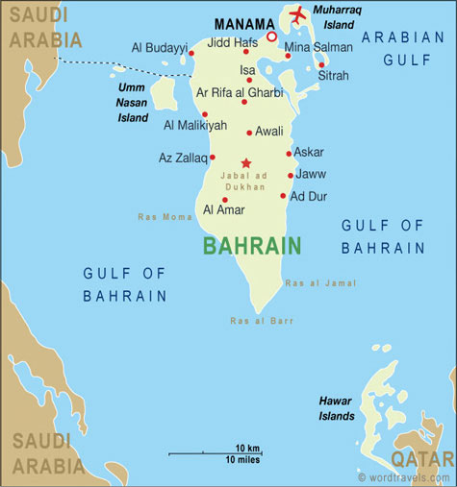
BAHRAIN
BACKGROUND: The capital is Manama and the population is 688,000. The literacy rate is 89 percent and a person can expect to live into their 70’s. Bahrain means two seas. It is the smallest Arab state and it is surrounded by the Gulf of Bahrain and the Persian Gulf. It was one of the first countries to find oil. There is a lot of money in Bahrain, and very few people. The majority of the people are Shia (70 percent) but they are ruled by Sunnis. The Sunnis try to please the Shia so they do not revolt. Governmental authority in Bahrain is defined as hereditary in the Khalifa family. The succession passes from the ruling emperor to his eldest son. Human trafficking is a huge problem. Bahrianians feel they are too rich to work, so Asians come as laborers. Bahrain is trying model the UAE and open up to tourism and international business.
MUSLIMS IN THE NEWS:
- President His Highness Sheikh Khalifa Bin Zayed Al Nahyan has sent a congratulatory cable to His Majesty King Hamad Bin Eisa Al Khalifa of Bahrain, on his country’s National Day.
- Bahrain-based Arab Banking Corporation (ABC) said it has entered into an agreement to acquire a 49 per cent stake in top Libyan bank, Mediterranean for 74 million Libyan Dinars ($60 million).
- December 16 is Bahrain's National Day. Previously a one-day holiday, it was extended to two days in 1999
- Bahrain’s king has made conciliatory noises on the controversial issue of naturalisation in an apparent attempt to placate the archipelago’s majority Shia community.

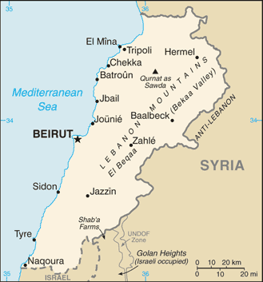
Lebanon
bACKGROUND: beirut is the capital of Lebanon and the population is 3.8 million. 95 percent of the people are Arab and Arabic is the major language. Only 60 percent of the people are Muslim and 30 percent are Christian. Lebanon is located on the East Mediterranean Sea. There is no oil in the country. The citizens get to use free banking and no taxes or tax laws. The literacy rate is 87 percent; number and letters were founded here. After World War I, Lebanon became a French mandate. French gave Lebanon its independence in 1943 but troops stayed until 1946. Today, the president has to be a Meronite Christian because that is what France wants. Olives, Hashish and Salt are the main exports and tourism is the main money maker for this country.
MUSLIMS IN THE NEWS:
- Lebanon sold 1.5 trillion Lebanese pounds ($1 billion) of seven-year government bonds today, its longest maturity for domestic borrowing.
- The Lebanese army said it found espionage devices including cameras that were planted by Israel in Lebanon’s mountains.
- Sunni leaders from opposite ends of Lebanon's political spectrum urged supporters to stand firm against the Shiite group Hezbollah.
- Saudi Arabia proposed an “Arab army” should be deployed in Lebanon, with US air and naval cover.
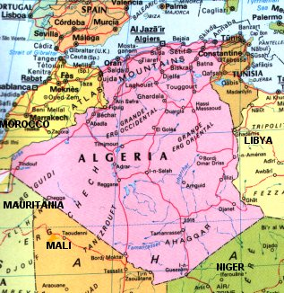
ALGERIA
BACKGROUND: The capital is Algiers and the population is 32 million. The life expectancy is 70 years and the adult literacy rate is 62 percent. 99 percent are Arab-Berber and 99 percent are Sunni, while 1percent is Shia Muslim, Christian and Jewish. Muslim is the state religion. Algeria is in North Africa and has problems with soil and water pollution. Much of the country is the Sahara Desert. On July 5, 1962 a treaty was signed with France and Algeria was an independent nation for the first time in history. Many educated people moved to France after the war. Arabic and French are the two major languages spoken in Algeria. 34 percent of the population is unemployed and they rely on oil, gas, iron and agriculture as their major exports.
MUSLIMS IN THE NEWS:
- Algeria, which acts as a defender of self-determination, does not hesitate to violate the basic rights of its own people and the Moroccan people held captive in Western Sahara Separatists Camps in Tindouf.
- The Algerian government is undertaking an aggressive new renewable energy development plan.
- A Catholic church that has been a landmark in Algeria's capital for over a century officially re-opened after restoration work, providing a symbol of religious tolerance in the mainly Muslim country.
- 50 Muslim extremists tried to prevent a congregation of Christian converts from holding a Christmas service in the city of Tizi-Ouzou.
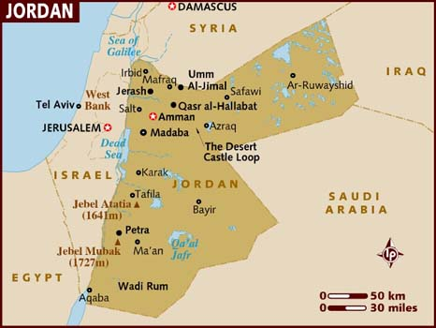
JORDAN
BACKGROUND: Amman is the capital and the population is almost 6 million. Arabic is the main language and 98 percent of the people are Arab. 92 percent are Sunni Muslim and 6 percent are Christians. The literacy rate is 91percent and the average life expectancy is up to 80 years. Jordan is divided into 12 provinces and shares the salty Dead Sea with Israel. People generally leave Jordan because it is such a small, poor place. Jordan is also known as The Hashimite Kingdom of Jordan, which means blood of the prophet. Abdullah was given the Transjordan Territory by the British after a revolt against the Ottomans. On July 20, 1951 He was assassinated with his grandson Hussein at his side. Queen Rania, a Palestinian, is an advocate for woman’s rights in Jordan. Olives, fruit, tomatoes, oat, barley, phosphate and petroleum are exports and Jordan heavily relies on exported labor for income.
MUSLIMS IN THE NEWS:
- The Jordanian government said that a fatwa issued by the Islamist opposition barring Muslims from assisting US and NATO troops in Afghanistan was "offensive."
- Jordan says its peacekeeping mission to Afghanistan is meant to help fellow Muslims rather than the American military, in response to opposition criticism.
- A majority favor changing current laws to allow stoning as a punishment for adultery, hand amputation for theft and death for those who convert from Islam to another religion.
- Jordan enlists mass prayer to try to ease its water problem

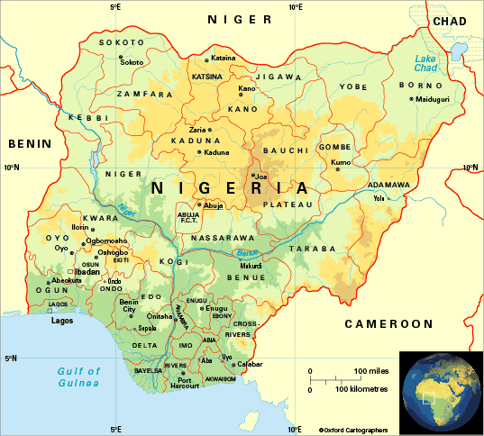
NIGERIA
BACKGROUND: The capital is Abuja and the population is 137million. English is the official language. The country is split with 50 percent Muslims and 50 percent Christians; 95 percent are Sunni Muslim. The literacy rate is 68percent and 52 years is the life expectancy. Nigeria is the most populated country in Africa and 8th in the world. 5.06 percent of the population has HIV/AIDS. They are the largest exporter of oil in Africa, while also producing cocoa, rubber, steel and petroleum. There is extreme inequality between the rich and the poor. Nigeria has the largest African economy but is the most impoverished country. Christians are heavy in the south and do not want Shariah Law.
MUSLIMS IN THE NEWS:
- Prosecutors accused Mr. Abdulmutallab, the 23-year-old son of one of Nigeria's richest men, of detonating an explosive device in his underwear on a Dec. 25, 2009, flight from Amsterdam to Detroit.
- Nigeria's anti-corruption police have dropped charges against Dick Cheney over a multi-million dollar bribery case.
- Nigeria's military has said 14 people, including eight soldiers and six civilians, were killed during a recent operation in a village in the main oil-producing region targeting a notorious gang leader.
- Christians have been killed for their faith by Muslim terrorists
TURKEY
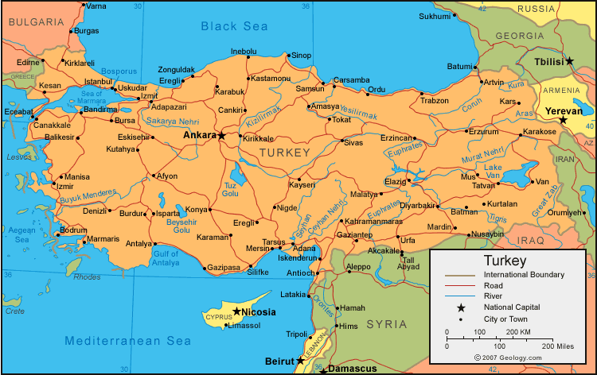
BACKGROUND: The capital of Turkey is Ankara and the population is 70 million. A person can expect to live around 70 years in Turkey and the literacy rate is 87 percent. The major languages are Turkish, Kurdish and Arabic. The Turkish language is simple and based on phonetics. Kemal Ataturk, who was perfect -especially in math- made the Turkish language. Turkey is between two large bodies of water- the Black Sea and the Mediterranean Sea. It is hot and dry with wet coastal winters and is the only country in which a man can only have one wife. 99% are Muslim, most being Sunni. They are a secular country so there is no Shariah Law. Turkey is becoming powerful because they have built more than 16 dams to stop the water flow to other countries such as Syria and Iraq. The PKK is a Kurdish organization the revolts against Turks and kills them all the time.
MUSLIMS IN THE NEWS:
- Despite its long-standing secular leanings, predominantly Sunni Muslim Turkey has been experiencing an upswing in religious violence aimed at non-Muslims
- Turkey and Croatia made a joint decision to increase business and trade relations during the Turkish-Croatian Business Council, held in Istanbul.
- Turkey seeks to improve trade relations with Nigeria
- Turkey is not deaf to discrimination against Roma people and their problems.

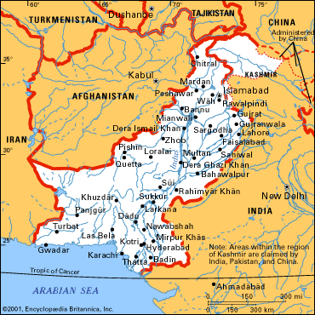
PAKISTAN
BACKGROUND: The capital of Pakistan is Islamabad. The population is about 160,000,000 people, most of which are in the north, and the life expectancy is 62 years. The literacy rate is 46 percent and the infant mortality rate is 75 in every 1,000 live births. 97 percent of the people are Muslim, with a vast majority being Sunni Muslim. Punjabi is the leading ethnic makeup with 63 percent, as well as the major language. The “stan” in Pakistan means “land of the pure”. The country is subject to flooding. Pakistan is the Muslim refuge for India, and the Pakistani people fear India. Pakistan celebrates the birthday of the nuke because they feel if they didn’t have it, india would have already taken them over. The two countries fight over Kashmir. Pakistan rules the Northwest portion, while India rules the South-central portion. Both countries constantly threaten to use nukes on each other and Pakistanis are almost always the terrorists in India. Pakistan is very poor, yet spends a lot of money on its military. Although Pakistan is a very religious country, for the past 60 years it has been in a continuous state of war.
MUSLIMS IN THE NEWS:
- A Christian girl that was raped by a Muslim fears retribution
- A Christian wife and mother, the woman commonly known as Asia Bibi was convicted by a district court last month of blaspheming the Prophet Muhammad. The punishment is mandatory death and Asia Bibi became the first female in Pakistan to be sentenced to hang for blasphemy.
- A suicide attacker drove a vehicle packed with explosives into a hospital for Shiite Muslims.

ERITREA
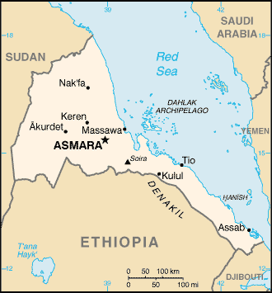
BACKGROUND: Eritrea has about 5.7 million people and the capital is Asmara. It is located in the African Horn where Islam flourished under the rule of the Italians. 50 percent of the population is Muslim. The two dominant religions are Islam and Christianity. The Tigrinya people make up about 80 percent of the population. Many languages are spoken in Eritrea today and there is no official one, however Tigrinya and Arabic are the two predominant ones. The East and Northeast part of the country is surrounded by the Red Sea. Eritrea’s relationships with its neighbors have been strained due to a series of wars and disputes. The country used to support a large elephant population but the wars have killed many of them out. 80 percent of the population is involved in farming and herding.
MUSLIMS IN THE NEWS:
- The US Embassy yesterday said 16 refugees from Eritrea, Sudan and Somalia left Malta to begin a new life in the US
- Pope Benedict XVI urged an end to the plight of dozens of migrants, mainly from Eritrea, believed to be held hostage by human traffickers, along the Egypt-Israel border.
- Vatican Radio reported that between 200 and 600 men and women refugees from Eritrea, Ethiopia and Sudan are being held in chains, tortured, beaten and threatened with being traded to organ traffickers.
- The EDA stated that Eritreans should have the right of religious freedom, including the right of Muslims to practice Sharia Law in Muslim-populated regions.

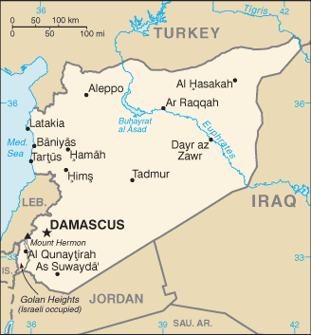
SYRIA
BACKGROUND: The capital of Syria is Damascus. The population is about 18,448,000 people, plus another 20,000 living in the Israeli-occupied Golan Heights (Druze). The major languages are Arabic, Kurdish and various minority languages. There is an 80 percent literacy rate; 90 percent of the people are Arab and 10 percent Kurd and Armenian. The major religion is Sunni Muslim with 74 percent. 16 percent are Alawite, Druze and other Muslim sects, while 10 percent are Christian and Jewish. The Euphrates River runs through Syria, the Tigris is at the top and the Mediterranean is to the left of the country. Syria was part of the Ottoman Empire up until World War II. They united with Egypt from 1940-1961. They produce mainly oil and petroleum and 30 percent of their exports go to Iraq. Syria has a dictorial government and once you turn 18 you must spend at least 30 months in the military. There has been an ongoing fight between Israel and Syria over the land of Golan Heights. Since 1967 it has been Israels. Many refugees are in Syria and human trafficking is a huge problem. Everyone goes to school for free in Syria because it is a socialist country. The Ba’th Party began in the 1940s as a political party dedicated to Arab unity. In 1982 the people of Hamah thought the president was not Muslim but Alawite and since then there has been no trouble with the Alawites in Syria.
MUSLIMS IN THE NEWS:
- A popular Islamic singer accused of working for a terrorist organization was sentenced to 12 months and one day in prison today after pleading guilty to charges that he lied to the FBI and immigration authorities.
- Rain and snow which swept many Syrian governorates, especially Damascus, inspired a general atmosphere of joy and optimism about a blissful season after a long-time shortage of rain that lasted for several years.

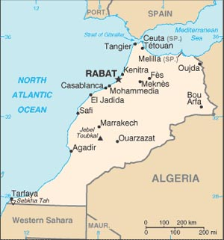
MOROCCO
BACKGROUND: The capital of Morocco is Rabat and the population is about 31 million people. The major language is Arabic with different Berber dialects and French. The Major ethnic backgrounds are 64% Arab, 35% Berber and 1% other. The major religion is Sunni Muslim at 99%, with only 1% being Christian and Jews. Many suicide bombers kill Jews every day. The literacy rate is only at about 44% and life expectancy is around 70 years old. Morocco was at one time occupied by the French and became independent in 1956. The country has a high child labor percentage and bad debt. Phosphate rock is the top export in the Mediterranean/desert climate. The dynasty traces itself back to the Prophet Muhammad. There is a huge mosque in Casa Blanca.
MUSLIMS IN THE NEWS:
- Morocco is fully committed to supporting Sierra Leone's post-conflict national reconstruction process, institutional stability and democratization.
- Since 2008, global malaria control efforts have helped reduce the disease, but a slowdown in funding risks is undoing those achievements.
- Women are starting to stand up and rise to the challenges that the modern world brings.
- The Abu Dhabi Fund for Development is funding a Dh367.3 million high-speed railway project in Morocco in line with its drive to support infrastructure projects in developing countries.

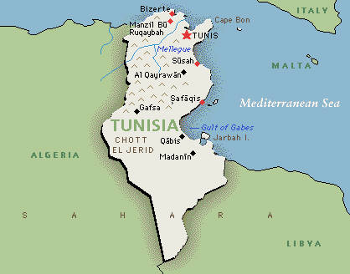
TUNISIA
BACKGROUND: The capital of Tunisia is Tunis and the population is almost 10 million people. The major languages of the country are Arabic and French. The Ethnic makeup is 98% Arab-Berber and 2% others. 98% of the people of Tunisia are Muslim and 1% Christian. Barely 1% of the population is Jewish. The life expectancy is 73 years and the literacy rate of the country is 71%. There are many ruins in Tunisia and it is a beautiful country along the Mediterranean Sea. The country has great French influence. Carthage is a great Roman ruin. The theater there is lovely and is lit by candles for the entire month of August. Arab armies brought Islam to the Tunisia in the late seventh century. The country does not follow Sharia Law. The campaign against Islamic fundamentalists has significantly reduced the civil rights normally observed in Tunisia. Foreign travel is routinely restricted and passports are randomly confiscated. Journalists are also sometimes arrested for articles that defame the country.
MUSLIMS IN THE NEWS:
- Tunisia and Mauritania have signed a security accord, marking new cooperation in the North African region where an al-Qaida affiliate is known to operate.
- Tunisia is planning a gradual liberalization of wheat and barley imports, which are now subject to a state monopoly.
- Olive oil exports are expected to fall 31.3 percent in this season but will draw on its stocks to boost its exports by 15 percent.
- Tunisian Electricity and Gas Company (STEG) and the European Investment Bank (EIB) signed a financing agreement amounting to 194 million Euro for the implementation of a Combined Cycle power plant.
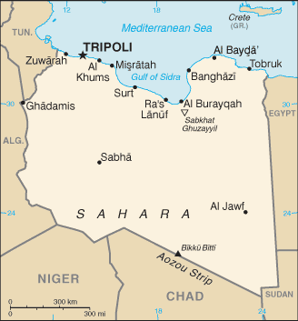
LIBYA
BACKGROUND: The capital of Libya is Tripoli and the population is about 5 million people. The major languages are Arabic, English and Italian. The major ethnic backgrounds are 97% Berber and Arab and 3% others. The major religion is Sunni Muslim with 97%. A person can expect to live about 75 years in Libya, while the literacy rate is 76%. The country was once occupied by the Italian government. The northern part of the country is a beautiful Mediterranean climate, while the southern part is covered in desert- primarily the Sahara Desert. Libya exports more than it imports and its primary trading partners are Italy, Germany and Tunisia. While Libya currently has normal relations with Europe, the United States continues to insist that the country is a sponsor of global terrorism. Libya’s government is a Jamahiriyya, which means a state belonging to the people. The General People’s Congress has the responsibility for passing laws and appointing a government. In 1994 the GPC approved legislation making Islamic law applicable in the country.
MUSLIMS IN THE NEWS:
- Libyan leader Muammar Gaddafi’s attempt to convert dozens of young women to Islam during a visit to Italy led to an angry reaction from Italian media.
- Leader Colonel Muammar Gaddafi has demanded 4 billion pounds to stop Europe from turning black. The dictator warned that the EU could be swamped by Muslims unless Africa gets the cash to tackle illegal immigration.
- Muammar Gaddafi called for a holy war against the Swiss.
- Several months after the leaders of the Libyan Islamic Fighting Group (LIFG) issued corrective studies delegitimizing the killing of civilians under the pretext of jihad, al-Qaeda leaders have still not issued a response to what appears to be one of the most serious challenges to their ideology to date.

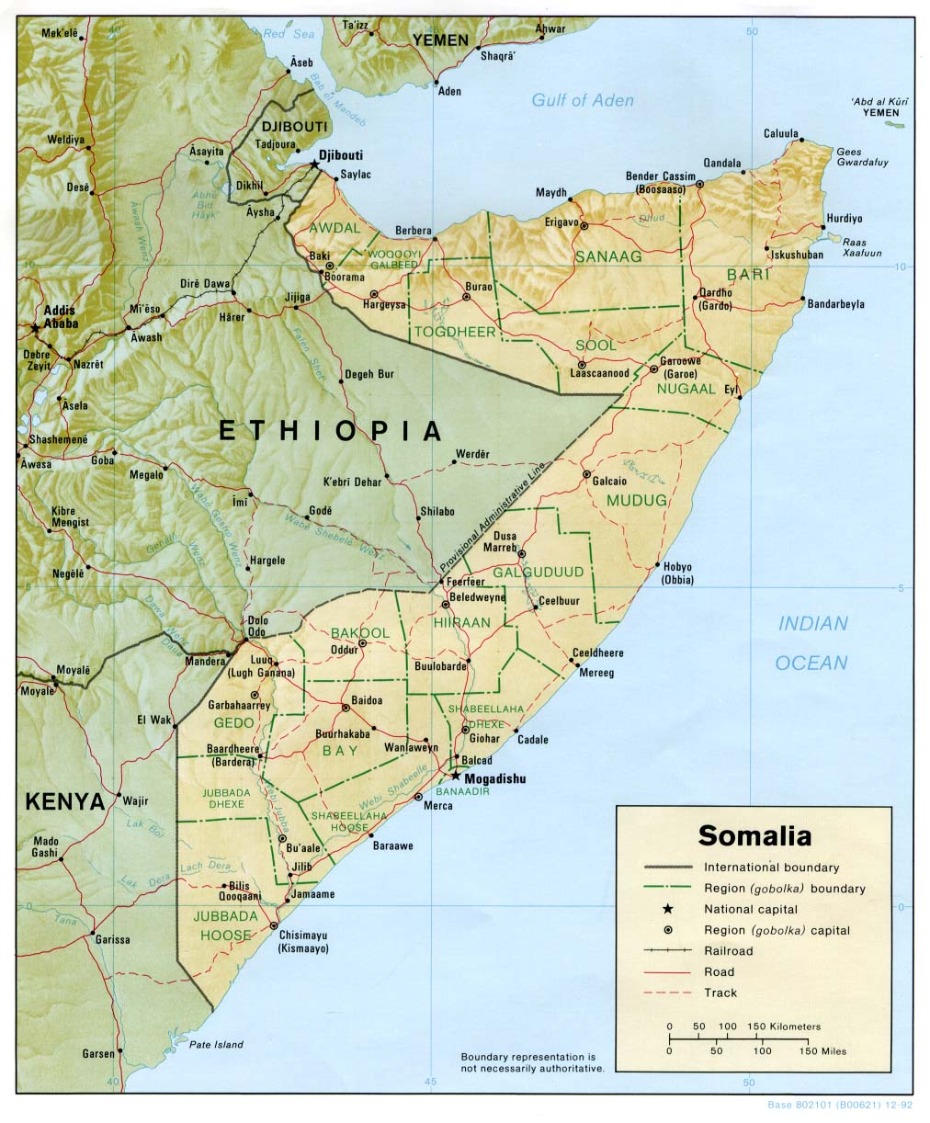
SOMALIA
BACKGROUND: The capital is Mogadishu and the population is about 8 million people. Somalia borders the Indian Ocean in North East Africa. The major languages are Somali, Arabic, Italian and English. The ethnic makeup is 85% Somali, Bantu and Arab, and the Religion is Sunni Muslim. The life expectancy is only 46 years old and the literacy rate is 38%. Most of the people in the country are poor and uneducated. There is also much famine that takes place in Somalia and the country basically lives on donations from other countries. Somalia also has universal suffrage at the age of 18 and is commonly known for having pirates. There is a small United Nations presence in the country. Most development projects have ended in Somalia and the material and infrastructure of the country has largely been destroyed by war and neglect- although some local rebuilding efforts are underway in the more peaceful central and northern parts of the country. In 1996, the European Union agreed to finance the reconstruction of the port of Berbera.
MUSLIMS IN THE NEWS:
- Somalia denied it suspended the work of international aid agencies, a day after the Water, Energy and Mining Ministry said it barred groups including the United Nations Children’s Fund for failing to attend a meeting.
- A chemical tanker operated by a Japanese company was shot at in the Gulf of Aden off Somalia, with two of its 21 crew members sustaining minor injuries.
- Reports from a village in southern Somalia say that Hizbul Islam fighters deserted parts of that region overnight.
- All 26 people on a Bangladeshi ship hijacked by Somali pirates last week were unharmed but confined on board with the vessel now anchored off shore.

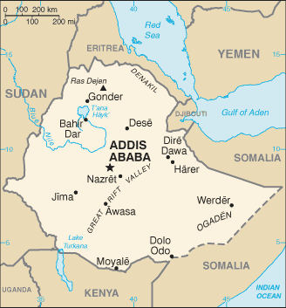
ETHIOPIA
BACKGROUND: The capital of Ethiopia is Addis Ababa and the population is over 85.2 million people. The life expectancy is about 55 years old and the HIV/AIDS rate is 2.1%. The two major ethnic groups are Oromo 34.5% and Amara 26.9%, and the most wide-spread religions are Orthodox 43.5%, Muslim 33.9%, Protestant 18.6%, traditional 2.6%, Catholic 0.7%. The most widely practiced religions are Amarigna 32.7% and Oromigna 31.6%. Arabic and English are also known official languages. Ethiopia is a landlocked country located in the Horn of Africa and is officially known as the Federal Democratic Republic of Ethiopia. Islam is second to Christianity in Ethiopia and there is 42% literacy. The per capita of the country is $900. There are many rivers in the country but no large bodies of water. Ethiopia's poverty-stricken economy is based on agriculture, accounting for about 45% of GDP, and 85% of total employment. The agricultural sector suffers from frequent drought and poor cultivation practices. Coffee is critical to the Ethiopian economy with exports of some $350 million in 2006, but historically low prices have seen many farmers switching to qat to supplement income.
MUSLIMS IN THE NEWS:
- The US-based human rights group International Christian Concern (ICC) has learned a mob of 300 Muslims killed six Christians in early October while 15 others were left seriously wounded by the attack during a midnight worship service in Beshasha, a town located in the Agaro province.
- On Aug. 21, Mohamed Ali Garas, a prominent Somali church leader and convert from Islam, was beaten by Muslims in Addis Ababa, Ethiopia, according to International Christian Concern.
- Mekelle University has dismissed three of its Muslim students. The three were found guilty of possessing and reading of the Holy Quran.

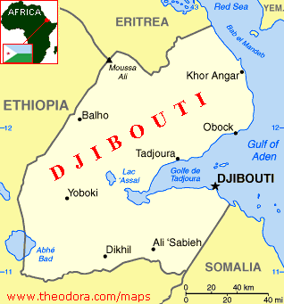
DJIBOUTI
BACKGROUND: The capital of Djibouti is Djibouti and there is about 466,000 people living in the country. The major languages are French, Arabic, Somali, and Afar. The ethnic makeup of the people is 60% Issa/Somali, 35% Afar, 5% French, Arab, Ehtiopian and Italian. The major religions are 94% Muslim and 6% Christian. The life expectancy in Djibouti is about 51 years old and the HIV/AIDS rate is very high at almost 12%. Only about 46 of the population are literate. Djibouti is a small country in North East Africa at the mouth of the Red Sea that has about a 50% unemployment rate. The country was at one time occupied by the French. The country imports many more good than are being exported. Recent discoveries of natural gas reserves in Djibouti could result in a surplus for export. A number of small-scale irrigation schemes have also been established. There is also a small, growing fishing industry.
MUSLIMS IN THE NEWS:
- The Foreign Minister of Djibouti, in talks with the US Embassy, called President Issaias Afwerki of neighboring Eritrea "a lunatic".
- A chance encounter last weekend in a Djibouti port with António Guterres, head of the UN refugee agency, may have saved the life of a 14-year-old Ethiopian called Ahmed.
- A Pune-based company, Mailhem Engineers, has proposed a solution to the Republic of Djibouti for its bio-waste and energy related issues.

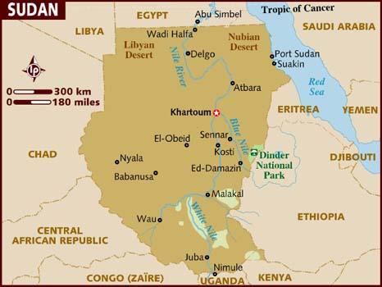
SUDAN
BACKGROUND: The capital of Sudan is Khartoum and the population is 39 million people. The major languages are Arabic and Sudanic and the ethnic makeup of the people are 52% blacks, 39% Arabs, and 6% Beja. The major religions that are being practiced are Sunni Muslim at 70%, especially in the North, 25% indigenous beliefs, and 5% Christian. The life expectancy is 57 years old and the literacy rate is only at 46%. Sudan is a country of slavery and the HIV/AIDS rate is very high. Genocide in Darfur is an on-going human rights crisis but the United States doesn’t really care for Sudan because we do not have any oil investments there. The current regime rules through massive repression. In 1992 Africa Watch accused it of practicing genocide against the Nuba people. Elsewhere, tales of massacres, forced relocations, enslavement, torture, and starvation are commonplace. The insurgent groups have also been responsible for numerous atrocities.
MUSLIMS IN THE NEWS:
- A Sudanese Muslim woman was publicly whipped for wearing trousers under her Islamic clothing.
- On 9 January 2011 the people of Southern Sudan will vote to decide their future. The referendum will decide whether the animist and Christian South and will gain independence or remain as a united Sudan with the Muslim and Arab North.
- A Sudanese court convicted seven men of indecency after police accused them of wearing makeup during a fashion show in Khartoum during the Sudanese Next Top Model Fashion Show.
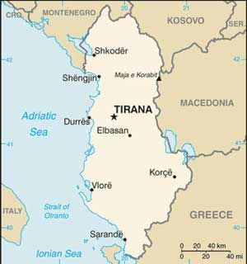
ALBANIA
BACKGROUND: The capital of Albania is Tirana and the population is 3.5 million. The major languages are Albanian and Greek and the ethnic makeup is 95% Albania, 5% Greek, Vlach, Romani and Bulgarian. The three major religions are 70% Muslim, 205 Albanian and 10% Catholic. A person in Albania can expect to live about 75 years and the literacy rate is high at 93% as the result of socialism. Once ruled by Italy, Albania has had a dictatorship in the past and is now under the socialist party/democratic. In the past, Albania and Kosovo have had many conflicts. 58% of the country’s labor is agriculture with a wide-range of temperate zone crops and livestock. Despite being a poor country, Albania sent 70 troops to aid America in Iraq. Twenty-five percent of the Albania population lives on the poverty line, with less than $3 a day. Water and electricity remain scarce and a massive grey economy is run by organized crime. Corruption and personal insecurity are pervasive and seemingly intractable problems to resolve despite encouragement and assistance from the EU.
MUSLIMS IN THE NEWS:
- Albanian Muslims risk their own lives to save Jews from Nazis during World War II

Albania, the Muslim World's Most Pro-American State

New Mosque Plan Catches Albania Muslims Off Guard
- The EU decided unanimously last month to end visa requirements for Bosnian and Albanian residents, but have warned the measure could be scrapped if it is abused for bogus asylum claims and illegal work.

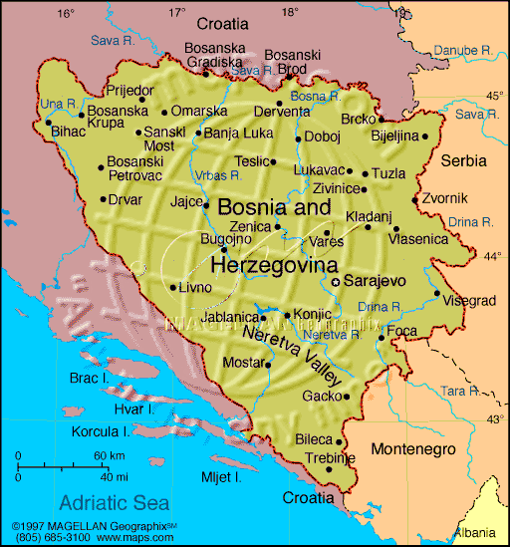
BOSNIA
BACKGROUND: The capital is Sarajevo and the population is about 4.6 million. A person in Bosnia can expect to live about 75 years and the chances of being literate are 97%. HIV/AIDS is very low at less than .1%. Bosnia is located in Southern Europe in the Balkan Peninsula. The ethnic groups are: Bosniak 48%, Serb 37.1% and Croat 14.3%. The term Bosniak has replaced Muslim as an ethnic term in part to avoid confusion with the religious term Muslim - an adherent of Islam. The religious practices in Bosnia are Muslim 40%, Orthodox 31%, Roman Catholic 15% and all others are 14%. The official languages are Bosnian and Croatian. The interethnic warfare in Bosnia and Herzegovina caused production to plummet by 80% from 1992 to 1995 and unemployment to soar. Parents may enroll their children in private schools for religious reasons. In Sarajevo, Tuzla, Travnik, Visoko, Mostar, and Bihac, Muslim students may attend madrassahs. These Islamic secondary schools provide training for students who want to become religious officials as well as general education to prepare students for university studies. There is one Serb Orthodox secondary school in Foca.
MUSLIMS IN THE NEWS:
- A Bosnian Serb lied on immigration forms about his role in a police unit that took part in a massacre of 8,000 Bosnian Muslims, U.S. prosecutors allege.
- Angelina Jolie is directing a film script she wrote about the relationship between a Serbian man and a Muslim woman set on the brink of the 1992-1995 war in Bosnia. More than controversy, she will most likely offend Serbs, Muslims and all Bosnians.
- Senior U.S. diplomat Richard Holbrooke won posthumous praise in Bosnia for brokering the Dayton treaty that ended its 1992-95 war -- even if peace since then has not been all that many had hoped for.

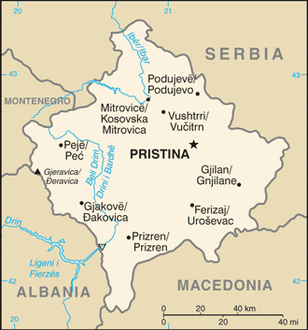
KOSOVO
BACKGROUND: The capital of Kosovo is Pristina and the population is approximately 1.8 million. The ethnic groups are Albanians 92% and all others (Serb, Bosniak, Gorani, Roma, Turk, Ashkali, Egyptian) 8%. The religions are Muslim, Serbian Orthodox, Roman Catholic, and the languages are Albanian, Serbian, Bosnian, Turkish, Roma. The literacy rate is 92% and most of the population is between the ages of 15-64. Over the past few years Kosovo's economy has shown significant progress in transitioning to a market-based system and maintaining macroeconomic stability, but it is still highly dependent on the international community and the diaspora for financial and technical assistance. Kosovo's citizens are the poorest in Europe with an average annual per capita income of only $2,500. Unemployment, around 40% of the population, is a significant problem that encourages outward migration and black market activity. Most of Kosovo's population lives in rural towns outside of the capital, Pristina.
MUSLIMS IN THE NEWS:
- The prime minister of Kosovo is accused of leading a clan of criminal entrepreneurs who presided over an organ-trafficking network that extracted kidneys from Serbian prisoners executed during the Kosovo conflict in 1999.
- Russia is deeply concerned over the information on Kosovo leadership’s alleged involvement in crimes against humanity.
- The December 13 election in Kosovo's Serb enclaves prompted the participation of more parties than in the previous vote, as well as fist fights at polling stations.

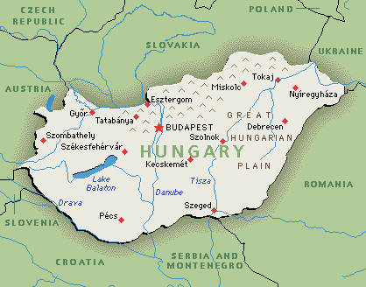
HUNGARY
BACKGROUND: The capital of Hungary is Budapest and the population is almost 10 million people. The ethnic groups are Hungarian 92.3% and Roma 1.9%. The practiced religions are Roman Catholic 51.9%, Calvinist 15.9%, Lutheran 3% and Greek Catholic 2.6%. Hungarian is also the main language with 94% of the people being fluent. The literacy rate in Hungary is almost 100% and the average life expectancy is about 75 years old. Hungary has made the transition from a centrally planned to a market economy, with a per capita income nearly two-thirds that of the European Union average. Hungary is landlocked; there are routes that pass between Western Europe and the Balkan Peninsula as well as the Mediterranean Sea. Hungary became a Christian kingdom in A.D. 1000 and for many centuries served as a bulwark against Ottoman Turkish expansion in Europe. The kingdom eventually became part of the polyglot Austro-Hungarian Empire, which collapsed during World War I. The country fell under Communist rule following World War II. Hungary held its first multiparty elections in 1990 and initiated a free market economy. It joined NATO in 1999 and the EU in 2004. Islam in Hungary has a long history that dates back to at least the twelfth century, predating the Ottoman Empire. The influence of Muslims was especially pronounced in the 16th century during the time of Ottoman Hungary.
MUSLIMS IN THE NEWS:
- In recent months, Europe has witnessed mass deportations and crackdowns on religious and ethnic minorities.
- ECB expresses concern over Hungary central bank independence.

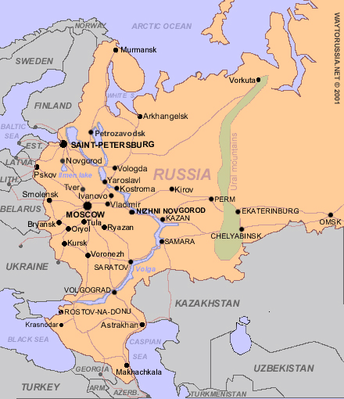
RUSSIA
BACKGROUND: The capital of Russia is Moscow and the population is about 140 million people. The life expectancy is around 65 years and the literacy rate is 99%. The main ethnic groups are: Russian 79.8%, Tatar 3.8% and Ukrainian 2%, and the major religions are Russian Orthodox 15-20%, Muslim 10-15% and Christian 2%. The official language is Russian with other small minority languages. The Communists under Vladimir Lenin seized power and formed the USSR. The brutal rule of Stalin strengthened Communist rule and Russian dominance of the Soviet Union at a cost of tens of millions of lives. The Soviet economy and society stagnated in the following decades until General Secretary Mikhail Gorbachev whom introduced glasnost and perestroika in an attempt to modernize Communism. Russia has undergone significant changes since the collapse of the Soviet Union, moving from a globally-isolated, centrally-planned economy to a more market-based and globally-integrated economy.
MUSLIMS IN THE NEWS:
- Ethnic Russians hostile to Muslims; Followers of Islam say they have been citizens a longtime.
- The rise of Russian Muslims worries Orthodox Church.
- 12 Muslims in Tatarstan imprisoned for attempting a violent overthrow of the republic's government.
- Muslims in Russia celebrate the 100th anniversary of St Petersburg Mosque.

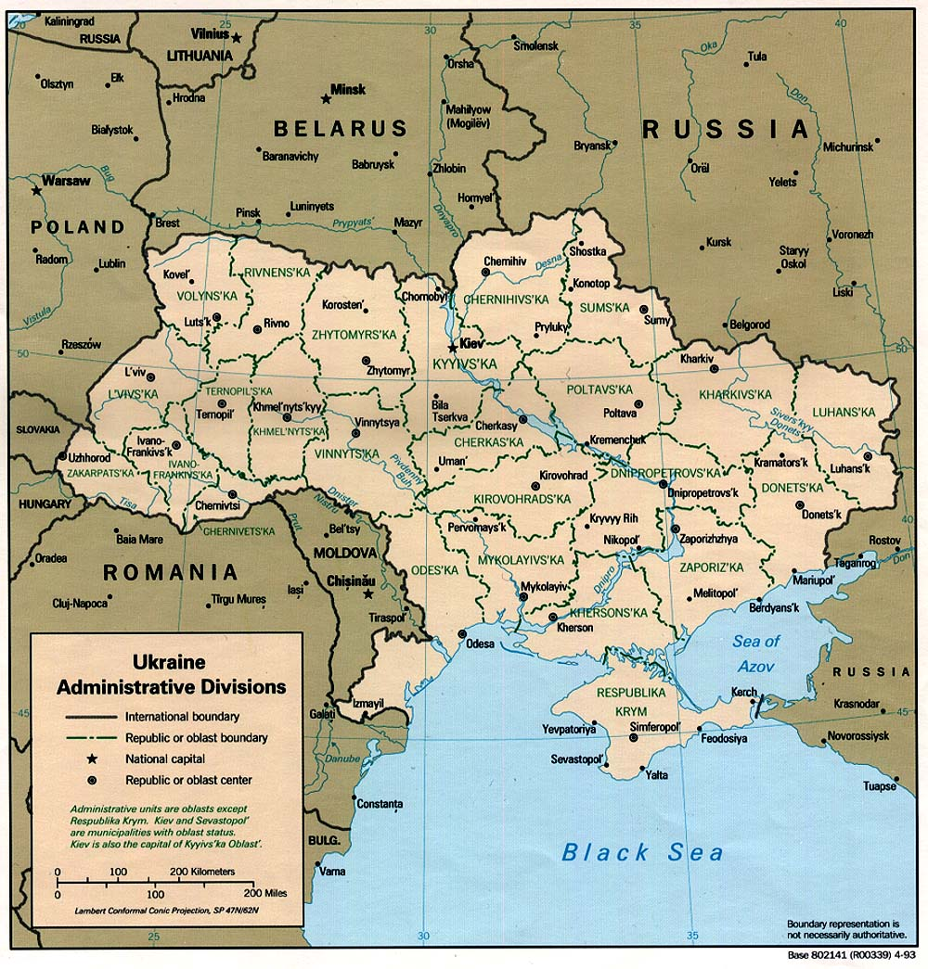
UKRAINE
BACKGROUND: The capital is Kyiv and the population is 45.9 million people. The life expectancy is about 70 years old and the literacy rate is 99%. Ukraine is in Eastern Europe and borders the Black Sea. 1.6% of the population has HIV/AIDS. The two major ethnic groups are Ukrainian 77.8% and Russian 17.3%, while Ukrainian Orthodox is the main religion. The official language is Ukrainian 67%, but 24% of the people can speak Russian. Ukraine was the center of the first eastern Slavic state, which was the largest and most powerful state in Europe. Weakened by quarrels and Mongol invasions, Kyivan Rus was incorporated into the Polish-Lithuanian Commonwealth. Ukraine was able to achieve a short-lived period of independence (1917-20), but was re-conquered and forced to endure a brutal Soviet rule that resulted in two famines in which over 8 million died. In World War II, German and Soviet armies were responsible for 8 million more deaths. Final independence for Ukraine was achieved in 1991 with the ending of the USSR. Ukraine was the most important economic component of the former Soviet Union other then Russia.
MUSLIMS IN THE NEWS:
- The Spiritual Directorate of Muslims of Ukraine reported some difficulties with registering new religious communities.
- Muslims are thought of as terrorists.

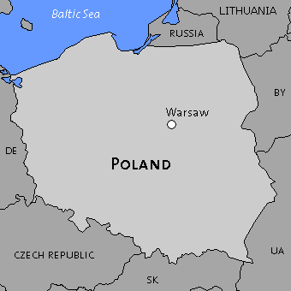
POLAND
BACKGROUND: The capital of Poland is Warsaw and the population is about 38 million. The life expectancy of a person living in Poland is about 75 and the literacy rate is almost 100%. 97% of the people are Polish and the main religion is Roman Catholic at 90%. 98% of the population speaks Polish, which is the official language. Poland regained its independence in 1918 only to be overrun by Germany and the Soviet Union in World War II. The country joined NATO in 1999 and the European Union in 2004. With its transformation to a democratic, market-oriented country largely completed, Poland is an increasingly active member of Euro-Atlantic organizations. Poland has pursued a policy of economic liberalization since 1990 and today stands out as a success story among transition economies. The government has moved slowly on major reforms and as a result the legislature passed a law significantly limiting early retirement benefits.
MUSLIMS IN THE NEWS:
- After six centuries, Poland's Muslims are still misunderstood.
- Warsaw's Muslim community is thriving in a tiny corner of the Polish capital; a microcosm of the country as a whole which has a minute Islamic minority living amongst a predominantly Catholic populace.
- Muslim Brotherhood to construct new mega mosque in Warsaw.
- In a remote rural corner of Catholic Poland, descendants of Muslim Tatars who settled here centuries ago try to revive a culture eroded by time, assimilation, emigration and communist-era oppression.

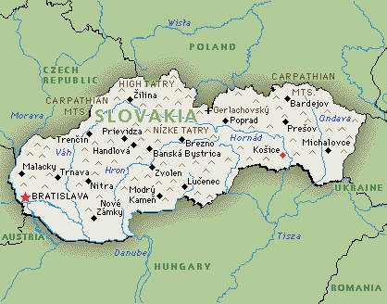
SLOVAKIA
BACKGROUND: The capital of is Bratislava and the population of the country is almost 5.5 million people. The life expectancy is 75 years old and the literacy rate is near 100%. The major ethnic groups are: Slovak 85.8%, Hungarian 9.7% and Roma 1.7%. The major religions are: Roman Catholic 68.9%, Protestant 10.8% and Greek Catholic 4.1%; and the main spoken languages are: Slovak 83.9%, which is the official language, and Hungarian 10.7%. The dissolution of the Austro-Hungarian Empire at the close of World War I allowed the Slovaks to join the closely related Czechs to form Czechoslovakia. Following the chaos of World War II, Czechoslovakia became a Communist nation within Soviet-dominated Eastern Europe. Soviet influence collapsed in 1989 and Czechoslovakia once more became free. The Slovaks and the Czechs agreed to separate peacefully on 1 January 1993. Slovakia joined both NATO and the EU in the spring of 2004 and the euro area on 1 January 2009. There are currently no mosques in Slovakia
MUSLIMS IN THE NEWS:
- Muslims in Slovakia work for positive integration.
- In 2000, a dispute erupted about the building of an Islamic centre in Bratislava: the capital's mayor refused such attempts of the Slovak Islamic Waqfs Foundation.

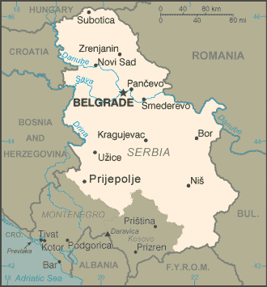
SERBIA
BACKGROUND: The capital of Serbia is Belgrade and the population is around 7 million people. The average life expectancy at birth is 74 years old and the literacy rate is 96%. The main ethnic groups is the Serbs with 83% of the total population and the major religion is Serbian Orthodox with 85% of the population practicing. Serbian is the official language and 88% of the people in Serbia speak that language. The Kingdom of Serbs, Croats, and Slovenes was formed in 1918; its name was changed to Yugoslavia in 1929. A new Serbian constitution was approved in October 2006 and adopted the following month. In February 2008, after nearly two years of inconclusive negotiations, the UNMIK-administered province of Kosovo declared itself independent of Serbia - an action Serbia was powerless to stop, but which it refuses to recognize. The Muslims in Serbia are mostly ethnic Bosniaks and Albanians, but also members of the smaller ethnic groups like Muslims by nationality, Ashkali, Egyptians, Gorani, Roma, and Turks. Islamic believers in Serbia are organized into two communities. There are about 240,000 Muslims in Serbia.
MUSLIMS IN THE NEWS:

Muslims threaten Christian over prayer meeting.
- Serbia’s President Boris Tadic and Bosnian Muslim member of the Presidency Bakir Izetbegovic met in Banja Luka saying that their friendly meeting opens a new phase in the Belgrade-Sarajevo relations.
- Serbian Muslims enter Ramadan, divided.
- Twelve alleged Serbian Muslim radicals are jailed for up to 13 years for plotting terrorist attacks on an imam and others.

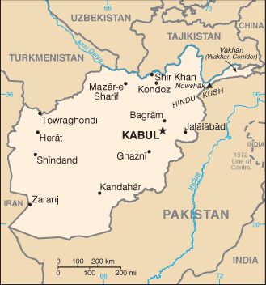
AFGHANISTAN

BACKGROUND: The capital is Kabul and the population is 28.5 million people. The literacy rate is 36% for males and 21% for females. The life expectancy is 42 years old for both males and females. The major languages are Pashtu, Dari and Turkic. There are 30 minor languages, also. The major ethnic makeup of Afghanistan is 42% Pushtun and 27% Tajik. The major religion is Sunni Muslim 80% and Shia Musslim 19%. Afghanistan imports way for than it exports. The countryside is rugged and is divided down the center by a high mountain range. Only 12% of the land is arable. The family and tribe have been the traditional sources of welfare in Afghanistan. Because of continuing warfare and limited access to safe water supplies, disease is prevalent. The overall life expectancy and the literacy rate are among the lowest in South Asia. The ban on women’s activities by the Taliban severely limited health and social services in the country. Steps toward a permanent government began with a national election for president in October 2004.
MUSLIMS IN THE NEWS:

Hazaras, a Shiite Muslim ethnic group once oppressed by the Taliban, welcome and work with Westerners, alienating Sunni Pashtuns.
- Afghanistan experts ask Barack Obama to end the war.
- A pair of white British Muslim converts who joined al-Qaeda have been killed in a drone attack in a mountainous region of Pakistan.
- The government slams IAF fatwa on Afghanistan mission.

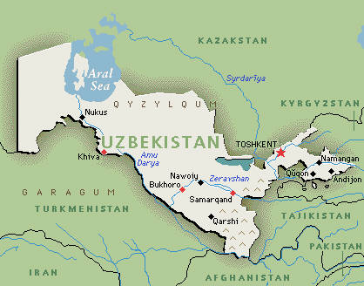
UZBEKISTAN
BACKGROUND: The capital is Tashkent and the population is 25 million people. The life expectancy is 65 years old and the literacy rate is 99%. The major languages are Uzbek and Russian, and the main ethnic makeup of those people is Uzbek 80%. 88% of the people are Muslim, most being Sunni. 9% of the population is also Eastern Orthodox. Samarqand is one of the oldest cities in the world and it is located in Uzbekistan. It is also one of the most important cities in Islam. Uzbekistan supports America in the current War on Terrorism. Their military is the best in that part of Asia. They do not want to be in a repression like Afghanistan; they get stronger every year. If the Uzbekistan government suspects any form of suspicion of religion a person can by thrown in jail. A person must obey the governments rule regarding religion. The government wants you to fear them, because they fear extremists. If a person wanted to teach in a Mosque they would have to be appointed by the government. That is how careful the Uzbekistan government is.
MUSLIMS IN THE NEWS:
- Terrorism is a battle of minds, not of bombs.
- Afghan and international forces missed their mark in the hunt for a senior leader of the Islamic Movement of Uzbekistan (IMU) in northern Afghanistan's Konduz Province last week, but they didn't go home empty-handed.
- In Uzbekistan Christian books are confiscated and a Christian has been fined the equivalent of seven years’ salary for possessing a movie about Jesus.
- Some 30 inmates of Uzbekistan's notorious Zhaslyq prison have been on a hunger strike since the end of October to protest their treatment of being religious extremists.

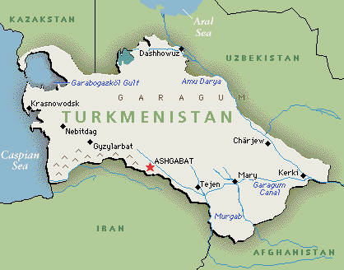
TURKMENISTAN
BACKGROUND: The capital is Ashkhabad and the total population is 4.6 million people. The major languages are Turkmen, Russian and Uzbek. The ethnic makeup of Turkmenistan is 85% Turkmen, 4% Russian and 5% Uzbek. 87% of the people are Muslim-mostly Sunni- and the other known 11% are Orthodox. The life expectancy is 61 years old and the literacy rate is 98%. Turkmenistan is mostly Black sand desert and it became an independent country on Christmas Day in 1991. In Turkmenistan a president is elected for life. There is a 60% unemployment rate and the economy is moving from government control to private control. A male must do a mandatory two years service in the military when he is old enough. Parts of the people of Turkmenistan are Russian so they are sort of afraid of the Muslim religion and do not want Islam to spread. They feel that if they don’t open their doors to the West they too will end up like Afghanistan. The United States has forces in Turkemistan. In early April 2003 the Kremlin concluded a lucrative oil deal with the country. There is a major oil line that runs through Russia.
MUSLIMS IN THE NEWS:
- Turkmenistan is said to have the world's fourth largest gas reserves.
- Global malaria control efforts have "helped reduce infections across Africa and [eliminate] the disease in Morocco and Turkmenistan.
- Turkmenistan signed an agreement Dec. 11 to build gas pipeline to India via Afghanistan and Pakistan, known as TAPI link.
- Turkmenistan is celebrating the 15th anniversary of the neutrality status.

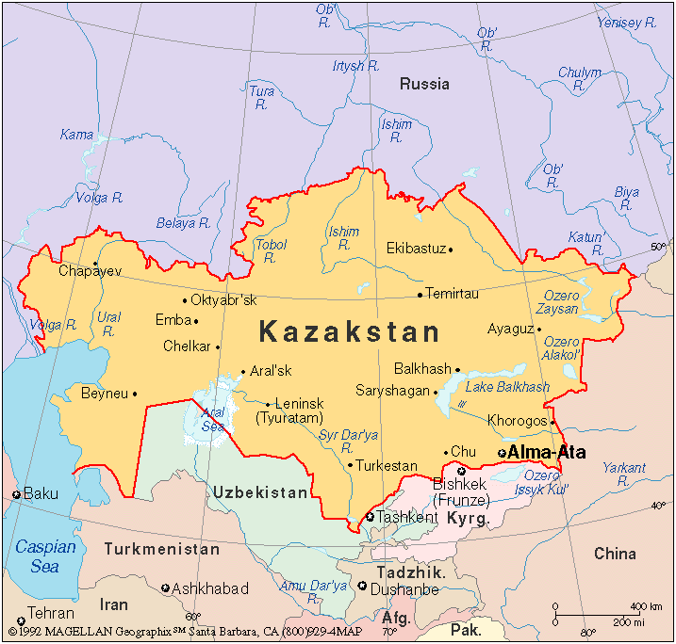
KAZAKHSTAN
BACKGROUND: The capital of Kazakhstan is Almy and the population is 16.7 million people. The major languages are Kazalja and Russian and the ethnic makeup is 42% Kazakh, 37% Russian and a small percentage of others. The main religion is Muslim 47%, Russian Orthodox 15% and others 38%. The life expectancy is 62 years old and the literacy rate is 98%. Kazakhstan borders Russia, China, the Caspian Sea and other Asian republics. In August 2003, Kazakhstan sent about 30 peacekeeping troops to Iraq to help with demining and the restoration of water supplies. It was the only country in Central Asia to give the United States help in Iraq. On February 23, 2004, Kazakhstan announced its intention of formally joining the U.S.-backed, Western-built oil pipeline project, which needed Kazakh business in order to become profitable.
MUSLIMS IN THE NEWS:
- The Tehreek-e-Taliban Pakistan warned the Punjab government to fire all non-Muslims officers or they and their offices will be targeted.
- The Caspian Pipeline Consortium has approved a multibillion-dollar investment to double the capacity of the Caspian pipeline, which carries crude oil from Western Kazakhstan to a dedicated terminal in the Black Sea.
- Since the beginning of the year Kazakhstan grain supplies volumes to Azerbaijan increased by 4 times.
- Kazakhstan, a former Soviet republic, will now send its military men to Afghanistan. Islamite’s may become much more active in Kazakhstan after the departure of Kazakh troops to Afghanistan.

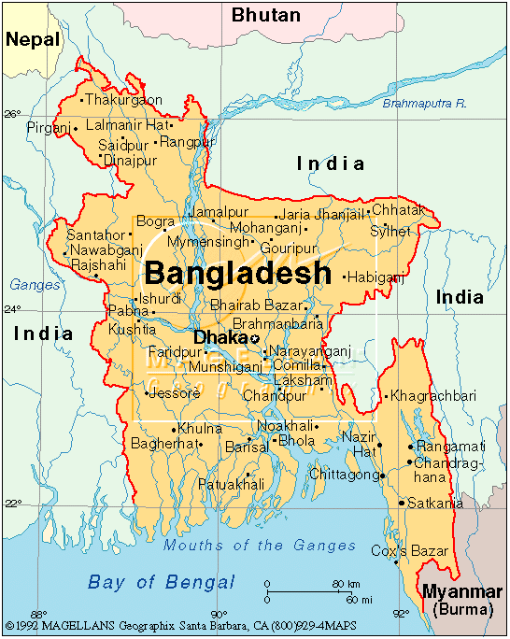
BANGLADESH
BACKGROUND: The capital of Bangladesh is Dhaka and the population exceeds 141 million people. The major languages are Bengali and English. 98% of the people are Bengali, and the two major religions are Muslim 83% and Hindu 16%. The life expectance is 61 years old and the literacy rate is 43%. Bangladesh is surrounded by India on three sides and was a part of Pakistan. The Bay of Bengal is to the south of the country. The unemployment rate is at 40% and the country survives off of foreign aid. Because of corruption, a lack of significant planning in government, and a large drop in foreign aid from industrial countries, most aid is now going more directly to nongovernmental organizations. There is estimated to be about 3 million children in the workforce and there is no formal education in Bangladesh. Although it is one of the smaller countries of the subcontinent, it is also the most densely populated. The country’s greatest agriculture products are clothes, sugar and tea, but its greatest potential is natural gas.
MUSLIMS IN THE NEWS:
- Muslims in Bangladesh and elsewhere will observe Ashura amid religious fervor and solemnity on Friday, the 10th day of the lunar month of Muharram in Islamic calendar.
- West under scrutiny over Bangladesh's garment trade.
- Around 20 Bangladesh Rifles Personnel entered India and allegedly prevented a joint team of survey officials from carrying an exercise of verification of the disputed Indo-Bangla border stretches.

INDIA
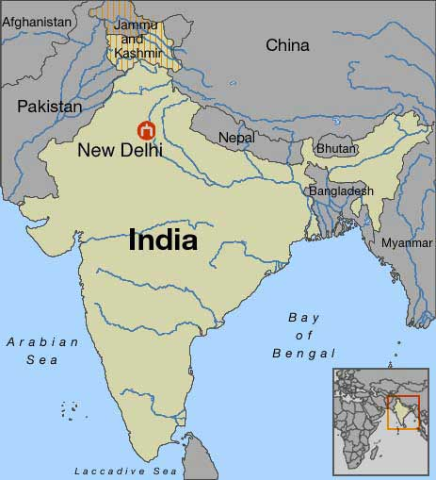

BACKGROUND: The capital is New Delhi and the population is over one billion people, with only less than 13 million being Muslim. The worshipped religions in India are Hindu 80.5%, Muslim 13.4% and Christian are 2.3%. Most of the people speak Hindu 81%. The literacy is 61% and the life expectancy is 66 years old. India was colonized by the British and many Muslims left India and moved to Pakistan because they felt like second class citizens. The two countries have fought three wars since independence, the last of which in 1971 resulted in East Pakistan becoming the separate nation of Bangladesh. India's nuclear weapons tests in 1998 caused Pakistan to conduct its own tests that same year. The two countries are constantly fighting and killing one another’s citizens. They fight over the land of Kashmir. India is also a destination for men, women and children trafficked for the purposes of forced labor and commercial sexual exploitation.

MUSLIMS IN THE NEWS:
- Police fired tear gas and swung batons to disperse hundreds of Muslims participating in religious processions in the Indian portion of Kashmir.
- The symposium on Socioeconomic Empowerment of Muslims in Plural India held at Saharanpur on November 26 proved to be a historical event as for the first time it succeeded in putting forward a roadmap for the progress of Muslims in India, with emphasis on socioeconomic empowerment.
- Shia Muslims throughout the world stage processions and hold rallies during Muharram to mark the anniversary of Imam Hussein’s martyrdom some 14 centuries ago.

MALDIVES

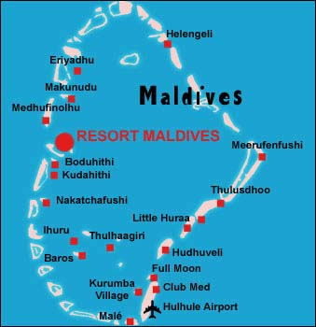
BACKGROUND: The capital of Maldives is Male and the population s only 339,330 people. English is spoken by most government officials but Maldivian Dhivehi is the language of the country. The ethnic makeup of the country is South Indians, Sinhalese and Arab. The country is 100% Sunni Muslim. A person living in Maldives can expect to live about 65 years and there is a 97% literacy rate. The country is a string of 1,190 tiny tropical islands grouped into 26 atolls in the Indian Ocean about 400 miles southwest of India. It is the smallest Muslim country in the world. The country has beautiful white sand beaches but also relies on some foreign aid. A major economic activity is fishing; tourism has also gained tremendous importance and is attracting foreign investment. Maldives imports 300 million more dollars than it exports, but tourism to the country makes up for this lack because the money gained from tourists is money that you do not see. Maldives has resisted superior attempts to place a naval base on its territory. To preserve its fragile environment and its peace-loving character, the country has become a strong advocate to make the Indian Ocean an arms-free, and particularly a nuclear-free, zone.

MUSLIMS IN THE NEWS:
- Pakistan beat Maldives in Woman’s football (American soccer).
- Maldives Muslims do not like the West coming into the country and bringing their night-life with them.
- Maldives Islamic Bank to Implement iMAL Islamic Core Banking Solution.
- Maldives wants US assistance to keep students out of radical Islamic schools.

NEPAL

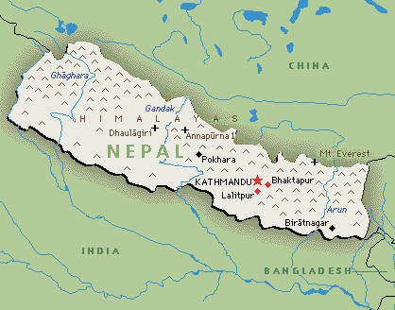
BACKGROUND: The capital of Nepal is Kathmandu and the population is almost 29 million people. The major ethnic groups are Chhettri 15.5% and Brahman-Hill 12.5%, with Muslims ranking in at 4.2%. The three most popular religions are Hindu 80.6%, Buddhist 10.7% and Muslim 4.2%. Nepali is the official language of Nepal and 48% of the population is fluent in it. Only 49% of the population is literate and the life expectancy for someone living in Nepal is about 65 years. An insurgency led by Maoist extremists broke out in 1996. The ensuing ten-year civil war between insurgents and government forces witnessed the dissolution of the cabinet and parliament and assumption of absolute power by the king. Nepal is among the poorest and least developed countries in the world, with almost one-quarter of its population living below the poverty line. Agriculture is the mainstay of the economy. Additional challenges to Nepal's growth include its technological backwardness, landlocked geographic location, civil strife and labor unrest, and its susceptibility to natural disaster.

MUSLIMS IN THE NEWS:
- The Nepali Muslim community travelling to Mecca for Hajj in Saudi Arabia complained about the poor management of the Hajj Committee.
- A young Muslim from Nepal, who had been held in an Indian prison for eight months on suspicion of being involved in the 26/11 Mumbai terror attack, has been freed on bail.

INDONESIA

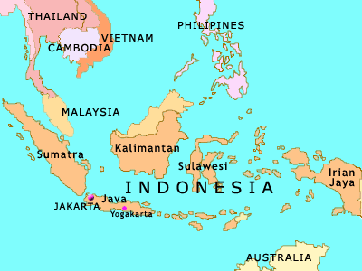
BACKGROUND: The capital is Jakarta and the population is 238 million people. The major languages are Bahasa Indonesian, English, Dutch and Javanese. The ethnic makeup of the population is 45 % Javanese, 14 % Sundanese. The country is 88% Muslim, 8% Christian and 4% Hindu, Buddhist and others. A person can expect to live about 68 years and the literacy rate is 87% among adults. Unlike other Muslim countries, there is no green in Indonesia’s flag. Indonesia is a chain of islands that lies between Asia and Australia. There is a high growth rate in the country and it also has the highest percent of Muslims in the world. Despite having very cheap labor, 9% are unemployed, and 27 % live in poverty. Indonesia continues to be dependent on foreign loans. There are always obstacles such as government corruption and natural disasters like the tsunami of 2004, which always hamper the country’s economic development.

MUSLIMS IN THE NEWS:
- American who stormed 'noisy' Muslim prayer room in Indonesia is jailed for blasphemy.
- Radical Muslim cleric Abu Bakar Bashir could face a death sentence after Indonesian police formally charged him with inciting terrorism.

Islamic defenders front, Indonesia Muslim group, targets immoral nightclubs, Christians and Liberal Muslims
- Indonesian police arrested one of the country’s most-wanted Muslim militants, accusing him of plotting high-profile assassinations and attacks on foreigners at luxury hotels in the capital.

BRUNEI

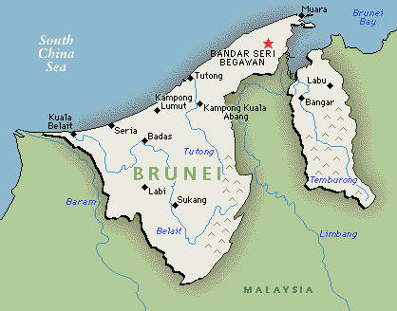
BACKGROUND: The capital of Brunei is Bandar Seri Begawan and the population is only 365, 251 people. The major languages are Malay, English and Chinese and the ethnic makeup of the people is 67% Malay, 15% Chinese and 18% others. 67% of the population is Muslim, 13% are Buddhist and 10% are Christians. The life expectancy is 75 years old and the literacy rate is 88%. Brunei boosts one of the highest standards of living in the world. The Sultan of Brunei is considered the richest person in the world. Oil and natural gas almost entirely support the economy. Chronic labor shortages are managed by the importation of thousands of foreign workers. Although Islam is the official state religion, the government practices religious tolerance. The constitution provides the sultan with the authority, which he has used to suppress opposition groups and political parties.

MUSLIMS IN THE NEWS:
- The government has expressed full confidence that standing issues on facilitation in the negotiations with the Moro Islamic Liberation Front (MILF) will be resolved.
- Japan and Brunei have agreed to extend their participation in a team watching the ceasefire with Muslim separatist rebels.
- In the age of digital al-Quran it is only logical that mosques embrace the information technology (IT) and help disseminate the richness of the Islamic religion through the information super highway.

MALAYSIA
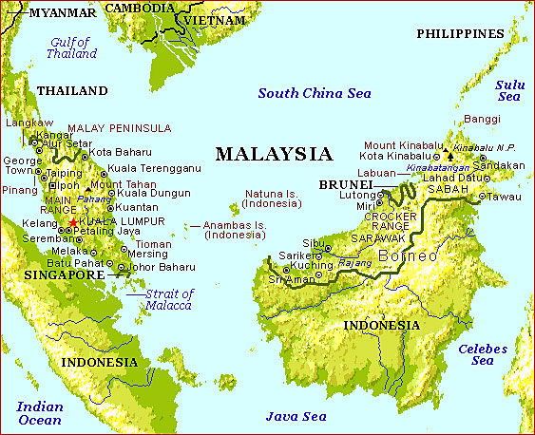
BACKGROUND: The capital of Malaysia is Kuala Lampur and the population is 23.5 million people. The life expectancy at birth is 72 years old and the literacy rate is 88%- one of the highest in the Pacific. The country spends only a small percentage of its GDP on education. HIV/AIDS affects 0.42% of the population and there are several different languages spoken in Malaysia. 58% of the people are Malay 26% are Chinese. There are as many religions in the country as there are languages; however, only 33% of the population is Muslim. Islam was brought to the country by Indian Muslim Traders. The official religion is Muslim and most of these people are Sunni; they have a very strict policy against all others. The country imports/exports numerous electronic devices. Efforts to move the economy from farming and toward industrial production have been very successful. Malaysia is the third-largest producer of semiconductors in the world. City dwellers have ready access to educational, medicinal, and social opportunities, but the quality of life declines in the countryside.

MUSLIMS IN THE NEWS:
- Malaysian Muslims below the age of 16 are allowed to marry as long as they obtain the permission of the religious courts. Sharia law runs in parallel with civil law in the multi-ethnic country.
- Islamic banking, the Muslim Brotherhood's invention to infiltrate and co-opt Western economy, was slow to catch on until 1993, when Anwar Ibrahim—then Malaysia’s finance minister—helped to introduce the newly invented Islamic Banking windows into conventional banks.
- South Korea wants to learn about Islamic finance from Malaysia.

PHILIPPINES

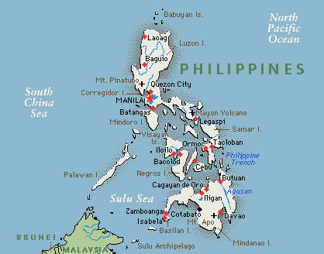
BACKGROUND: The capital is Manila and the population of the country is almost 1 billion people. The life expectancy is about 70 years old and the literacy rate is 93%. The three major ethnic groups are Tagalog 28.1%, Cebuano 13.1% and Ilocano 9%. The major religion is Roman Catholic with 81% and Muslim is second with 5%. The official languages of the Philippines are Filipino and English. The Philippine Islands became a Spanish colony during the 16th century; they were ceded to the US in 1898 following the Spanish-American War. In 1935 the Philippines became a self-governing commonwealth. The Philippine Government faces threats from three terrorist groups on the US Government's Foreign Terrorist Organization list. Decades of Muslim insurgency in the southern Philippines have led to a peace accord with one group and on-again/off-again peace talks with another.

MUSLIMS IN THE NEWS:
- A recently freed kidnap victim, school principal Cecilia Sosas, said her abductors told her they wanted non-Muslim.
- Hundreds of families in North Cotabato, southern Philippines have left their homes as government troops and Muslim rebel groups belonging to the Moro Islamic Liberation Front (MILF) clash in the town of Pikit.
- Muslim rebels in the Philippines warned that the expiration of the mandate of Malaysian-led international peace monitors next week might lead to resurgence of armed conflict in Mindanao.

CAMBODIA
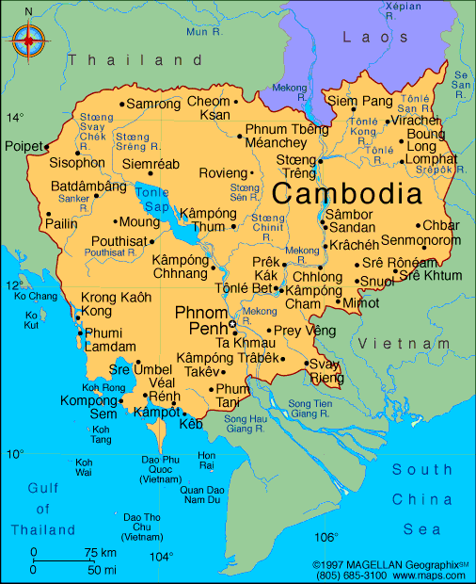
BACKGROUND: The capital is Phnom Penh and the population is about 14.5 million people. The life expectancy is 62 years old and the literacy rate is 74%. More than 50% of the population is less than 21 years old. The population lacks education and productive skills, particularly in the poverty-ridden countryside, which suffers from an almost total lack of basic infrastructure. The major ethnic groups are Khmer 90%, Vietnamese 5% and Chinese 1%. Buddhists is the main religion with 97% of the population being followers, only 2% of the population are Muslims in Cambodia. The official language is Khmer 95%, but people also speak French and English. Most Cambodians consider themselves to be Khmers. The king placed the country under French protection in 1863 and it became part of French Indochina in 1887. Following Japanese occupation in World War II, Cambodia gained full independence from France in 1953.
MUSLIMS IN THE NEWS:
- An elephant that killed its owner last week and then terrorized residents of a village in southern Cambodia has been subdued.
- The Cambodian government has ordered the closure of a UN centre for asylum seekers from the Vietnamese highlands, prompting fears that some could face persecution when repatriated.

COUNTRY PORTFOLIO

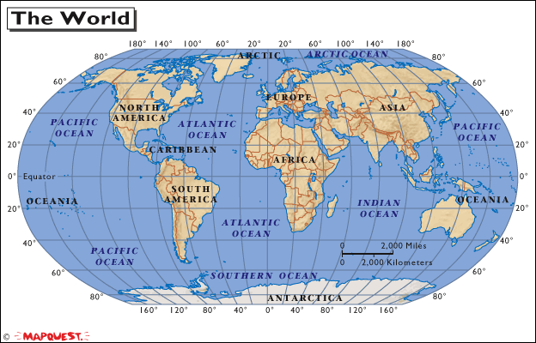

Lezlie Zucker
REL 4050
December 16, 2010

CONTENTS
- South Asia
- Bangladesh
- India
- Maldives
- Nepal
- Pakistan

- South East Asia
- Brunei
- Cambodia
- Indonesia
- Malaysia
- Philippines

- South West Asia
- Bahrain
- Jordan
- Lebanon
- Saudi Arabia
- Syria

- Central Asia
- Afghanistan
- Iran
- Kazakhstan
- Turkmenistan
- Uzbekistan

- East Europe
- Poland
- Russia
- Serbia
- Slovakia
- Ukraine

- South Europe
- Albania
- Bosnia
- Hungary
- Kosovo
- Turkey

- North Africa
- Algeria
- Libya
- Morocco
- Nigeria
- Tunisia

- North East Africa
- Djibouti
- Eritrea
- Ethiopia
- Somalia
- Sudan

I.

II.

III.

IV.

V.

VI.

VII.

VII.

