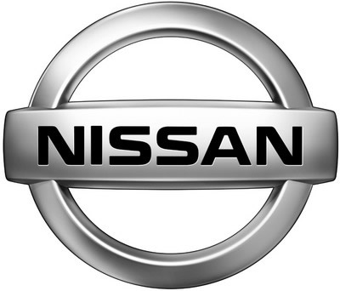

Nissan Quantitative Survey Report
Hannah Brooker, Ashley Farrar, Melissa, Michael Pattison
Oklahoma State University
Dr. Fullerton
December 11, 2011

INTRODUCTION

The goal of this survey was to find numerical data about Multicultural Millennials, specifically African Americans, Asians, and Hispanics. The data collected was also compared to answers by the Caucasian respondents.The survey was conducted on surveymonkey.com. It was started on November 21, 2011 and ended on December 10, 2011. The types of questions included were: multiple choice, Likert scale, and open-ended.

DEMOGRAPHIC INFORMATION

123 respondents started the survey and 115 respondents completed the survey (93.5%).111 respondents were between the ages of 18 through 29. 103 respondents matched the criteria, being18 through 29 year old andwere African American, Asian American, Caucasian, Hispanic, or Other.
Out of the 103 respondents that matched the criteria, 26 were male and 77 were female.

Respondent Data
 | Frequency | Percentage
Started Survey | 123 | 100
Completed Survey | 115 | 93.5
Matched Criteria | 103 | 83.7

Gender
Gender | Frequency | Percentage
Male | 26 | 25.2
Female | 77 | 74.8

Ethnicity of 18 through 29 Year Olds Out of 111 Respondents
Race | Frequency | Percentage
Caucasian | 52 | 46.8
African American | 27 | 24.3
Hispanic | 17 | 15.3
Native American | 8 | 7.2
Asian | 4 | 3.6
Other | 3 | 2.7

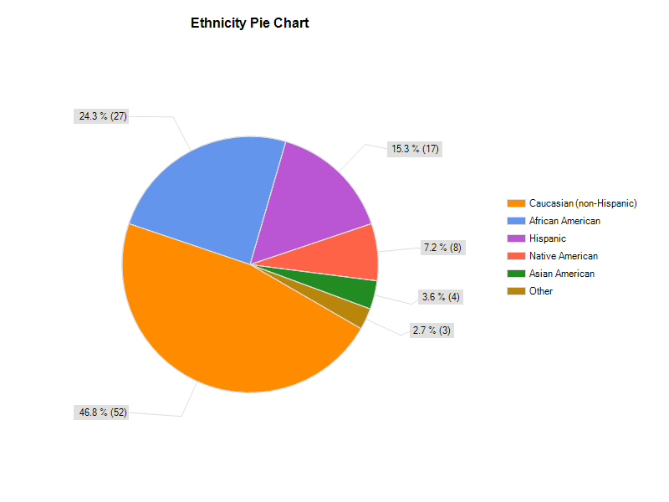

For income, African Americans, Caucasians and Others made the greatest amount of money, while Asians and Hispanics made the least amount of money. For all the Millennials, the most popular income bracket was $0 through $15,000 a year.
Income Brackets for Each Ethnicity

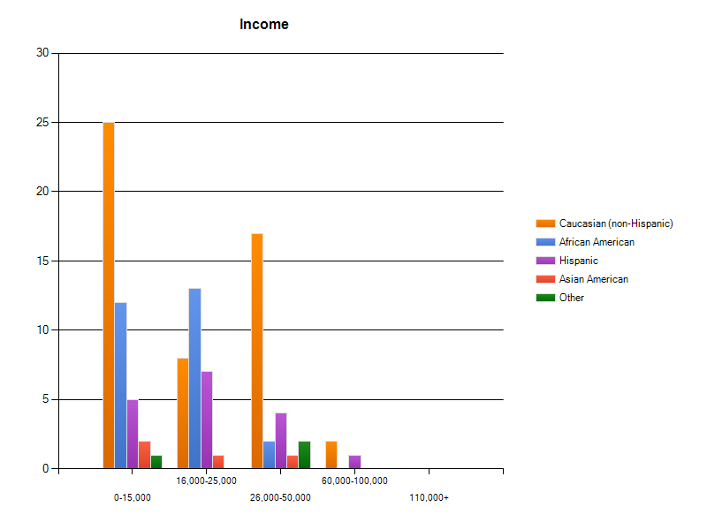

KEY INSIGHTS

While each race’s opinions differed on some questions, there were a lot of similarities between Multicultural Millennials, as well as similarities between Caucasian and Multicultural Millennials.
When it came to cultural questions, Millennials tended to differ greatly, though there were some
similarities.
Millennials want a reliable car that is safe. They care more about practicality and performance than looks. They listen to their family when choosing a car while also seeking the advice of experts and online reviews. For Millennials, brand reputation is important when buying a car, while seeing a celebrity drive a car doesn’t necessarily make make them want to know more about the car. They consider price an important factor in the decision making process, especially since most Millennials in the survey make less than 25 thousnd a year. Millennials will pay more to have a gas efficient car and don’t care if it’s new or used, although they aren’t interested in electric cars. Millennials would not buy a car based on what their family drives, but seek family approval and consider tradition a big part of their lifestyle.
Preferences Concerning Cars
 | Likert Score
Price | 4.58
Safety | 4.19
Read Online Review Before Purchase | 4.16
Listen To Experts Before Purchase | 3.87
Listen to Family Before Purchase | 3.77
Brand Reputation | 3.56
Prefer Practicality Over Looks | 3.5
Buying New Cars Over Used | 3.01
Buying an All-electric Car | 3.01
Celebrities on Car Ads Piquing Interest | 2.07

Most Important Feature in a Car
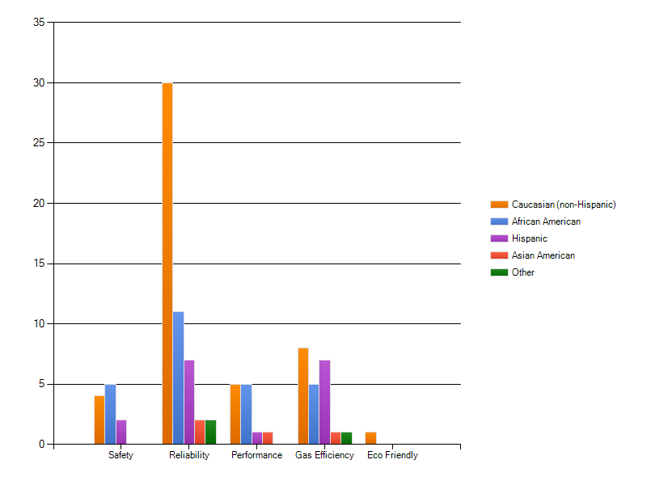

KEY DIFFERENECES BY ETHNICITY

Though there are many similarities between Millennials, there were some differences in opinion with each race. For example, Millennials drive cars and want cars, except Hispanics who drive cars but want SUVs. While everyone favored “safety” as the most important feature in a vehicle, Hispanics rated both “safety” and “gas efficiency” as the most important features in a vehicle. There was, though, little differences when comparing Caucasians to Multiculturals.
African Americans were most likely to drive and prefer an American-made car, especially Chevys. They were most likely to prefer practical cars and least likely to seek a friend’s advice when buying cars. They don’t care to buy electric cars but are most likely to like ads that show people driving cars. African Americans were most likely to prefer safety in a car. They are generally neutral about the Nissan brand. African Americans are proud of their cultural background and like seeing celebrities of their race in ads. Their cultural background is very imporant to them.
Asians are most likely to favor Asian brands, and don’t care for cars that are American-made. Asian responents all drove Japanese brands and were most likely to want a Japanese brand of car. They were most likely to drive a Toyota but desire a Honda. They were most likely to listen to their family. They strongly relate to their cultural background and are most likely to participate in cultural events. Asians enjoy seeing ads with aspects of their culture and were most likely to enjoy seeing celebrities of their race in ads. Asians, though, didn’t care to see cars in acton on TV ads. They were most likely to like Nissan and state that Nissan was a brand for them. When buying a car, they were most likely to listen to family and experts . All Asians respondents spoke fluent or some foreign language.
Hispanics want to drive SUVs and desire vehicles that are reliable but equally gas efficient. They’re most likely to drive a Honda and most likely to desire Hondas. They are most likely to consider price an important factor when buying a car and most likely to listen to close friends when buying a car. Hispanics are least interested in cars when seeing cars drive on TV ads or a celebrity driving a car. They prefer safe cars. They are least favorable towards the Nissan brand and are least likely to find Nissan to be a brand for them. They are most likely to find find family approval important and value their cultural background. 10 out of 17 people spoke little or fluent Spanish, in addition to English.

Listening to Close Friends When buyin a Vehicle
Ethnicity | Likert Score
African American | 2.74
Asian American | 3.5
Caucasian | 3.13
Hispanic | 3.88
Other | 3.0

Millennial’s Brands Currently Driven and Desired

Overall Feelings about Nissan
 | African Americans | Asian Americans | Caucasians | Hispanics
Likert Score | 3.13 | 2.17 | 3.06 | 3.41

SECONDARY RESEARCH AND FOCUS GROUP FINDINGS RELATING

After conducting this survey, there are consistent similarities between the secondary and primary research concerning Multicultural Millennials.
First, Multicultural Millennials find price, safety and gas efficieny the important factors when choosing a car. Price was stated as an important buying factor in the focus group, while in the secondary research it was stated that they will pay more for a gas-efficient car. As eco-friendly Millennials are, it is interesting to note that they did not prefer electric cars in the survey. This might be an indication of region, as many respondents were Oklahomans. In the survey it was found that Multicultural Millennials don’t care about getting new cars or are concerned about looks, which agrees with the secondary research that they don’t care much about cars.
Second, Multicultural Millennials listen heavily to online reviews and seek advice from experts. They want a reputable brand and to get the most for their money especially if they are going to spend a lot of money. In the focus groups, it was stated that many Multicultural Millennials like to research before making a decision. With all the choices that are available to them, they want to know why one car is better than the other, as stressed in the focus group. Multicultural Millennial’s lives are continuously merging with technology. The online world is often times their real world, especially with social media sites like Facebook and Twitter. If they want to know something, they Google it. So, if they want to know what the most reliable and safe car is, they are going to check out an online review or see what Carfax.com says.
Third, Multicultural Millennials, having grown up in a comercially saturated world, are tired of the average, generic ads. They’ve seen it all. It’s going to take more than just an ad to gain their interest. In one of the focus groups, few Multicultural Millennials could not think of a car commercial, and fewer could think of a car commercial they liked. It was also found that they generally enjoy ads that show aspects of their culture.
Lastly, Multicultural Millennials are listen to their families. Culture is a big part of their life. Asians and Hispanics are more connected to foreign countries and foreign languages, while African Americans are not. Asians and Hispanics were most likely to identify with their native culture while African Americans were not.

RECCOMMENDATION

Millennials have grown up with lots of options when it comes to buying. They have grown up seeing tons of ads, and have the ability to be smart shoppers thanks to the Internet. Multicultural Millennials have grown up in an environment where the consumer is in charge, not the corporation. Because they are used to companies catering to their need, many Millennieals might want incentives when buying a car. They want their moneys worth, and will listen to a company who will accommodate and appreciate them. Also, since Nissan is seen as an expensive brand, it is important to show the affordability of Nissan’s cars. This could mean putting an example loand price at the end of their commercials.
Nissan should consider taking a non-conventional approach to advertising. Most Multicultural Millennials do not think much of Nissan. Though this is a weakness, it is also a great chance to create an image for themselves. In this survey, most Multicultural Millennials did not prefer commericals with people driving cars in them, except for African Americans. This was also found to be true in the focus groups previously conducted. Nissan must do more than just put a TV ad to grab their attention. It is extremely important for Nissan to build an online presence and to stress any awards they have won.

