Melissa Roesslein
Final Project
Botany
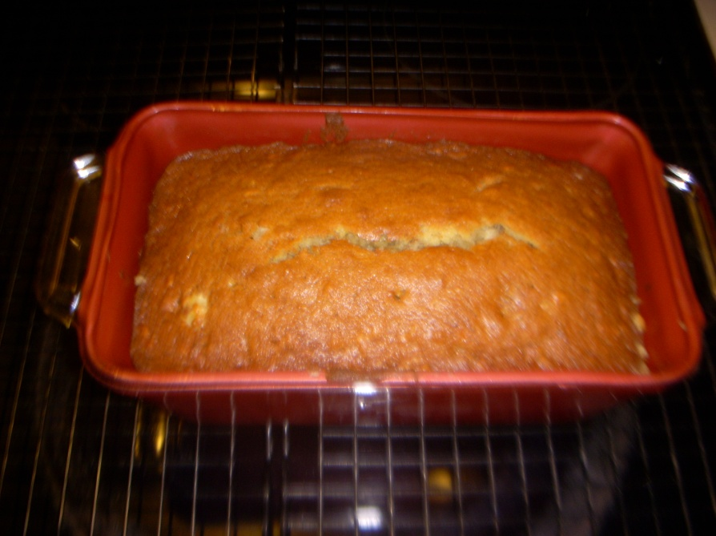
Walker
25 April 2012

Smell is known to be the greatest memory sensory that humans have. The smell of baking banana walnut bread takes me back to when I was a kid. When the weather started getting cooler my mom would make homemade chicken noodle soup and to go with it she would get premade banana nut bread but heat it up in the oven. There is just something magical about fresh baked bread covered in melted butter. I decided to pick my project on banana nut bread because I wanted to learn firsthand how one of my favorite things came out to be.
Bread is defined as a staple food of life. Bread is often thought to be the first or among the first foods man created. Bread is prepared many different ways. Traditionally, breads can be baked or fried. Different cultures prepare bread differently and where you are from helps determine what kind of breads you eat. (McGee)
Most commonly breads are made either leavened or unleavened. The main difference between the two types is in the chemical makeup. Leavened bread contains air caused by a leavening agent. Loaves of bread fall into this category. Unleavened bread does not contain a leavening agent and that makes the bread remain flat. Most commonly the breads that are eaten in the United States are leavened. Typically, unleavened breads are eaten traditionally at religious ceremonies. (Kaplan)
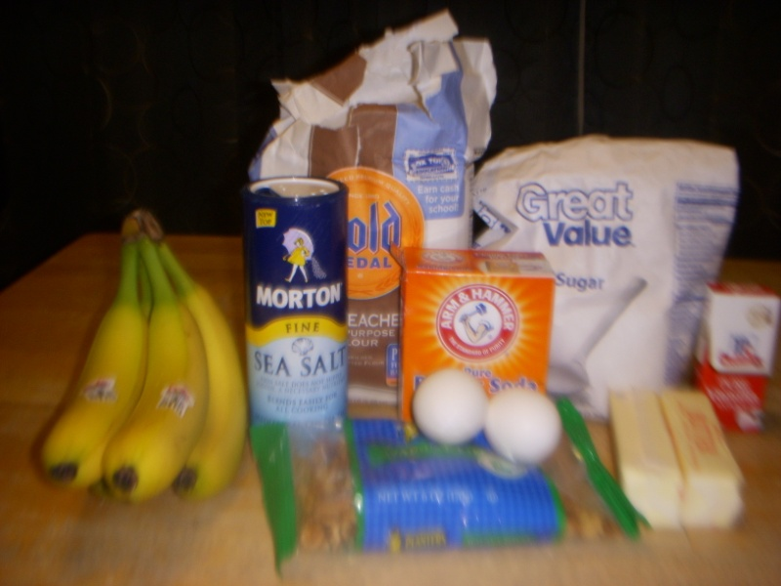
Banana nut bread contains a leavening agent and forms into a loaf. Therefore, banana nut bread is leavened bread. When thinking of leavening agents they think of yeast. Although, banana nut bread is leavened it does not contain yeast.

The ingredient list surprised me when I saw how simple it was. I was expecting it to be a lot more complex but it didn’t take much to create perhaps the best bread I’ve ever tasted and the first I’ve ever made. The ingredients were eggs, flour, sugar, fine salt, unsalted butter, bananas, baking soda, vanilla extract and walnuts. The ingredient list surprised me for several reasons. First, I was surprised that it didn’t need yeast. Everyone I talked to about making bread mentioned yeast. Second, I thought that pecans were the nuts needed in banana nut bread but every recipe I found needed walnuts. Lastly, I didn’t know there were different kinds of flour. The recipe I made needed unbleached all purpose flour. I was expecting it to be brown or a color other than white. I was shocked when I opened the unbleached flour and it came out white and looked like all the other flour I’ve ever used.
Each ingredient has a very important role in the creation of banana nut bread. Without just one ingredient you would have something completely different than what you originally intended on making. Each ingredient and its role are as follows.
Flour is perhaps the most important ingredient in bread. Flour is used to create the final structure of the bread. Flour leads to directly how much protein and starch the bread contains.
Flour is made from grounded grain, which then turns into a powdery substance. Flour contains both water insoluble and water soluble proteins. After the bread has been kneaded or risen depending on if you are working with wet or dry dough. After either of these two things has happened the gluten forms into long strands while the gliadin forms into shorter strands. During the baking process the gliadin molecules form bridges in between the gluten. These strands then result in the shape of the bread.
The next ingredient is baking soda. Baking soda is used as a leavening agent. The reaction caused by baking a leavening agent produces a gas. This gas causes the bread to rise. Without baking soda or another leavening agent you would have flat bread instead of a loaf.
Salt is used in bread dough not only to enhance the flavor of the grain but also is used to help in the chemical makeup of the bread itself. Salt is used most commonly in bread recipes to “control the rate of fermentation”. By controlling fermentation you are strengthening the developing gluten content. By creating stronger gluten bonds the bread is given a longer shelf life and is fresher longer than breads made without salt.
Eggs and vanilla extract do very similar things in the creation of bread. Eggs are important in baking bread because they add “color, flavor and texture” to the overall product. Eggs also help in the leavening process. They retain the gas bubbles causing the bread to rise. Vanilla extract is used to give added flavoring to the product. Most people don’t think it necessary to use when cooking. During the mixing process the vanilla is blended in to the other ingredients. It is also helpful to help tone down the egg taste.
Butter is used in the bread making process to add moisture and flavor. During the baking process the butter is melted and is absorbed into the other ingredients. This causes the bread to become moist it also adds flavoring. Butter is also used to grease the pan so that when the finished product is done cooking it comes out of the pan evenly and smooth.
The butter needed in bread making is unsalted butter. The reason the butter has to be unsalted is because if it contained salt it would be much harder to measure the salt content, which would affect the taste. (Czernohorsky, Campbell, & Humphrey)
The final essential ingredient is the sugar. Sugar is not used for the reason I thought it was. Unlike acting as a sweetener or flavor additive sugar is added to baked goods for several other reasons. Sugar undergoes several different chemical reactions during the bread making process.
The Maillard reactions are the chemical changes made in sugar during baking. These reactions involve a carbohydrate in this initial step. The carbonyl group of the sugar combines with the amino group of an amino acid or protein with the removal of a molecule of water. After this, a series of chemical reactions occurs, including fragmentation and hen polymerization, with the eventual formation of brown pigments. The compounds involved and the conditions of temperature, pH, and moisture under which the reaction occurs, affect the final flavor and color which may be desirable or not desirable. The browning of a loaf of bread during baking is due mainly to the mallard reaction. Along with the browning sugar also increases the rate of fermentation in bread by providing the yeast a direct food source. (Bennion, M., & Scheule)
The last two ingredients aren’t essential to bread in general but they are essential when making banana nut bread. Bananas and Walnuts are used to create the flavor and texture of banana nut bread. Without walnuts and bananas you wouldn’t have banana nut bread. While the walnuts remain essentially the same and don’t undergo any chemical changes the bananas undergo several physical changes. First the bananas are peeled, cut and then mashed. Once they are mashed they because a clumpy mess that looks very similar to baby food. Once the bananas are mixed in the mixer they become liquid and combine with all the other ingredients.
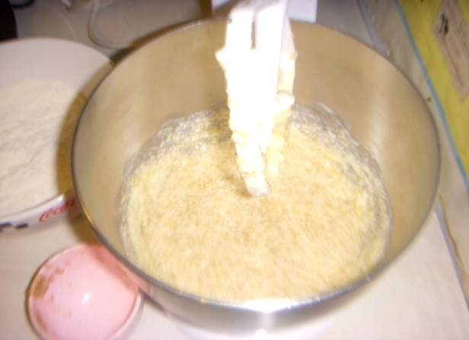
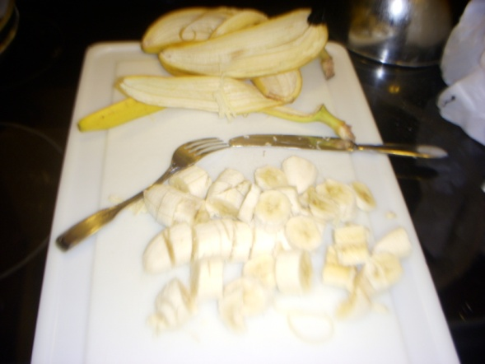

Walnuts belong to the family Juglans. There are two major types of walnuts grown for their seeds, the English walnut and the Black walnut. The English walnut originated in Persia and the Black walnut originated in the United States. Commercially produced walnuts are nearly all hybrids of the English walnut.
The walnut was first cultivated in the United States during the 1700’s.Before that the walnuts across Europe had been around since the beginning of civilization. In Rome the walnut was persevered for royalty. According to historians it is one of the first tree foods known to man. (12Ap1)
Bananas were first domesticated in New Guinea. They are native to Southern Asia and today are grown in over one hundred countries. Historians date the cultivation of bananas back to 5000 BCE. Although, there are dozens of different types of bananas all widely cultivated bananas come from the Musa acuminate and Musa balbisiana. Modern cultivated bananas have lost the ability to produce seeds, meaning that they are parthenocarpic. To grow a banana tree you can pretty much plant any part of the plant and a new tree will grow. Bananas are also are not seasonal so you can buy them fresh all year round. Due to their wide availability helps keep the cost down. (Bananas)
According to Wikipedia, there is little known about the origin of banana bread and even less known about banana nut bread. Banana bread is native to the United States and first appeared in cook books in the 30’s after the introduction of baking soda to the world. It regained popularity during the 50’s and 60’s and at some point someone along the way decided to put nuts in it.

Before making the banana nut bread I looked thru several different recipes before I picked the one I decided to make. I choose the recipe I did by the number of good reviews it received. The recipe is as follows:
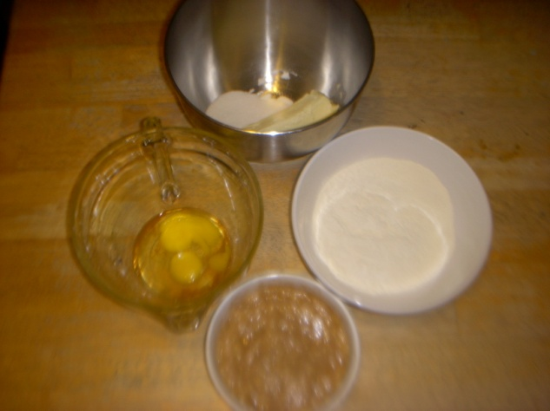
1 ¼ cups unbleached all purpose sugar
1 teaspoonful baking soda
½ teaspoonful fine salt
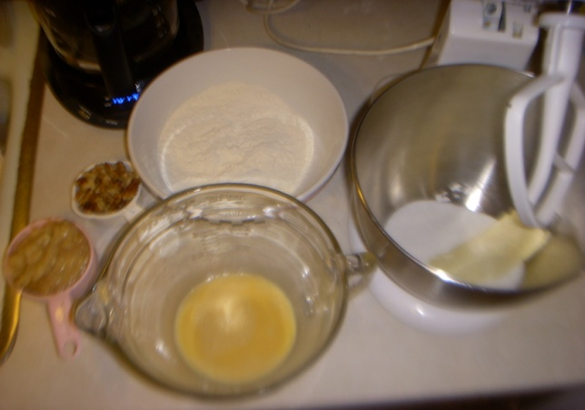
2 large eggs at room temperature
½ teaspoonful vanilla extract
½ cup unsalted butter
1 cup sugar
3 very ripe bananas
½ cup toasted walnuts
Making the bread was just as simple as the ingredient list. First you put the flour, salt and baking soda into a bowl and mix it together set it aside. Next whisk the eggs and the vanilla together then set it aside. Then mix the butter and sugar together in a mixer, pour in the egg mixture a little at a time until blended together. Then you peel, cut and mash the bananas and pour the bananas into the mixing bowl. After the bananas are mixed in with the eggs etc. remove the bowl from the mixer and then pour in the flour mix and stir it all together. Once it is all mixed in pour in the walnuts and turn the batter over so that the walnuts are covered in the middle. Then you take butter and spread it around a 9 by 5 3 inch loaf pan pour in the batter and cook it in the oven at 350 degrees for 55 minutes. Once it is done you let it cool inside the pan for five minutes remove it and allow it to cool completely. Once it is cool completely wrap it in plastic wrap and serve it the next day.
Most of the problems I had when making the bread occurred before I even made the bread. I didn’t have any of the ingredients when I first decided to make it so I had to go to the store. I had a hard time finding unsalted butter. Before this I never paid attention when buying butter to whether or not it was salted or unsalted. The next problem I had was finding toasted walnuts. I had to go to three different places before finding some. That same day I had a hard time finding bananas to use. The recipe said they had to be very ripe bananas. Unfortunately, all the bananas I was finding were green or not very ripe at all. I finally found some on the final stop of my journey.
Later when I went to make the first loaf I didn’t realize the eggs and butter had to be at room temperature. Both items had been in the fridge all day so I had to come up with a way to warm them up in order to use them. I wasn’t sure how to do that without cooking them. After doing some research I discovered some tricks. To warm up eggs to room temperature quickly you get a bowl of warm water place the eggs in the water for ten minutes. The trick is to not have the water too hot or the eggs will cook.
To heat up the butter without melting all of it is really tricky. I melted a whole stick of butter in the microwave before perfecting it. To get the butter to heat up perfectly, place a stick in the microwave at an angle for 10 seconds. Then you move it to another angle for another ten seconds. This way the butter is heated evenly.
The second time I made the bread I thought I was being smarter however, I ran into very similar problems as the first time. This time I got the bananas a couple days in advance that way they would be perfectly aged for when I needed them. I also took the butter out of the fridge before going to work so when I got home it would be perfect temperature. However, even with my careful planning I found myself in the same boat as before. Someone put the butter back in the fridge so it was just as hard as before. This time though I didn’t ruin any in the microwave. I also had to go to the store and get new bananas because my nephew decided the ones on the counter were toys and the ones that my brother replaced them with were too green to use.

Works Cited
(n.d.). Retrieved April 10, 20012, from www.walnuts.org
Bananas. (n.d.). Retrieved April 15, 20012, from http://en.wikipedia.org/wiki/Banana_nut_bread
Bennion, M., & Scheule, B. (2010). Introductory Foods 13th Edition. Prentice Hall.
Czernohorsky, J. H., Campbell, A., & Jumphrey, T. (n.d.). Chemical Process. Retrieved from Food Information: http://nzic.org.nz/ChemProcesses/food/6D.pdf
Kaplan, Steven Laurence: Good Bread is Back: A Contemporary History of French Bread, the Way It Is Made, and the People Who Make It. Durham/ London: Duke University Press, 2006
McGee, Harold (2004). On food and cooking. Scribner.

