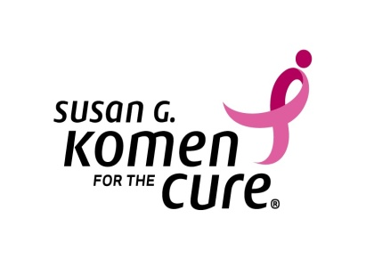
5005 LBJ Freeway, Suite 250/ Dallas, TX 75244

NEWS RELEASE

April 15, 2012 Contact Information:
FOR IMMEDIATE RELEASE Christy Wedoe, Communications Director
Office: (612) 532-9050
Email: cwedoe@komen.org

SUSAN G. KOMEN IS COMING TO THE TWIN CITIES

MINNEAPOLIS, MINN.—Susan G. Komen, one of the largest organizations dedicated to end breast cancer, will have the Susan G. Komen 3-Day in the Twin Cities Aug. 24-26.
The Susan G. Komen 3-Day is a 60-mile walk for women and men to make a personal difference in the fight to end breast cancer. Registration is due by Aug. 1 with a $50 fee per person. Participants can register at komen.org or call 1-877-GO KOMEN (1-877-465-6636). Proceeds from the event will fund innovative global breast cancer research and local community programs supporting education, screening and treatment.
Since its beginning in 2003, the Susan G. Komen 3-Day has raised nearly $600 million. Seventy-five percent of 3-Day funds go to ground breaking research focused on decreasing breast cancer rates and deaths in the next decade. The remaining 25 percent of the funds support Komen Affiliates and community-based breast health programs throughout the U.S.
-more-

page 2 of 2
Since 1982, Susan G. Komen for the Cure has invested more than $1.9 billion in its mission to save lives and end breast cancer. In 2010, Komen made grants to more than 1,900 community organizations totaling more than $93 million.
For more information about Susan G. Komen 3-Day in the Twin Cities contact Christy Wedoe at (612) 532-9050 or cwedoe@komen.org.
Founder Nancy G. Brinker promised her dying sister Susan G. Komen, she would do everything in her power to end breast cancer forever. In 1982, Susan G. Komen for the Cure was established, and is now the world’s largest grassroots network of breast cancer survivors and activists fighting to save lives, empower people, ensure quality care for all and energize science to find cures.

-###-

