Nellie Cronin
March 20,2012
Dr. Avtgis
Health Project

Background: In 2009, lung cancer was the leading cause of death. 94% of people who had lung cancer got it from smoking cigarettes. James Bonsack first introduced tobacco in 1881. Now days, the tobacco industry is one of the biggest industries. Tobacco users are in a wide range of ages. About one in eight middle school students reported to use some form of tobacco, which was found out in 2008. Also, in 2008 more than one-third of high school students admitted to using tobacco on a regular basis. For ages 18-24, 30 percent used tobacco on a regular basis. Kids that grow up in a family with history of tobacco use are more likely to use themselves. For the past few years, tobacco use in younger kids and young adults have drastically increased. That is even after the law of banning smoking inside was put into effect. Younger kids are starting to get hooked on the addiction at a very young age.
Statistics include some such as: About 30 percent of youth smokers will continue smoking or using tobacco products and die at an early age from tobacco related disease.
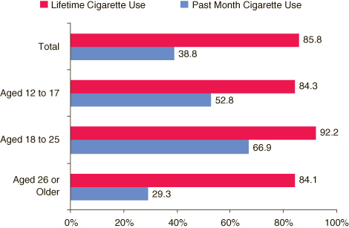
The graph above is showing the cigarette use in the different demographics. Ages 18-25 is the largest for lifetime cigarette use and for the past month cigarette use. The age group of 12-17 is trailing right behind.
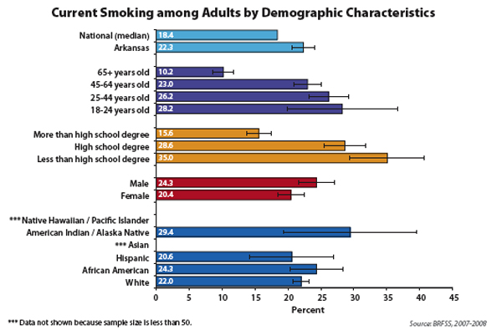
The graph above is showing the current smoking adults. As you can see it does not matter what race you are because they all have the history of smoking. Looking at the ages, the largest is the 18-24 year olds with 29 percent.
Situation Analysis: The current situation would be younger kids are starting to use tobacco more and becoming addicted earlier which leads to early death. The challenge is to get youths and young adults to stop using tobacco products and or to not even start. With the easy availability of tobacco products it is harder to not let youths get ahold of them.
The potential difficulties are the law of tobacco. The age for purchasing and using tobacco is eighteen but that law is not the harshest of laws. Another difficulty is that the young kids or young adults are around their parents who might smoke which would lead them into smoking or using tobacco products. Another difficulty would be that tobacco is not illegal and it is very easy to purchase. The younger kids and young adults have a large availability of tobacco products.
Core Problem/Opportunity: The core problem would be that over the past few years, younger kids and young adults are using more tobacco products than every before. This is leading into earlier deaths or cancer at a younger age.
Goal: My goal is to have younger adults not use tobacco by raising the tobacco products prices and cracking down on the tobacco law of being 18 years of age or older to buy.
Objectives: 1. Make younger kids and young adults more aware of the risks and
dangers of tobacco products. This could be by making more aware with classes in school
2. Advertise the downfalls of tobacco via television, commercials
billboards, etc.
3. Attempt to raise tobacco prices and make the law harsher.
Strategies: Strategies to raise the age of tobacco use and cut back the number of young users could be:
- Raise the cost of tobacco products
- Raise the age of tobacco use
- Make more aware of the dangers that come with tobacco
- Give more education on tobacco, the nicotine in it, and the addiction
- Give classes on how to quit if you are a user.
- Buy Back Program
Tactics: In order to make any of this work the government would most likely need to be involved and families. We could also make a tobacco awareness day every month. To make the dangers more known to the public, I could do an advertisement either on the radio or make a commercial. For the buy back program you would have kids come to me and give me cigarettes. For every 10 cigarettes a youth adult gives me, I would give them a five-dollar coupon to GameStop, McDonald’s, or Wendy’s.
Budget: For the first two strategies, I know it seems far-fetched, but it is possible. We would need to get someone who could go to the mall, park, or even house to house to sign a petition. This person would be paid 10 dollars hourly and would work for three hours, four days a week. After signing this petition, then the hired person would need to contact the government and work it out from there. Once again this person would still be on hourly pay and the same hours. To make the dangers more known, advertisement (radio or television) would be the best. For radio advertisement it is 500-800 dollars for the one commercial. This includes strategy, copywriting, and production. For television advertisement it is 300,000 dollars for a thirty-second commercial, but that is for national television. If the commercial is only going to be viewed for the area or local markets it is 1,000 dollars for a thirty second commercial. Finally for the Buy Back program there is a lot that goes into it. I would need to get employees, which could be parents, and pay them for sitting there. I would get three employees and pay them 10 dollars an hour and work five hours Monday thru Thursday. To rent out a room, I asked the Kroc Center, and it is 150 dollars for their three-hour minimum then any hours after that it is an additional 50 dollars. Therefore I was thinking that we would rent the room out 5 hours and four days for two weeks. For tables to go into this room there are 8-inch rectangular tables that are 10 dollars a day. I would get three tables. For chairs, they are the folding white chairs and those are 2.25 dollars a day. I would get about ten chairs. Now for catering I would get Subway and Panera because it is nice to have food there but they do not need a whole meal just something to snack on while in line. For Subway, a platter is 35 dollars and then their giant subs are 42 dollars. Now for Panera, I would get five packs of bagels, which is 69.95 dollars and then 4 plain cream cheeses and 4 reduce fat chive and onion cream cheeses, which adds up to 13.99 dollars.
Raising age/cost |  | Hourly Wage |  | How Many Days |  | Total
Hired Worker |  | $10 |  | 4 days (3 hours each day) |  | $120 (four days)
Advertisement |  | Cost |  | How long |  | Total
Television |  | 300,000 |  | 30 Seconds |  | $300,000
Television |  | $1,000 |  | 30 Seconds |  | $1,000
Radio |  | $500-800 |  | Commercial |  | $500-800
Billboard |  | $900 |  | Monthly |  | $900
Buy Back |  | Cost |  | Days | How many | Total
Tables |  | $10 |  | 8 | 3 | $240
Chairs |  | $2.25 |  | 8 | 10 | $180
Employees |  | $10 |  | 8 | 3 | $240
Panera |  | $83.94 |  | 8 | 1 | $671.52
Subway |  | $77 |  | 8 | 1 | $616
Flyers |  | $2 |  | n/a | 200 | $400

http://healthliteracy.worlded.org/docs/tobacco/Unit1/3economics_of.html

http://oralcancerfoundation.org/tobacco/demographics_tobacco.ht

http://www.salemkroc.org/pricing

http://www.webpagefx.com/blog/business-advice/the-cost-of-advertising-nationally-broken-down-by-medium/

http://www.chairandtablerental.org

http://www.subway.com

http://www.panera.com

http://www.lamaroutdoor.com/index.html

