Justin Haver
Step 1: Determine the minimum area to be mapped:
The parks and recreation staff in your city are looking for a 25 acre site for a minor league baseball field and stadium.
Minimum mapping unit: 1:15,000
Step 2: Identify map scale:
Your city has three source maps for you to use: Parcels, Park and Recreation Facilities, and Slope. The map scale of the Parcels map is 1:5,000, the map scale of the Park and Recreation Facilities map is 1:24,000, and the map scale of the Slope map is 1:24,000.
Which source map will most accurately show the smallest areas?
1:5,000 Parcels
Step 3: Determine the appropriate error table to use:
Review the two error tables below.

TABLE A:

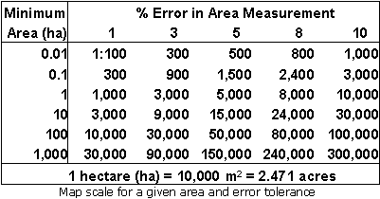

TABLE B:
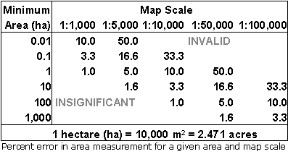
Which table (A or B) should you use to find sites for the baseball field? Table A
Step 4: Estimating error tolerance
Using the table you selected in step 3, estimate the error tolerance for the maps of the proposed baseball stadium sites:
Place your value here: Minimum area: 10 ha, Scale1:15,000,
Error Tolerance 1.6%

Map Scale Determination Questions (40 points)
Step 1: Determine the minimum area to be mapped
One of your information products is a statewide map showing water bodies. The map needs to show lakes larger than 25 acres, reservoirs larger than 25 acres, and playas larger than 50 acres.
What is the minimum size water body (in hectares) that needs to be mapped to create this information product?
Minimum size: 1:50,000

Step 2: Determine the percent error in an area
The information product description for the statewide water body map requires that the area of the water bodies being mapped needs to be accurate to within +/- 1 hectare. Using the minimum area to be mapped from step 1, determine the percent error in area that is acceptable.
What is the acceptable percent error in area? 5%
Step 3: Determine which error table to use
Review the two error tables in the previous set of questions (Tables A and B).
Which table should you use to find the appropriate sale for mapping water bodies?
Tables A and B
Step 4: Determine the map scale
Using the table you chose in step 3; determine the smallest map scale for the water bodies’ information product.
What is the smallest scale map that should be used? 1:100,000

Create a Data Error Tolerance Exercise (40 points)
As with the previous exercise, create an exercise that mimics the assignment above (minus the use of the discussion channel on blackboard). Select one or two data types that you want to use to create the questions regarding error tolerance and map scale. (Use the space below).
1. The military wants a map showing 500m² open areas within a 10km² area of operations for a new forward operating base.
2. Minimum Mapping Unit. 1:50,000
3. Error Tolerance. 5%
4. Smallest Map Scale. 1:100,000
Review of Metadata (20 points)
There are many sets of metadata for GIS data. Select a set of metadata from either the internet (e.g. TIGER/Line metadata) or any other source of data you can find (including the Valles Caldera).
Answer the following from the metadata. Place the name of the data in the line below:

DATASEST NAME (e.g. 1995 TIGER/Line data): tl_2011_us_mil

Step 1: Determine the source
What is the source of the data for this dataset? U.S. Census Bureau
Step 2: Determine the scale
What is the scale of the dataset? 1:100,000
Step 3: Determine the map projection. North American Datum 1983
What is the horizontal coordinate system for the dataset? Geodetic Reference System 80
Step 4: Determine the map accuracy 5%
What is the positional accuracy of the dataset? 5%
Step 5: Determine the data format
What is the format of the data? Tiger Line

