Benefit Cost Analysis & Risk Analysis

Discussion Questions: (100 Points)

Learning Objectives (when completed the student will be able to…)

1. Perform a cost-benefit analysis for Jasper National Park over a seven-year period.

2. Develop a practical awareness of the application of the benefit-cost analysis to determine the appropriateness of the investment in GIS.

3. Conceptually extrapolate this procedure to the Valles Caldera situation.

4. Intelligently discuss benefit-cost analysis with your peers.

Methods:

Use this document to perform the following steps (Place your answers here, rename the document by placing your last name before the 08 in the title. Submit this document as an attachment through the discussion tool):

PART I.

1. Identify costs per year

Below are the results of the Jasper National Park ‘s total costs over a seven-year period.

|  |  |  |  |  |  |  |  |
| --- | --- | --- | --- | --- | --- | --- | --- |
| Year (all figures in $1,000) | 2005 | 2006 | 2007 | 2008 | 2009 | 2010 | 2011 |
| Total Costs (non-discounted) | 25.25 | 335.69 | 217.58 | 167.08 | 166.88 | 216.98 | 117.08 |

The costs above are non-discounted amounts. Use a discount rate of 7 percent to calculate discounted costs to the base year of 1995. Enter the results in the table below.

|  |  |  |  |  |  |  |  |
| --- | --- | --- | --- | --- | --- | --- | --- |
| Year (figures in $000’s) | 1995 | 1996 | 1997 | 1998 | 1999 | 2000 | 2001 |
| Total Costs (discounted to 2005 | 23.48 | 312.19 | 202.35 | 155.38 | 155.20 | 201.79 | 108.88 |

2. Calculate benefits per year.

Below are the results of the Jasper National Park’s total benefits for their seven-year planning period.

|  |  |  |  |  |  |  |  |
| --- | --- | --- | --- | --- | --- | --- | --- |
| Year (figures in $000’s) | 2005 | 2006 | 2007 | 2008 | 2009 | 2010 | 2011 |
| Total Costs (discounted to 2005 | 0 | 0 | 192.2 | 214.7 | 606.7 | 1164.2 | 1701.1 |

The benefits above are in non-discounted amounts. Use a discount rate of 7 percent to calculate discounted benefits to the base year of 1995. Enter the results in the table below.

|  |  |  |  |  |  |  |  |
| --- | --- | --- | --- | --- | --- | --- | --- |
| Year (figures in $000’s) | 2005 | 2006 | 2007 | 2008 | 2009 | 2010 | 2011 |
| Total Costs (discounted to 2005 | 0 | 0 | 178.75 | 199.67 | 564.23 | 1082.71 | 1582.02 |

3. Create a graph to compare benefits and costs.

Use MS Excel to create a graphic similar to that below. Replace the graphic below with your graph. To produce the graph, take the results from steps 1 and 2 and manually create a line graph that compares discounted benefits and costs over the planning period.

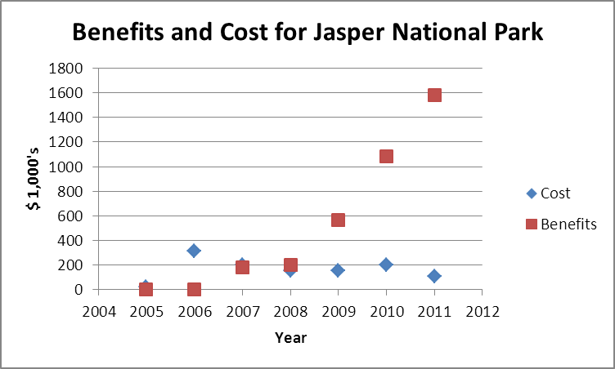

** Note the crossover point to a positive cash flow

4. Calculate cumulative benefits and costs

Calculate cumulative benefits and costs for each year. Enter the results into the table below.

|  |  |  |  |  |  |  |  |
| --- | --- | --- | --- | --- | --- | --- | --- |
| Year (figures in $000’s) | 2005 | 2006 | 2007 | 2008 | 2009 | 2010 | 2011 |
| Total costs | 25.25 | 312.19 | 202.35 | 155.38 | 155.20 | 201.79 | 108.88 |
| Cumulative costs | 25.25 | 337.44 | 540.79 | 696.17 | 851.37 | 1053.16 | 1162.04 |
| Total benefits | 0 | 0 | 178.75 | 199.67 | 564.23 | 1082.7 | 1582.0 |
| Cumulative Benefits | 0 | 0 | 178.75 | 378.42 | 942.65 | 2025.35 | 3607.35 |

5. Create a chart to compare cumulative benefits and costs.

Use the results from step 4 to manually create a bar chart that compares cumulative benefits and costs over the planning period. Graph the results using MS Excel and replace the graph blow with your own.

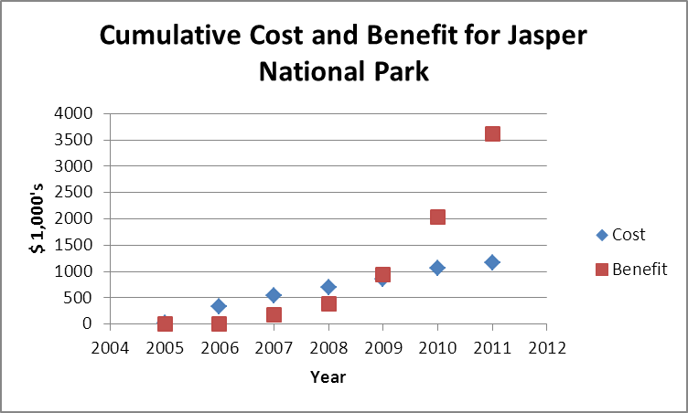

** Note when the cumulative benefits begin to exceed the cumulative costs.

6. Calculate the cumulative benefit to cost ratio

Use the results from step 4 to calculate the cumulative benefit to cost ratio for each year. Enter the results into the table below.

Cumulative Benefit to Cumulative Cost Ratio



PART II.

7. Answer the following questions:

a. From step 3 above: what is the crossover point to positive cash flow?

2008

b. From step 6, when do the cumulative benefits begin to exceed the cumulative costs?

2009

c. What is the discounted benefit-cost ratio over seven years?

3.111768613

d. Does this indicate that GIS at Jasper National Park is an appropriate investment?

Yes

GRADING:

Correctness: All answers correct (100 points), most answers correct (75 points), about half the answers are wrong (50) points, most answers wrong (25) points. No answers correct (0).