GIS Design: Summary Discussion

Discussion Questions: (100 Points)
In this exercise, you are going to discuss the overall progress of the design of a GIS that you have made through the first 8 exercises.

Learning Objectives (when completed the student will be able to…)
1. Intelligently discuss the overall process of GIS design prior to the development of the final Review and Procedure Planning & Benchmarking operations.
PART I.
Review the summary of the Fire Response information product description below. You'll use this information to answer the questions in the next step.
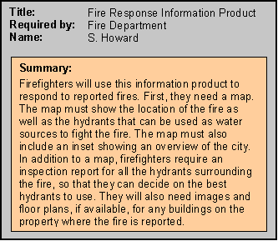

Answer the following questions: see the information from the fire response information product (originally provided in module 3) to answer the questions below. Refer to exercise 3 if needed.

1. What information and data will you provide to prospective vendors before the benchmark test? City maps will be provided as well as hydrant locations.

2. What will you ask vendors to demonstrate at the time of the benchmark test? What information will you need to do this? They will need to demonstrate the ability to provide relevant information products. In order to demonstrate this hydrant location and city maps will be required.

3. What functionality will you be testing? Testing will include the ability to develop information products relevant to the mission. This will include products that are needed immediately as well as products that are not. Budgetary constraints will also be taken into account.

4. What output products would you like displayed at the benchmark? What the best route to a fire would be and the closest hydrant to the location.

PART II.

Design a benchmark test for an information product required by the Valles Caldera.

Design a benchmark test to evaluate the ability of different systems to produce an information product for your own organization. First, decide which information product you will consider. Then, answer the same four questions as above:

1: What information and data will you provide to prospective vendors before the benchmark test? Maps of the VCNP as well as infrastructure data.

2: What work will you ask vendors to do at the time of the benchmark test? What will you have to observe and measure? Develop a product that will best demonstrate the information needed to develop infrastructure within VCNP.

3: What functionality will you be testing? How relevant it is to the VCNP. How closely it follows the VCNP mandates. How much it costs.

4: What output products will be displayed at the benchmark? Products demonstrating current and future infrastructure within the VCNP.

Part III.

Thought Question:

Answer the following question:

1. Provide a short succinct, but precise paragraph that describes your feelings regarding the importance or lack thereof of doing benchmarking in GIS design. Give some specific examples from your assignment and/or from the Valles Caldera information products at large. It is important to conduct benchmark testing to develop a successful GIS for several reasons. First, it allows you to see the development of the product. Second, it allows you to evaluate the products based on the needs of the organization. Third, it allows you to determine cost.

RENAME THIS DOCUMENT TO “MYNAME_EXERCISE_09” and return it via the assignment tool.

GRADING:
Part I & II answers: 10 points per correct answer
Part III answer: 20 points (insightful = 20 points), (correct but not showing much insight = 15), ( correct but with little effort or examples = 10), (marginally correct = 5).

