Rachel M. Mudrich
January 30, 2012
ISD 581 – Hypermedia Tools
Dr. Lewis
Anchored Instruction
In implementing what was learned about anchored instruction from this weeks’ lesson, I found that it was important to provide rigor and real world scenarios to apply what was learned. I have included screen shots taken from a website that I was doing research on UDL. I found this as a way to put what I had read in our reading this week into a real life scenario, to answer my problems: How can I use UDL to reach all types of learners, what are some examples of UDL in use? This website did a great job in providing more information, examples, and answering many of my important questions, in which I provided below.
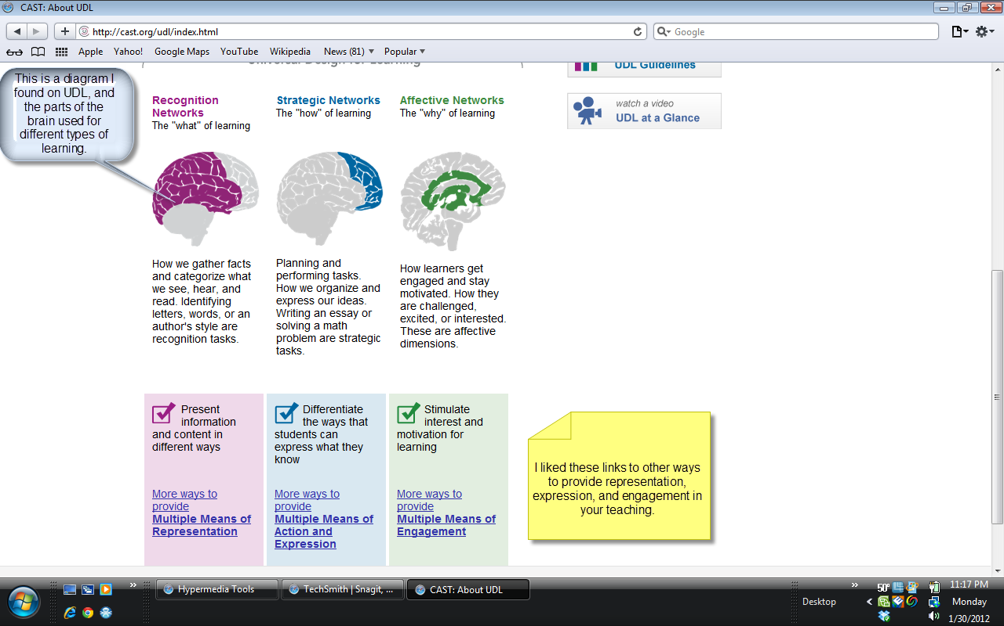
This first screen shot includes some notes I added. This was a neat visual representation of UDL and what areas of the brain we use to implement the three UDL principles: Representation, Expression, and Engagement.
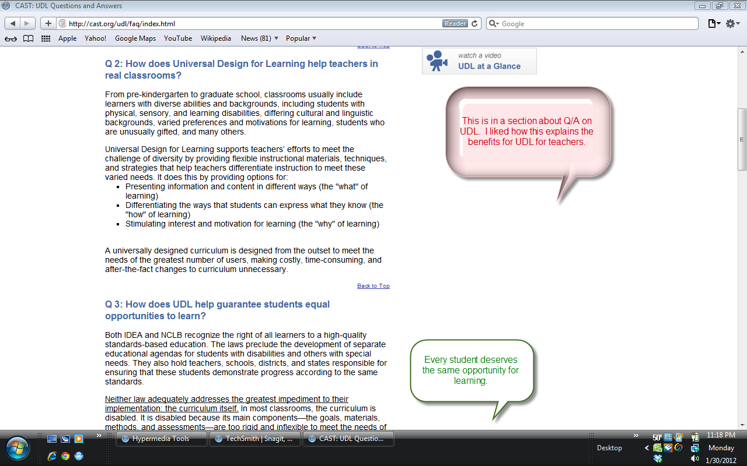
I came across several commonly asked questions about UDL and its implementation. I, as a teacher, was very informed after reading the answers to these questions. We as educators must be well prepared for any type of learner, and how to reach the needs of all learners as best we can. Each student deserves an equal opportunity to learn, as stated above.
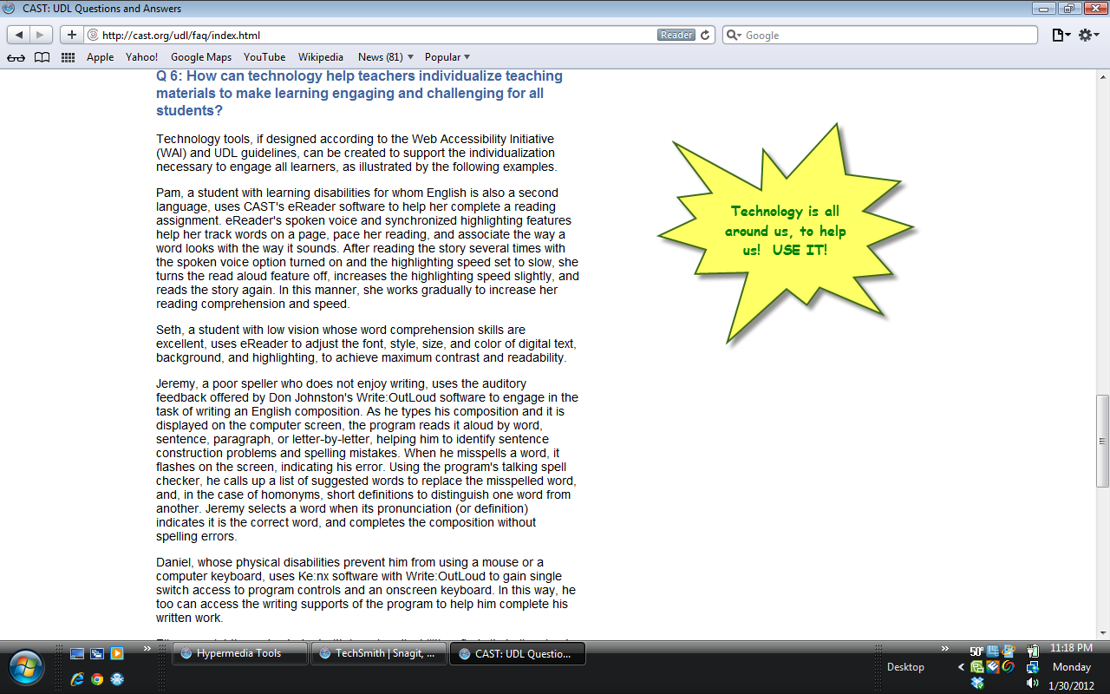
The technology train is at the station! GET ON BOARD! So many wide varieties of things are available to help us engage our learners in the technological world. We must realize how to use this tool to our advantage and engage more learners.
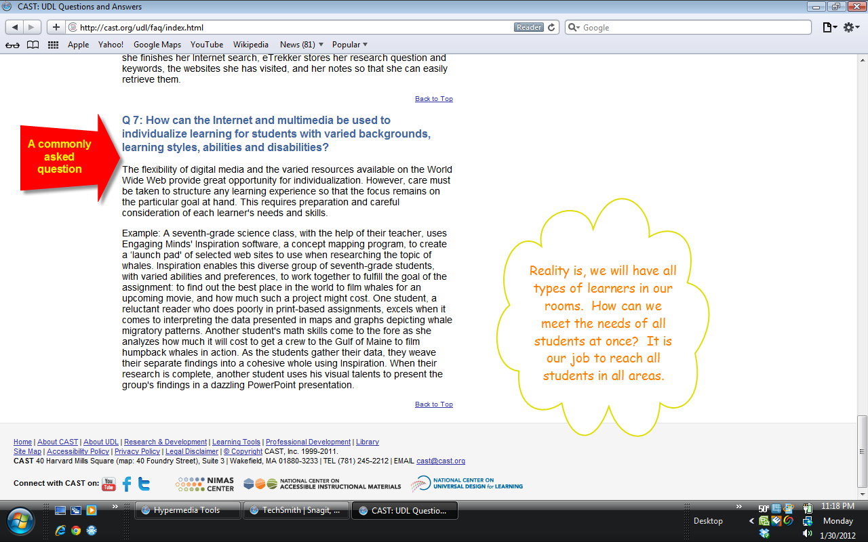
This question was most beneficial to me in my research, as I am always looking for new ways to keep my kids up with the changing of the times. I cannot stress enough my desire for people to realize that a teacher must be prepared to teach WHOEVER walks/crawls/enters through his or her doorway. Not every student has the best home life, support system, or mind ability; but every student deserves your best in every area, including life preparation. Thus, using up to date information and tools for every type of learner gives the student the best opportunity to build their future.

