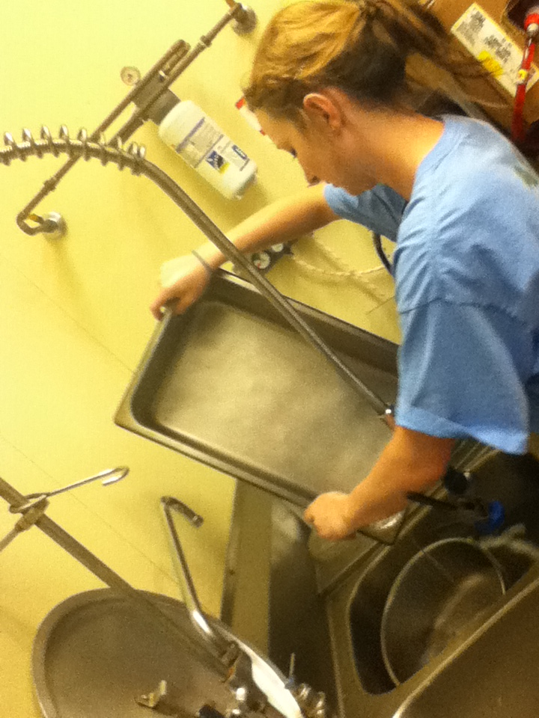

Me doing everyone’s dishes, because I’m a nice person.

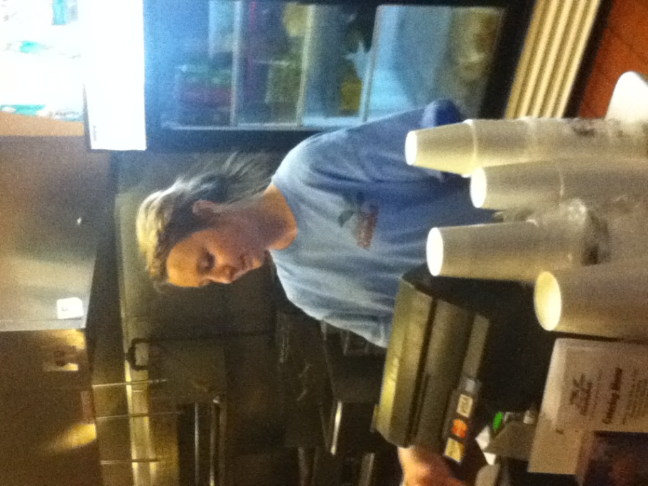

Working the cash register at Café Rumba.