
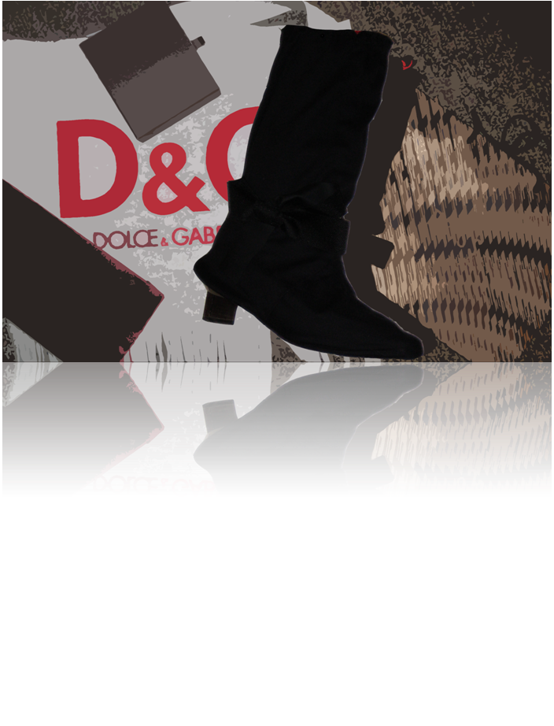
X2 Team 4
Spring Semester
April 15th, 2008
Heart & Soles
HEARTS&SOLES
INC.

This business plan is the original work of the undersigned. All facts and figures are authentic. All contributions from others have been appropriately acknowledged.

Michael Boyd Jr. Khanh Nguyen
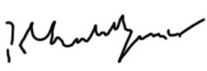
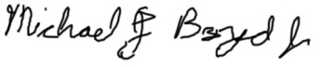
__________________ __________________

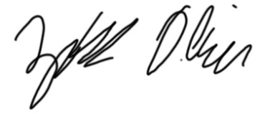
Katherine Djaferis Zachary Oliver
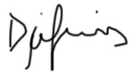
__________________ __________________

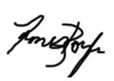
Regina Enriquez James Rochon-Boyle
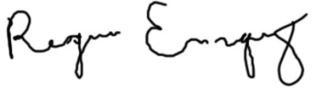
__________________ __________________

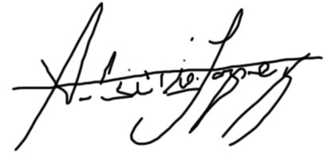
Alberto Lopez Stephanie Sousa
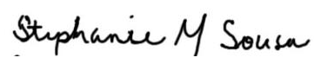
__________________ __________________

Table of Contents
EXECUTIVE SUMMARY 1
CORPORATE SOCIAL RESPONSIBILITY 3
PRODUCT AND CUSTOMER OVERVIEW 5
INDUSTRY AND TRENDS 5
Competitor Analysis 7
MARKETING 10
Market Segmentation 11
Target Segment and Characteristics 12
Marketing Objectives 13
Communication Strategy 14
Company Logo and Colors 14
Pull Strategy 15
Push Strategy 18
Year 2-5 19
Measurement of Effectiveness 20
Packaging 20
Channels of Distribution and Sales 20
Pricing 21
Sales Force 22
Base Case 22
Worst Case 23
OPERATIONS MANAGEMENT 25
Product Design 26
Supply Chain 27
Production and Staffing Plan 33
Year 1 Production 35
Year 2 Production 35
Year 3 Production 37
Year 4 Production 38
Year 5 Production 38
Best and Worst Case Production 38
Best Case 38
Worst Case 39
Improving Our Business Processes 40
Improving Product Design 41
INFORMATION SYSTEMS 43
The Business Model and Organizational Goal 43
Value Chain 43
Critical Success Factors 44
Creating Value-Added Processes 46
Inbound Logistics 46
Operations 46
Outbound Logistic 46
Marketing & Sales 47
System Design 47
Inbound Data 47
Outbound Data 48
Entity Relationship Diagram 48
Software Evaluation Process 49
Fully Integrated vs. Best of Breed Evaluation Process 49
Implementation 51
Technology Startup Requirements 51
Integration with Finance 55
Future Technology 55
Costing 56
FINANCE 57
Base Case Analysis 58
Ratios Analysis 60
Major Business Risk 62
Worst Case Analysis 64
Best Case Analysis 64
Why Investors Should Choose SoleMates 65
CONCLUSION 65
APPENDICES 66

Table of Contents

Appendix MK-01: Awareness Levels Years 0-5 Error! Bookmark not defined.
Appendix MK-02: Spending Levels Years 0-5 Error! Bookmark not defined.
Appendix MK-03: Magazine Advertisement 1 Error! Bookmark not defined.
Appendix MK-04: Magazine Advertisement 2 Error! Bookmark not defined.
Appendix MK-05: Focus Groups Summaries Error! Bookmark not defined.
Appendix MK-06: Press Release Error! Bookmark not defined.
Appendix MK-07: Promotional Brochure Error! Bookmark not defined.
Appendix MK-8: MySpace Error! Bookmark not defined.
Appendix MK-9: 30-second Video Storyboard Error! Bookmark not defined.
Appendix MK-10: Product Life Cycle Error! Bookmark not defined.
Appendix MK-12: Base Case Error! Bookmark not defined.
Appendix MK-14: Best Case Error! Bookmark not defined.
Appendix OM-01: House of Quality Error! Bookmark not defined.
Appendix OM-03: Supplier Locations Error! Bookmark not defined.
Appendix OM-04: In-House Production Process Error! Bookmark not defined.
Appendix OM-05: Facility Layout Error! Bookmark not defined.
Appendix OM-06: Aggregate Planning Year 1 Error! Bookmark not defined.
Appendix OM-07: Aggregate Planning Year 2 Error! Bookmark not defined.
Appendix OM-08: Aggregate Planning Year 3 Error! Bookmark not defined.
Appendix OM-09: Aggregate Planning Year 4 Error! Bookmark not defined.
Appendix OM-10: Aggregate Planning Year 5 Error! Bookmark not defined.
Appendix OM-11: Bill of Materials Error! Bookmark not defined.
Appendix OM-12: Product Blueprint Error! Bookmark not defined.
Appendix OM-13: Process Flow Diagram Error! Bookmark not defined.
Appendix OM-14: Employee Organizational Breakdown Year 1 Error! Bookmark not defined.
Appendix OM-15: Employee Organizational Breakdown Year 2 Error! Bookmark not defined.
Appendix OM-16: Employee Organizational Breakdown Year 3 Error! Bookmark not defined.
Appendix OM-17: Employee Organizational Breakdown Year 4 Error! Bookmark not defined.
Appendix OM-18: Employee Organizational Breakdown Year 5 Error! Bookmark not defined.
Appendix OM-19: Base Case Inventory Error! Bookmark not defined.
Appendix OM-20: Base Case Production Schedule Hiring and Purchases Error! Bookmark not defined.
Appendix OM-21: Best Case Inventory Error! Bookmark not defined.
Appendix OM-22: Best Case Production Schedule Hiring and Purchases Error! Bookmark not defined.
Appendix OM- 23: Worst Case Inventory Error! Bookmark not defined.
Appendix OM-24: Worst Case Production Schedule Hiring and Purch Error! Bookmark not defined.
Appendix IS-01: DFD Error! Bookmark not defined.
Appendix IS-02: Finance and Accounting BOB Error! Bookmark not defined.
Appendix IS-03: CRM BOB Error! Bookmark not defined.
Appendix IS-04: Supply Chain Management Error! Bookmark not defined.
Appendix IS-05: Costing Error! Bookmark not defined.
Appendix FE-01: Base Case Balance Sheet Error! Bookmark not defined.
Appendix FE-02: Year 0 Start-up Costs Error! Bookmark not defined.
Appendix FE-03: Assumptions Error! Bookmark not defined.
Appendix FE-04: Base Case Income Statement Error! Bookmark not defined.
Appendix FE-05: Base Case Cash Flows Error! Bookmark not defined.
Appendix FE-06: Risk Factors Error! Bookmark not defined.
Appendix FE-07: Margin of Safety Error! Bookmark not defined.
Appendix FE-08: Worst Case Income Statement Error! Bookmark not defined.
Appendix FE-09: Worst Case Balance Sheet Error! Bookmark not defined.
Appendix FE-10: Worst Case Cash Flows Error! Bookmark not defined.
Appendix FE-11: Best Case Income Statement Error! Bookmark not defined.
Appendix FE-12: Best Case Balance Sheet Error! Bookmark not defined.
Appendix FE-13: Best Case Cash Flows Error! Bookmark not defined.

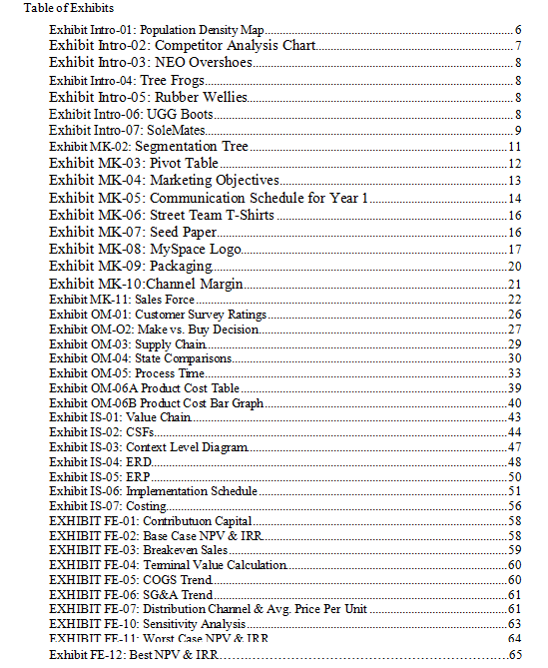

EXECUTIVE SUMMARY

SoleMates are a lightweight and portable alternative to rain boots or carrying around an extra pair of shoes. Fitting easily over heels, our product is a shoe cover that zips up to the calf, protecting a woman’s heels and helping to keep her feet dry. The key benefits of our product are that it is worn over heels and can be compressed for easy storage in a tote bag. SoleMates eliminate the annoyances of having to choose what shoes to wear because of rainy or snowy conditions.
Our company’s target market consist of females ages 18-24 and 25-44 who find themselves having to carry around an extra pair of shoes due to inclement weather or find themselves wearing heels on a regular basis. These two age segments will allow us to easily and effectively target the needs of young and established professionals, while marketing to them in a distinct manner.
We decided to target the Northeast, selling SoleMates through independent retailers and online through our website during the first two years. Beginning in year 3, the mix of distribution channels will change as we expect to get shelf space in Macy’s and Nordstrom’s. We also plan to rollout distribution to nine additional states in the Midwest and Mid-Atlantic. In year 4, we will continue to increase penetration of department stores and rollout into 6 states in the South and West. In year 5, we will drop our product from independent stores, continue selling direct online through our website, and penetrate our department stores even further. The retail price of our product will charge throughout its lifecycle. Initially, the price will be $27.99 and it will decrease to $24.99 in Year 3.
We have decided to manufacture SoleMates in-house instead of subcontracting. Our company can take advantage of economies of scale by Year 5, making the investment in production equipment cost effective. Most of our raw materials suppliers are located in the Midwest, and all are located in the United States. These suppliers will ship materials to our facility in Owensboro, Kentucky where the final product will be tested in our facility, before being packaged and shipped off to our retailers and customers. The costs we expect to incur include shipping cost from suppliers, raw material cost, inventory cost due to seasonality of our product, machinery cost, and direct labor cost. Direct costs amount to $6.84 per unit in the first year of production and will decrease in the years following.
In Year 1, we will use an integrated marketing communications strategy to generate over 15% awareness in each target segment. We plan on doing so through street team demonstrations, sending out press kits to get coverage in local publications, and hosting a product launch party sponsored by local retailers. We have budgeted $115,000 for marketing in year 1, and by year 5 we will spend $508,988 and will generated 29.13%.
Customer satisfaction will be a key to our company’s success. Managing our product quality will have a big impact in this area. We will test 20 percent of all shoe covers that we produce, which will help minimize the external defect rate. We also want to maintain good relationships with our retailers by providing them with our product when they need it. Specifically, it is our goal to achieve a 99.35% service level. The cost of holding our inventory is low compared to the cost of stocking out, and this service level is our optimal.
Total capital required from investors is $996,791, which makes up 75% of total capital needed. Investors will receive 60% ownership of the company for their investment. This amount will be paid out over the first 3 years until our company becomes cash flow positive in Year 4. Our business will earn investors a competitive return. Investor net present value using a 25% discount rate is $865,904 and the investor internal rate of return is 38.85%.
Unit sales will grow from 8,700 in Year 1 to 382,092 in Year 5. Our total sales in Year 5 are $5,170,499, and we do not expect our business to peak until year 8. Our product life cycle of 12 years means a substantial terminal value of our business in the peak year.

CORPORATE SOCIAL RESPONSIBILITY
SoleSupport
In addition to designing a beneficial product for women everywhere, Heart&Soles’ mission is to make a positive contribution to our planet. We have created the SoleSupport initiative and the slogan; Give.Save.Protect.
Give
Give is the charitable side of our organization, we will partner with Soles4Souls, a charity that provides shoes to those in desperate need around the world. In the brief four years they have been in existence, Soles4Souls has provided over a million pairs of shoes to people around the world – such as the United States during the hurricane Katrina disaster.
Donations are accepted in many different forms from odds and ends to used shoes. This company works hard to use what they can get to create functioning shoes. With a distribution center near our production plant, we will easily be able to donate scrap material from our production such as fabric, rubber, and thread.
Our main support to the charity will be made by donation cards that will be packaged into each of our product boxes. The card contains a brief description of our product and an online code that gives our customer access to donate money to the Soles4Souls charity through our website. In addition, Soles4Soles depends on large shoe drives and benefit concerts to stay in operation. We plan to sponsor a few of these events to create awareness about our dedication to their cause.
Save
Our partnership with Women&Co. will help our female customers understand how they can budget their financial situations and save money. Women& Co. “was created to address the unique needs of women as they seek more command over their personal finances. Their goal is to help women feel that their money is working for them—not the other way around.” There are a number of incentives that make this partnership beneficial. Women&Co. have a large active membership of women who tend to be eco-friendly and charitable. There are many opportunities of women being aware of our product available to us such as a monthly newsletter sent out to all the members.
Protect
Our company image will go beyond offering a shoe cover, but will invoke a lifestyle of protecting the environment. Heart&Soles will only use recyclable paper for communication and eco-friendly packaging. Seed paper will also be used for the donation cards in our packaging that can be planted in soil. Our company will avoid using toxic chemicals or animal products which will set us apart from other footwear companies in the industry.
Heart&Soles believes in giving back to the community and the environment. By implementing Give.Save.Protect, not only will we portray a good message but increase sales of our product as we get noticed for our efforts.

PRODUCT AND CUSTOMER OVERVIEW
The Product
SoleMates are portable, weather resistant shoe covers that women can wear to protect their high heeled shoes on their everyday commute. With their stylish boot-like appearance, the covers reach mid calf, keeping ankles and pants dry. Made from vinyl coated polyester lined with nylon oxford cloth, SoleMates are easy to compress and store, unlike the hassle of wearing heavy rain boots or carrying an extra pair of shoes. A small, waterproof tote bag will be included in which the shoe covers can be folded into and tucked away for later use.
Rubber strips at the bottom of the shoe cover will allow for extra traction on slippery surfaces. In addition, a small rubber around the area where the heel is exposed will prevent water from entering the shoe cover. Although SoleMates are available in one size, they can easily be adjusted for all sizes with a fashionable bow around the ankle. Offered in a neutral black color, the shoe covers are made to be versatile for any outfit and occasion. Overall, our product will help eliminate the annoyances associated with choosing what shoes to wear on days when weather is unpredictable.
The customers that will use SoleMates are mainly women between the ages of 18 to 45 who wear high heeled shoes and care about protecting them. These women live in or around urban areas and rely on walking or public transportation for their daily commutes.

INDUSTRY AND TRENDS
Heart&Soles Inc. is a company within the Rubber and Plastics Footwear Manufacturing Industry. A major trend that affects our distribution strategy is the rising US population in urban areas. Since three fourths of the US population lives in urban areas, SoleMates will launch in urban areas in the northeast during its first year and then expand to the rest of the country. We will start in the North East because that part of the country has the highest average population per square mile (see Exhibit Intro-01) and then we will begin moving out of the North East in the third year. By year five we will have essentially put our product on the shelf of retailers in all of the major regions of the United States.
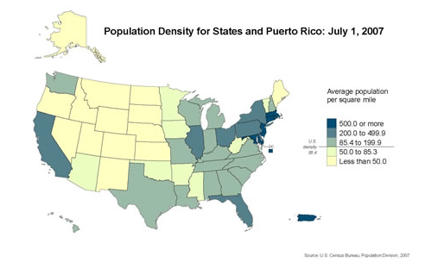
Exhibit Intro-01: Population Density Map
A technological trend that we found is an increase in online retailers within the footwear industry. Because of this trend, we will have to continue to keep our websites updated and fun as well as perhaps selling into more online distributors in order to gain more sales in years to come.
A social trend within our industry will be “The emergence of certain types of shoes as fashion staples rather than fleeting trends has helped boost sales.” To ensure the success of SoleMates as a fashion staple, rather than a fleeting trend, we will focus on updating the design of our shoe cover. We must constantly be ahead of the fashion trend and continue to focus on our customer’s likes and dislikes, their channels of communication, as well as their lifestyles. We will also look into repositioning our product in later years, as well as branching out towards children and male market segments.
Another important aspect for the success of SoleMates is the donation card we place in each box to make donations to Soles4Souls. By having a connection with a humanitarian cause in our marketing campaign, our customers will know they are helping a cause by purchasing our product and donating to the charity using our recycled paper donation cards. SoleMates makes it easier to donate by giving the customer access to donate through our website.

Competitor Analysis
SoleMates competes with many products in the footwear industry, however no other product offers the same key benefits. Our product distinguishes itself from others in that it fits over heels, is lightweight, and adjustable. SoleMates are also portable and fold into a water proof 10 by 6 inch tote bag that will fit into most purses, keeping the contents of the bag dry. In addition, they can be purchased at a relatively inexpensive price of $27.99.
Within the footwear industry, our four main competitors include; Neo Overshoes, Tree Frogs, Rubber Wellies, and UGG boots (See Exhibit Intro-02).

Product Name | Price | Strengths | Weaknesses
Neo’s Overshoes | $ 85 | 100% waterproof, lightweight | Not compatible with heels, not fashionable, bulky, expensive
Tree Frogs | $ 20 - $ 50 | Waterproof, slips over your regular sneakers  Comes in a range of sizes, inexpensive | Bad traction on soles  Only covers sneakers until laces
Rubber Wellies | Ranges from $15- $300 depending on designer | 100% Waterproof  Keeps pant hems dry and protected  Fashionable, comes in a variety of colors | Cold in the snow  Heavy to carry as an extra pair of shoes
UGG Boots | $ 80 - $200 | Warm, stylish,  Variety of shoe sizes | Heavy to carry, expensive, not waterproof, not worn over shoes
SoleMates | $ 27.99 | Worn over heels, portable, protects heels and pants, light-weight, comes with tote bag for carrying, durable and inexpensive, has liner for warmth, weather resistant. | May be cold in winter, not completely waterproof, only comes in one adjustable size, only comes in one color.
Exhibit Intro-02: Competitor Analysis Chart

NEO Overshoes
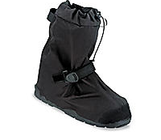
NEO overshoes are similar to our product because they are worn over shoes and shields harsh weather conditions (See Exhibit Intro-03). Although completely waterproof, NEO overshoes are only compatible with sneakers and flats and are relatively expensive at $85.
Exhibit Intro-03: NEO Overshoes

Tree Frogs

Tree Frogs made by Amphibious Sportswear, Inc., range from $20 to $50 and are worn over regular walking shoes (See Exhibit Intro-04). They come in a variety of sizes for men and women, ranging from small to extra large. However, Tree Frogs only cover the base of a shoe, giving no protection to the bottom of pants. They also have bad traction for use in slippery conditions.
_{Exhibit Intro-04: Tree Frogs}

Rubber Wellies
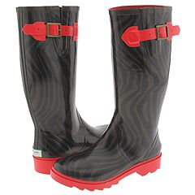
Rubber Wellies are plastic rubber boots that come in a variety of colors, prints, sizes and heights (See Exhibit Intro-05). They are 100% waterproof and keep pants dry and protected when tucked into them. However, Rubber Wellies can be very expensive depending on the designer, with prices ranging from $15 to $300. In addition, Rubber Wellies are bulky and heavy making it less practical to carry in a bag or purse.
Exhibit Intro-05: Rubber Wellies
UGG Boots
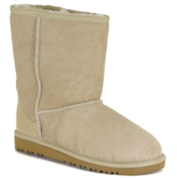
UGG Boots, made by Deckers Outdoor Corporation, are warm, stylish, and come in a variety of shoe sizes for men and women (See Exhibit Intro-06). The price of UGGs range from $80 to $200 depending on the style, and are not meant to be worn over shoes. UGG Boots are also heavy and not waterproof, making them unpractical to wear in the rain.
_{Exhibit Intro-06: UGG Boots}
SoleMates
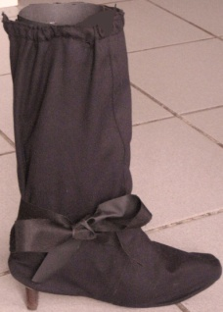
SoleMates offer something our competitors do not: a portable, lightweight shoe cover for high heeled shoes (See Exhibit Intro-07). Our product will not necessarily affect our competitor’s sales as it is differentiated by its key benefits within the industry. SoleMates target women ages 18-45 who care about protecting their shoes against inclement weather conditions and want a practical, lightweight, portable alternative to carrying heavy boots and shoes in their purses on their way to school, work, or a night out on the town.
_{Exhibit Intro-07: SoleMates}

MARKETING
“I don’t design clothes. I design dreams.”
Ralph Lauren

Market Segmentation
SoleMates’ market segmentation tree begins with total number of women in the United States which is then separated into two target age groups; 18-24 and 25-44. This age division accounts for different purchase intents and lifestyles of women in each segment. Originally, the age groups were 18-24, 25-34 and 35-44, but we combined the last two segments based on similar communication channels (See Exhibit MK-01).
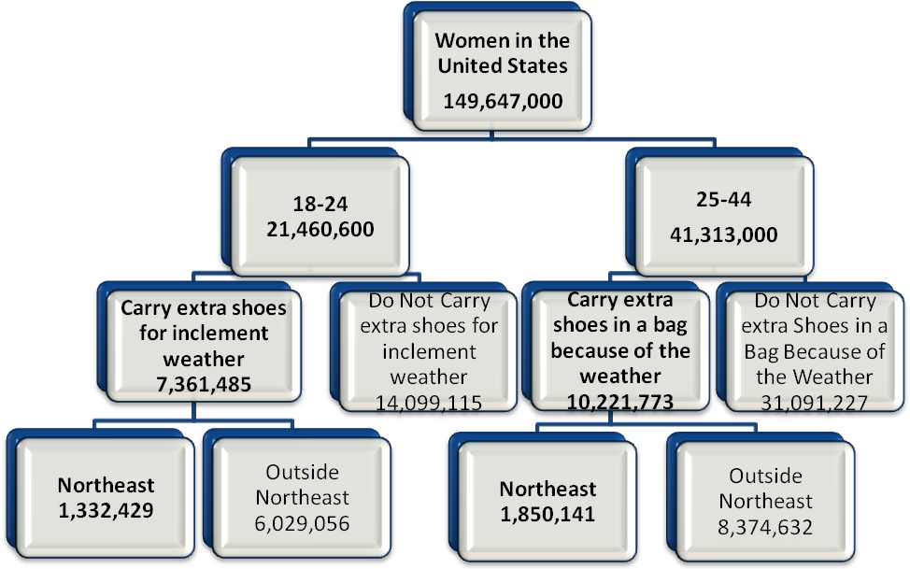
Exhibit MK-01: Segmentation Tree
We further break down the age groups into women who carry extra shoes for inclement weather and those who do not. Finally, the segments are then broken down into women who live in the Northeast and those who do not. We then applied this percentage to each of the psychographic segments to find the total number of women in our target market We decided to use a regional rollout for our product because it is more cost efficient and effective since.
Even though we are targeting women who carry an extra pair of shoes due to unpredictable weather, our market surveys concluded that women outside that psychographic found other benefits in purchasing SoleMates (See Exhibit MK-02). Therefore, when awareness was calculated, we included all the women in the Northeast within our target age ranges. We then can account for women who do not regularly carry an extra pair of shoes but are concerned with the protection of their heels.
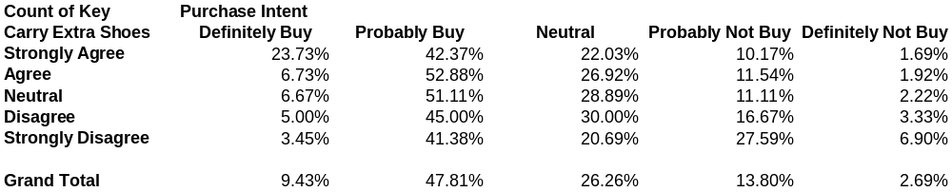
Exhibit MK-02: Pivot Table – Purchase Intent vs. Carrying Extra Shoes b/c Weather

Target Segment and Characteristics
Our primary target segments are women ages 18-24 and 25-44, who carry an extra pair of shoes due to inclement weather and live in the Northeast region. These segments, in total, account for 3,182,570 women (See Exhibit MK-01). Each segment is differentiated by its own set of characteristics. Women ages 18-24 are usually attending college or graduate school. These women are in the beginning stages of financial independence and are into the latest fashion trends. According to Mintel, segments “aged 18-24 are most likely to have the desire to purchase more shoes but are without the means to do so. These young women also find shoe shopping a pleasure and will buy shoes they do not need but want.” Of these women, 24% of them will have purchased at least four or more pairs of shoes within the last year. These women also depend on communication strategies through text messaging on cell phones, use of the internet, or from watching television.
Women ages 25-44 are either becoming established in the work force or are already at the peak of their careers. They are financially independent, some have families, and they rely on advice from friends and family for most everyday purchases. They are less likely to make impulse purchases, and instead purchase shoes for practicality and function. These women are fashion savvy, but they receive their information through magazines such as Cosmopolitan, Vogue, or through television.
Both segments make up 64% of women in the Northeast who have purchased casual and dress shoes, not including athletic wear, within a 12 month period as stated by a survey taken in March of 2007. In addition, Mintel states that,
Women living in warmer climates have more opportunity to wear shoes that are meant to be shown off and that will not suffer from inclement weather In comparison, at least some women who live in the rainy and snowy Northeast and Midwest regions of the country are likely to seek out and regularly wear shoes that are purely utilitarian, offering comfort and warmth.

Therefore, women in our segments will have a need for our product for they constantly seek out alternatives that will that will provide them with protection from inclement weather conditions.

Marketing Objectives
The following three objectives are critical in the success of our business (see Exhibit MK-03).
- Spend 2/3 of Yearly Sales on New Marketing Strategies
- Enter into National Department Stores such as Nordstrom and Macys by Year 3 Which Will in the End Increase our ACV to at east 20% by Year 5.
- Obtain 30% Acceptance into Independent Shoe Stores by Year 1

Exhibit MK-03: Marketing Objectives
Since our target market is constantly growing, it is crucial that we spend two thirds of our sales on new innovative marketing strategies to increase our appeal to new consumers. In order to increase our ACV in year 5 we must enter into Nordstrom and Macys by year 3. To do this, we will avoid using manufacture’s sales representatives by hiring our own sales department that will only focus on promoting SoleMates. During the introduction phase, acceptance into 30% of independent shoe stores (in year 1) will help us generate higher sales revenues in years 3 and 4 due to informed consumers. Successfully implementing our communication strategy will enable us to achieve our critical success factors.

COMMUNICATION STRATEGY
Our communication schedule consists of both push and pull strategies to convey the key benefits of using SoleMates to each of our target segments. During Year 1, our pull strategies will create 16.11% awareness in segment 1, and 16.47% awareness in segment 2. Push strategies for Year 1 will account for .83% awareness in segment 1, and 1.01% awareness in segment 2 (See Exhibit MK-04). Also, in Year 1 we will be spending $98,564 on pull activities and $17,332 for push activities, for a total marketing budget of $115,896. The combination of push and pull activities will help emphasize our unique selling proposition;
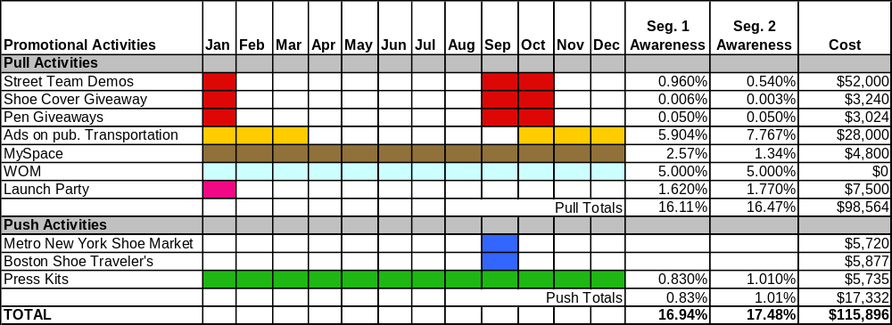
SoleMates are weather-resistant shoe covers designed to fit over most women heels. SoleMates creates a lightweight, compact alternative to regular rain boots or lugging two pairs of shoes around – perfect for those rainy days at the office. SoleMates are able to withstand harsh weather while maintaining a fashionable design.
Exhibit MK-04: Communication Schedule for Year 1

Company Logo and Colors
Each of our advertisements will include our company logo along with our slogan, “Your heels’ perfect match.” The logo consists of white glowing letters on a black background (See Exhibit MK-05). We choose the color scheme of red, white and black to in order to make our product name stand out. Our product logo will be placed on all marketing materials to promote our brand image.
_{Exhibit MK-05: Product Logo}

The heart indicates the protection that can be provided by our product for women’s high heeled shoes and the feeling associated with the use of SoleMates; Women will love wearing our product because it allows them to wear their favorite pair of shoes on days when weather conditions would have otherwise prevented them from doing so. Our company name, Heart&Soles Inc. is consistent with this theme, assisting with the promotion of our brand image. The letter L is a little boot that represents our boot-like product. The color red invokes strong reactions and draws people’s attention and is normally associated with strength and authority. At the same time, black is linked to elegance and power. These two colors together will create an eye-catching advertisement sure to impress our customers.
Year 0
In order to target retailers and generate awareness prior to Year 1, we have scheduled push activities for Year 0. Due to the seasonality of our product we expect most of our demand in winter months. Year 0 activities will help us to prepare for our January product launch. These push activities will include sending out press kits to 300 publications with the expectation to be written about in at least six of them. We will also attend two Northeast trade shows. This will help us to inform our retailers and consumers of our product before entering our independent retail channels in Year1. We will have our CEO/Marketing Manager and MySpace/website employee attending these events. The total cost for attendance will be $11,597. This includes set up and space fees, giveaways, and the cost of employee expenses (See Appendix MK-02).
Year 1
The communication schedule for Year 1 includes a series of push and pulls activities. In total we will generate at least 17% awareness in each of our target segments, spending a total of $125,161. While some forms of promotional activities are in effect all year, such as our MySpace page and press kit mailings, we have scheduled most of our promotional activities to take place in the fall and winter months.

Pull Strategy
In order to build up consumer awareness, our company has created a diverse pull strategy consisting of promotion via street team demos, ads on public transportation, MySpace, a launch party, and Word-of-Mouth.
Street Team Demonstrations
We will be using approximately 45% of the total marketing budget on street team demonstrations, as we expect to generate 1.5% awareness in our target markets (See Exhibit MK-04). These demonstrations will be used to expose the details of our product and allow consumers to test its integrity prior to purchase. They will be held in high traffic areas of Boston, New York, and Philadelphia during the months of January, September, and October. We have selected September and October to generate awareness prior to our busy winter season. January will help reinforce our products benefits at a time of harsh weather conditions.
Exhibit MK-06: Street Team T-shirts
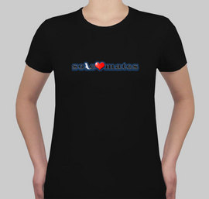

In order to promote our product our three person street teams will wear custom t-shirts displaying our logo (See Exhibit MK-06). Each member will show the product in action and allow volunteers to try it on. They will also pass out pens personalized with our logo and website address. Additionally, we will hand out postcards made out of seed paper, containing our logo and an image of our product. These postcards are made of recycled paper with seeds embedded inside. They are completely biodegradable and can be planted in soil (See Exhibit MK-07). We hope that this innovative technique will help further our eco-conscious image. Together, these giveaways will increase our awareness by an additional .1%.
_{Exhibit MK-07: Seed Paper}

By using these street demonstrations we can display the unique functionality and ease of use of SoleMates to our target segments in the Northeast.
Advertisements on Public Transportation
To add to our communication strategy, we will use billboards inside of public transportation stations to gain 13.67% awareness of our target market (See Appendix MK-01). Women who use public transportation will be able to see our advertisements multiple times per day on their commute; an occasion we expect our product to be used. Signs and billboards will be posted in busy subway stations in Boston, Massachusetts and Philadelphia, Pennsylvania.
We will not be using MTA in New York City because the cost of each impression is extremely high due to a low impact rate. Also, each station has far more advertisements competing for attention than the cities we have selected. Instead, we will use Amtrak as another outlet for our transit advertising. We will place advertisements on their high-speed Acela line, which travels through the Northeast. Stops on this train route include; Philadelphia, Trenton, New York, New Haven, Providence, and Boston.
MySpace

MySpace, the international internet phenomenon, will be used to communicate directly with our customers. By sending 5,000 friend requests directly to women in our target segments each year, we will be able to produce 3.91% awareness (See Appendix MK-01). Since internet advertising can be unreliable
_{Exhibit MK-08: MySpace logo}
and costly, we have decided to use MySpace as advertising for our company website. There will be multiple links to LoveSoleMates.com which is where our customer can purchase our product directly. Our SoleSupport pledge of, “Give.Save.Protect,” will be described in detail, giving information on how the visitor can become a part of our cause. (Reference back to CSRs) A 30-second video advertisement will also be on our MySpace page so the visitor can see how our product works.
One of the most popular trends on social networking websites is taking personality quizzes. We will create a quiz titled, “Which designer shoe are you?” The visitor will answer a few questions and then receive a response with a picture of their designer shoe match result. Our logo and website address will be at the bottom of all results, which the visitor can then post on their personal MySpace page for all of their friends to see. The picture will be a link to our MySpace page where their friends can click and explore our company site and take the quiz themselves.
Launch Party
In January of Year 1, we plan to hold a launch party in Boston, Massachusetts that will generate an expected 3.39% awareness. The guest list will include Northeast retailers as well as some of their most loyal clients. We will also invite local artists to display their work and stage a fashion show for a designer selected by us. Local and regional advertisers will be welcome, which will cover costs beyond our budget. Our partner charity, Soles4Souls, will have a representative present to talk about our common mission. The venue will be decided based on how many people are interested and what advertisers would like to be a part of this event. Press will also be invited to cover the event, which will help us generate awareness through their coverage. Our street team demonstrators will walk around the event showing our product, and finally they will be the last to walk in our fashion show. This event will help us display the practicality of our product, but with a fashionable flair. Our prospective retailers and customers who attend will get an idea of our company goals and an amazing display of our product in a trendy and fun atmosphere.
Word-of-Mouth
Word-of-Mouth is the most cost-effective way of increasing awareness since no actual cost is incurred by our company. Whether seeing one of our ads, reading about our launch party, using one of our pens, encountering one of our street team demonstrations, or visiting our MySpace, we expect people to share their experience with others. We will continue to come up with unique marketing campaigns that will intrigue people’s interest and spread through conversation.

Push Strategy
Our push communication strategies have been designed to increase our future acceptance into stores by effectively promoting our product through the following methods.
Trade Shows
Heart&Soles will attend the Metro New York Shoe Market and Boston Shoe Traveler’s shows, both held in September of Year 1(See Exhibit MK-04). Our CEO/marketing manager and website/MySpace manager will present our product and speak with major retail representatives prior to the winter season.
The Boston Shoe Traveler’s show is a three day event held in Manchester, New Hampshire. The show hosts approximately 300 specialty stores and shoe retailers from the Northeast region, and the event will incur a total cost of $5,720 (See Appendix MK-02)
The Metro New York Shoe Market is a two day event held in Edison, NJ. This event caters to over 400 retailers and will cost $5,788 for Heart&Soles Inc. to attend. This cost includes travel expenses, giveaways, advertisements and the cost of designing a booth. Since only shoe retailers and industry professionals attend these shows, 0% awareness is created.
Press Kits
A total of 100 media kits will be sent to regional and national magazines all year long generating a total of 1.84% awareness of our target segments in Year 1. As was described before, press kits will include a pair of SoleMates, product brochure, media disc, SoleSupport information, press release and business card. The media disc will be a DVD including images of our product; current advertisements and a 30 second commercial (See Appendix MK-09). Retailers will receive a “push” version of our brochure in their press kits, offering tips on how to sell our product to their customers.

Year 2-5
In Years 2-5, we plan on maintaining the mix of push and pull strategies from Year 1, (with the exception of a launch party) with the following additions:
In Year 2, we will keep our marketing budget at $119,036 and introduce our first print ad in the Boston Globe attachment, Lola generating .29% awareness. Our main goal is to focus on penetrating this market deeper, and capitalize on the most successful strategies.
Year 3 will be a large transition for our company since we expect to enter national department stores. We will experience a price change, and huge ACV growth. At this time, we expand our street teams and public transportation advertising to at least one city in each of our new states. In this year we will plan on attending the New York Shoe Expo in New York City, the largest footwear trade show on the east coast with over 4,000 retailers attending. Our budget will grow to $154,645 to accommodate for these new promotions and expect our total awareness from all Year 3 activities to be 21.9 % (See Appendix MK-01)
Finally, in Years 4 and 5 we will have our first national advertisement in Cosmopolitan, a women’s magazine with a circulation of almost 3 million people.(cite) We have chosen Cosmopolitan because it will help us generate the highest awareness in our target segments based on their demographic data (See Appendix MK-11). We will attend the World Shoe Accessories trade show in Las Vegas, Nevada. This is the world’s largest trade show for the footwear industry with more than 1600 exhibiting companies representing over 6000 brands. Our marketing budget in Year 4 will be $489,343, and increase to $508,988 in Year 5 (See Appendix MK-02). With the highest marketing budget yet, we expect total awareness to be 23.56% and 29.13%, respectively.

Measurement of Effectiveness
Our CEO/market manager is primarily responsible for overseeing and utilizing NetSuite Enterprise Resource Planning Software to measure the effectiveness of all our promotional activities. The software will create databases that we can use to analyze the effectiveness of certain marketing strategies on sales. Customer information from online sales will automatically be added to our database and used to find patterns and potential new markets. Once we find our most successful communication outlets in the Northeast, we will be able to adjust our future promotions to mimic the results when we expand into other regions.
Web analytics will be implemented on our MySpace page and company website to monitor and track our web visits. This information will include where the browser is directed from and what pages they view on our site.
We can gage the success of our press kits based on how many publications feature articles about SoleMates. The demographic information we receive from the donation card for SoleSupport, inside each package, will be used to monitor the location of purchases and ages of our customers. With this information, we can emphasize the most effective marketing strategies and improve or eliminate the inefficient ones.

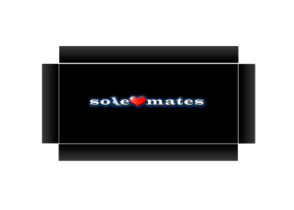
Packaging
The SoleMates packing will contain the same colors, black and red, that is used through our marketing campaign. The packing design will be a rectangular black shoe box with our logo on the sides of the box and on the cover of the shoe box. On the end sides of the box we will also have a brief description of our product and of our charity organization, Soles4Souls that our company will work with. Each package will contain a one-size fits all pair of SoleMates heels covers in the color black. Each package will also come with a small black zip up tote which can be used to carry around a pair of SoleMates.
_{Exhibit MK-09: Packaging}

Channels of Distribution and Sales
The following is a breakdown of the channels we plan to distribute in each year and the respective sales volumes. We do not anticipate conflict between our channels, as we will be selling our product at a consistent retail price, and charging a shipping fee for all direct online purchases through our company website.
In Year 1 we expect to generate a total sales volume of 8,700 units through two channels of distribution. Approximately 35% of this volume will come from our independent stores throughout the Northeastern such as, Thom Brown, Berk’s, and Wild Pair. The remaining 65% will come from direct online sales from our company’s website.
In Year 2, we expect to see our sales volume increase to 17,105 units by using the same channels as Year 1. However, we will be accepted into more independent shoe stores, increasing our ACV. Direct online sales will continue in Year 2 but account for less volume than Year 1, since SoleMates will be available in more retail locations.
Year 3 will be our first expansion outside of the Northeast region. We will continue to sell at our independent stores and direct online, however, we will begin targeting department stores such as Macy’s and Nordstrom. We plan to penetrate only store locations in our targeted region, including nine additional states and cities such as; Baltimore, Chicago, St. Louis, and Detroit.
During Year 4 we plan to penetrate our department chains further to stores in locations such as Florida, Seattle, Portland, San Francisco, Atlanta, Dallas and Denver. Year 4 will be our final regional expansion.
In year 5, we focus on penetrating our department stores deeper to increase ACV across our chosen cities and states. This focus will give us a sales volume of 382,092 units. We also continue to sell directly online, which accounts for 8% of our sales. We drop our product from all independent stores as we gain higher acceptance into the department store channel

Pricing
Assuming the standard mark-ups in our industry, our retailers will expect a 50 percent
channel margin. Based on a retail price of $27.99, the price to our retailers will be $13.99 (See Exhibit MK-10). Our largest profits will come from sales on our website; since these are direct there is no channel margin.
Year 1 | Direct | Independent
Retail Price | $27.99 | $27.99
Retail Channel Margin | 0% | 50%
Price to Retailer | N/A | $13.99
Manufacturer Cost | $7.35 | $7.35
_{Exhibit MK-10: Channel Margin}
Starting in Year 3, the factory price will decrease to $12.50 due to our expansion into national department stores and SoleMates’ transition out of the introductory stage of its life cycle (See Appendix MK-10).

Sales Force
Our sales force strategy for Year 1 consists purely of manufacturer’s representatives. We decided that it would be more important to use our marketing budget to increase awareness through our planned advertising tactics. For Years 1 and 2, our manufacturer’s representatives will earn 5% commission on the factory price of our product.
In Year 3, we will transition into our own sales force; at this time we will employ four representatives to adequately handle our retail store accounts. Year 3 will be a vital time to have proper representation of our product since we begin to target department stores. Our sales representatives will work directly with our marketing manager who will monitor their performance. Each representative will be paid $30,000 with an additional 2% commission on their sales. A hybrid salary-commission pay scale will encourage our employees to stay active with our accounts without putting too much pressure on our current or potential clients.
Sales Force Requirements | Year 3 | Year 4 | Year 5
Independent Stores | 1550 | 3413 | 3707
Department Stores | 151 | 402 | 704
Total Hours Needed | 2471.166667 | 3786.166667 | 5092
# hrs from each employee | 768 | 768 | 768
Total Employees Needed | 4 | 5 | 7
SALES PROJECTION
Exhibit MK-11: Sales Force Requirements

Base Case
To calculate our base case sales forecast for each year, we determined our approximate segment size, retail price, adjusted purchase intent at the retail price, awareness, ACV, repurchases from past years, and units lost to competition (see Appendix MK-12).
Segment Size
We calculated a base target market size of 3.8 million. For the years following we added 1% to account for population growth each year. Then, we subtracted the number of units sold in the previous year, totaling the new segment size.
Retail Price and Purchase Intent
Our retail price was calculated based on the purchase intent from our survey data. The purchase intent equaled 11.73% in segment one and 11.43% for segment two. Using this information, we created a demand curve showing the expected purchase intent at each price. Using the odd-even pricing method, we found that our NPV maximizing price to $27.99.
Awareness
Our awareness calculations for each segment come from our marketing communication plan, described earlier. (See Exhibit MK-04)
Re-trial Rate
Based on our survey data we found that 35% of the people who purchased SoleMates would repurchase that same year. Due to the seasonality of our product and expected wear over the harsh winter months, we found that 75% of women who purchased our product would buy it again in the following years. Starting in Year 3, we included a 10% drop-off rate to account for the women who stop their yearly purchases of our product.
All Commodity Value (ACV)
Total ACV was calculated based on the number of stores that accept our product out of the total number we target. We used a 30 % acceptance rate for all stores we target in Year 1. In Year 3, we start to target department stores and expect to be accepted by at least two chains. The first year in department stores we assumed that we would penetrate at least 15% of their stores. In Year 2-5, we calculated an increase in ACV based on acceptance from new stores we target.
All of our calculations in the base case were carefully revised based on strong research and information directly from retailers. We were conservative in our estimates to account for any unexpected variations; we expect this case to be the closest to our actual outcome.
Worst Case
To calculate the worst case scenario we took factors that negatively affect ACV, awareness, and repurchase rate. We assumed a lower acceptance rate of 20% from retailers which could occur if interest in our product is not as high as forecasted. In this case we may also expect a lower penetration of department stores due to similar reasons; thus, we assumed 10% . However, we have implemented strong push strategies and use trade shows to connect with our targeted retailers, which why we expect a higher acceptance rate in our base case.
To find the pessimistic awareness for each year, we kept the same promotional activities from the base case but adjusted for a lower impact. We would expect to see a drop of 2 percent in each year from our base case. To avoid any awareness issues following Year 1, our marketing manager will monitor the effectiveness of our communications and properly adjust them to resolve any problems (see Appendix MK-13).
To account for a lower repurchase rate than expected, we increased the drop-off rate to 15 percent each year. This can be avoided if we are able to continue to differentiate our product, reinforce our benefits, and maintain brand loyalty with our marketing.
Best Case
We based our best case scenario on our base case and adjusted for potential changes in ACV, awareness, and repurchase rate. To find an appropriate ACV, we assumed that our acceptance rate would be 40 percent and our department store penetration increase to 30%. We follow a regional rollout schedule, so this could be possible since we are able to focus our push strategies on each region at a time.
We assumed a 4 percent increase in awareness each year. Since we have a highly public product, it is likely that our awareness will be higher than expected due to increased word-of-mouth. Between our MySpace and the information we receive from our donation cards, we expect to have direct communication with many of our customers. Finally, we assumed a 5% dropout rate instead of 10%, for repurchases. We hope to continue creating minor variations of our product based on what we learn from feedback that will entice our customers to continue their yearly purchases (see Appendix MK-14).

OPERATIONS

MANAGEMENT
“So soon as a fashion is universal, it is out of date.”
Marie Von Ebner-Eschenbach

Product Design
To ensure that our design will meet customer requirements, we incorporated the results from our questionnaire and focus groups into the customer attribute section of the House of Quality (HOQ) (See Appendix OM-01for HOQ). The top three requirements that our customers value and that we chose to be incorporated in our design are (See Exhibit OM-01):
- A waterproof material, that is also lightweight and durable.
- A hole that will expose the heel of the shoe, to allow for a more fashionable look.
- A product that is easy to put on and wear for all sizes.
Exhibit OM-01: Customer Survey Ratings
Customer Requirements From Questionnaire
 | Waterproof | Fashion | Portability | Worn Over Shoes | Ease of Use | Durability | Form Fitting | Lightweight
Importance Ranking | 1 | 2 | 5 | 6 | 3 | 4 | 7 | 8

Weather Resistant Material
Our largest tradeoff was choosing between a material that would be 100% waterproof or lightweight. It was difficult to find a material suitable enough to provide this protection while still being lightweight and portable to distinguish our product from competitors. Therefore we opted to design our product using a weather resistant, vinyl coated polyester material. This material has a plastic coated inside and a softer cloth-like outside. This material will allow us to design a product that will protect the consumer’s shoes from harsh weather conditions, and will fit easily into a bag or purse for transporting. The sole will be made up of three rubber tread strips, which will provide for extra grip during slippery outside conditions.
Through our focus groups we also learned that consumers prefer if there were lining on the inside of the shoe cover for extra warmth and protection. The women also said that they would be willing to pay more for our product if it had extra features such as lining (See Appendix MK-05). Our Nylon oxford cloth lining will meet their request, providing warmth and a layer of protection from snagging nylons due to the seams of the interior material.
Creating a Fashionable Design
A rubber hole on the sole of the coated polyester, allows for the heel of the customers’ shoe to show, adding a fashionable aspect to our product. The hole will serve as a rubber stopper to prevent water from entering inside the shoe cover if submerged within a small amount of water, such as a puddle. A problem we were left to address was how to make our product form fitting to women with various shoe and ankle sizes. Our solution to this problem is a dual functional bow that women will be able to tie securely around their ankle, combining a stylish accessory with the functional purpose.
To add to the fashionable aspect of our product, we decided to stick with a neutral black color. We chose the color black due to the majority of women in our preliminary focus groups and our market segment surveys, who said they prefer a neutral color. (See Appendix MK-05) We believe that black is the most versatile color for any outfit and any occasion for women in our targets, and so SoleMates will be available exclusively in that color.
Ease of Use
Our customers were also concerned with the ease of use of SoleMates over high heeled shoes. In order to create the most efficient way to wear SoleMates over heels, we added a zipper to the back of the shoe cover. This will make it easier for women to place their shoes inside the cover as it will be zipped up from the back of the ankle.
Recognizing the relationships between customer values from survey results, HOQ and focus groups, we were able to find a balance between the different engineering characteristics to design a final product that meets the needs of the end consumers.

SUPPLY CHAIN
Make Versus Buy
After weighing out the costs and benefits of subcontracting our cutting process, we have arrived at the conclusion that we will manufacture SoleMates in-house. To get a sense for the cost of subcontracting, we performed a make-buy analysis on our cutting operations, which are required for vinyl coated polyester, nylon oxford cloth and rubber. After contacting cutting subcontractor Brown Sales Corporation, we learned the cost of outsourcing our cutting process is $100 per hour, at a rate of 60 inches per minute. We then calculated the total cost of subcontracting our cutting operation to be $428,134.10 for the first five years (See Exhibit OM-02). To complete our make vs. buy analysis, we contacted Gerber Technologies for the cost of the necessary computer automated cutting machine. Over five years of production, we arrived at the expense of $140,000 for a total of two machines based on capacity requirements. This $288,134.10 difference does not even take into account the shipping costs that would be incurred if we subcontracted. Our cost analysis proves that we can take advantage of economies of scale over five years if we produce in house, which is more cost effective than outsourcing manufacturing.
Exhibit OM-O2: Make vs. Buy Decision
 | Brown Sales Corp Outsourcing Cutting Cost | Cutting Machine Cost
Year 1 | $9,748.35 | $70,000
Year 2 | $19,166.15 | 0
Year 3 | $72,327.16 | 0
Year 4 | $213,083.25 | 0
Year 5 | $428,134.10 | $70,000
Totals | $742,459.01 | $140,000
Not only is producing our own product cost effective, it allows us to; maintain flexibility in our manufacturing process, effectively match supply with demand, and change design characteristics if needed to yield higher customer satisfaction. By keeping production in-house, we will be able to maintain control of the process and ownership of our idea. In-house manufacturing also allows us to keep a close relationship with suppliers of raw materials by having direct interaction with them, as they will be making deliveries to our facility instead of to a subcontractor. We will also gain experience in the footwear production process, which could lead to the expansion of our product line in the future.
Supplier Information
SoleMates are comprised of five materials; vinyl coated polyester, nylon oxford cloth, thread, zipper and rubber. The majority of SoleMates’ raw material suppliers are located in the mid western region of the United States. In addition to the appeal to customers of producing a product completely in the U.S, we have chosen American suppliers based on other factors including the location of our facility, shipping costs, lead times, and possible tariffs or restrictions associated with using international suppliers. Also, as a highly seasonal product, we need to minimize raw materials lead times so that we can quickly procure more raw materials if needed (A full list of our suppliers and locations can be found in Appendix OM-03).
To keep strong relationships with our suppliers we will emphasize timely bill payments and giving them ample time to process our demand requests. Our suppliers have networks of their own to store customer data and so we will work with those extranet systems to place orders and pay bills electronically. Since excessive material lead times can be costly, keeping direct communication with suppliers allows us to save money by reducing the time it takes to place and process an order. To achieve good communication we will accommodate supplier systems to provide for the most efficient and effective method of sharing information.
The lead times for our raw materials inventory vary from two days to twelve weeks. The longest lead time of ten to twelve weeks is for vinyl coated polyester and nylon oxford cloth. When raw materials arrive at our facility they are unloaded into raw materials inventory and are kept there until needed. The raw materials will be used in the manufacturing stage of the supply chain and placed in finished goods inventory upon completion. The total time for in-house assembly and packaging of SoleMates takes one day, however to be conservative our estimates range from one to two days in case of a problem. After production, our finished goods are distributed to our retailers and customers, taking three to five business days to ship using third party shipping.
Heart&Soles will also have a secure external network with retailers so we may communicate directly with them as well, eliminating extra time placing and processing orders over the phone. We will also post the production status of their order, ship dates and tracking numbers information. Our extranet will support online payment in order to encourage retailers to pay on time.
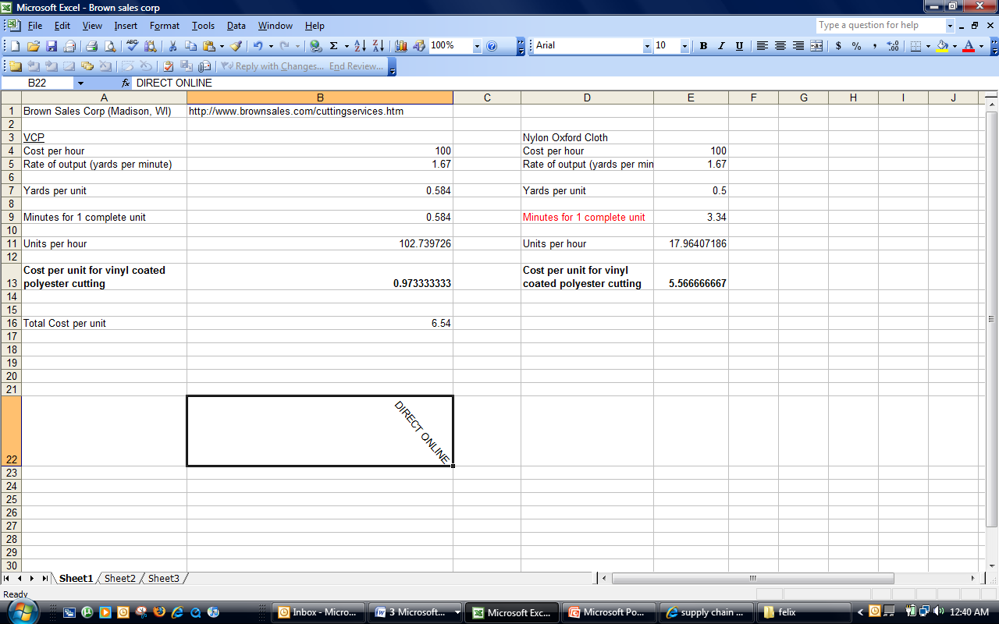
Exhibit OM-03: Supply Chain
RM SUPPLIERS
RETAILERS
Thread
(1-2 weeks)

Zippers
(2-3 days)

Vinyl Coated Polyester
(10-12 weeks)

Nylon Oxford Cloth Liner
(10-12 weeks)

Rubber
(2 -3 days)

In-House Assembly and Packaging
Finished Goods
Raw Materials
Independent Retailers

National Dept. Chains

CUSTOMERS

Critical Supply Chain Activities
The most critical areas of the supply chain for our company would have to be the flow of information forward and back through the processes and the forward flow of a high quality product. If orders are not placed on time due to poor communication between our facility, suppliers and retailers, sales could suffer do to stock out. Heart&Soles could in turn lose credibility with suppliers, retailers, and customers. Billing of retailers is also critical, because if they do not pay us on time, we may not have sufficient cash on hand to pay our suppliers. Clear and direct communication can solve this dilemma, and our company will emphasize this in our business to business relationships.
In order for retailers and customers to keep ordering SoleMates, our company needs to allocate time and resources to managing quality. Before each line worker is hired, they will be properly trained in our production processes. We also want every line worker to be quality inspectors to keep the internal defect rate below .5%, placing us in line with our critical success factors. The quality of our product will also be reinforced through job design, as our line workers will see a product through the entire production line from start to finish. Being involved in the whole process will give them greater satisfaction as well as accountability for quality issues.
By emphasizing good communication and a high quality good, we can achieve success in the marketplace. SoleMates need to be readily available to customers when they wish to make a purchase in order to keep our customers satisfied. We plan on achieving through effective communication with our supply chain partners. Also, a high level of quality is required to keep get repeat customers in subsequent years.
In-House Production
Factory Location
After computing centers of gravity for Years 1 through 5, taking into consideration our retailer and customer regions, we were able to narrow down the possible facility locations to cities in Tennessee, Missouri, Kentucky, and Pennsylvania (See Appendix OM-02). These states reflect our decision to locate our facility based on a long-term future outlook for years 3, 4, and 5. Next we compare the costs and benefits of producing in these states.
The most significant differences between choosing state locations were minimum wages, property and corporate tax rates. Since Kentucky has the lowest tax rates and minimum wage rates, in addition to being located slightly east of our center of gravity points in Years 4 and 5, we chose to house our facility there (See Exhibit OM-04). Our decision is based on our long-term strategy of nationally distributing our product by Year 4. We believe that choosing to locate in Kentucky initially will save us the cost of moving our facility in later years. Given all of these facts, we chose to lease our facility in Owensboro, Kentucky. Our facility lease costs are expected to be $1500 with a utility cost of $600 per month.
Exhibit OM-04: State Comparisons
 | State Minimum Wage | State and Local Tax Burden | State Property Tax Collected | State Property Tax Rankings (1st being highest tax) | State Corporate Tax
Greenville,  TN | $5.85 | 7% | $794 | 40th | 6.5%
Owensboro, KY | $5.85 | 6% | $693 | 43rd | 4%-6%
Van Buren, MO | $6.65 | 4.225% | ^{$1,012} | 36th | 6.25%
Somerset,  PA | $7.15 | 6% | $1,937 | 14th | 9.99%

Our Manufacturing Facility (See Appendix OM-05)
Around 50% of our facility will be used for manufacturing our product. This area will contain all of our workstations and machinery which consist of: cutting machines, sewing machines, a testing station, and a packaging station. For years 1-3, we will only need one machine to cut all of our fabric, rubber, and liner, one sewing machine, one testing station, and one packaging area. By year four, however, we will buy two more sewing machines and two more zipper cutters, and in year five we will add one machine to cut fabric, rubber, and liner, two more sewing machines, and two more zipper cutters. The highly automated nature of our cutting machines make our line worker’s job much simpler and reduces the type of errors that often result from cutting processes. Our other work stations are much more labor intensive.
The sewing machines we use require the line workers to clamp down the materials they wish to sew and then push them through the machine. The testing station is where we employ quality control. The worker will inspect 20% of all shoe covers he makes by inspecting the sewing and stretching the shoe cover to make sure the seams are strong. Workers will also test only 5% of tote bags, as quality issues with these are fairly insignificant. Finally, the packaging station is where boxes are assembled and each unit (2 shoe covers and a tote bag) is placed a box.
The office space will make up about 35% of our facility. The CEO, the operations and technology specialist, and the marketing & sales manager will each have their own office. Next to the offices will be the cubicle area where customer service representatives, sales representatives, an accountant, and an information systems associate will work. Two conference rooms will be placed adjacent to the managers’ offices for general meetings, and we will also have a break room where employees can go to relax, eat, and take breaks during the day. There will also be magazines and a pool table in this room to decrease employee turnover, stress, and job fatigue. The men’s and women’s bathrooms will be located near the break room.
A storage room makes up the majority of the remaining 15% of our facility. This room will be used to store the anticipated large levels of raw materials and finished goods inventory that our company will need build up in order to combat our product’s seasonal demand.
Overall Production Process
Our process begins with unloading raw materials from the loading docks into our raw materials inventory portion of the warehouse to use when needed. Although we purchase our raw materials of vinyl coated polyester, oxford nylon cloth, rubber, thread and zippers, we will trust that the materials sent from suppliers are in proper condition if we have ordered from that supplier previously and there will be no need to test materials before use. Year 0 is the only year that may require some initial testing of materials to make sure they meet our standards.
The actual in house process of manufacturing SoleMates consists of six stages after raw materials are inventoried. First our raw materials are moved from inventory to be loaded onto the cutting machine where it will be cut into patterns of our shoe covers and tote bag. Second, our material is then sewed and assembled, of which 20% of shoe covers and 5% of tote bags will be tested in step three. In stage four the units will be packaged depending on whether the finished goods need to be shipped out in the same day. If not, each unit, two shoe covers and one tote bag, will be stored in finished goods inventory without packaging in stage six to minimize storage space until shipped.

Daily Manufacturing Process
Each work day is composed of a seven and a half hour shift in which one employee is working on the line, performing all tasks. This will allow for job enlargement and enrichment as the employee is accomplishing all the tasks necessary in the assembly of SoleMates. Heart&Soles believes that increasing worker responsibility will yield higher productivity, satisfaction and worker accountability from seeing the process all the way through. Line workers will also be able to evaluate our manufacturing processes to make changes as they see fit, promoting efficiency and higher quality and productivity.
At the beginning of each work day, an employee will take vinyl coated polyester, from raw materials inventory, set up and load the cutting machine with the proper pattern. The machine will spend the first part of the day cutting out the patterns for the actual shoe cover and liner, and the second part of the day cutting out rubber sole, tote and ribbon pieces. The amount of time spent cutting each pattern is dependent on the production level for the day and our work in process buffer inventories. The machines will cut the material and separate scrap from the actual fabric pieces into work in process bins, from which the line worker will take the material out to sew together (See Appendix OM-04, 13).
The bottle neck in of our production process is the sewing station, taking 224 seconds out of the total process of 263.5 seconds. The capacity per worker of 1,947 units exceeds demand per month for the first 2 years, and so we decided on employing a chase strategy production to avoid inventory holding costs (See Appendix OM-06, 07 for Aggregate Plans). In order to keep the process of start to finish manufacturing, we will add more workers, machines and shifts as needed (See Exhibit OM-04).
Exhibit OM-04
Process time
Total Time (sec) | 263.5
Units per day (95% capacity) | 97.34
Units per month (95% capacity) | 1,947
Units per year at (95% capacity) | 23,362

PRODUCTION AND STAFFING PLAN
Year | Unit Sales | Capacity
1 | 8700 | 23,362
2 | 17,105 | 23,362
3 | 64,549 | 70,087
4 | 190,168 | 210,262
5 | 382,092 | 584,061
Over the course of the first five years of production, Heart&Soles will undergo staffing and capacity changes in response to the increase in demand, from our rollout in year three. Our inventory aggregate plans differ from year to year based on the most efficient and cost effective method of matching supply with demand; however, our manufacturing process does not move towards specialization as demand increases. As we mentioned before, we will keep the same process of each employee operating an entire line, being in charge of their own testing and packaging.
For the first year and a half, we will use a chase strategy because our capacity per month is greater than monthly demand and switch to a level strategy in year three to build up inventory during the low demand months to meet the demand in higher months (See Appendices OM-06-10). We used monthly demand percentages of comparable firms to forecast demand for our seasonal product. These percentage assumptions are carried out through five years.
Year 1 Staff
In the first year of our production Heart&Soles will hire three employees; one full time line worker, one, one Operations and Technology Specialist, and Corporate Executive Officer (See Appendix OM-14).
The one line worker will need to be trained in simple manufacturing and sewing processes and will be paid in salary form including benefits with annual raises of 3%. He or she will work 7.5 hours per day with a 30 minute lunch break and will be given two weeks un-paid vacation during the low production months. To promote employee satisfaction and participation, every six months the employee will be given a review on work performance and an opportunity to share their input on how to make manufacturing more efficient.
The Operations and Technology Specialist will supervise the manufacturing line, revise production plans, and solve information technology problems around the facility. He will also be responsible for turning on the machines and setting materials up to allow for ample work in process inventory to be built up for when the line worker arrives each day. In addition, he will be in charge of conducting the semi-annual reviews of the line workers and CEO.
The Corporate Executive Officer will have experience with accounting functions, customer service and marketing management. The CEO will attend tradeshows along side our Operations and Technology Specialist and will also need to establish relationships with suppliers and retailers. Although the CEO is at the top of the business hierarchy, he too will be reviewed and review the operations manager.

Year 1 Production
In year 1 we will have one DCS-2500 computer automated design cutting machine (capacity 1,500 units per day), one PLK-E0504 sewing machine with material clamps and a table, and a mechanical zipper cutter. The cost of each machine is $70,000, $9,040, and $99.99 respectively. We will not need to purchase any additional machines in year one.
To prepare for our regional product launch, we will start manufacturing in December of Year 0 in which half the first month’s production will be manufactured as well as 300 SoleMates for press kits, 100 units for press kits in year one and 40 units for trade shows. Our ramp-up production will also include the 250 units of safety stock that will remain in inventory throughout the year in case of shortage and in total the production for month zero will be 1,079 units.
A chase strategy is in place due to the capacity per worker of 1,947 units per month and for the first year and so monthly inventory levels will remain at 250 units of safety stock. This will keep inventory holding costs low and allow the line employee to take vacation time or perform other tasks during the slow months. However in month twelve of Year 1 we will need to manufacture 576 units to meet the demand of January in year 2.
Year 2 Staff
In year two, Heart&Soles will start the year with the same workforce of one line worker, one Operations and Technology Specialist, and one CEO (See Appendix OM-15). However, in October (month 10) we will hire an additional worker to help prepare for the upcoming winter months and beginning year three demand. These two line workers will be working two different shifts during the day, so capacity will double and no new machinery will be needed.

Year 2 Production
The chase strategy will remain in place for the same reasons as in year one and capacity will remain constant at 1947 units per month per worker. SoleMates’ safety stock increases by an additional 287 units to 537 which will be produced in January and remain in inventory for the duration of the year. At the end of year two our production increases to 2,842 units in month 10, and reaches capacity of 3,894 units in months 11 and 12 to make sure demand is met for the beginning of year three.

Year 3 Staff
By year three, the Operations and Technology Specialist will be able to focus more on information technology work because we will hire a General Operations Manager (See Appendix OM-16). We will experience a lot of change companywide this year, and salaries expense is much higher. The General Operations Manager ($98,986) in year 3 will oversee and coordinate all supply chain activities. In year 3 we will replace the manufacturing representative company with four of our own sales representatives ($30,000 base salary with 2% commission). Subsequently, there will be five sales representatives in year 4 and seven in year 5. Year 3 is when the business truly begins to grow in size and numbers so we will hire a marketing sales manager ($73,224), a customer service representative ($36,250), a general operations manager, and an accountant ($53,409). Volumes will be much greater so one employee can no longer handle more than one function of the business.
The marketing sales manager will oversee the sales representatives and the customer service representative while also handling all marketing aspects of the company. This person will be responsible for evaluating the employees under him. In addition, the marketing sales manager will shape the image of our company and attend trade shows to make sure that product is marketed effectively. Furthermore, the marketing sales manager is the one that approves different sales tactics before the sales representatives implement them. From a financial standpoint, this manager keeps track of all marketing costs to keep within our marketing budget.
The sales representatives will be responsible for establishing relationships with retailers to increase our distribution. They will go to trade shows when necessary to introduce our new product and will also be visiting small and large retailers to convince them to put our product on their shelves. They are responsible for coming up with new ideas to market our product and to work well as a team.
The customer service representative will be answering phone calls and emails that come from suppliers, retailers, and customers. This person will also act as the receptionist that will forward necessary calls to upper level management. This employee will answer any customer complaints or inquires about the product and try his best to satisfy the needs of the customer. If a customer was not satisfied with the product, then the customer representative is able to offer a refund or replace the product with a new one. Maintaining good relationships with suppliers, retailers, and customers are key to superior service. Therefore, in Year 3 when our sales are substantial, it is important for us to hire customer service employees to manage these relationships.
The accountant will be responsible for making sure all the finances and accounting for the company are in perfect order and balance. This employee will create balance sheets, income statements, and cash flow statements to convey to upper management and investors on how well the company is doing every quarter. Furthermore, this person is to keep track of all costs associated with the business as well business expenses that are incurred by other employees. Another major duty of this person is to file the necessary tax forms to the government to make sure we are in compliance with federal and state standards.
In addition, Heart&Soles will hire an additional line worker for a total of three line workers, each of which will work a different 7.5 hour shift during the day. This requires no additional machine purchases. Our company will also hire an additional line worker in November to build up inventory for peak demand in the winter months, purchasing another sewing machine and zipper cutting to match with the number of workers. Although we are working our machines for three shifts per day, we are not worried about machine failure for several reasons. First, we have calculated manufacturing at 95% capacity, thus factoring in downtime. We have also allocated 30 minutes for worker breaks each shift. Lastly, each machine will have idle time as other processes are performed.

Year 3 Production
Our demand increases significantly as we begin our roll out in Year 3. We will begin to employ a level production strategy that allows us to build up our inventory in preparation for the high season. Safety stock increases to 2,079 units, of which 1,542 will be produced and added in January, which will remain in inventory throughout the year even though inventory levels are constantly building up for the winter months. Total capacity of our three workers is 5,841 units per month and we need to hire a fourth worker in December to build up enough inventory to meet year four’s demand and safety stock additions. By hiring a fourth worker, we will also need to purchase another sewing machine and zipper cutter in December.
Year 4 Staff
Demand jumps to 21,186 in January and so at the beginning of year four we will hire 6 additional line workers, for a total of nine. Three employees will work each shift and we hire three more workers in December to increase capacity. We also hire one more sales representative to help with the increasing number of retail stores. Heart&Soles will not hire any additional upper level management during this year (See Appendix OM-17).

Year 4 Production
To meet demand for year four we will need to purchase one more sewing and zipper cutter for a grand total of three apiece until December. We will also purchase one more sewing and zipper cutter in December to match the number of workers per shift. Capacity is now 17,523 units per month and safety stock jumps by 4,098 units to 6,177.
Year 5 Staff
Heart&Soles will employ one more customer service representative to answer phone calls and hire three more line workers to total fifteen, five in each shift. We will also need 2 more sales representatives. (See Appendix OM-18).

Year 5 Production
In year five the demand for SoleMates exceeds the capacity of the main material cutting machine of 1,500 units per day and so we will need to purchase a second cutting machine to meet the demand of 39,549 units in January. We will also need to purchase one more sewing and zipper cutting machine to meet demand, and to allow every worker to have one of each machine (5 in total)
Monthly demand peaks at 49,198 in November and safety stock increases by 5290 to total 11,467 units. In the months of March and December when we have backlogged inventory, we will tap into our safety stock to meet demand for the months.

BEST AND WORST CASE PRODUCTION

Best Case
Based on marketing assumptions, our best case scenario demand will start off at 12,975 units in year 1 to 604,504 units in year 5 (See Appendix OM-21,22). To account for this increase Heart&Soles will need to hire 25 assembly line workers over the course of five years, 10 more workers than in our base case projection. In years 1 and 2 we will employ the chase inventory method of production, and in year 3 we will start a level strategy to build up inventory throughout the year.
In years 1 and 2 we will hire our first and second worker respectively, adding another shift in year 2 to avoid buying new machines. In year 3 we will need to hire three more workers to total six, and they will be working three shifts per day, two employees per shift. Heart&Soles will also purchase another sewing and zipper cutter in year 3 to maintain capacity. In year 4 we will hire our 15th worker and purchase a material cutting machine, three more sewing and zipper cutting machines to adjust for the new employees. In year five our demand is at its highest needing twenty four workers, eight sewing and zipper cutting machines, and two material cutting machines in total.
Since direct materials cost remain the same in best and base case, direct labor costs are responsible for the change in total product costs. Our best case starts with $1.93 per unit in year 1 and drops $1.04 by year 5. Base case starts at $2.87 per unit and drops to $1.06 in year 5 (See Appendix OM-19).

Worst Case
In our worst case scenario demand starts in Year 1 at 6,683 units and ends in year 5 with 249,444 units, 100,000 units less than our base case year 5 (See Appendix OM-23). As a result we will only employ up to twelve workers in year 5 to meet this demand, keeping our manufacturing strategy. Like the best and worst cases, we will produce with a chase strategy in years 1 through 3 and start with a level strategy in year 4.
In year 1 and 2 we will employ one line worker to meet demand, buying one of each machine: material cutting, sewing, and zipper cutting. In year 3 we will only need to hire one more worker that will work the second shift of the day to save on machinery costs. In year 4 we will four more workers, six in total, needing to purchase two more sewing and zipper cutting machines. By the fifth year 5, Heart&Soles will be staffing twelve assembly line workers, with overall purchases of one material cutting machines, four sewing and zipper cutting machines (See ExhibitS OM-06A&B). Direct Labor costs are the highest in the worst case for all years except year 2. Labor cost per unit starts at $3.74 per unit and ends with $1.20.
Product Cost Per Unit
 | Year 1 |  | Year 2 |  | Year 3 |  | Year 4 |  | Year 5
 | Direct Labor | Direct Materials | Direct Labor | Direct Materials | Direct Labor | Direct Materials | Direct Labor | Direct Materials | Direct Labor | Direct Materials
Base | $2.87 | $3.97 | $1.46 | $3.89 | $1.16 | $3.85 | $1.18 | $3.85 | $1.06 | $3.85
Best | $1.93 | $3.97 | $1.99 | $3.89 | $1.03 | $3.85 | $1.11 | $3.85 | $1.04 | $3.85
Worst | $3.74 | $3.97 | $1.79 | $3.89 | $1.21 | $3.85 | $1.20 | $3.85 | $1.20 | $3.85
Exhibit OM-06A

Exhibit OM-06B
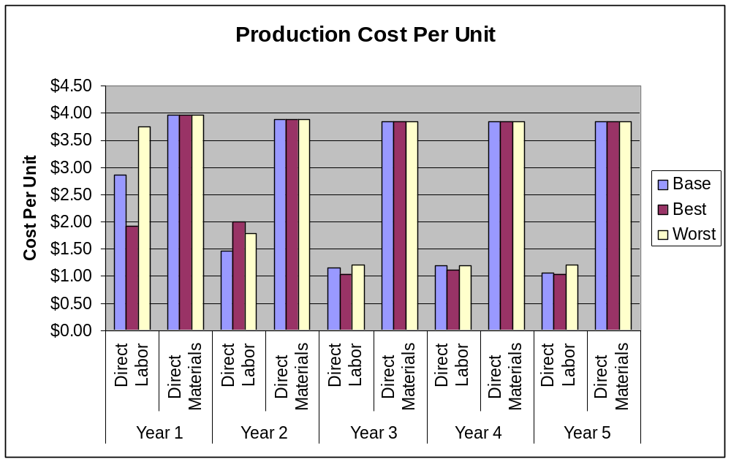

IMPROVING OUR PRODUCTION PROCESSES
Employees
All of our line workers will be well-trained, independent individuals. They will be trained to run every aspect of the production process. In order to improve upon our process in the first two years, the line worker will fill out monthly reports on what works best in the process and what can be improved.
When we begin our rollout in year three, sales volume increases and our operations will require good coordination, so we will hire a General Operations Manager at the start of the third year. He will be responsible for training all new assembly line workers, and we will have meetings every other week to discuss any issues faced in the production process as well as possible improvements to job design.
Partnering with the University of Evansville
As a start-up business without a lot of extra cash on hand, we will need to find ways to inexpensively improve upon our production process because we simply cannot afford to hire consults to come in and critique our process. One way we can inexpensively get an evaluation of our facility is by partnering with the University of Evansville which is located just over 40 miles away from our facility. We plan on reaching out to their engineering management degree program which is geared towards people interested in operations and production careers. We would allow students to come in and study our production process as well as present suggestions to management as to how we could improve our process. This would be a great learning opportunity that would benefit the students involved as well as our company.

IMPROVING PRODUCT DESIGN
In addition to improving the production process, we plan on having our product design evolve based on feedback from retailers and consumers over the product life cycle. If our product design remains stagnant and does not change with customer needs, we will face the threat of competition taking our sales. Having flexibility in our design was a major factor in deciding to manufacture in-house. There are multiple in ways which we will be able to receive this key feedback. Once we hire our own sales force in year three, we will establish much closer relationships with our independent retailers and national department chain stores. Through the face-to-face interaction of our sales representatives with retail store managers, we will obtain direct feedback. In order to capture this feedback in a useful way, we will ask sales reps to document retailer suggestions and comments about our product. This information will be reviewed by our Marketing Sales Manager who will then share anything of importance with our Operations Manager.
Just as we initially incorporated the customer voice into the design of our product, we will continue to listen to customers and make the necessary changes over time. The cheapest, fastest and easiest way for us to connect with the customer is by utilizing the web. Our MySpace site and our homepage at Solemates.com will have a drop box for customer suggestions on everything from product design to distribution.
INFORMATION SYSTEMS
”The difference between style and fashion is quality.”
Giorgio Armani

INFORMATION SYSTEMS
Managing Information Systems is an intricate part of our company’s infrastructure as it is the foundation of all operations within our company. Effectively managing the flow of information throughout the organization will lead to an efficient and organized business. With uniformity in place, the flow of data between our company and outsiders will help us achieve our company objectives.

THE BUSINESS MODEL AND ORGANIZATIONAL GOAL
We will use information systems to create a fully integrated business and achieve our overall goal to provide our female customers with a weather resistant, durable, and compactable shoe cover to be worn over high heeled shoes. To accomplish this goal, it is imperative that we incorporate cross-functional communication throughout the organization with the implementation of a well-planned information system. We must integrate all the facets of our company; marketing, operations, information systems and finance, into one dynamic union to achieve our company goals. With the integration of information systems, we will be able to adapt to increases in competition, demand fluctuations, and technological changes, thus establishing a competitive advantage.

VALUE CHAIN
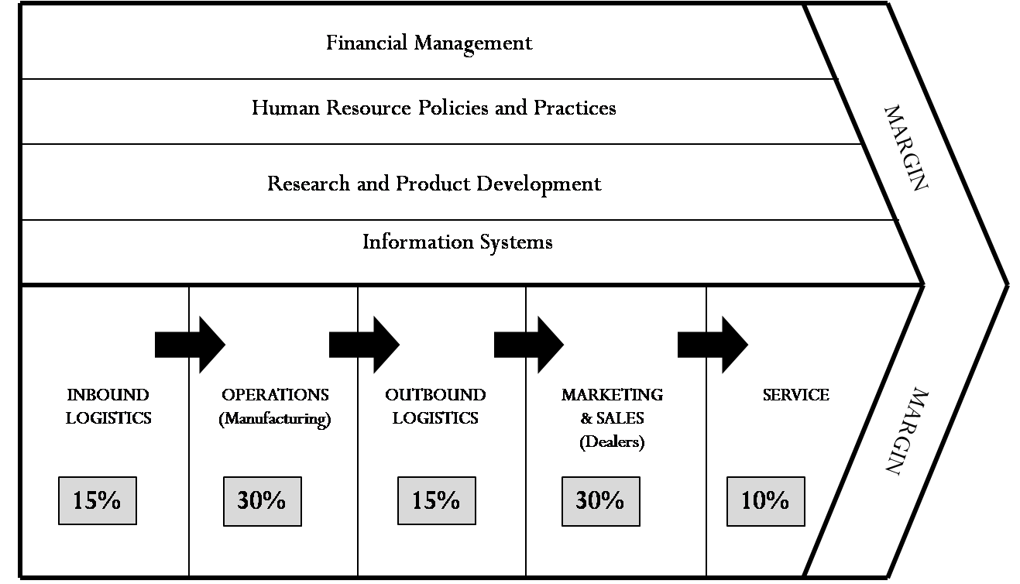
As we move along the value chain, we can identify the most crucial components of our business processes and IT systems. Our value chain depicts how we plan to integrate information systems into all the parts of our company from the beginning process to the end (See Exhibit IS-01). There are five primary processes in our value chain, starting with inbound logistics, and ending with customer service. Based on our critical success factors, we have assigned values to signify which business processes we will concentrate on for our company to be successful.
Exhibit IS-01: Value Chain
Marketing and operations receive the highest value ratings, making the processes the most important aspects to the success of our business. Emphasizing operations will ensure that we produce a quality product that customers are satisfied with, which in turn, will help maintain high levels of customer satisfaction.
We must also rely heavily on marketing and sales to inform potential customers about the benefits our innovative product provides. With an effective utilization of marketing and sales, we will be able to make SoleMates available to our targeted market segments in the most efficient channels.
Manipulating information systems and the flow of information will be key in order achieve our critical success factors in conformity with the value chain. Our ERP system will also encompass our secondary processes such as finance, accounting employee management and product development which are also key to Heart&Soles’ success.

CRITICAL SUCCESS FACTORS
We believe that our company will be successful by excelling in the following four critical success factors (See Exhibit IS-02):
- CSF #1: Have a Northeast regional awareness for each segment of 15% by year 1
- CSF #2: Resolve 98% of all customer issues within 72 hours
- CSF #3: Maintain a 99.35% service level to retailers
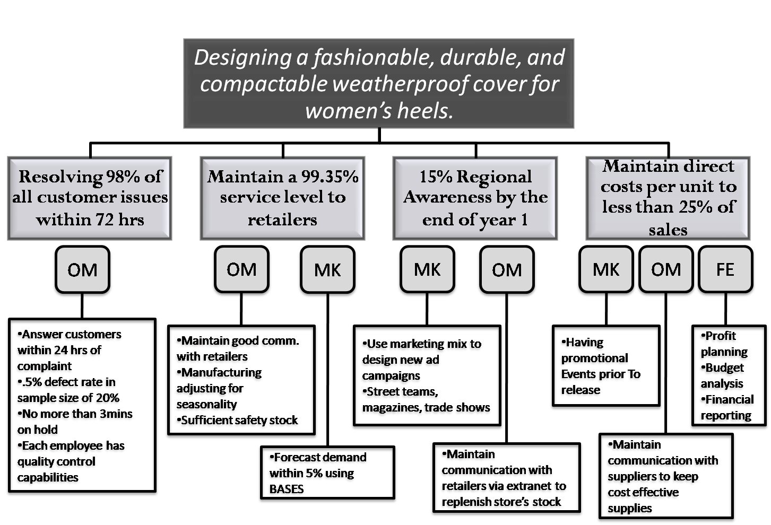
- CSF #4: Maintain direct costs per unit below 25% of sales every year
Exhibit IS-02: CSFs

Have a Northeast regional awareness for each segment of at least 15% by Year 1
It is important for our product to have a regional awareness of at least 15% in order to meet our forecasted sales volume. By spending $115,896 on marketing push and pull activities to reach target segments in Year 1, we plan exceeding this awareness percentage (See Marketing Segment for further details). From an operations perspective, we will maintain communication with retailers through the use of an extranet source to replenish stock so customers always have the product available to them. A high awareness in Year 1 will allow SoleMates to be even more successful in the following years in which implement a national roll out strategy.
Resolving 98% of all customer issues within 72 hours
In order to build and maintain customer satisfaction it is important to create a quality product and respond to customer concerns when they arise, in a timely and efficient manner. From an operations management perspective through process planning, we will standardize jobs and the assembly line in a manner to track defects during testing. We plan on testing 20% of shoe covers produced and 5% of tote bags, and maintain an internal defect rate of less than 0.5%. Also, we plan on equipping our customer service people with the knowledge and resources to resolve 98% of all issues presented within 72 hours through quick response of emails, less than three minutes on hold during phone calls, and replacement of defected units.
Maintain a 99.35% service level to retailers
It is important that we maintain a 99.35% service level to retailers in order to avoid the cost of stock outs. Since our cost of shortage is high, and the cost of holding inventory is low, we will maximize profits with this optimal service level that balances these two costs. We plan on achieving this level by putting in place an extranet that retailers can log into and place orders. This extranet will enable us to have demand information that is both accurate and timely enough to make the proper adjustments in our production plan. We have also located our facility in a way that minimizes distribution costs and time.
Maintain direct costs per unit below 25% of sales every year
The risk of competition will encourage us to maintain direct costs per unit lower than 25% of sales every year to ensure that we are profitable. This is important for the OM and FE aspects of our company, as low direct costs will give us the competitive advantage of higher than average margins. With an ERP system in place and communication with suppliers, we can track the most cost effective suppliers, inventory levels, and distribution costs. From a financial standpoint, we can use information gathered from different parts of the company through a well-integrated system to perform profit planning, budget analysis, and financial reporting to keep our direct costs below 25% of sales. With software in place, our financial personnel will be able to make decisions on cost effective strategies.

CREATING VALUE-ADDED PROCESSESS
Taking our critical success factors into consideration, there are processes that we have to accomplish in order to add value to our product. The following is an explanation of our value chain activities and their relative importance for the success of our company.

Inbound Logistics
Inbound logistics plays an important role in our organization because we have to ensure that we are provided with quality materials from local suppliers. We estimate that inbound logistics will encompass 15% of our business functions. We will use raw material suppliers that are close to us, thus lowering shipping time and costs. In order for operation aspects of our company to work efficiently, inbound logistics must also be efficient. To receive high quality materials, we will establish a good relationship with suppliers though constant communications within a closed extranet. It is important to gather supplier information such as lead times, quantity supplied, costs, delivery dates, and track orders to keep our business functioning smoothly.

Operations
It is important that we manufacture our product at a low cost and maintain high production level to meet our retailer’s demand on time. With an ERP system in place we should be able to keep communications with our retailers to process orders as soon as they are sent in. From this information, we can manage labor schedules, and materials needed. Also, we will test finished goods, and record information, before packaging order to ensure that we are producing SoleMates of high quality.

Outbound Logistic
Like inbound logistics, outbound logistics we estimate, will encompass 15% of our value chain. Following our initial product launch, reaching retail outlets will be of utmost importance. We will need to fluidly pass information to and from our distributors, to make sure that our retailers are receiving shipments on time. We are working with a third party shipping company in order to reach our retailers.

Marketing & Sales
We estimate that marketing and sales will make up 30% of our value chain. We will need to generate awareness and brand credibility to expand our retailer and customer base. In order to reach our targeted market in the most effective way, we have to track our internet campaigns and promotions as well as use our ERP systems to track sales and distribution figures.
Services
We established a 1-800 number that customers can call with complaints, comments, or any other input that they have that might improve our product. We will also gather customer information when they call in that will assist our marketing team with new promotions or campaigns.

SYSTEM DESIGN
Before choosing system software for Heart&Soles, we analyzed how data flowed through our company in order to implement a software system that would cater to our needs. We valued which information flowed into and out of our company.
Data Flows through Hearts&Soles
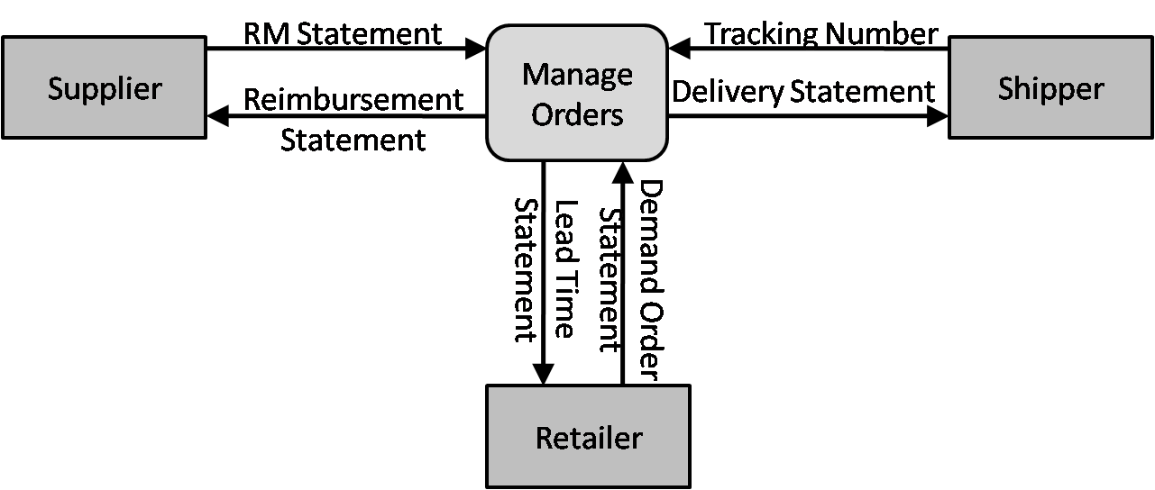
When choosing a system for an organization, we decided that production management was a key aspect in the success of our organization. As our context level diagram illustrates, our information system is arranged so that we can administer our internal processes as we send and receive information from external resources, such as our suppliers, retailers, and shippers (See Exhibit IS-03).
Exhibit IS-03: Context Level Diagram

Inbound Data
Date collected from the suppliers include, a raw material statement that gives the lead times, type of material, amount of that material, costing information, and confirmation number. We will also obtain a demand order statement from retailers letting us know demand quantities and when they need new shipments. Lastly, we will get tracking information from the shipping company, for our staff to keep track of shipments.

Outbound Data
When shipments are sent out, quantity and lead time information is sent to the retailer. The shipping company is given a delivery statement, so that they can keep it in their record about how much they are actually shipping. Suppliers are given a reimbursement statement for raw materials in order to keep raw materials coming in without delays. For a complete chart on our data flow throughout our organization, refer to our DFD (Appendix IS-01).

Entity Relationship Diagram
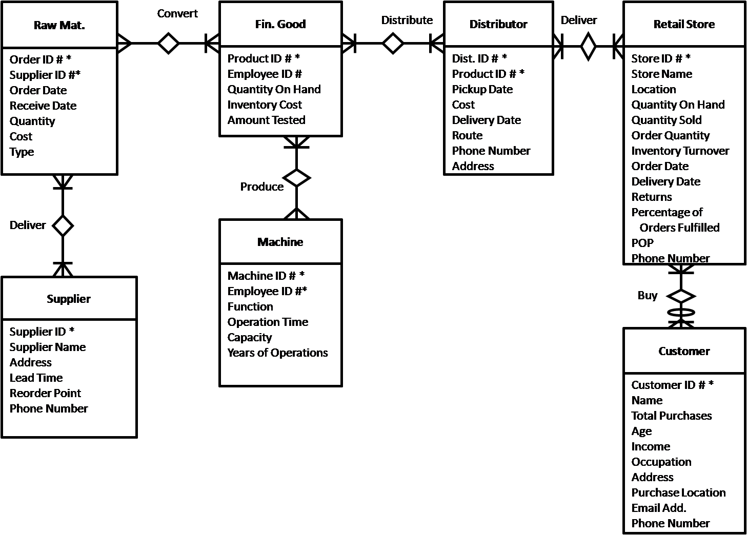
Our entity relationship diagram shows requirements for our operations management system software. The most important data recorded in our company is specific ID numbers from different entities, which consist of an identifying number. SoleMates will generate these ID numbers and assign them to different categories: suppliers, retailers, distributors, product ID number, orders, customers, and finally machine ID numbers. Each ID number is unique within its entity of information. Within the entities, the primary key is the combination of ID numbers and other specific information for that entity. In addition, there will be no overlap when combining the two primary keys. Our full ERD is as follows (Exhibit IS-04):
Exhibit IS-04: ERD

SOFTWARE EVALUTAION PROCESS

Fully Integrated vs. Best of Breed Evaluation Process
After evaluating all our informational needs and flows through our organization along our value chain, schematic diagram, sample reports (Appendices IS02-04), DFD and ERD, we determined that our systems needs to manage our business function consistently and efficiently. Before deciding exactly which system to buy, we carefully analyzed the benefits of a fully integrated system compared to those of individual modules. We started this analysis by comparing two types of each individual module and deciding which one we would buy if we were to purchase components individually. Lastly, we compared these preferred individual modules to a fully-integrated ERP system to determine which system would ultimately serve our company most effectively.
Our critical success factors and value chain reveal a strong emphasis on supply chain management, accounting management, and operations management. Instead of purchasing each of these systems separately, we will integrate all of our business processes into an ERP system because we have found this alternative to be most cost-effective. Also, aside from costing issues, we feel that one overall integrated system would be more beneficial for our smaller scale implementation. We do not need systems that are specific, rather systems that keep information uniform throughout the organization.
We have also concluded that developing our own system would be too costly, even if we could benefit from the experience and knowledge gains. We used the eight criterion evaluation steps to determine which software is suited for our company’s information needs. We analyzed two different ERP applications: NetSuite Small Business, Everest Software, and Microsoft Small Business Financials based on their reputability as industry leaders in ERP system software. For a full comparison of the ERP systems please refer to Exhibit IS-05 on the next page.

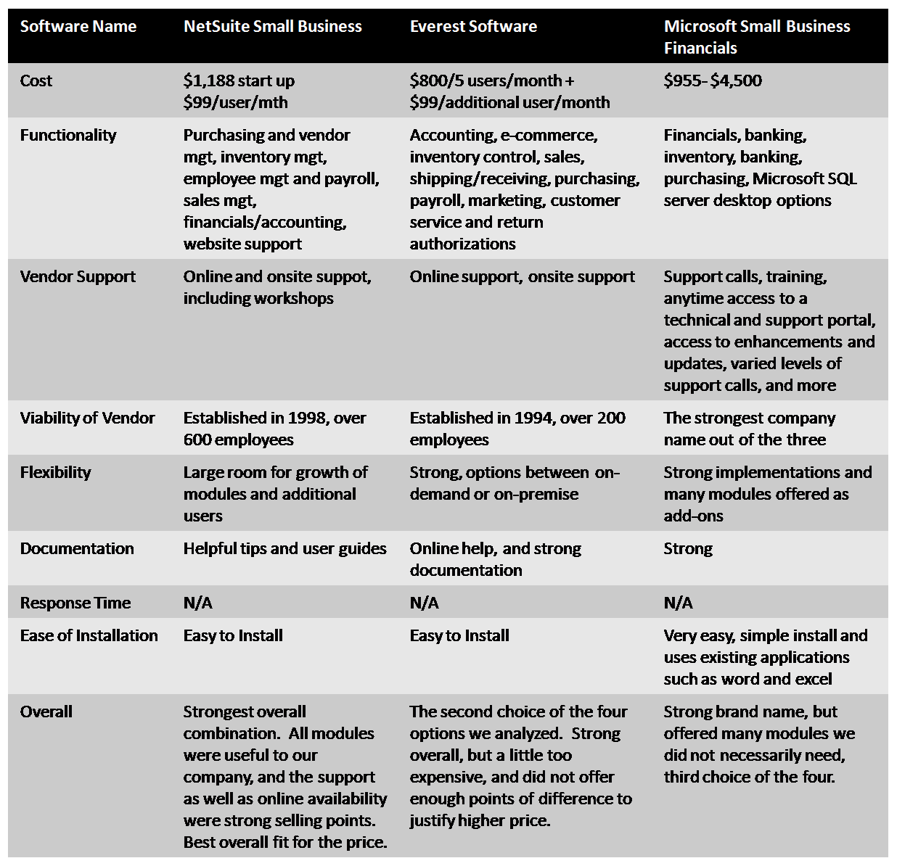
In the end, we decided to purchase the NetSuite Small Business ERP system due to the cross-functionality of our company. Our ERP system will incorporate all of our data into one easy-to-use comprehensive form. NetSuite Small Business is an external database accessible through the Internet and will hold and manage all of our data. Also, the system offers different modules that we can tailor to our company’s needs, which ended up being a strong selling point for our organization. These modules will help us fully integrate our company from the beginning to the end of our value chain. The system has a low start up cost of $1,188 in addition to a monthly cost of $99 per user. NetSuite is a viable company that launched in 1998 and has over 600 current employees. They offer vendor support such as workshops and online training tutorials. For comparisons of all the Best of Breeds, please refer to Appendix IS-05 though 07.
Exhibit IS-05: ERP Comparisons

Implementation
We foresee an implementation requirement of three months to get our system up and running with all the hardware and software. Below is an implementation schedule for our company (Exhibit IS-06):

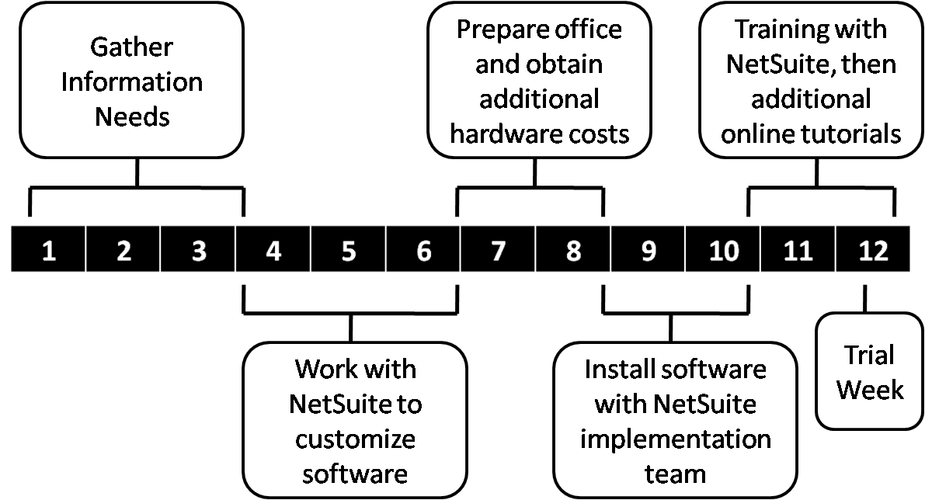
Exhibit IS-06: Implementation Schedule

Technology Startup Requirements
We have a three month startup window to purchase and implement all of the hardware and software for our organization. In addition to NetSuite, we will need to purchase other application software to go with our designated hardware. We will also need telecommunication tools, support, security, and backup hardware and software, to ultimately create a LAN structure. We will put together all of our hardware to implement a bus topology within our organization, since it is simple to integrate and inexpensive for a smaller firm. We chose bus over a star topology because if the hub fails, the entire network fails. Also, we did not choose a ring topology because it is fairly expensive to implement. A bus topology is superior for our needs because it is relatively inexpensive and scalable.
Office Desktops:
Our company will require just one desktop computer in year one. The model we will purchase is the Dell Vostro 200 Mini Tower for $937. The computer has a 2.2 GHz Intel Core Duo Processor, which enables more applications to be used at once. The desktop is configured with 2GB of RAM and 160GB of memory. This desktop is well equipped for the processing needs of our company, with enough RAM and memory to do all the applications that will be necessary within the organization. The desktop also comes installed with a Windows XP Professional operating system and Microsoft Office Small Business Productivity software, which are included in the price.
Office NoteBook
We have chosen to purchase the Dell Vostro 1000 notebook, which is capable of high productivity and will be used by our CEO. At a cost of $852, it has an AMD Athlon 64 X2 Dual-Core processor at 1.9GHz. It contains 2GB of RAM, 120GB of memory and a 15.4” display, which is small enough for portability purposes, but large enough for easy reading. The notebook will be equipped with a Windows XP Professional operating system and Microsoft Office Small Business Productivity software, which are included in the price.
Office Server
Our desktops will be connected to a main server that will be used to store and backup important information. We found that the Dell PowerEdge 2900 III, priced at $3244. The server is equipped with a Quad Core Intel Xeon processor running at 2.66GHz, making it powerful enough for usage within our company. It has 4GB of RAM and 500GB of memory. It also comes equipped with a Windows Server 2003 R2 Standard Edition operating system with 5 CALS for our users. The server’s main purpose is to act as a central hub for the office workers to connect to as well as store and exchange organization-wide information.
Software
The desktop and notebooks both include Windows XP Professional operating system and Microsoft Office Small Business Productivity 2007 software, which are included in the price of the office desktops. The application software included is Excel, Outlook, PowerPoint, Word, Office Accounting Express, Publisher, and Business Contact manager. Upgrades can be purchased for around $280, when available.

Printer
We will connect a central printer to our bus topology. We have chosen to use a Color Laser MFP 3115cn printer, which is large enough to handle our everyday office needs and shipment labels. The cost of this printer is $848. We assume we will require a toner replacement every four months, incurring an additional cost of $716.
Network
We will set up the computers, server, and printer to a Dell PowerConnect 3524 Switch, which can be purchased for $365. We will be using a T1 business connection for our internet needs. AT&T will be our service provider, at a cost of $600 a month. This price includes installation, modem, and 24/7 service. The total cost for our whole network will be $7200 per year
Security
All of our computers and notebooks come equipped with McAfee SecurityCenter with VirusScan, Firewall, and Spyware removal. The price of these three year subscriptions is included in the hardware costs of the desktops and notebooks. The software updates automatically, and is easy to implement and manage.
Personnel
Our professional will be in charge of overlooking and running our information system department the first two years. The manager’s main responsibilities include but are not limited to providing basic IT help, manage the company website, and make sure all the software and hardware are running smoothly.
Web Presence
Our website, www.lovesolemates.com, will be utilized both by our ultimate consumer and retailers who want to sell our product in their stores. We are purchasing our domain name from GoDaddy.com for $9.99 a year, and we will have NetSuite take care of our hosting.
Our website will educate the consumer as to what our product does, where it can be purchased, how much it costs, and how to contact our customer service representatives. In addition to this preliminary information, our site will allow the consumer to buy our product direct online. To help build a community around our product and site, we will have a section where women can upload photos of themselves using our product, a forum where they can comment on how our product has helped to protect their heels, and an updates section where they can learn about discounts, events, or new retail locations that carry our product. This section of our website will be used by our Marketing team to learn more about our target segment. They can gain important insight about the popular features of our product as well as the needs that our product fails to meet.
The features of our site that will be utilized by retailers are those that allow the retailer to purchase our product, track their purchases, and report any problems that they have with our product or their shipment.
We will use NetSuite’s web analytics to analyze how our viewers spend their time on our site and figure out ways to direct their navigation to the pages we feel should be viewed. If we feel that one service of the site is being particularly underutilized we will use this technology to quickly fix this problem. Any updates or maintenance will be performed by our OM/IS manager.
Contingency Plan
We plan to back up our data on site as well as through an internet service in the event of a disaster or unforeseen event. All our computers will be connected to our server, which is used as a backup to NetSuite’s already hosting server. Also, our server will also have a backup via a tape drive.
Data Backup
First, we will purchase a PV110T LTO-2L External tape dive for the server for $1096. It has 400GB of memory. We will connect the tape drive to the file server to create additional daily prevention from any losses or accidental shut downs. In addition, we will purchase the services of iBackup.com, which enables us to backup data online to their servers for a yearly fee. Every computer will be connected to this online as an extra form of backup. The company charges $500 for every 50GB. We will utilize 50GB for the first two years, before expanding to 100GB in Year 3, and 200GB for Years 4 and 5. We are taking these extra measures to backup our data online in case our tape drive is damaged.
Uninterrupted Power Supply
To prevent data loss due to power outages, we will connect our desktops with an uninterrupted power supply. We will purchase a TrippLite AVR 550U, with 550VA, for the desktops for a price of $69.99. For the server, we will purchase a more powerful UPS, a TrippLite 120V SmartPro, with 1050VA for $309.99 to ensure that the server continues running even if the power goes down.
Policies: Security, Ethics, and Privacy
Aside from having a technical backup strategy, we also want implement policies that ensure efficiency throughout our organization. For example, all employees will be given passwords-protected accounts that will give access to their respective databases that they require to work. Also, each employee will take part in NetSuite’s training program.

Integration with Finance
We will be using NetSuite Small Business as the basis for our financial information needs. NetSuite Small Business is broken down into modules that are beneficial to our company’s needs. Their Financials/Accounting module will assist us in creating our essential financial statements, such as the balance sheet, income statements, and cash flow statements for our CEO. Also, the Employee Management and Payroll module will allow us to manage our employees by minimizing mistakes with the use of one universal source. In addition, it will simplify paperwork. Most importantly, with the system fully integrated, we will insure that we cut down on duplication mistakes and help the company keep financial information consistent throughout the organization.

Future Technology
To stay aligned with advances in technology and size of our company, we will be making upgrades in Year 3. We will purchase new desktops and notebook computers, and increase the amount of desktops from one on Year 1, to six in Year 3. In Year 5 we will add one last desktop. We will also increase the amount of notebooks from one in Year 1, to four in Year 3. We will then purchase one more in Years 4 and 5 for a total of six notebooks.
After looking into electronic data interchange (EDI), we have decided against using EDI over the first 5 years of our company. We came to this decision after looking into the cost of implementing an EDI system and finding out that the cost more than outweighed the benefit for our small business. When speaking with a EDI service provider, they suggested that a small startup company like ours should not implement an EDI because not only is the cost of implementation too high, but EDI is normally implemented with large corporations. We plan to reassess this option in years four and five when production scales are much greater.

COSTING
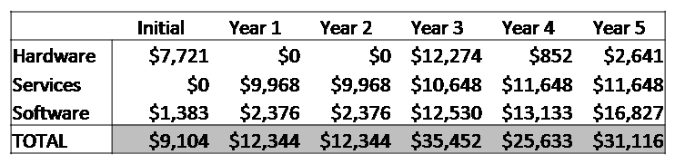
The costs associated with hardware, software, telecommunications, training, personnel, and support are summed up in Exhibit IS-07. These costs are spread out across years 0 to 5. We are aware that there are intangibles costs, that not are difficult to quantify, therefore are left out of the costing sheet. These costs include but are not limited to cables, machine breakdowns, everyday problems, etc. There are no additional costs for training, as NetSuite provides the service in their package. Nor does it include the costing for IS labor. We expect to incur high costs in year three since we are upgrading and buying new hardware throughout the organization to keep up with technological changes. We are forecasting our total IS costs for the five years to be $125,993, which is necessary to operate efficiently through all aspects and functions throughout the organization, thus establishing a competitive advantage. The full costing can be found in Appendix IS-08.
Exhibit IS-07: Costing

FINANCE
“In order to be irreplaceable, one must be different.”
Coco Chanel
INTRODUCTION TO FINANCE
Heart&Soles, Inc. will require significant capital resources from investors to begin marketing and manufacturing our product. As with any start-up company, we will be faced with many uncertainties and risks. Our base case, best case, and worst case financial models describe the total range of possible scenarios that could occur. However, we are confident that our base case represents the most likely scenario, and will take the necessary steps to mitigate major risks that could push our company towards financially unsuccessful outcomes. Heart&Soles’ goal is to provide investors with a healthy return on their investment and the following describes in detail how we plan to do so.

BASE CASE ANALYSIS
In our base case model, the total capital required is $1,329,055 (See Appendix FE-01). We are asking investors to contribute 75% of the total funds needed, or $996,791. This money will be paid out over the first three years of our project to cover our operating losses until we become cash flow positive in Year 4. We have also forecasted that SoleMates will peak in Year 8 of our product life cycle and will be repositioned or discontinued in Year 12 when volumes decrease to 20% of peak year sales.
EXHIBIT FE-01 | Ownership | Contribution of Capital | Year 0 | Year 1 | Year 2 | Year 3
Investors | 60% | 75% | $324,015 | $201,471 | $134,678 | $336,627
FFM | 40% | 25% | $108,005 | $67,157 | $44,893 | $112,209
Total | 100% | 100% | $432,020 | $268,628 | $179,571 | $448,836

Investors will be rewarded 60% ownership for their investment, with an internal rate of return of 33.76%, and a net present value of $370,794 at a 25% percent discount rate. Friends, family, and management will contribute 25% of the total capital and will receive 40% of the ownership. The reason for the discrepancy between contribution and ownership percentage is due to the fact that we will incur a higher initial risk in starting the company and product manufacturing. We also feel that we should be compensated for the invention of the product idea by a higher ownership percentage.
EXHIBIT FE-02 | NPV @ 25% | IRR
Investors | $370,794 | 33.76%
FFM | $495,109 | 50.18%
Project | $865,904 | 38.85%
Significant initial investments include production machines, software, hardware, and office furnishings. Aside from investment in fixed assets, we will also need; two weeks of emergency cash on hand, two weeks of first year inventory, and additional funds for product development and pre-marketing expenses. We will also need to account for the salary expense associated with hiring our CEO and Operations and Technology Specialist to go to trade shows, begin sending out media kits, and speak with retailers four months before our product launch in January of Year 1(See Appendix FE-02).
Assumptions
The assumptions that drive our base case model represent the environment we will most likely face. We assume the inflation rate will be 3% per year, and salary increases will be in lockstep with inflation. We also assume our accounts receivable days are 60, while accounts payable are only 30 days. Accounts receivable and accounts payable figures are based on our comparable companies and the belief that as a new company we will have relatively low credit extended to us. Using an odd-even pricing scheme, our profit maximizing retail price is $27.99 per unit in Year 1, and is expected to drop to $24.99 in Year 3 once SoleMates are accepted into national department chains (See Appendix FE-03 for complete assumptions page).
Breakeven
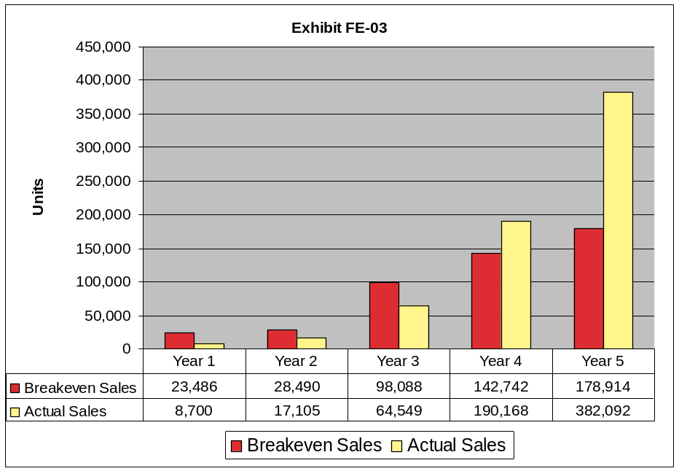
Heart and Soles, Inc. is expected to achieve breakeven sales levels in Year 4 by generating $2,677,921 in revenue from 190,168 units sold (See Appendix FE-04). In year 5, our unit sales are over twice the amount of breakeven sales.
EXHIBIT FE-03
Our company will first show positive cash flows in Year 4. This is not a cause for concern because we expect significant growth in net income and cash flows after Year 5 up until our peak in Year 8. Our inability to achieve high sales volumes in early years is due to our low initial ACV (See marketing Channels of Distribution).
Results
All net present values are calculated using a 25% discount rate for 8 years of production. Our business is projected to have a net present dollar value of $865,904 and an internal rate of return of 38.85%. Investor NPV is $370,794 and IRR is 33.78%. Friends, family, and management obtain an NPV of $495,109 and an IRR of 50.18%. (See Appendix FE-05).
There are two major factors contributing to our positive net present value. First, our company experiences solid cash flow growth from Years 5 to 8 due to the leveling out of our marketing expenses while sales continue to increase. The second factor is that our terminal value is substantial when assuming a product life cycle of approximately 12 years. We calculated our terminal value using the Dividend Growth model. Peak year cash flow in Year 8 is projected to be $2,197,278, after which we used a growth rate of negative 25% which reflects our product life cycle of 12 years. This results in a terminal value of $3,295,918 in Year 8.
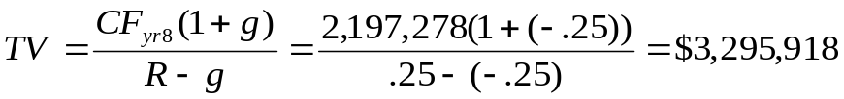
EXHIBIT FE-04

Ratios Analysis
Industry and Comparables
For ratio analysis, we used two comparable companies in the footwear manufacturing industry; LaCrosse Footwear, Inc. and Deckers Corp. We chose these companies because they are the most similar to our company in size, and seasonality of their products. The most reliable industry data available for comparison is for the plastics and rubber product manufacturing industry. Data from Year 5 is used because Heart&Soles will start to mature in that year making comparisons with established companies more beneficial.
Ratios (% sales) | Industry | LaCrosse Footwear | Deckers | SoleMates
COGS | 67.47% | 60.76% | 53.62% | 37.20%
SG&A | 24.07% | 31.04% | 24.30% | 29.41%
Operating Margin | 8.46% | 8.19% | 17.05% | 35.09%
Net Income | 5.27% | 5.89% | 10.35% | 24.79%
EXHIBIT F 5
EXHIBIT FE-05
Although we spend a similar percentage of sales on selling, general, and administrative expenses, our cost of goods sold are significantly lower than our comparables and the industry. This enables us to have higher operating margin and net income percentages. By Year 5 we will be competitively positioned in the footwear marketplace and the rubber and plastics manufacturing industry with higher than average margins.
Ratio Trends
In addition to seeing how our ratios compare to other comparable companies, it is important to understand how our company changes over time. As the time trend below
EXHIBIT FE-06
displays, our cost of goods sold as a percentage of sales increases from Year 1 to 3, and then stabilizes from then on. At first look, it appears that our company will experience difficulty controlling variable costs in the first few years. This is because in the first Year of operations, distribution of SoleMates is mainly through the direct online channel, with no channel margin. As we get into more stores and penetration of retail stores grows from year to year, our direct online sales make up a smaller and smaller percentage of overall sales. Although direct cost per unit is $1.83 less in Year 3 than it is in Year 1, our shrinking average price per unit more than offsets that decrease in direct cost. In addition to our changing distribution mix, our retail price will drop in Year 3 once our product is sold in national department chains. Both of these factors decrease our margins and cause the cost of goods sold percentage to rise.
Year | 1 | 2 | 3 | 4 | 5
COGS % Sales | 29.77% | 32.90% | 37.21% | 35.60% | 37.20%
Year | 1 | 2 | 3 | 4 | 5
SG&A % Sales | 191.66% | 111.86% | 95.44% | 48.35% | 29.41%
EXHIBIT FE-07
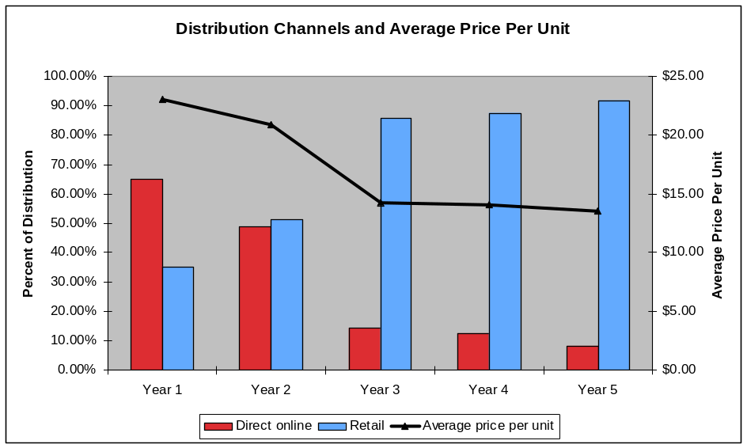
Also, you can see that we start out spending nearly twice our sales on SG&A. This ratio decreases steadily over the next five years due to our increasing sales volumes and the leveling out of our marketing budget and staff, demonstrating economies of scale in our business.
EXHIBIT FE-08

MAJOR BUSINESS RISKS
As with any business, our company faces a wide array of risks (See Appendix FE-06 for a list all of our risk factors, categorized by severity and probability). A discussion of our major risks and what we can do to control the potential damage is discussed below.
Sensitivity Analysis
In order to gain a better understanding of the risks that face our company, we performed sensitivity analysis on a variety of variables in our financial model to see how net present value changed. We found that NPV is the most sensitive to changes in unit sales. If unit sales of SoleMates were 10% lower than expected each year, our project NPV would decrease by 41.75%, and investor NPV would drop by 62.50%. This variable also has the highest probability of occurring out of all risks.
Variables | % change of variable until Project NPV = 0 | % change of variable until Investor NPV = 0
Unit Sales | 23.89% | 15.99%
ACV | 24.04% | 16.10%
Awareness | 24.04% | 16.10%
Purchase Intent | 24.04% | 16.10%
Price | 26.98% | 21.61%
Direct Cost | 36.69% | 24.42%
EXHIBIT FE-09
The marketing variables ACV, awareness and purchase intent all play an equally significant role in determining annual units sold. If any of these variables were 10% lower than expected each year, project NPV would be 41.42% lower and investor NPV would be 62.04% lower.
Direct cost per unit also has a significant impact on our net present value. If costs were to increase by 10% every year, project NPV would decrease by 27.26%, while investor NPV would decrease by 40.88%. Not only is the cost of our product a risk, but the retail price that we can sell it for is too. If price were 10% lower each year than expected ($2.80 decrease year 1 and 2, $2.40 decrease year 3, 4 and 5), project NPV would only decrease by 17.71%, while investor NPV would decrease by 26.10%.

NPV Breakeven (Margin of Safety)
Another way to look at the relationship between NPV and these variables is using margin of safety analysis to see how much each variable can change before net present value equals zero, the table below summarizes our calculations. This is consistent with our finding through sensitivity analysis that unit sales are our company’s greatest risk, closely followed by the marketing variables.

Other risks
If our company fails to get into Nordstrom or Macy’s in Year 3, our sales volumes would continue to be below breakeven levels. In order to decrease the likelihood of this event, we will hire and train our own sales force in Year 3 to establish closer relationships with retailers. Our product life cycle may also be risk. Right now, we have estimated it to be about 12 years. It turns out that net present value is fairly insensitive to changes in the perpetual growth rate. If “g” changes from -25% to -35%, project net present value only decreases by 5.09%.

Strategies to Mitigate Risks
Although the severity of our price risk is potentially high, the probability that our retail price per unit will decrease is very low because we will largely dictate the price that our customers pay. In order to get into national department chains in Year 3, we might have to drop our price. We have already accounted for this by dropping the price about 10% from Year 2 to Year 3, from $27.99 to $24.99. The most likely factor that would subject us to price risk is a change in the relative proportion of the channels of distribution that we gain access to. If we sell fewer units online than expected, our average price per unit will decrease and profits will drop. To ensure that direct online sales make up a sufficient part of our total sales in the first two years, we will guide customers to our company website through our marketing efforts (See Marketing Section on direct online).
Our biggest risk overall is possible variations in unit sales. If each year, unit sales were to be 25% lower than expected, our net present value would be zero. This risk is also the most probable, as sales projections are an art, not a science. We plan to mitigate this risk through creative, low cost marketing strategies that generate sufficient awareness in our target market and clearly communicate SoleMates’ key functions and benefits.

WORST CASE ANALYSIS
WORST CASE | NPV @ 25% | IRR
Investors | -$491,864 | 10.66%
FFM | $18,121 | 26.20%
Project | -$473,743 | 15.50%
EXHIBIT FE-10
The worst case scenario for our company is built around the possible situation described in the marketing section. This case is meant to illustrate the lower bound of the range of financial possibilities. In the addition to changes in marketing variables, cash as a percentage of sales will be 5 percentage points higher. Also, the perpetual growth rate will be 10 percentage points lower (g = -35%), reflecting a shorter product life cycle than expected. Our accounts receivable days would be 10 days longer if we have problems getting our payments from customers on time, and accounts payable days would be 5 days lower if we have difficulty obtaining credit from suppliers.
If all of this occurred, project and investor NPV would be negative using a 25% discount rate. However, the project would still return 15.50% and investors would earn a return of 10.66% on their investment. Even in the worst case scenario no one would have a loss on their investment (See Appendix FE-08, 09, and 10 for worst case Income Statement, Balance Sheet and Cash Flow Statements).

BEST CASE ANALYSIS
Our best case scenario uses the same changes we assumed in the worst case, simply in the other direction. This helps describe the true potential for the financial success of our project. In our best case investors could earn as much as 65.48% on their investment in our company and an NPV of $1,638,216. (See Appendix FE-11, 12, and 13 for best case Income Statement, Balance Sheet and Cash Flow Statements).
BEST CASE | NPV @ 25% | IRR
Investors | $2,224,578 | 65.48%
FFM | $1,638,216 | 86.21%
Project | $3,862,794 | 71.80%
EXHIBIT FE-11

WHY INVESTORS SHOULD CHOOSE SOLEMATES
Investing in Heart&Soles, Inc. is a wise decision for investors for multiple reasons. First, our base case results offer a competitive return, with a fairly low level of risk. Second, even in the worst case scenario, we still have positive internal rates of return. We will also employ a variety of strategies to mitigate our most serious risks.
Another attractive feature of our project is the rollout plan. By starting in the Northeast for the first two years, we can test out the market for SoleMates and make any necessary adjustments in the marketing campaign and the design of our product. We can also make sure that our information systems are implemented well and are functioning properly before we rollout in Year 3. Overall, we believe that it makes more business sense to start small, and scale up our operations so that we limit our risk exposure in the early years. Then, if disaster strikes, there is always the option to liquidate the business to prevent further financial losses.

CONCLUSION
SoleMates provide the answer to the ongoing dilemma of choosing what shoes to wear because of weather conditions. Unlike any other product in the footwear market, SoleMates are designed to cover high heeled shoes and protect them from weather elements encountered on everyday commutes. Heart&Soles’ corporate social responsibilities will allow our company to be viewed as innovative and eco-friendly organization that cares for the environment as a whole.
Our company is a low risk, high return investment opportunity for investors; generating a total internal rate of return of 33.68% and NPV of $368,081, given a 25% discount rate. This is a safe investment given our positive return in even our worst case scenario and the strategies we have emplaced to protect our company from uncontrollable risks.

APPENDICES
Zest is the secret of all beauty. There is no beauty that is attractive without zest.
Christian Dior

Works Cited

“2007 NAICS Definition.” http://www.census.gov/eos/www/naics/htmls/3/316211.htm
(accessed April 7, 2008)

Boot & Shoe Travelers Association of New York, Inc.. “Member Documents.” http://bootshoeny.com/default.asp?a=docs (accessed March 25, 2008)
“Boston Shoe Travelers Association.” http://www.bostonshoetravelers.org.(accessed April 1,
2008)

“Botanical Paperworks.” http://www.botanicalpaperworks.com.(accessed April 1, 2008)

BizStats. Plastics and Rubber Products Manufacturing Corp http://bizstats.com/reports/corp.asp?industry=Plastics+and+rubber+products+manufacturi ng&profType=income&var=&coding=32.6 (accessed February 17, 2008)
Brown Sales Corporation. “Automated Cutting Services.” http://www.brownsales.com/cuttingservices.htm (accessed April 1, 2008)
"Color Wheel Pro: Color Meaning." 2002. http://www.color-wheel-pro.com/color-meaning.html
(accessed April 8, 2008).

“Cosmopolitan Magazine Media Kit.”
http://www.cosmomediakit.com/r5/showkiosk.asp?listing_id=360478&category_code=ci
rc&category_id=27808(accessed April 7, 2008)

“CustomInk.” 2002.http://www.customink.com/ (accessed April 5th, 2008).

Dell Multifunction Color Laser Printer 3115cn Details. Dell.
http://accessories.us.dell.com/sna/productdetail.aspx?c=us&cs=04&l=en&s=bsd&sku=222-6548&redirect=1. (accessed March 27, 2008)

Dell PowerEdge 2900 III Server Product details. Dell.
http://www.dell.com/content/products/productdetails.aspx/pedge_2900_3_tower?c=us& s=04&l=en&s=bsd (accessed March 27, 2008)

Everest Software. http://www.everesterp.com/default2.asp-products-ERP-active_page_id-57
(accessed March 27, 2008)

Fashion Footwear Association of New York. “Exhibitor Applications.”
http://www.ffany.org/exhib_applic.html (accessed March 25, 2008).

Federation of Tax Administrators. Range of State Corporate Income Tax Rates.
http://www.taxadmin.org/fta/rate/corp_inc.html (accessed April 5, 2008)

IBackup Drive-Online Storage . IBackup. http://www.ibackup.com/online-storage-drive/.
(accessed March 29, 2008)

McAfee. McAfee Total Protection Solutions.
http://www.mcafee.com/us/small/products/security_suite_solutions/total_protection_solutions/index.html (accessed April 12, 2008)

“Metropolitan New York Shoe Market.” http://www.bootshoeny.com/default.asp
(accessed April 7, 2008)

Microsoft Dynamics: Business Management. Microsoft Dynamics.
http://www.microsoft.com/dynamics/default.mspx. (accessed March 27, 2008)

“Minimum Wage in the United States.” http://www.laborlawcenter.com/state-Minimum-Wage
rates.asp?gclid=CKvLwcb1x5ICFUU2FQod3yFUcA

MySpace. www.myspace.com

NEOS Overshoe. <http://www.overshoe.com/recreational/products/allseason.php>

“Property taxes: Where does your state rank?” MSN Money. 2007. 3 April 2008
http://articles.moneycentral.msn.com/Taxes/Advice/PropertyTaxesWhereDoesYourStateRank.aspx

Retirement Living Information Center. Taxes by State: Kentucky, Missouri, Pennsylvania, Tennessee. http://www.retirementliving.com/RLstate2.html (accessed April 10, 2008).

Tax Foundation. Tax Data. State Corporate Income Tax Rates. http://www.taxfoundation.org/taxdata/show/230.html (accessed April 7, 2008)

Salary.com. http://www.salary.com/ (accessed April 7, 2008)
Small Business Software. NetSuite,
http://www.netsuite.com/portal/products/nsb/main.shtml. (accessed March 27, 2008)

“Soles4Souls Inc.” http://www.soles4souls.org/ (accessed March 27th, 2008)

“Spending Power of Young Adults - US - November 2006.” Mintel Oxygen.2007. 1 March 2008
http://academic.mintel.com.ezproxy.bu.edu/sinatra/oxygen_academic/export_basket/&sort=my_order&list=export_basket/display/id=167402&aim/display/id=247111

Stevenson, William J. Operations Management. Boston: McGraw-Hill, 2007.
ThomasNet. http://www.thomasnet.com/. (accessed February 25th, 2008)
Tree Frogs. http://www.treefrogsports.com/product.html (accessed February 1st, 2008)

UGG Boots. http://www.uggaustralia.com/ProductsList.aspx?gID=w&categoryID=283&page=1
(accessed February 1st, 2008)

United States Securities and Exchange Commission. Form 10-k. Deckers Corporation.
http://www.sec.gov/Archives/edgar/data/910521/000104746908002087/a218301 z10-k.htm (accessed March 12, 2008)

United States Securities and Exchange Commission. Form 10-k. LaCrosse Footwear,
Inc.http://www.sec.gov/Archives/edgar/data/919443/000095013408004355/v37356e10vk.htm (accessed April 05, 2008)

Vostro 1000 Laptop. Dell.
http://www.dell.com/content/products/productdetails.aspx/vostronb_1000?c=us&cs=04&l=en&s=bsd&~tab=bundlestab. (accessed April 05, 2008)

Vostro 200 Mini Tower. Dell.
http://www.dell.com/content/products/productdetails.aspx/vostrodt_200mt?c=us&cs=04&l=en&s=bsd&~tab=bundlestab. (accessed April 05, 2008)

“Women & Co.” https://www.citibank.com/womenandco/pages/index.jsp.(accessed April 05,
2008)

“Women's Dress and Casual Footwear - US - June 2007.” Mintel Oxygen. 2007. 1 March 2008
<http://academic.mintel.com.ezproxy.bu.edu/sinatra/oxygen_academic/search_results/show&/display/id=226576/display/id=285010#hit1>

Word Resources Institute. 2007 <http://archive.wri.org>

World Shoe Association. 2007. http://www.wsashow.com/

Yahoo! Finance. http://finance.yahoo.com/ (accessed April 4, 2008)

1. Indicate the extent to which you agree or disagree with each statement. | Strongly Disagree | Disagree | Neutral | Agree | Strongly Agree
I consider myself a fashionable person
I buy shoes specifically for inclement weather (i.e. Rain boots, snow boots)
I try to protect my dress shoes
I carry a separate pair of shoes in a bag because of the weather

Product Concept Description: Our product is a weatherproof shoe cover that will be designed to fit over most heels and flats. Our main goal is to create a lightweight, compact alternative to regular rain boots or lugging two pairs of shoes around. It will be able to withstand harsh weather while maintaining a fashionable design. The product will include a small carrying case (10 by 7 inches).
**See pictures on last page**
2. Where would you expect to find this product in a store? (check one)
Shoe Accessories (laces, shoe polish) | Shoes | Clothing/Apparel | Umbrellas or purses
Raincoats/Outerwear | Other: ___________
3. Based on our product concept, please rank the following eight attributes based on importance to you (1=most important, 8=least important, use each number once)
___ Waterproof Capability ___ Fashion ___ Portability ____Worn over shoes
___ Ease of Use ___ Durability ___ Form Fitting ____Lightweight
4. Which one of these names do you think would fit this product? (Check one):
Boots-to-Go Booties Heel Seals Aquas Other:_______
5. Where would you buy this product? (Check all that apply)
Department Store (i.e. Macys, Nordstrom’s) Boutique (Steve Madden) Discount Shoe Store (Payless) Direct Online (manufacturers’ website) Wholesale shoe store (DSW) Other: _______________

6. Would you buy this product direct online? Yes No
6a. If yes, how much would you be willing to pay for shipping? ______

7. How much would you be willing to pay for this product?
$0-19 $20-29 $30-39 $40-49 $50-59 $60+
8. At the price you just indicated, would you buy this product?
Definitely buy Probably buy Indifferent Probably not buy Definitely not buy
9. How many times do you think you would purchase this product during a year? _____
10. Would you wear this product with your (Check all that apply):
Business Attire Jeans Skirts Shorts Cocktail Attire None
11. What height would you like this product to be?
Ankle Mid-Calf Below the Knee
12. What is the maximum price you would be willing to pay for this product? _______
13. How many pairs of shoes do you spend $100+ on during a year?
Never 1 or 2 3 or 4 5 or more
14. How often do you wear heels?
Daily Several times a week Several times a month Almost never
15. When do you most often wear heels?
Daytime Nighttime Both Never
16. What is your main mode of transportation?
Walk Car Train Other_____________
17. How many minutes do you walk outside per day in dress shoes?
About 10 About 15 About 20 About 30 or more
Demographics (information will be kept confidential)
Age? 17 or younger 18 to 24 25 to 34 35 to 44 45 +
What is your approximate annual Income?
$24,999 or less 25,000 to 49,999 50,000 to 99,999 100,000 or more
What city, state and zip code do you live in? _______________________________________

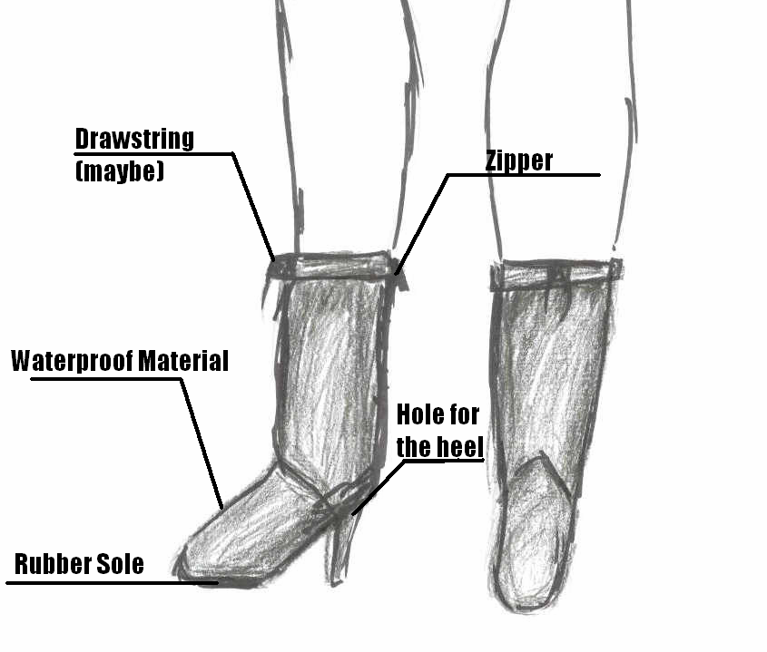

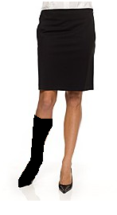

Soles4Souls. <http://www.soles4souls.org>.
Women&Co. <https://www.citibank.com/womenandco/pages/index.jsp>.
http://www.census.gov/eos/www/naics/htmls/3/316211.htm
http://archive.wri.org
http://www.census.gov/popest/gallery/maps/popsize-2007.html
“Spending Power of Young Adults - US - November 2006.” Mintel Oxygen. academic.mintel.com.ezproxy.bu.edu/sinatra/oxygen_academic/export_basket/&sort=my_order&list=export_basket/display/id=167402&aim/display/id=247111
http://www.overshoe.com/recreational/products/allseason.php
http://www.treefrogsports.com/product.html
http://www.wellieart.co.uk/categories.php?cat=8
UGG Boots. http://www.uggaustralia.com/ProductsList.aspx?gID=w&categoryID=283&page=1
“Spending Power of Young Adults - US - November 2006.” Mintel Oxygen.2007. 1 March 2008 http://academic.mintel.com.ezproxy.bu.edu/sinatra/oxygen_academic/export_basket/&sort=my_order&list=export_basket/display/id=167402&aim/display/id=247111
http://academic.mintel.com.ezproxy.bu.edu/sinatra/oxygen_academic/search_results/show&/display/id=226576/display/id=285006?select_section=285010
Ibid.
http://www.botanicalpaperworks.com/
http://www.bostonshoetravelers.org/
http://www.bootshoeny.com/default.asp
http://www.ffany.org/trade_overview.html
http://www.wsashow.com/
Stevenson, William J. Operations Management. Boston: McGraw-Hill, 2007. page 314.
LaCrosse Footwear. http://finance.yahoo.com/q/is?s=BOOT&annual Decker’s Outdoor Corporation. http://finance.yahoo.com/q/is?s=DECK
http://www.evansville.edu/prospects/areasofstudy/engineering/programs.asp
NetSuite. http://www.netsuite.com/portal/products/nsb/main.shtml
Everest. http://www.everesterp.com/default2.asp-products-ERP-active_page_id-57
Microsoft Dynamics. http://www.microsoft.com/dynamics/default.mspx
NetSuite. http://www.netsuite.com/portal/products/netsuite/main.shtml
Dell. http://www.dell.com/content/products/productdetails.aspx/vostrodt_200mt?c=us&cs=04&l=en&s=bsd&~tab=bundlestab
Dell. http://www.dell.com/content/products/productdetails.aspx/vostronb_1000?c=us&cs=04&l=en&s=bsd&~tab=bundlestab
Dell. http://www.dell.com/content/products/productdetails.aspx/pedge_2900_3_tower?c=us&cs=04&l=en&s=bsd
Dell. http://accessories.us.dell.com/sna/productdetail.aspx?c=us&cs=04&l=en&s=bsd&sku=222-6548&redirect=1
Dell. http://accessories.us.dell.com/sna/suppliesselector.aspx?step=1&c=us&cs=04&l=en&s=bsd&seg=bsd&~ck=mn&printersku=222-6548
Dell. http://accessories.us.dell.com/sna/products/Backup_Tape_Zip/productdetail.aspx?c=us&l=en&s=bsd&cs=04&sku=341-2834
iBackup. http://www.ibackup.com/online-storage-drive/
Dell. http://accessories.us.dell.com/sna/products/Power/productdetail.aspx?c=us&l=en&s=bsd&cs=04&sku=A0534479
Dell. http://accessories.us.dell.com/sna/products/Power/productdetail.aspx?c=us&l=en&s=bsd&cs=04&sku=A0574263
BizStats.com

