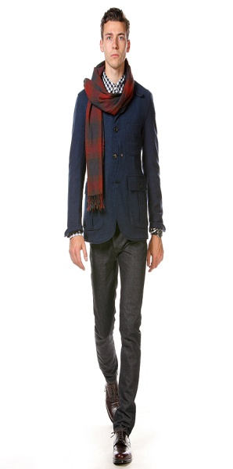Glover Graphic Design’s

Jeans are unacceptable when they are holey and generally scruffy.

Ladies please no bear tummies.

For health and safety reasons on thongs or any other open toed shoes to be worn.

Tattoos and body piercings must be out of sight or removed, many people still find this offensive. All ways make sure that you maintain good hygiene and grooming.

Also please no way out hairstyles or colouring, you can still be up with the latest trends and not stand out because of your way out hairstyle, tattoos and piercings.

WELCOME to the team. In our office we only expect you to dress formally for business meetings with clients, e.g.: for men suit trousers, jacket, shirt with collar and tie, also enclosed leather shoes. Our lady employees need to dress appropriately for meetings also, smart suits or frocks with a jacket and enclosed shoes. Ladies, accessories are always important to get the right look.

Acceptable work wear for everyday would be to make sure that you are dressed smartly, whether it be tailored pants, suits, jeans are only acceptable if they are well pressed and in excellent condition.

www.porhomme.com

**Newsletter for New Employees 0n Appropriate Work Attire**

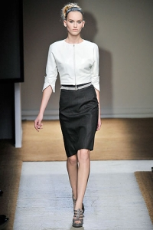wwwbecomegorgeous.com.

