Hypothalamic Dysfunction
March 9, 2012 | Leave a Comment

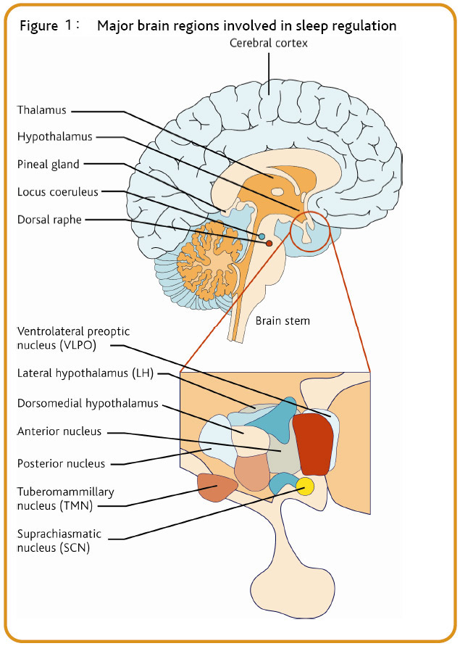
Throughout some courses I’ve taken since high school, I’ve learned that the main function of the hypothalamus is controlling the drives of the body and is involved in mood regulation. It controls hunger, thirst, sleep, as well as the regulation of body temperature in relation to the suffiency or insufficiency of hormones.
Hypothalamic disorder/dysfunction is a condition in which the hypothalamus is damaged, impairing its ability to carry out its role to the body. The hypothalamus works with the endocrine system, primarily with the pituitary and adrenal glands, in order to carry out crucial functions necessary for human development. Causes include eating disorders such as anorexia and bulimia nervosa (which could also lead to hypothalamic disorder), malnutrition, genetic disorders. I will specifically focus on the changes within the hypothalamus and its neighboring structures involved in anorexia.

After doing research on hypothalamic disorder, I realized that the neuroanatomical changes that occur as a result of someone with anorexia seem to be at the heart of understanding what the role of the hypothalamus is. For example, to reiterate, the symptoms of hypothalamic disorders such as the ability to regulate certain behaviors and thermoregulation, sleep conflicts, headaches, and fatigue are consistent with the prior knowledge I had about the disorder; it makes sense that because the hypothalamus is being disrupted, an individual with anorexia is more likely to feel cold due to the lack of energy intake. This may cause them to also feel tired, increasing the need to sleep or so hungry they cannot.
Now, after discussing these main symptoms, we can look at what is actually occurring in the hypothalamus to a sufferer. As previously stated, the hypothalamus does not work alone in regulating food consumption (or lack there-of). The hypothalamic–pituitary–adrenal axis (HPA axis) involved the areas of the brain that are said within its name—hypothalamus, pituitary gland, and adrenal glands.
Figure 1. The location of the thalamus in the
The HPA axis is also involved when a person experiences stressful situations.
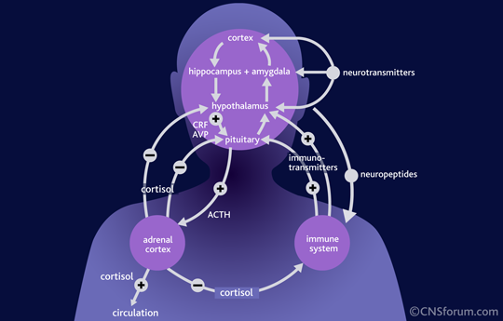
thus also affecting appetite (Sauro, Ravaldi, Cabras, Faravelli, & Valdo, 2007). This is because stress stimulates certain areas involving the regulation of energy expenditure as well as food consumption within the
Figure 2. Peptides in the HPA axis.
hypothalamus of the interaction loop in the HPA. So—what exactly is going in these areas when a person with anorexia is going through a “fasting” phase?It involves the disruption of the HPAaxis’ functions. Food deprivation may eventually lead the person to habituate to the feeling of hunger (hypothalamus), decreasing the release of hormones (by the pituitary gland) and hormones specific to the sex of the person (adrenal gland). The inhibition of hormone secretion for, let’s say women, directly affects the menstrual cycle also due to the overall outcome–loss in fat.
When a person is depriving his or herself from food, an amino acid called potent orexigenic peptide (NPY) in the hypothalamus is suppressed. The suppression does not allow energy storage to take place and so digestion is also inhibited. Thus, NPY is the neuropeptide involved in the stimulation of food-consumption (Schwartz, Woods, Porte, Seeley, &Basking, 2009). When
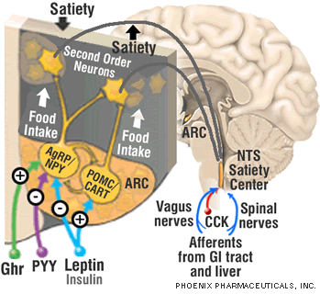
an individual with anorexia undergoes a starving phase, the inhibition of NPY signals a region called the ventromedial hypothalamus that they are feeling “full” (Jamshidi and Taylor, 2009). This may be why after a few days of fasting, it is easier to continue their to starve themselves.
Figure 3. POMC and NPY in the brain.
Another peptide involved in food regulation is pro-opiomelanocortin (POMC) (Broburger, Johansen, Brismar, Johansson, & Challing, 1999). POMC’s influence in the HPA axis is the opposite of what NPY’s role is—it decreases appetite and thus, for the sufferer, induces starvation (Lambert, Anderson, Sleeman, Wong, & Hijuranguru, 2011). Just like NPY is involved with the ventromedial hypothalamus, POMC signals the lateral hypothalamus that the body is hungry. A person with anorexia may have high levels of the POMC and just like the inhibition of NPY, the lack of food will obviously not allow the storage of fat and thus cause weight loss.

While there are other neuropeptides involved in the hunger feedback loop, NPY and POM play the biggest role. These neuropeptides work with one another in order to signal to parts of the hypothalamus when they feel hunger or satiation after they eat. Specifically, the ventromedial hypothalamus is involved in feeling satiated after having a meal, and signal the body to stop eating while the lateral hypothalamus. The major contributers to the dysfunction of the hypothalamus–specifically in anorexia nerviosa– occur in the disregulations and homeostatic imbalances in the peptides that work along with the hypothalamus and its neighbours in the axis.

Jamshidi, N. Taylor, D.A. (2009). Anandamide administration into the ventromedial hypothalamus stimulates appetite in rats. Brittish Journal of Pharmacology, 134(6), 1151-1154. doi:10.1038/sj.bjp.0704379

Lambert, P.D., Anderson, K.D., Sleeman, M.W., Wong, V., Tan, J., Hijarunguru, A., Corcoran, T.L., Murray, J.D., Thabelt, K.E., Yancopoulos, G.D., Wiegand, S.J., Ciliary neurotrophic factor activates leptin-like pathways and reduces body fat, without cachexia or rebound weight gain, even in leptin-resistant obesity. Regeneron Pharmaceuticals, 98(8), 4652-4657.

Sauro, L.C., Ravaldi C., Cabras, P.L. Faravelli, C. Ricca, V. (2008). Stress, hypothalamic-pituitary-adrenal axis and eating disorders. Neuropsichobiology, 57(3), 95-115.

Schwartz, M.W., Woods, S.C., Porte, D. Jr., Steeley, R.J., Basking, D.G. (2000). Central nervous system control of food intake. Insight Review Article, 404 (6778). 661-671.

