Name: Jourdann Rhodes

Behavioral Goal or Topic: Sugar Sweetened Beverages

Date of Lesson: 24 October 12

Title of Lesson: Drink It!

- Target Audience: Four year old HeadStart children

- Learner Objectives:
- After receiving lessons on healthy drink choices, children will receive visuals of the drinks, and be able to group themselves appropriately based on visual and peer matching.

- After grouping themselves based on visuals, children will be able to identify how often they drink the specified healthy drinks based on daily meal times.

- Time allotted: 2-3 minutes

- Preassessment Question: Once children have grouped together based on their visuals, ask the children, “Which drink do you have?” The children will respond based on beverage visual. Then ask, “How many of you drink milk in the morning?” The children will hold up their card (visual of beverage) if they answer yes. This same question will be asked for all three discussed beverages and all three meal times.

- Context and Sequence:

- Begin lesson with greeting the children and introducing myself. “Good Morning class, my name is Ms. Jourdann.”
- Then introduce the matching activity and hand out visuals. “We are going to do a little activity. Everyone needs to take a card, and when I say go you are going to find everyone who has the same card as you. Ready, Go.”
- Children will stand up and find their matching visuals with the aid of myself and possibly the teacher to conserve time. Then I will announce, “When you find your matches sit down with your group.”
- Children will sit and I will ask each group what drink they have. E.g. “This group, what drink do you have?” Children will answer with milk, juice or water.
- Next I will instruct children raise their hand/visual if they respond “yes” to my question. E.g. “Now I want you all to raise your card if you drink water for breakfast.” This process will repeat with all beverages per meal time. Depending on time, there may only be enough time to go through each meal time once. With that, ensure at least each beverage gets discussed at least once.
- End lesson with congratulating children on a job well done. E.g. “Good job class, you all did great today!”

- Materials
- Milk, water, juice visual cards. Cards will be made with colored cards due to color contrast between normal index card and color of beverages i.e. white milk.

- Evaluation
- By participating in matching activity, children will be able to identify the healthy drinks they need to be drinking and when they need to be drinking them.

CARD ONE

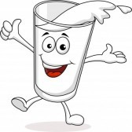
MILK

CARD TWO

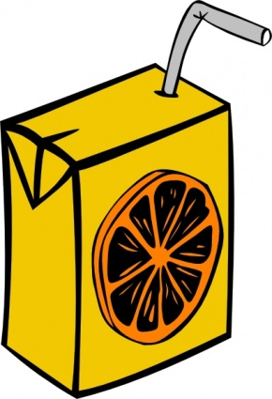
JUICE

CARD THREE

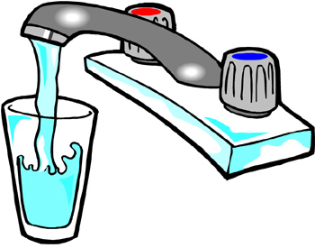
WATER

