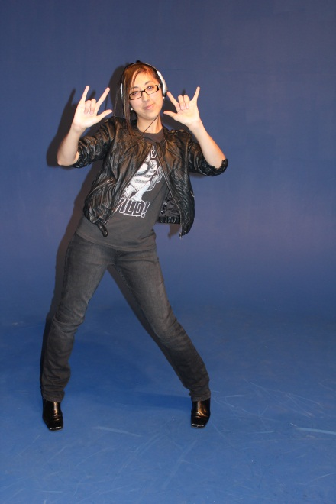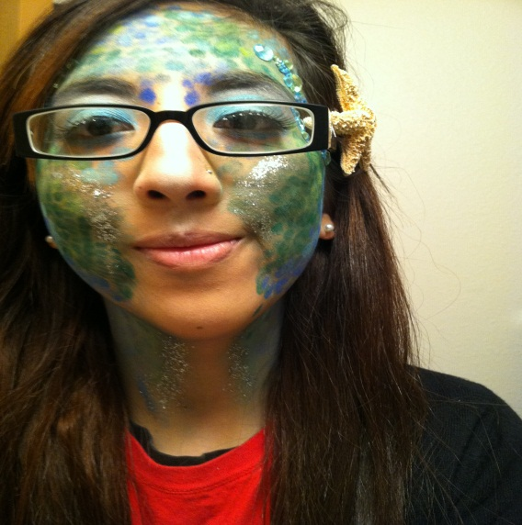bgbox.jpgbgbox.jpgbgbox.jpg` of trust

Contacts

Twitter: @heyalma89

Email: [aflores01@drury.edu](mailto:aflores01@drury.edu)

LinkedIn: http://www.linkedin.com/pub/alma-flores/57/901/476

* Favorite tv shows: Doctor Who and Sherlock
* Her favorite pizza toppings are pepperoni and jalapenos

.Rocking out to Green Day is one of Alma’s

favorite pastimes

* Alma’s favorite band has been the same since she was seven: Green Day

She was born in Houston, TX and followed three older brothers. Being the smallest Flores is not the easiest spot but she has proven herself time and time again. Whether it was moving away from home, changing universities, an writing a 20 page research paper then she can do anything,

**WHOVIAN, NERDFIGHTER, & FUTURE COSTUME DESIGNER**

**Flores**

**Alma**

Fun Facts

Tri-Lingual:

Spanish

English

French

Favorite quote:

“Far from what I once was but not yet what I’m going to be”

A FASHIONISTA AT HER FINEST

It’s a soulful world

Alma, whose name means soul in Spanish, is a 23 year old future costume designer. She has been a punk Cinderella, a peacock, and a mermaid just to name a few characters.

Blogging

Website building

Final Cut Pro

Stage-makeup

Dresser

Sewing

**Skills she can offer**