THE KODAK Zi8
A picture is worth a 1,000 words 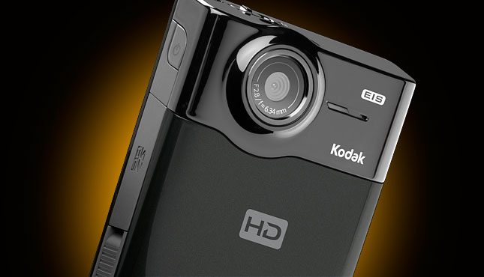
So save your breath and capture every moment with The Kodak Zi8 Pocket Video Camera
The Kodak Zi8 is great for everyday use as well as special occasions. Whether you’re watching your son’s soccer game or celebrating a birthday, this small, convenient camera has it all. With remarkable ability to capture in 1080p HD video, you’ll never miss another moment again!

Table 1: Ad 1: ELM Central Peripheral Route
FINAL PROJECT
MATCH YOUR MESSAGE TO THE THEORY
What the theory says… | What I say in my ad to match what the theory says…
(Assumptions and directions here) | (How does your ad meet each assumption or direction here)
1: Two ways to persuade: Through thinking and feeling | Headline and Image: Reflects relevance of never missing special moments and fun times.
2: The central route is one where people use cognition:  - Price of product  - Complexity  - Difficult to operate | Ad states: simplicity and convenience
3: Motivation: Depends on individual motivation to engage in processing | Desire to be able to capture every laugh and celebration that passes target audience in life
4: High Involvement: Also depends on individual and how it affects her/him personally | Not reflected in ad, based on each individual of target audience
5: Central Route: Requires different strategies | Central Route:  Attention: Image of friends laughing and having a good time.  Interest: Headline “A picture is worth a 1000 words.”  Comprehension: Seeing image, target is able to understand there is a story behind someone having cake all over their face.  Acceptance: A connection to friends having a good time celebrating a birthday- everyone celebrates birthdays with their friends and family.  Retention: Importance of never missing another happy moment in life again

