HP Announces Next Generation Pavilion dm1
By Amber Riippa, NotebookReview Staff
Thursday, September 08, 2011
12446 Reads
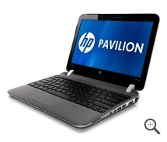Although the last 11.6-inch HP Pavilion dm1 wasreleased in January, HP is updating the notebook again and releasing it before the end of the year. The updated, next generation HP Pavilion dm1 will sport a new design, Beats Audio software and a new feature of the HP Premier Experience, and the upcoming AMD E-450 dual-core processor at 1.65GHz.
HP has brought the popular Pavilion dm1 to light with the slogan "...mobility of a netbook and the performance of a notebook." The reason the company goes with this slogan is because it weighs only 3.52 lbs, but has enough power to make even 3D gaming possible. The last generation separated itself from its competition even further by being offered up for less than $500; this generation stays in that price range, too.
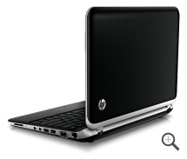Other new features include improved Windows boot-up times and resume times from sleep mode due to the new CPU, a textured edgeless touchpad, a new vent location on the left side, and improved AMD graphics. The update will have AMD Radeon HD 6320 discrete-class graphics (a step up from the prior HD 6310 graphics). Users should also see better all-around system performance because of the improved core hardware.
The new lid style looks similar to the branded HP design already employed on some of the company's notebooks, and is what HP calls the "pinwheel design." It's soft to the touch and imprinted with a pattern made by printing it on a film with a rubberized finish. The optional available accessories, the wireless mouse and notebook carrying case, will also sport the same design.
The HP Premier Experience will be included again, this time with a few tweaks to make Windows 7 usage easier. The software engineers have made an HP "Launch Box" application, where users can customize their own launch box by grouping similar programs together in one place in the launch box manager. For example, users might choose to put all installed programs concerning shopping and productivity in one place, and with the launch box they can. The HP CoolSense technology, which helps the notebook stay cool and protected while in motion, also got a small interface update.
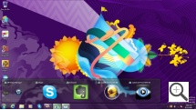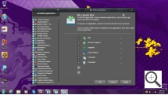
One feature that will remain the same is the easy removal of the whole bottom of the notebook. The entire bottom plate can still be removed by simply taking the battery out and sliding the release. There users will have access to the RAM, hard drive and wireless card for upgrading purposes. Notably, the glossy 11.6-inch 720p (1366 x 768) display with LED backlighting is the same as last time as well.
The port selection include three USB 2.0 ports, HDMI, VGA, Ethernet, a media card reader and lock slot, and headphone and microphone slots.
Pricing and Availability
The next generation HP Pavilion dm1 will be sold for as low as $399 for the base configuration and as high as $599 for the version with the Intel SSD. Shipments will begin at the end of October.

