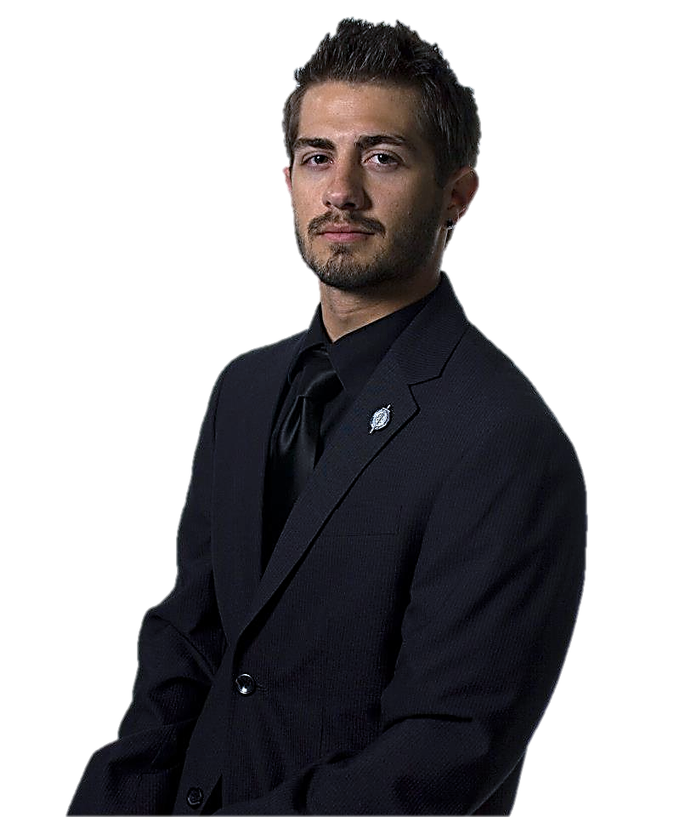
Kelly Claar

899 Pine Knob Rd. Osterburg, PA 16667 • (814) 327-2256 • kclaar11@gmail.com

Education Robert Morris University, Moon Township, PA
Bachelor of Arts in Communication, concentration in Public Relations
Minor in Documentary Studies
Expected December 2012, GPA: 3.75/4.0
Deans List Fall 2009 – Spring 2012

Work New Perspective Productions, Pittsburgh Pa
Experience Production Assistant Intern, September 2012 - Present
- Assist on productions including lighting, camera, and prompter
- Contact and coordinate with new clients to promote business

Staples: The Office Superstore, Pittsburgh, PA
Easy Tech Associate, July 2011 – Present
- Provide excellent customer service in retail sales
- Assist in the sale of computers and other electronics

Robert Morris University, Moon Township, PA
Admissions Office Ambassador, September 2010 – Present
- Lead campus tours to prospective students and families
- Perform office work such as answering phones and filing

Project Brand Design
Experience - Developed company logos for two mock PR companies
- Created rush logo for fraternity in Fall 2011
- Established a photo to promote scholarship for fallen fraternity brother

Production Assistance
- Worked as technical director, camera operator, and teleprompter for RMU-TV
- Assisted director, sound designer, and gaffer for New Perspective Productions
- Performed as director, producer, and talent for various classwork productions

Public Relations Campaigning
- Wrote press releases, news articles, and video script as fraternity PR chairman
- Constructed interviews and feature stories to promote RMU Builders Project
- Utilized primary research and multimedia to create “Stay a Kid” campaign

Skills Lighting and Camera Work Public Speaking and Presentation
Microsoft Word and Excel Sales Experience Professional Document Writing Social Networking

Activities Alpha Chi Lambda Pi Eta
Alpha Psi Omega Phi Delta Theta Fraternity
College Democrats RMU Colonial Theatre
Colonial Ambassadors RMU-TV

