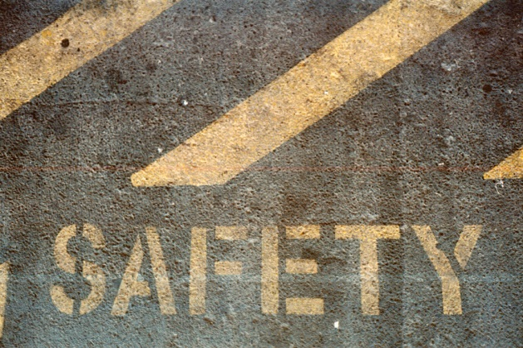
Five Things to Consider For Child Safety Protection Month

Submitted by Dana Pool on Mon, 11/19/2012 - 8:39am

November is Child Safety Protection Month
Every parent tries to be aware of the dangers that their children face every day, including ensuring that they are safe in their own home. However, no matter how proactive you are in child-proofing your home, you may not realize some everyday items could present unknown dangers.
Kids are quick, curious and fast! And sometimes, those traits can get them in "trouble". Here are five things to consider when child proofing your home to help prevent as many injuries as possible:
- Workout Equipment Safety. Nearly 25,000 kids are injured every year because of workout equipment. Be sure to keep your exercise equipment in a locked room, remove and hide the safety key in a place your children will not find it (this way the machine will not turn on), and put your weights in a place your children cannot access them.
- Bathroom Safety. 40,000 emergency room visits a year are made by children who suffered injuries in their own bathroom. Make sure you have safety caps on all prescriptions and medicines and put all cleaning products in a locked cabinet or up high out of their reach. Never leave young children alone in the bathtub or near water and keep the floors dry so your kids do not slip.
- In the Bedroom. Almost 10,000 babies and infants are injured in cribs and playpens each year. To keep your kids safe from the potential dangers in their own beds, be sure to check the furniture so that it is steady and there are no sharp edges. Don’t use any type of plastic sheets on their beds, never tie pacifiers or bibs around your child’s neck before putting them to bed, and avoid cribs with cutouts that a child can slip through or become stuck in.
- Living Room Dangers. The TV is a frequent cause of injuries that are treated in the emergency room. Make sure your television in out of your kids reach so they are unable to pull it over on themselves. Cords from blinds or drapes, and other rope-like treatments, present a strangulation danger for your kids, so be sure they are put up high so your kids are unable to get their hands on them.
- Be Safe in the Kitchen. The kitchen contains more dangerous items than any other room in your house and is the most dangerous to your children. When using the stove, always use the back burners and be sure the handles are turned inward. Keep your kids away from blenders and beaters; many kids have gotten their hair and fingers tangled up, so be sure to remind them pull their hair back and not to touch. Keep your cleaning supplies out of reach or in a locked cabinet, this way your kids can’t get into any chemicals that could be fatal to them.
Many children like to help their parents cook in the kitchen. Before you allow them to help out, make sure you go over the rules that you have set to keep them safe. Never let your kids cook alone until they are at an appropriate age and have your permission to use the appliances without your supervision.
Related Links:
- Child Safety and Protection Network
- Safe Kids USA
- Safety at Home
- WebMD- How to Child Proof Your Home

