Girl Scouts and K12 Weave Together at Rock the Mall

Submitted by Dana Pool on Thu, 08/23/2012 - 11:39am

Girl Scouts and K12 Rock the Mall
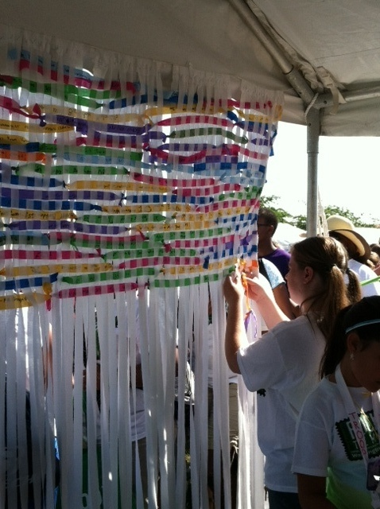
Can you imagine a birthday party with 250,000 guests? Or being a part of a Guinness World Record for the largest sing-along and flash mob? The Girl Scouts orchestrated this epic event on June 9th on the National Mall in Washington, D.C. in celebration of their 100th birthday. Girl Scouts, friends, family and alumnae from around the world traveled to our nation's capital to participate in Girl Scouts Rock the Mall: 100th Anniversary Sing-Along; now, that’s what I call a birthday celebration, if I do say so myself.
Think about it: 100 years of helping girls develop confidence, build character and volunteering to make the world a better place. More than 50 million American women have been a girl scout during their childhood.
We were so honored to be able to celebrate this amazing milestone and sponsor a very special project for the thousands of Girl Scouts who came out to celebrate. Each girl scout who stopped by our booth was given the opportunity to contribute to the creation of a unique Native American blanket. Navajo blanket weavings are recognized for their colorful, yet complex, designs and are highly regarded by many around the world.
This one of a kind blanket was woven using over 5,500 strips of fabric and each strip contained a hand written message from a girl scout. The girls wrote messages of inspiration, notes about the Girl Scouts organziation and troops, and other ties to the larger community.
On Monday, August 20th, we presented the finished blanket to members of the Girl Scout Council of the Nation’s Capital as our birthday gift to them and to represent our commitment to helping build children of courage, confidence, and character, who make the world a better place.
Want to do this type of project with your own kids? Here are some sites to learn how to weave your own blankets, rugs and placemats!
- Paper weaving and Ribbon weaving tutorial
- Simply Made ~ Weaving
- How to Weave Fabric Placemats
- Recycle Tutorial: Woven Rag Rug

