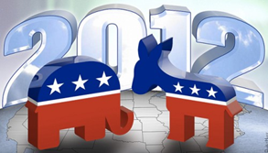
What do Your Kids Know About the 2012 Election?
Submitted by Dana Pool on Thu, 10/25/2012 - 10:22am

Election 2012
The battle between President Barack Obama and Governor Mitt Romney has been one for the record books and the decision of the nation will be determine who will be our next president on November 6, 2012. But do you kids understand what is going on?
As someone in my 20’s, sometimes I do not follow everything that is going on in politics, so I know that most kids don’t either. Scholastic has a page devoted to the 2012 Election so that kids can follow the campaign trail of both the republican and democratic candidates. The site also contains games and election maps so kids can participate and be engaged in past and potential presidents.
250,000 students across the United States got involved by participating in the Scholastic Student Vote 2012 by voting for who they think would be the best choice for our nation.
To get your kids interested in our current election take them to the “What You Need to Know About the Election” link so they can learn all about how an election works; including why 2012 is an election year, why we have presidential debates, and what an electoral college is and how it works.
Our kids are the future of our country so why not help them understand why elections are so important with visuals too. The Scholastic website also has a “video highlights” section covering how the election works. Schoolhouse Rock has a video on teaching kids about the Electoral College making it easier and fun to understand what the election is all about.
Meet the Candidates is a great section to have your kids to get to know each runner a little bit better and to learn about the background of two of the nation’s most respected leaders.
Related Links:
- Scholastic
- USA.gov
- LIVESTRONG.COM -How to Help Children Learn About Elections

